# **Staff**

## **1.1. Account**

| Username | Password |
| --- | --- |
| staff | 123 |
| staff1 | 123 |
| staff2 | 123 |

## **1.2. MainGUI of Staff role:**

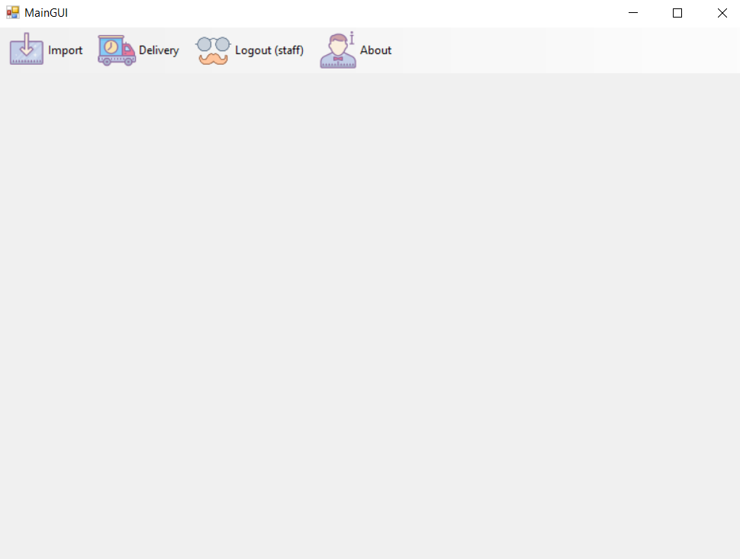

# **Manager:**

## **1.1. Account**

| Username | Password |
| --- | --- |
| manager | 123 |

## **1.2. MainGUI of Manager role:**

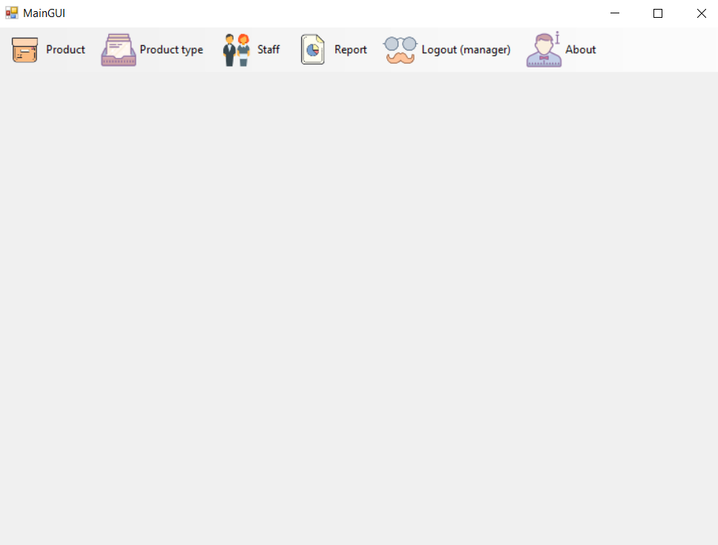

# **Customer:**

## **1.1. Account**

| Username | Password |
| --- | --- |
| customer1 | 123 |
| customer2 | 123 |
| customer3 | 123 |
| customer4 | 123 |
| customer5 | 123 |

## **1.2. MainGUI of Customer role:**

