# **Lab 3**

## ***Entity Relationship Diagram***

## Student name: Ngô Văn Phương

## Student ID: HE140784

## Class: SE1431

EXERCISES

* E/R Diagrams:

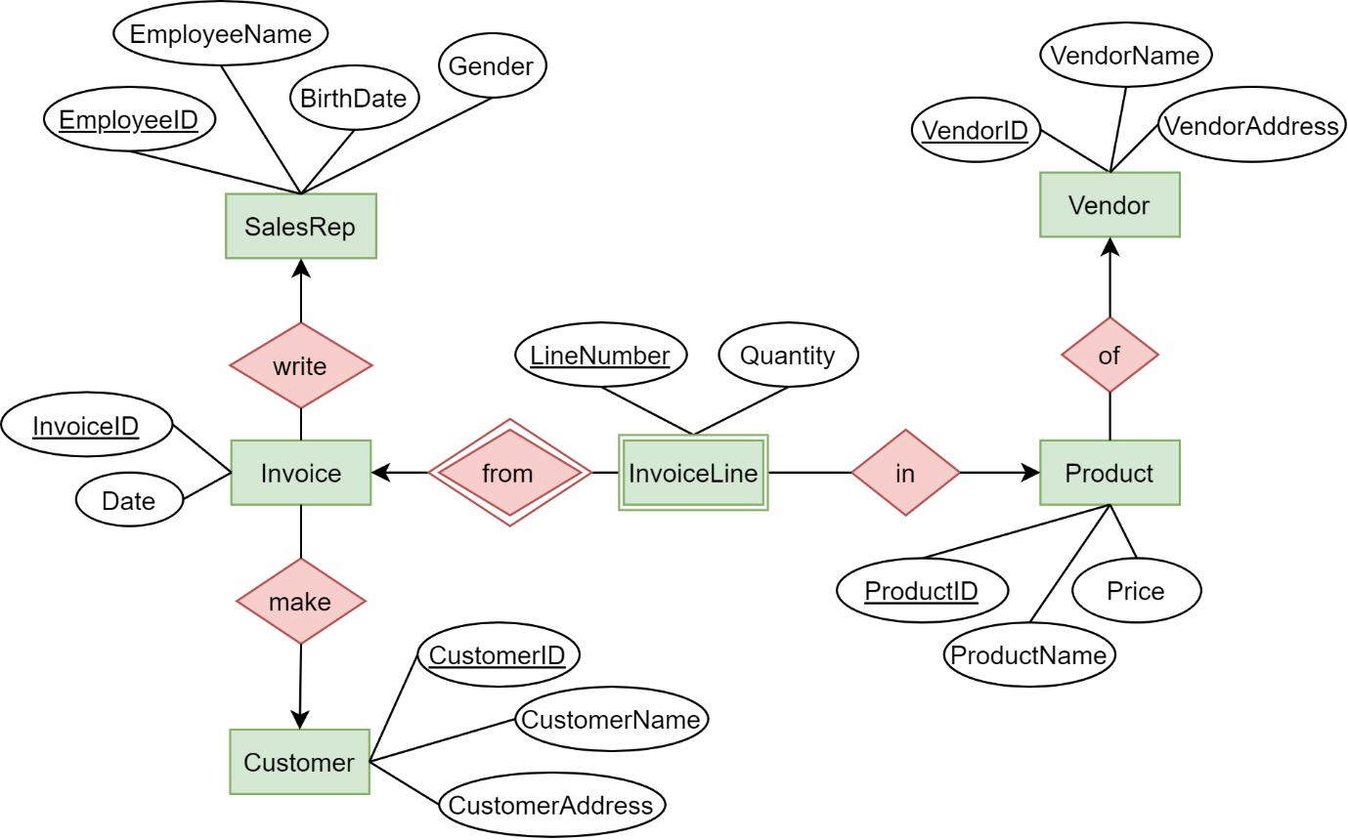

* RD model:

**SalesRep**(EmployeeID, EmployeeName, BirthDate, Gender)

**Customer**(CustomerID, CustomerName, CustomerAddress)

**Invoice**(InvoiceID, EmployeeID, CustomerID, Date)

**InvoiceLine**(InvoiceID, LineNumber, ProductID, Quantity)

**Product**(ProductID, VendorID, ProductName, Price)

**Vendor**(VendorID, VendorName, VendorAddress)

* Conceptual model: 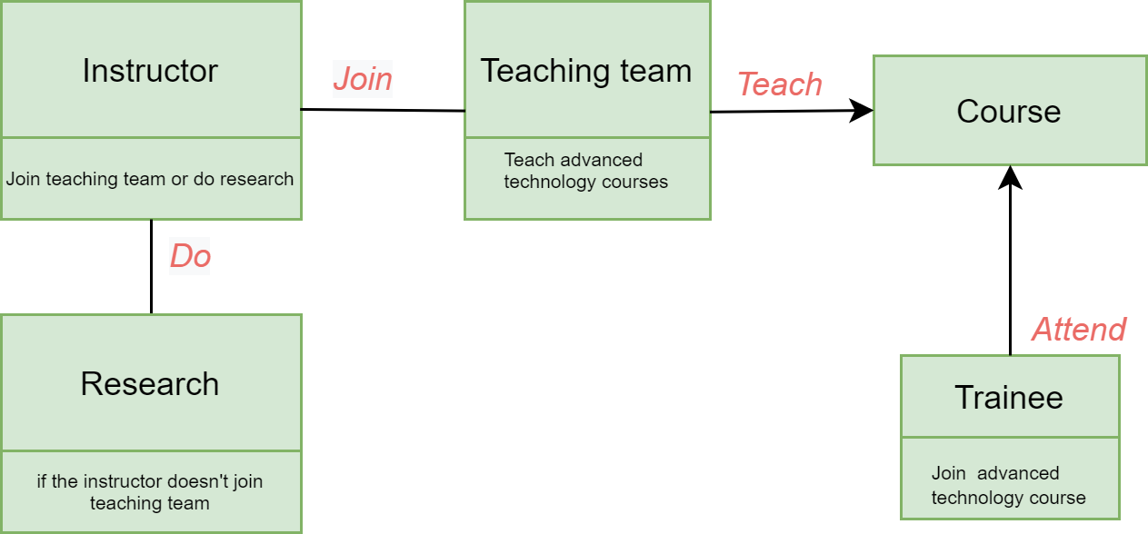
* E/R model:

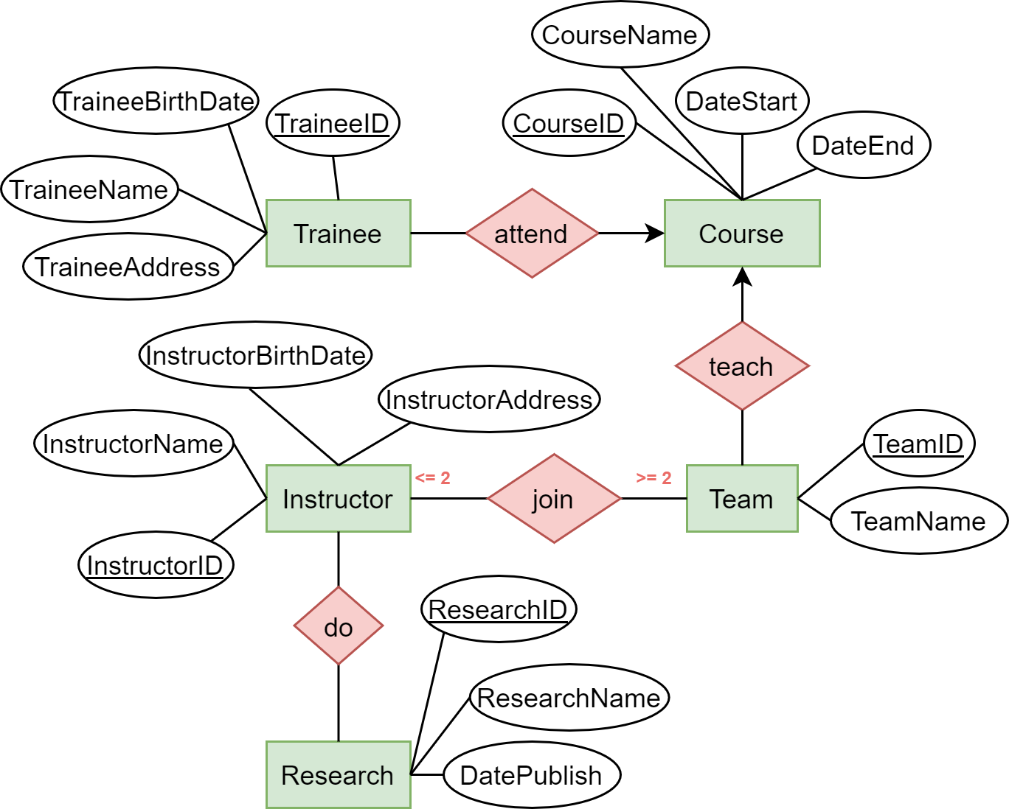

* RD model:

**Course**(CourseID, CourseName, DateStart, DateEnd)

**Trainee**(TraineeID, TraineeName, TraineeBirthDate, TraineeAddress)

**Team**(TeamID, CourseID, TeamName)

**Instructor** (InstructorID, InstructorName, InstructorBirthDate, InstructorAddress)

**JoinTeam**(InstructorID, TeamID)

**Research**(ResearchID, ResearchName, DatePublish)

**DoResearch**(InstructorID, ResearchID)

* E/R Diagrams:

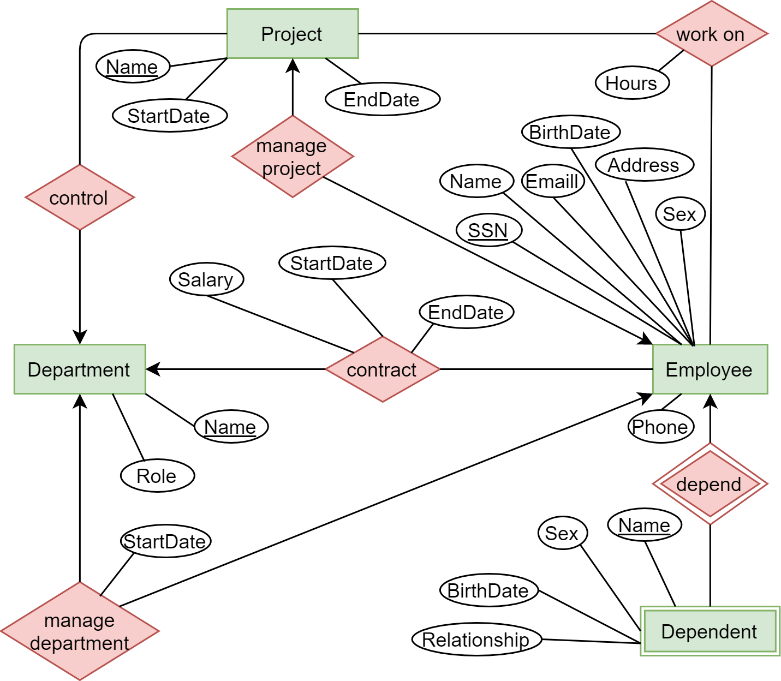

* RD model:

**Employee**(SSN, EmpName, Address, Sex, Birthdate, Phone, Email)

**Dependent**(SSN, DpName, Sex, Birthdate, Relationship)

**Department**(DpName, Role)

**Contract**(SSN, DpName, Salary, StartDate, EndDate)

**DpManager**(DpName, SSN, StartDate)

**Project**(PjName, DpName, StartDate, EndDate, PjManager)

**PjWorker**(SSN, PjName, Hours)

**DpManager**(PjName, SSN)