# **Lab 1 : Algebraic query language**

## Student name: Ngô Văn Phương

## Student ID: HE140784

## Class: SE1431

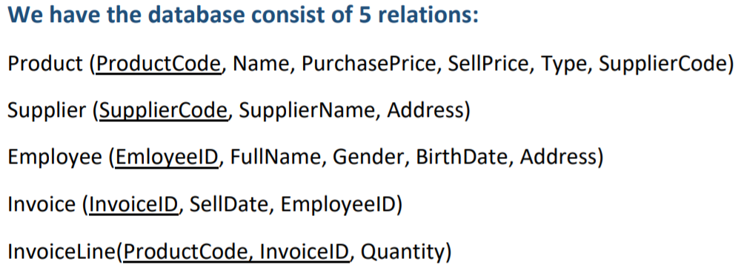

**Exercise 1:**

1. **Find name and sell price of televisions supplied by Samsung.**



1. **Find name and address of all suppliers who supply television product.**



1. **Find name of all employee who were born in 1983.**



1. **Find name and type of all products sold in ‘23/05/2018’**



1. **Find name of female employees who sold televisions.**



1. **Find name and address of suppliers who supply both television and mobile.**



1. **List name and price of all product sold by employee “Nguyễn Văn A” in April 2018.**



1. **Find name and price of all mobile products of Samsung sold in April 2018.**



1. **Find the product with highest SellPrice.**



1. **Find the amount (quantity * sellPrice) of each invoice line of product sold in 30/04/2018.**



**Exercise 2:**

1. **The sell price must be higher than the purchase price.**



1. **A product of Samsung must be television, mobile or tablet.**



1. **No supplier of mobile’s or tablet’s may also supply food.**



1. **No product may appear more than one time in an invoice.**



1. **The quantity of each product in each invoice should be greater than 0.**



1. **There is no invoice without product.**



1. **If purchase price is less than 500.000 VND, the sell price could not be greater than 9.000.000 VND.**



1. **The sell price could not be greater than 2 times the purchase price.**



1. **The gender of an employee should be “Nam” or “Nữ”.**



1. **With the same purchase price, the sell price of two products could not have the difference more than 0.5 times of the purchase price**

