**Instructions**

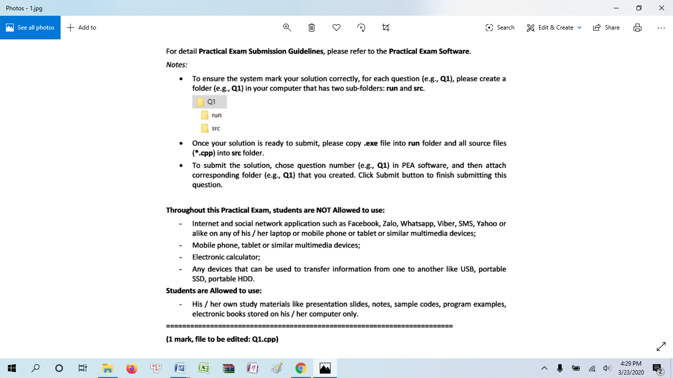

**Q1(1 mark, file to be edited: Q1.cpp)**

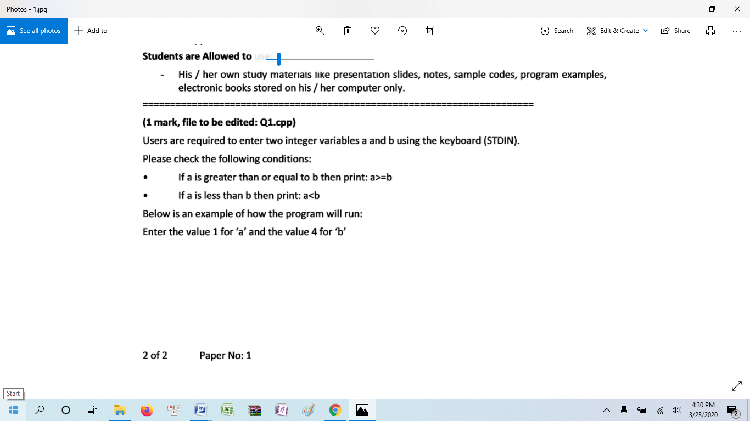

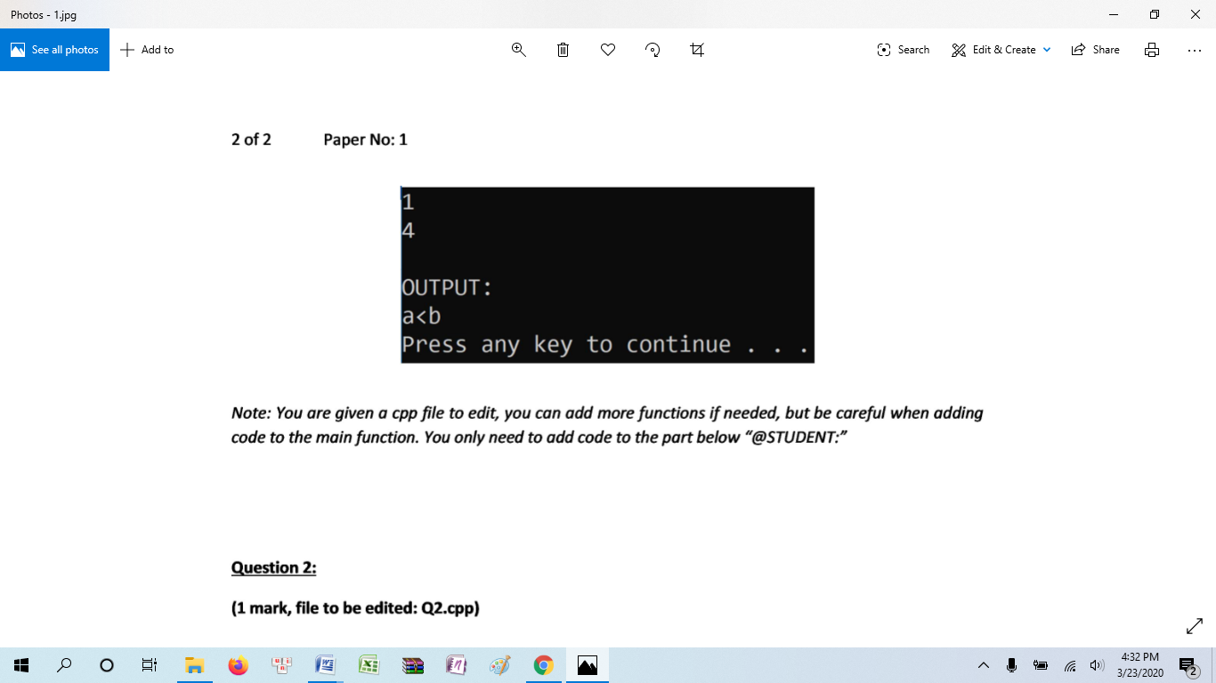

**Q2 (1 mark, file to be edited: Q2.cpp)**

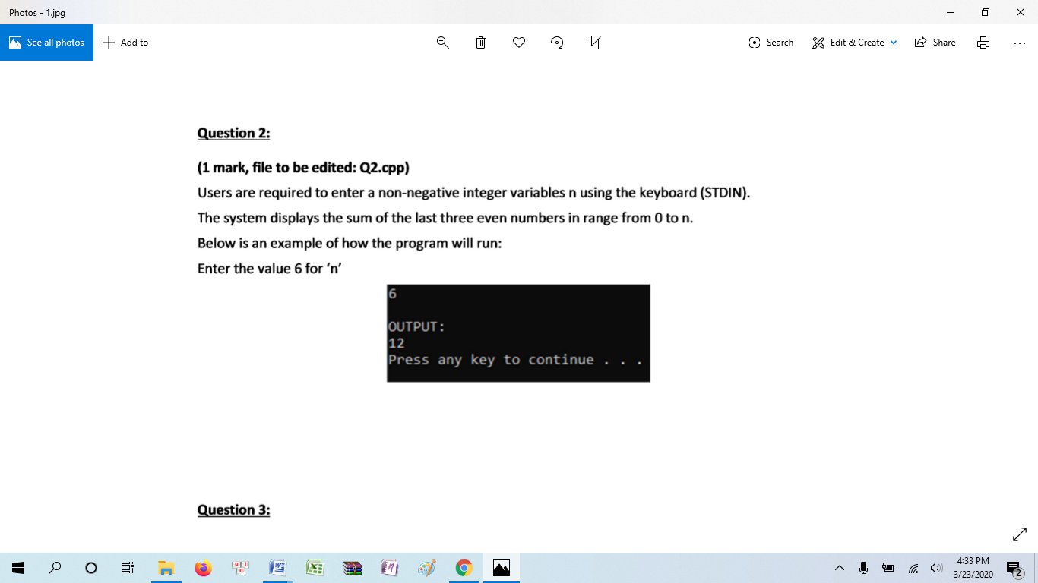

**Q3 (1 mark, file to be edited: Q3.cpp)**

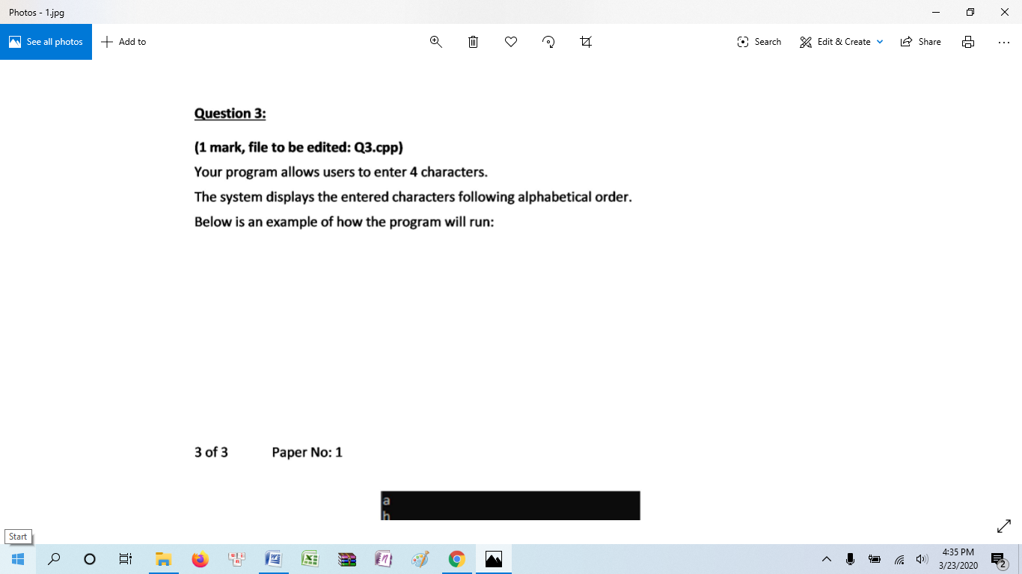

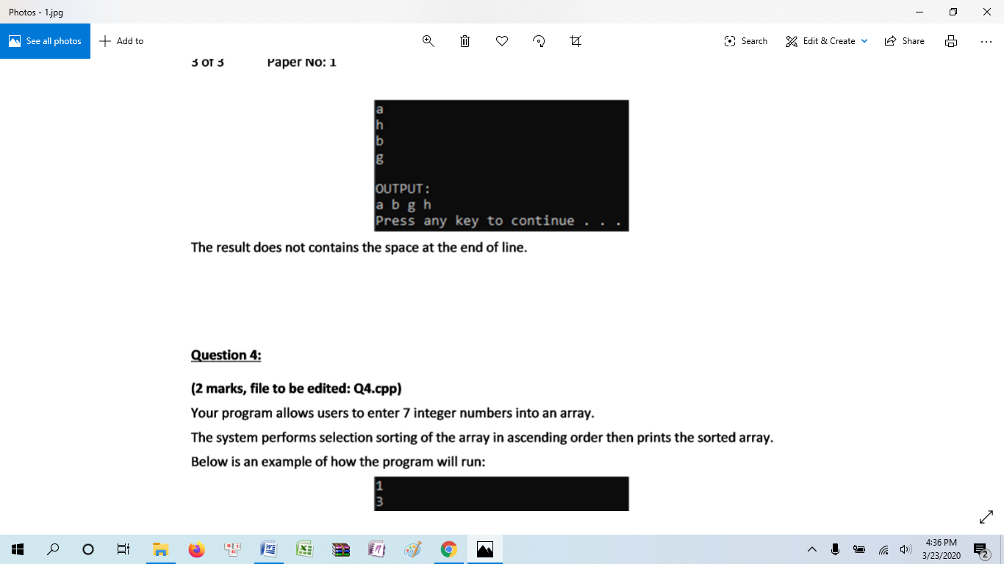

**Q4 (2 marks, file to be edited: Q4.cpp)**

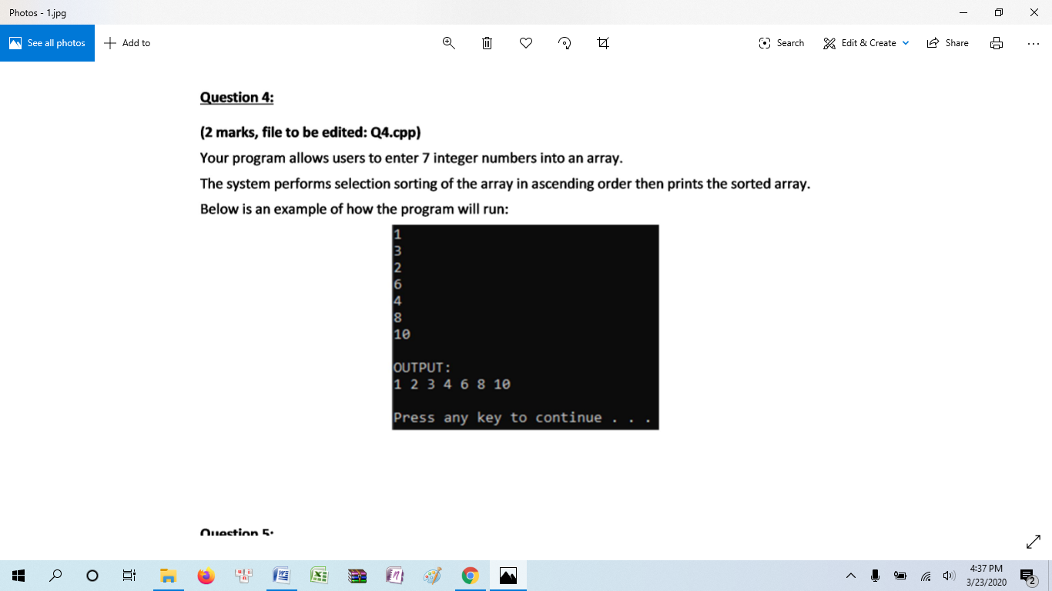

**Q5 (2 marks, file to be edited: Q5.cpp)**

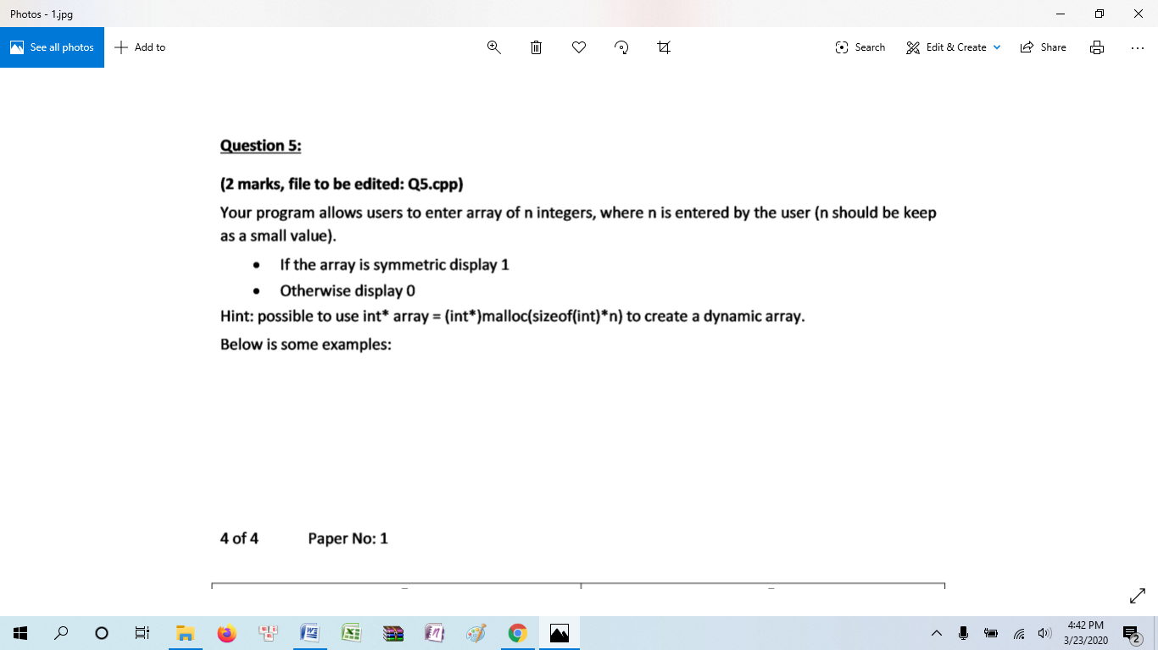

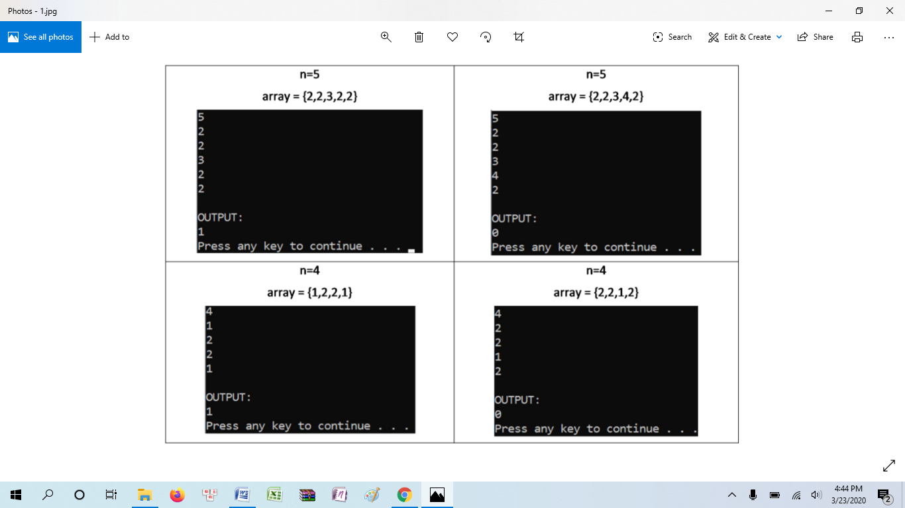

**Q6 (2 marks, file to be edited: Q6.cpp)**

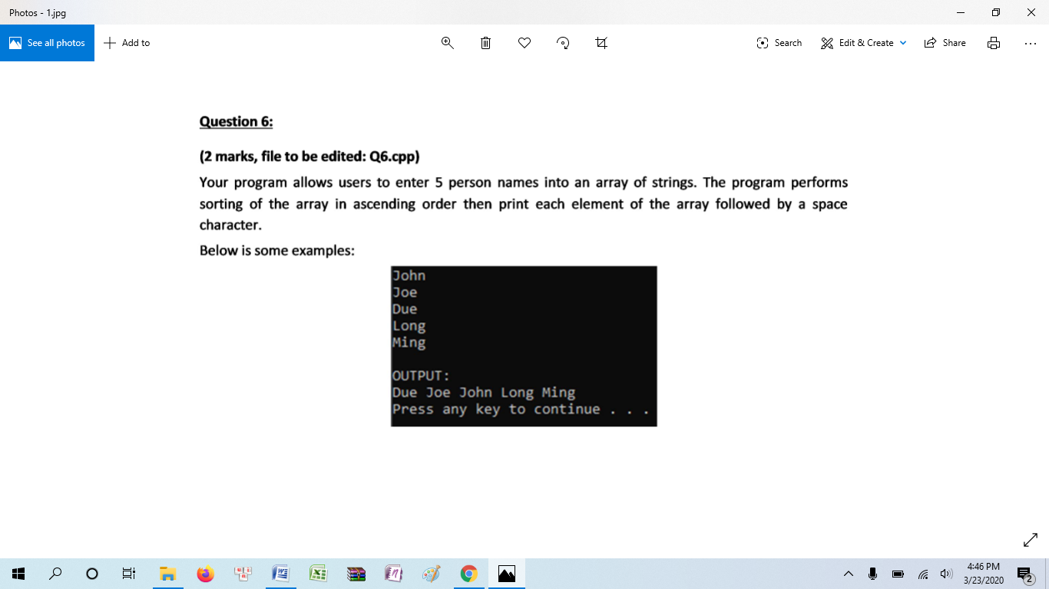

**Q7 (1 mark, file to be edited: Q7.cpp)**

