

Software Requirements Specification

Version 1.0

December 17, 2019

Stock Management System

Group Project

* Members:
* Luv Uprety
* Dipti Pathak
* Muskan Khatun
* Gaurav Poudel
* Kaustuv Kumar Shrestha

Table of Contents

1. Introduction 3

2. Fact Finding Techniques 3

3. Software Requirement Specification (SRS) 8

3.1 Introduction 8

3.2 Scope 8

3.3 SRS Legend 8

3.4 Requirement 9

3.5 SRS Table 9

4. Software Requirement 11

4. Hardware Requirement 11

5. Functional Decomposition Diagram 12

6. System Modeling 13

6.1 Context Modeling 13

6.2 Data Modeling 14

Data Dictionary 14

6.3 Structural Modeling 15

6.4 State Diagram 16

6.5 Sequence Diagram 17

6.6 UI Model 18

# Introduction

Valley Mart Departmental store is a one of the top destinations for shoppers throughout the Kathmandu valley looking for day to day use goods. The store has wide range of items on sale and has new clothing store added to its service. Due to the growing number of customers and problem in managing the store, the owner has decided to computerize its stock management and billing process through the stock management system. Now the main objective is to create the system. To create the system first of all various facts should be collected regarding the problem of the store that can occur in the future and how it can be solved using the system.

# Fact Finding Techniques

Some of the most common fact-finding techniques are used to collect the data which are described in the paragraph below.

* 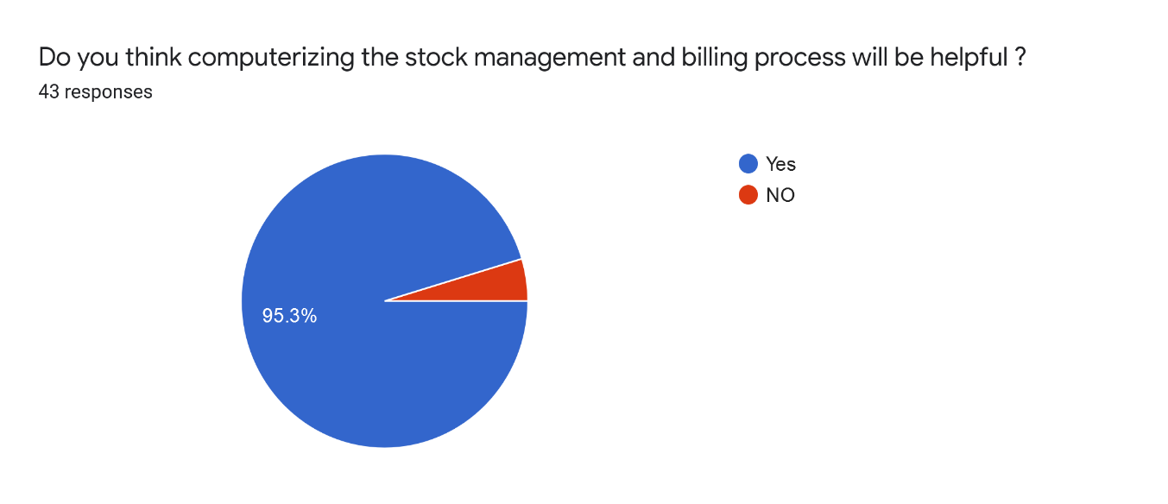Survey: Survey with staffs of different departmental stores inside the Kathmandu valley was taken. The results of the survey are as follows:

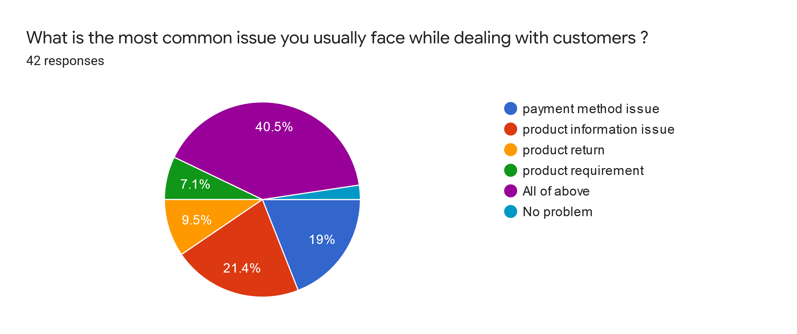

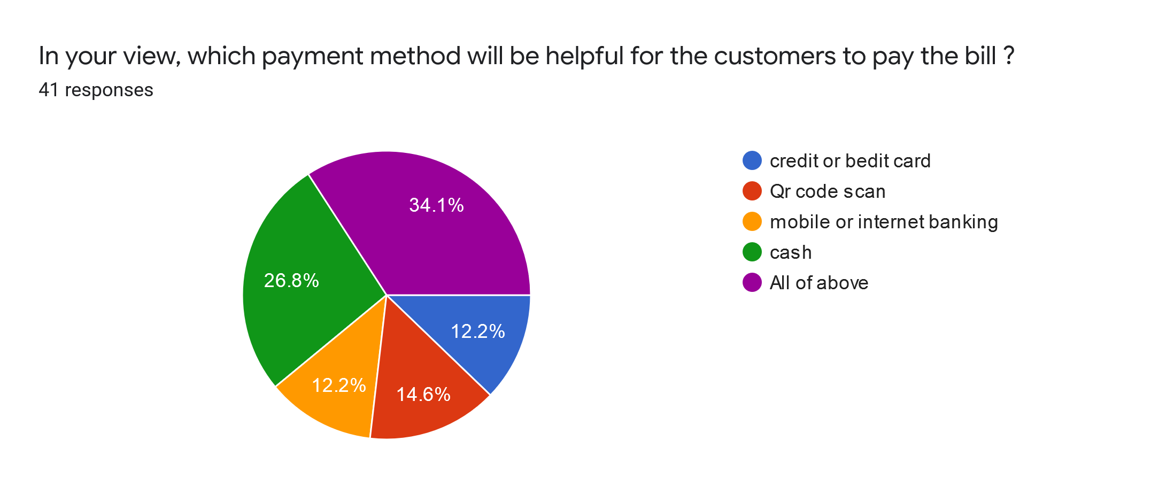

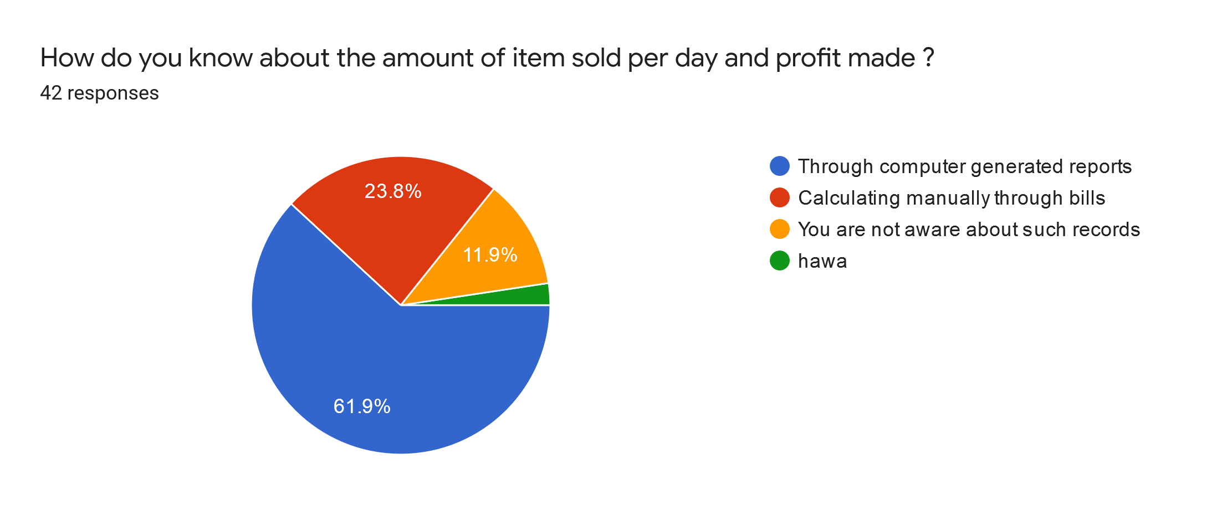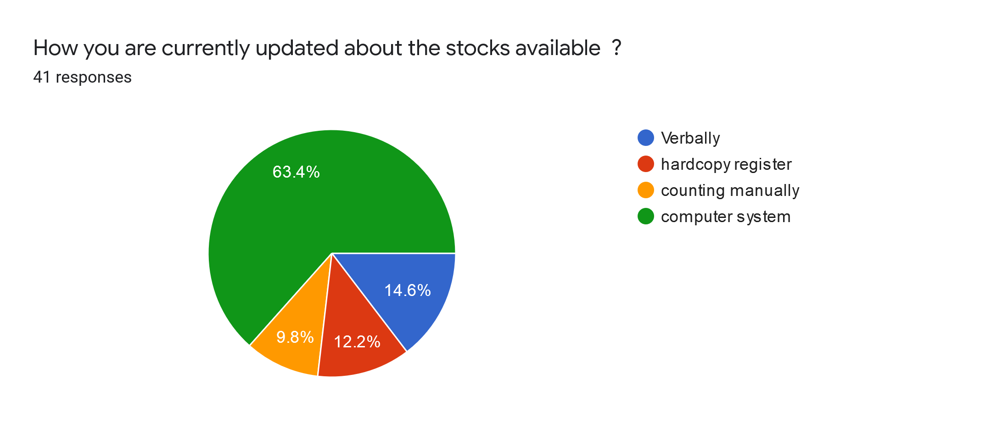

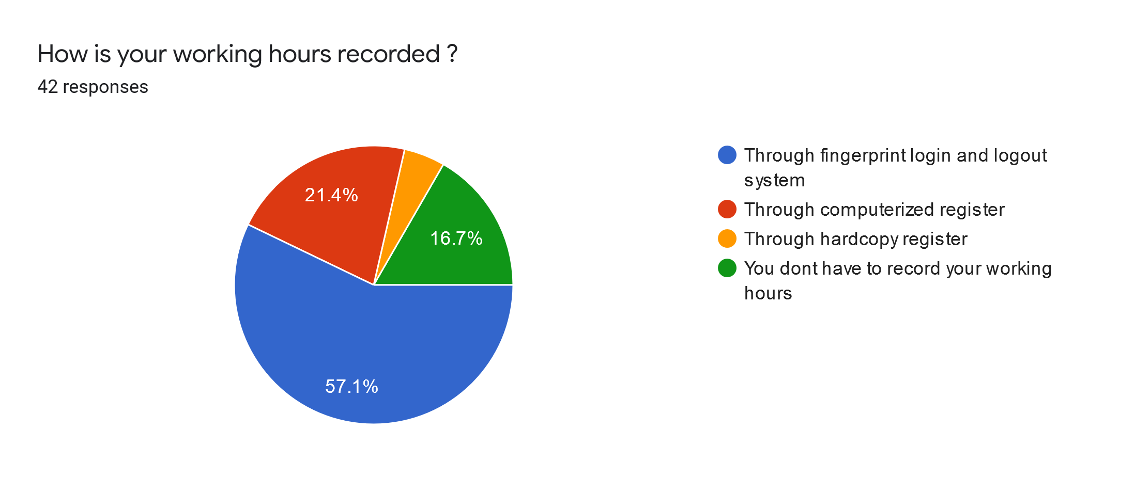

* Interview: Interview was taken with the manager of departmental store. Some of the questions asked and facts found are given below.

1. As a manager what are the issues you are having to manage the employee and store?

Ans: I am having the issue on managing the salary of the employee as per their working hours. Specially I am unable to keep the records of the employee.

1. How you are updated about the stocks available in the store?

Ans: At the end of the week each employee working under the different sections of the store manually count the number of goods available and generate the report which is then forwarded to me.

1. Do you think it is reliable to depend on digitized system?

Ans: Yes, with the growing technological advancement I think it is reliable to depend on digitized system. Specially knowing the features of digitized system: speed, accuracy and manageability and user convenience computerizing the stock management and billing process will be more helpful on tracking the business.

1. What kind of features do you want in the system?

Ans: I prefer the system to be very easy to use with simple design. It should have the functionality to login individual staff to track their working hours. More specifically it should be able to create the bills for total amount to be paid by the customers after the product is being scanned through scanner. It should be able to receive payment through different digital payment options. The sold item should get automatically updated in the stock details. While it should also be able to generate the stock and transaction report at the end of every month.

* Research:

URL: hashmicro.com/blog/6-major-challenge-in-retail-industry/

Findings:

* Meeting customers’ expectations:

The requirements of the customers always keep on changing.

Products required by the customers may not be available all the time. For that the store must be able to add the products as per the requirement of the customers.

* Managing the internal communication system:

Nowadays almost all the mart, departmental stores are computer based in which all the transactions are done in the computer.

Departmental store has many internal communication systems. Disturbance in the communication may interrupt the whole system of the store so, all the records of the department should be managed and stored properly to run the system smoothly.

* Managing the employees:

Behavior of the employee towards the customers, highly dedication towards their work, system management are the most important factors to run any shopping stores.

So, active engagement of the employees in their work is necessary.

* Management of stocks:

If the stocks available are not managed in proper way it is difficult for the customers to select the required items so the products available should be managed and updated timely.

(Business Tech, 2018)

# 3. Software Requirement Specification (SRS)

## 3.1 Introduction

This Software Requirements Specification provides a complete description of all the functions and specifications of the Stock Management System which can be used in various stores to manage the goods and keep Report.

## 3.2 Scope

Stock Management System is designed to run on normal pc and allows user to know the available stock, keep records and manage bill process.

## 3.3 SRS Legend

UM-F-1 Numbering

UM (User Management) Functional (F)

AM (Accounting Management) Non-Functional (NF)

PM (Payment Management) Usability (UR)

RM (Report Management)

## 3.4 Requirement

Functional Requirement:

It defines the services/functions required by the customer that must be provided by the system that helps to capture the intended behavior of the system.

•Non-Functional Requirement:

It defines the quality attributes of a software system and represents a set of standards used to judge the specific operation of a system. Also defines the system properties and constraints (constraints are I/O device capacity representation).

•Usability Requirement:

It defines how easy it is for an operator to make use of the system. It deals with how well should the task be performed by the user to achieve the goal.

## 3.5 SRS Table

|  |  |  |
| --- | --- | --- |
| Requirement ID | Requirement Specification | Moscow |
| UM-F-1 | System should allow user to login into dash board through login portal | Must have |
| UM-UR-1 | User should be provided with the opinion for the password visible. | Must have |
| UM-UR-2 | System should show error message to user just beside the button. | Must have |
| UM – NF – 1 | Password should contain alpha numeric, symbols. | Must have |
| UM – F – 2 | System should allow user to fill up the bill. | Must have |
| UM – UR – 3 | Individual user would like to able to check the number of customers they attend. | Must have |
| UM – F – 3 | Individual user would be able to register the customer for member ship card in the system. | Must have |
| UM – F – 4 | Manager should keep daily Report of the goods sold to the customer. | Must have |
| UM – F - 5 | System should allow individual user to sign out after their working hour. | Must have |
| AM – F – 1 | System should allow accounting manager to check the number of goods sold and amount collected | Must have |
| AM – F – 2 | System should allow accounting manager to check the working hours of the individual staff | Must have |
| AM – NF – 1 | System should load data within 1-3 second. | Must have |
| AM – NF – 2 | System should notify user through SMS or Email for their salary | Must have |
| AM – UR – 1 | System should allow account manager to choose Notification methods through SMS or Email. | Should have |
| PM – F – 1 | Customer must pay the fee after they purchase the goods. | Must have |
| PM – NF – 1 | System should generate QR code to fulfil the payment. | Could have |
| PM – UR – 1 | System should provide options for the payment through online or cash for the purchase of goods. | Should have |
| PM – UR – 2 | System should provide option of credit card or mobile payment in online payment method. | Should have |
| PM – F – 2 | System should provide user to make discount during payment. | Must have |
| PM – F – 3 | Accounting officer should keep the Report of payment. | Must have |
| RM – F - 1 | Accounting officer should keep the reports of goods, sales and expenses. | Must have |
| RM – F – 2 | Accounting Officer must update the reports of goods, sales and expenses. | Must have |
| RM – F – 3 | System should generate the total amount of profit made per day. | Must have |
| RM – UR – 1 | Reports should be separated by their date. | Must have |
| RM – F – 4 | Stock page must show frequency of each goods sold per day. | Must have |
| RM – UR – 2 | User should have option to view sold items by categories. | Must have |
| RM – F – 5 | Printing device should be connected to print the Reports. | Must have |
| RM – F – 5 | System should print the report. | Must have |

# 4. Software Requirement

Front end: Html, CSS, JavaScript

Back end: Java, MySQL

# 4. Hardware Requirement

Windows 7 or latest

4 Gigabyte Ram

Core i3

The product needs following third party application for the development of the project:

* Sellinium
* NetBeans, Photoshop

# 5. Functional Decomposition Diagram

Management System

User Management

Accounting management

Payment Management

Report Management

7NFW3P2

Login

Generate report for products sold, sales and expenses

Provide options for payment (online or cash)

Check amount collected

Generate QR code for payment

Fill up the bill

Generate total amount of profits made per day report.

Checking no of working hours

Print Report

Print Bill

View sold item by category

Create final Bill

Allow to make discount

Notify Staff for their salary

logout

Keep daily records of good sold

Check no of customers

# 6. System Modeling

## 6.1 Context Modeling

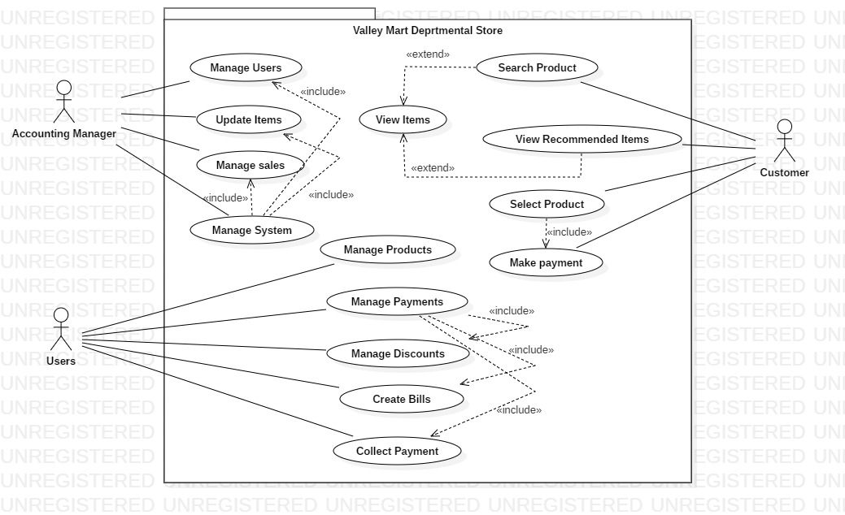

## 6.2 Data Modeling

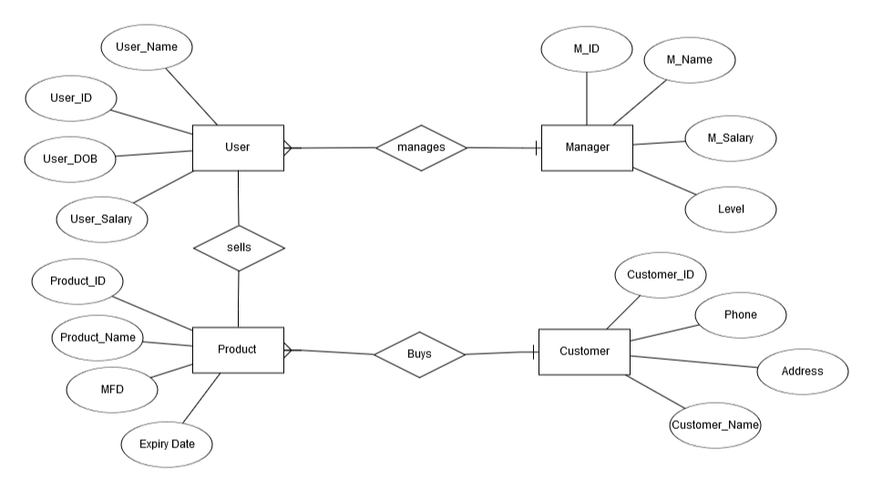

## Data Dictionary

User: User_Name: String, User_ID: Int, User_Salary: Int, User_DOB: date

Manager: M_Name: String, M_ID: Int, M_Salary: double, M_Address: char

Customer: Customer_ID: Int, Customer_Name: String, Phone: Int, Address: char

Product: Product_Name: String, Product_ID: Int, Expiry_Date: date

## 6.3 Structural Modeling

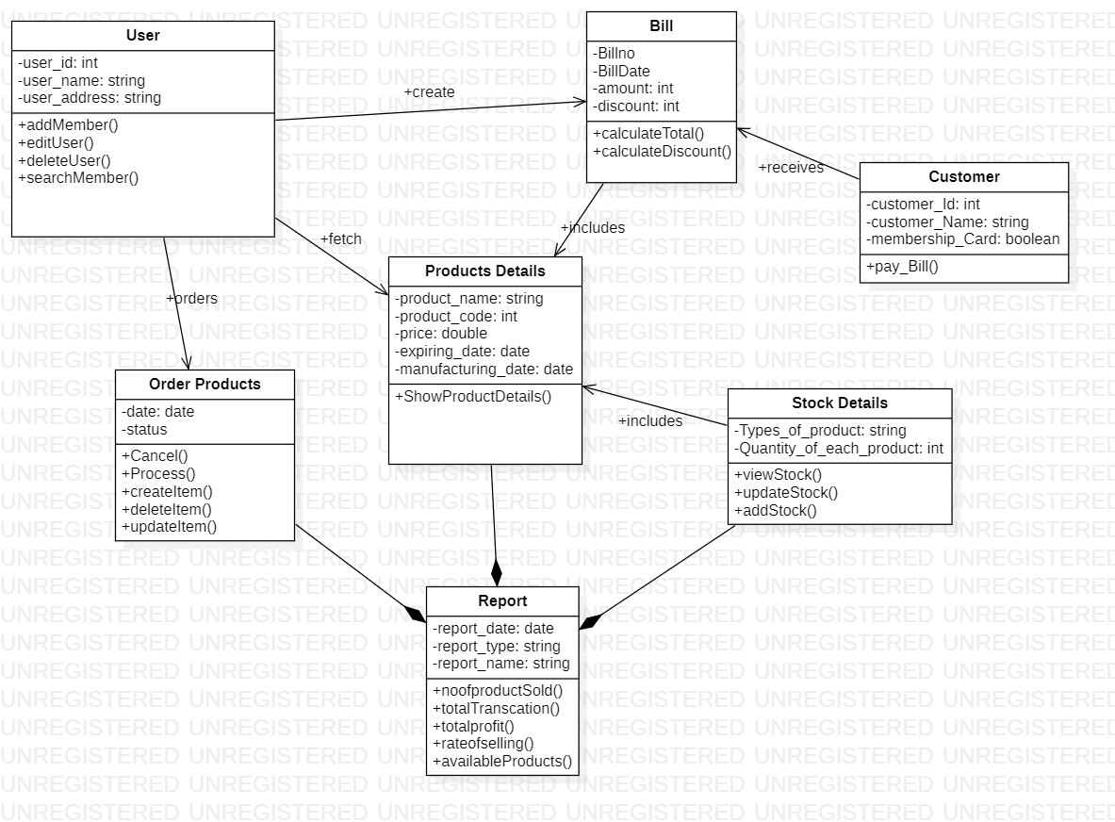

## 6.4 State Diagram

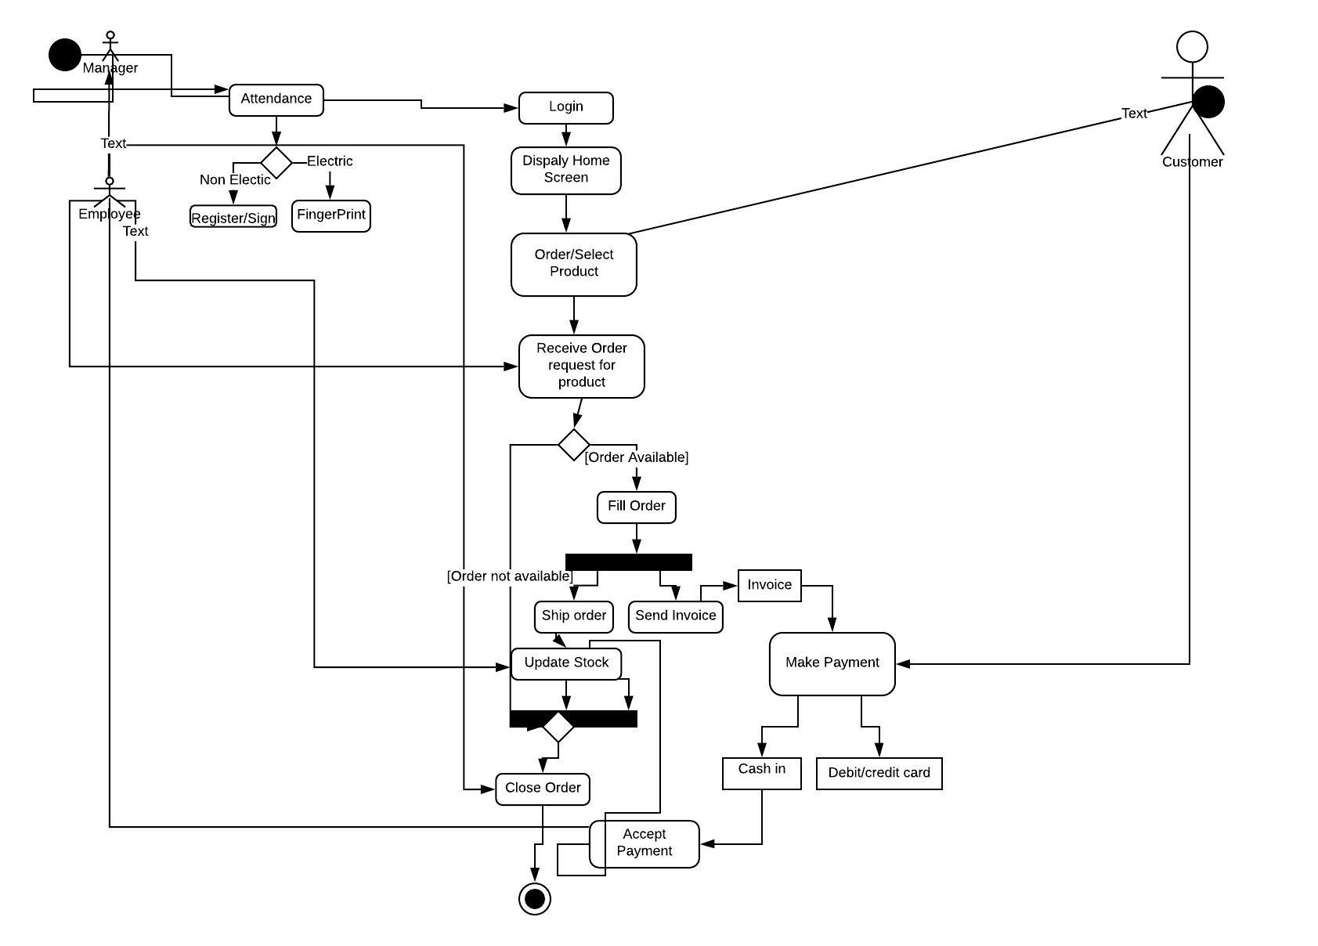

## 6.5 Sequence Diagram

# 6.6 UI Model

