**handymanshopper.com**

**THIS PROJECT WILL BE SIMILAR TO UPWORK. THINK UPWORK WHEN BUILDING THIS.**

**CODE:** The system will use Apache, PHP, MySQL on a Linux infrastructure (LAMP) based. Any framework can be used as long as it’s secure. **WE WILL RUN A SECURITY SCAN, SO, PLEASE KEEP THAT IN MIND.** We will NOT need build this from scratch, but can use a clone from <http://demo.ncryptedprojects.com/nlance-ent/> and customize it as needed.

**Summary:**

This application is similar to a freelancer app (like upwork), where it would connect handyman (painters, plumbers, electricians, carpenters, maids, landscapers, etc) with potential customers. The customer would post a job, similar to any freelancer website. As an example, assume the customer posts the following job:

*I’m looking for a handyman to help paint a 4 bedroom house. The rooms are as follows:*

*Room 1: 10 x 10*

*Room 2: 14 x 8*

*Room 3: 8 x 10*

*Room 4: 12 x 12*

*Attached are pictures of each of the rooms.*

*Please post a bid for the job.*

Just like this freelancer website, the handyman and customer can message back and forth to get all the answers.

Then as an example, the handyman can post the following bids in one of **2 ways**:

**FIXED Amount:**

$800 total to paint each room 1 time.

**RANGE:**

Cost would be $700 - $1200 based on the type of paint that you choose and the color you would like to paint. In this case, the customer would deposit the MAX amount into the escrow and after the job is complete, only release what is required. So, here they would deposit $1200 into the escrow and after the job, if the total invoice is $1000, they would only capture a payment of $1000 (not $1200).

So, the handyman can post the bid in EITHER FIXED amount or RANGE. Not Both. They can choose one way to post the bid.

Once the work is completed, the customer would login and can release the funds. The handyman would get an alert/email that the funds have been released and they have been paid. For the payment portion, need to decide what gateway to use.

**Handyman Profile:**

* **Provider will be known as "Handyman"**
* Will show reviews of customers. Once a review is posted by the customer, it goes in PENDING state, until the admin approves the review.
* The number of STARS in the review will be averaged as percentage of job success: “95% Job Success”
* Example:

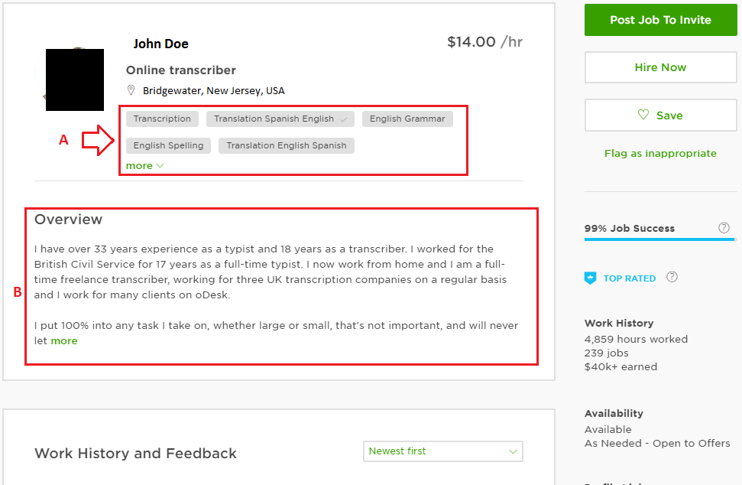

A: will be jobs the freelancer can do. Example: Painter, Plumber, Electrician, etc.

B: Description that the handyman will write.

**When a new profile is created, it goes into PENDING state, until an admin approves.**

**Customer Job Posting:**

When a customer posts a new job, they will be asked the following:

Similar to the following:

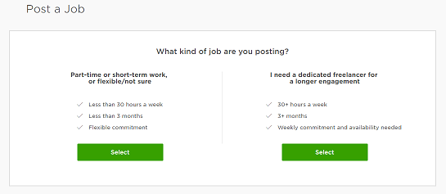

* LEFT Side: Ready to Hire
  + Need someone now – Emergency
* RIGHT Side: Planning and Budgeting
  + Not an emergency.
  + Time to hire is flexible.

After clicking one of the 2 choices:

* Describe the Job:
  + Name of your job posting
  + Describe the work to be done. Including measurements.
  + Attach pictures (recommended for an accurate quote):
  + What type of location is this?
    - Home
    - Business
  + Type skills required
    - Example:
      * Painter
      * Plumber
      * Electrician
      * Landscaper
      * Maid
  + ~~What is your budget?~~
    - ~~Pay a fixed Price~~
  + Confirm the project address
    - Street, City, Zip Code – Can use google point lookup. If someone enters address **1 Main street, Somerville, NJ 08876**, then it would match up handyman near this area (maybe 50 miles radius. This variable is set on the admin page). When the list of handyman are shown to the customer, it will show the location of the handyman. City, State.

**Customer Registration (from template):**

1) Remove "Country" and replace it by Google Point Lookup and call it "Location of Project"

2) For username: increase 10 character limit to 25 character limit

**Handyman Registration (from template):**

1) Remove "Country" and replace it by Google Point Lookup and call it "Company Location"

2) For username: increase 10 character limit to 25 character limit

**Explore Type Skills on the index page will be replaced with (also icons replaced) (from template):**

1) Plumbing -

2) Electrical -

3) Painting -

4) Cleaning/Maid Service -

5) Appliance Repair

6) Landscaping -

7) Heating & Cooling

8) Other Handyman Services

**COMMISSION:**

~~Commission will be determined based on "Job Success" Percentage. So, I should be able to set the commission to the handyman based on his success rate.~~

~~Examples:~~

~~90% or higher will pay 7% commission.~~

~~80% - 89% will pay 9% commission.~~

~~70% - 79% will pay 11% commission.~~

~~60% - 69% will pay 13% commission.~~

~~59% or below will pay 15% commission.~~

~~(Again all percentage and commission will be set from admin panel. NOT hard coded)~~

* ~~Regarding the percentage. There should be another field that says: "Introductory Commission" and the number of days to use this introductory commission. So, if I set the introductory commission to 7%, then no matter what the job success rate is, they will ALWAYS pay this "Introductory Commission" for the number of days specified.~~

~~Example:~~

* ~~Introductory Commission: 7% for 180 days. This means, for 6 months after the profile has been APPROVED, they will only pay 7%. This would give them enough time to build up a success rate. After 6 months, if they have a job success rate of 72%, they will start paying 11% for all future jobs, until the approval rate goes up.~~

**RATING SYSTEM:**

Job success Rate will be calculated by averaging all jobs completed. Each job will have an equal weight.

~~Job Success Rate percentage is calculated as higher paying jobs carry a bigger impact on the success rate percentage, than less paying jobs. For example, if this person got a 50% success rate on a $2,000 job, and got 95% on THREE $50 jobs, then it DOES NOT mean = (.50 + .95 + .95 + .95) = 0.8375 OR 84%.~~

**MONEY FLOW:**

Will be done in “Phase 2”

~~This part is VERY IMPORTANT. We need to link to an escrow service and then release the funds to the handyman’s account based on routing and checking details. Need to think about it.~~