|  |  |
| --- | --- |
| **ref keyword** | **out keyword** |
| It is necessary the parameters should initialize before it pass to ref. | It is not necessary to initialize parameters before it pass to out. |
| It is not necessary to initialize the value of a parameter before returning to the calling method. | It is necessary to initialize the value of a parameter before returning to the calling method. |
| The passing of value through ref parameter is useful when the called method also need to change the value of passed parameter. | The declaring of parameter through out parameter is useful when a method return multiple values. |
| When ref keyword is used the data may pass in bi-directional. | When out keyword is used the data only passed in unidirectional. |

Both ref and out parameter treated same at compile-time but different at run-time.

**Ref Keyword**

The ref keyword passes arguments by reference. It means any changes made to this argument in the method will be reflected in that variable when control returns to the calling method.

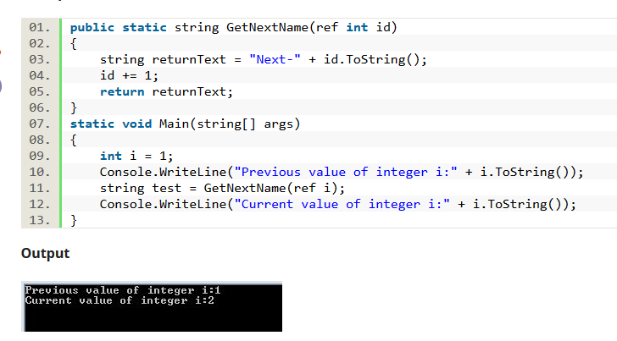

**Out Keyword**

The out keyword passes arguments by reference. This is very similar to the ref keyword

