Math Question Generation Assignment – Lovekush

This document contains two math questions generated using a Large Language Model (LLM) based on the provided base questions.

**Question 1: Combinatorics Style**

@title Outfit Combinations at Riverdale High

@description Assessing understanding of combinations in clothing choices

@question Students at Riverdale High can choose 1 jacket and 1 pair of shoes for their uniform. The available options are shown below. How many unique outfit combinations are possible?

## Outfit Choices

| Jacket Color | Shoe Color |

| :---: | :---: |

| Blue | Black |

| Green | White |

| Red | Brown |

| Yellow | |

@instruction Choose the correct number of combinations.

@difficulty easy

@Order 1

@option 9

@option 8

@@option 12

@option 12

@explanation Multiply the number of jacket choices (4) by shoe choices (3): 4 × 3 = 12

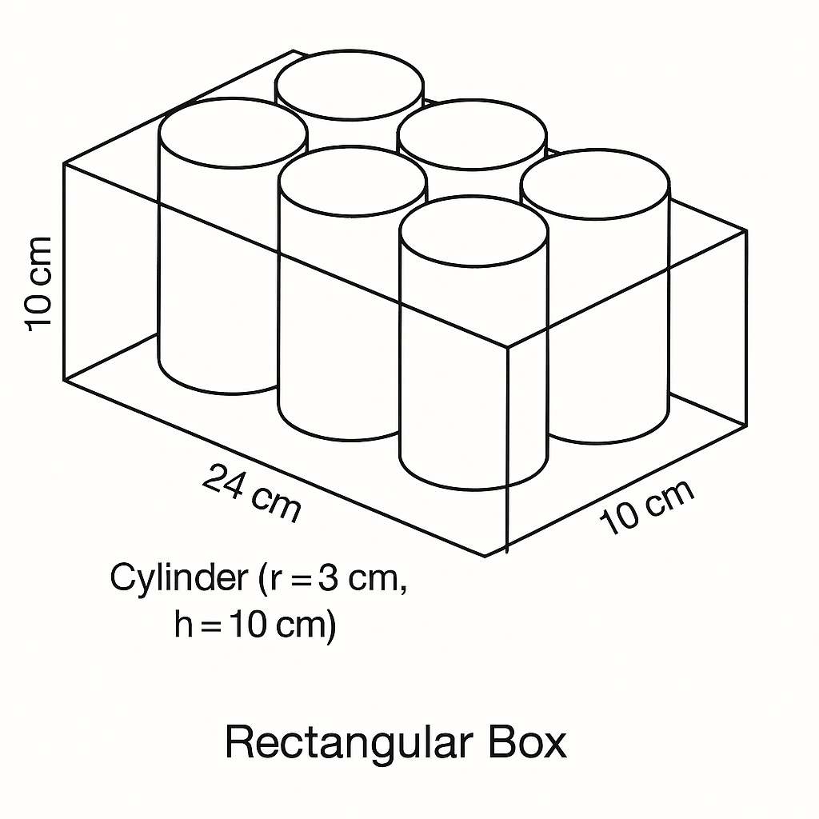@subject Quantitative Math

@unit Problem Solving

@topic Numbers and Operations

@plusmarks 1

**Question 2: Geometry Style**

@title Packing Cylinders in a Box

@description Understanding spatial reasoning and volume estimation

@question A rectangular box contains 8 tightly packed cylindrical cans arranged in two rows. Each can has a radius of 3 cm and height of 10 cm. What are the closest dimensions of the box?

@instruction Choose the correct dimensions.

@difficulty moderate

@Order 2

@option $6 \times 10 \times 12$

@option $12 \times 10 \times 6$

@@option $24 \times 12 \times 10$

@option $8 \times 10 \times 12$

@explanation Two rows of 4 cans means @explanation Two rows of 4 cans means width = 4 × diameter = 4 × 6 = 24 cm, depth = 2 × diameter = 12 cm, height = 10 cm, depth = 2 × diameter = 12 cm, height = 10 cm

@subject Quantitative Math

@unit Geometry and Measurement

@topic Solid Figures (Volume of Cubes)

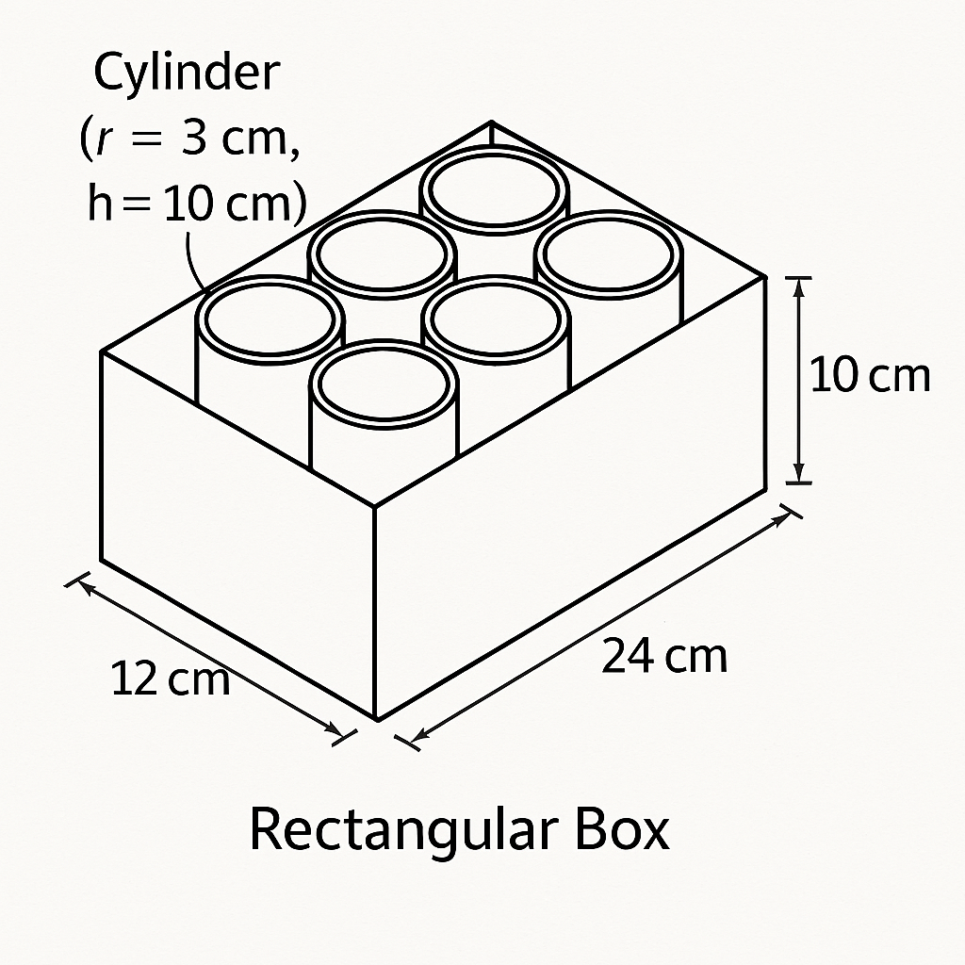@plusmarks 1