The purpose of modeling is to obtain measure of preference update to best explain the collected data. Thus we allowed the model to have as much flexibility, within the constrains suggested by the behavioral results. The model is described in more detail below.
The Bayesian model explains the preference update with three processes: (1) an initial rating is drawn from a prior distribution, (2) this prior distribution is updated in the light of Amazon reviews to form a posterior distribution, and (3) a second rating is drawn from the posterior distribution.
First, a prior distribution is formalized with Gaussian distribution, whose mean is determined by a by-subject by-product parameter and its variance is determined by another by-subject parameter. Following the behavioral results, we let the variance to vary between products rated with low and high confidence.
Thus, a prior distribution for subject on product is:
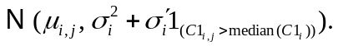
Here, is an identity function: it returns 1 when confidence in rating is above the median confidence, and otherwise 0. As the behavioral results indicate, higher confidence is related to more precise prior distribution. Thus, 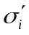 is forced to be non-positive.
Similarly, the model includes a by-subject parameter for perceived variance in Amazon reviews, and another by-subject parameter for the perceived number of Amazon reviews. Again following the behavioral results, we fixed the perceived variance across the 210 products but let the perceived number of reviews to vary between products with a few and many reviews.
Thus, Amazon review for product is parameterized to contain 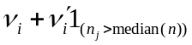 reviews, where 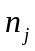 is the number of Amazon reviews as presented to subjects during the experiment. Also as we do not expect the larger number of reviews to be perceived as smaller, 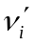 is forced to be non-negative. This Amazon review has a mean of 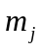 and a variance of 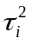. Again, is the mean of Amazon reviews, as presented to subjects during the experiment, and is a parameter.
Then, a posterior distribution is derived with Bayes theorem, and therefore, the model does not havea parameter specifically for a posterior distribution.
In summary, the model explains 420 ratings (210 initial and 210 second ratings) from each participant with 210 parameters (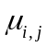) for prior means, 2 parameters (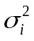 and ) for prior variance, 2 parameters (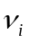 and ) for the perceived number of Amazon reviews, and 1 parameter () for the perceived variance in Amazon reviews. The parameter values were estimated independently for each subject, to maximize likelihood of both initial and second ratings.
Estimated prior mean and derived posterior mean show strong, positive correlations with initial and second ratings: across 18 subjects, correlation coefficients range from .75 to .96 (mean:.90, 95% CI: [.88, .93]) between prior mean and an initial rating, and from .85 to .96 (mean: .90, 95% CI: [.89, .92]) between posterior mean and a second rating.
Although the parameter values are not estimated to explain confidence in second ratings, precisions of posterior distributions generally show positive correlations with confidence in second ratings. Seventeen out of 18 subjects show positive correlations, with correlation coefficients ranging from -.14 to .40 (mean: .18, 95% CI: [.12, .24]). One-sample t-test indicates that these coefficients are significantly different from zero: t(17) = 5.95, p<.001. Additionally, a mixed-effect linear regression supports an overall significant positive relationship between the prior precisions and confidence: (1)=20.36, p<.001.
These results indicate that our Bayesian model captures processes of preference update. As a measure of update, we employ Kullback-Leibler (KL) divergence. KL divergence measures the extent to which a prior distribution was updated to form a posterior. Thus, a larger KL divergence indicates a greater preference update. Letting  and denote prior and posterior density function respectively, KL divergence is computed as follows:
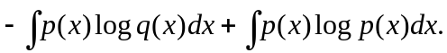
In our Bayesian model, both prior and posterior distributions are Gaussian distributions. Therefore, the above equation is reduced to the following:
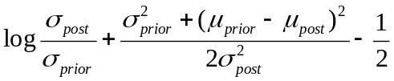
where 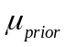 and 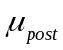 are a prior and posterior mean, and 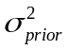 and 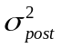 are a prior and posterior variance.

Using the estimates from the model, the degree of defying Amazon reviews is computed for each participant for each product as follows:
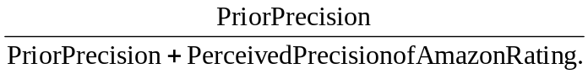
Here, prior precision is the inverse of prior variance, and perceived precision of Amazon rating is estimated Amazon N divided by estimated Amazon variance. Given Bayes theorem, the above specification captures how heavily prior mean is weighted toward posterior mean.
Specifically, the degree of defying is 1 when Amazon rating is completely ignored and prior mean is the same as posterior mean. Also the degree of defying is 0 when prior is completely discarded and Amazon mean is the same as posterior mean. A larger value indicates that Amazon mean is more heavily weighted toward posterior mean than prior mean is.
This degree of defying is mean-averaged for each participant across 210 product ratings.

