**SQUIRREL-NUTS DOCUMENTATION**

**Elise Tang**

**100626492**

1. GAME DESCRIPTION

This is a 2D unity game. A player will be control a red squirrel to collect nuts and avoid touch another green squirrel. Player will get 100 score per nut that he/she collect. Total life in the game are 3, each time the player touch the enemy squirrel(green one) will lost one life. While all 3 life gone, game is over.

1. CONTROL DESCRIPTION  
   Player using left, right, up, down arrow to control the squirrel.
2. INTERFACE SKETCH

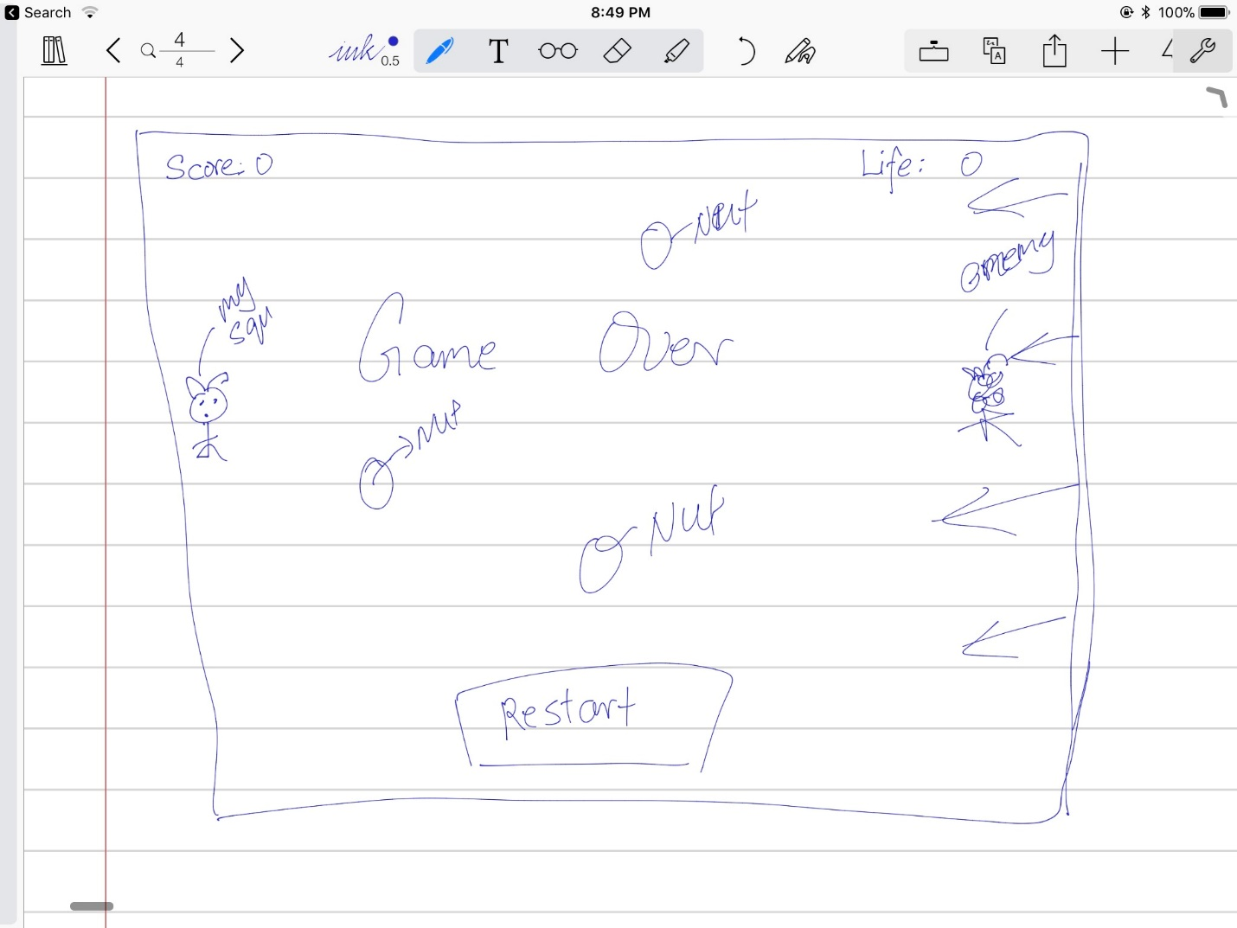

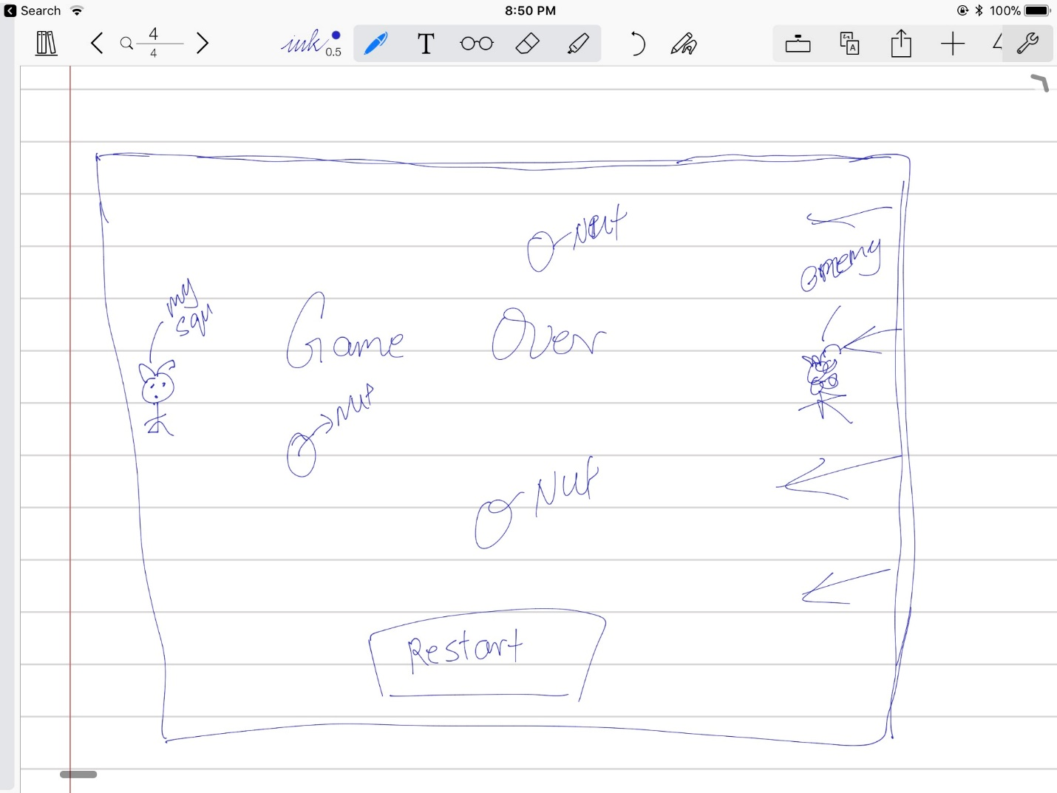

1. SCREEN DESCRIPTIONS
   1. Start Screen

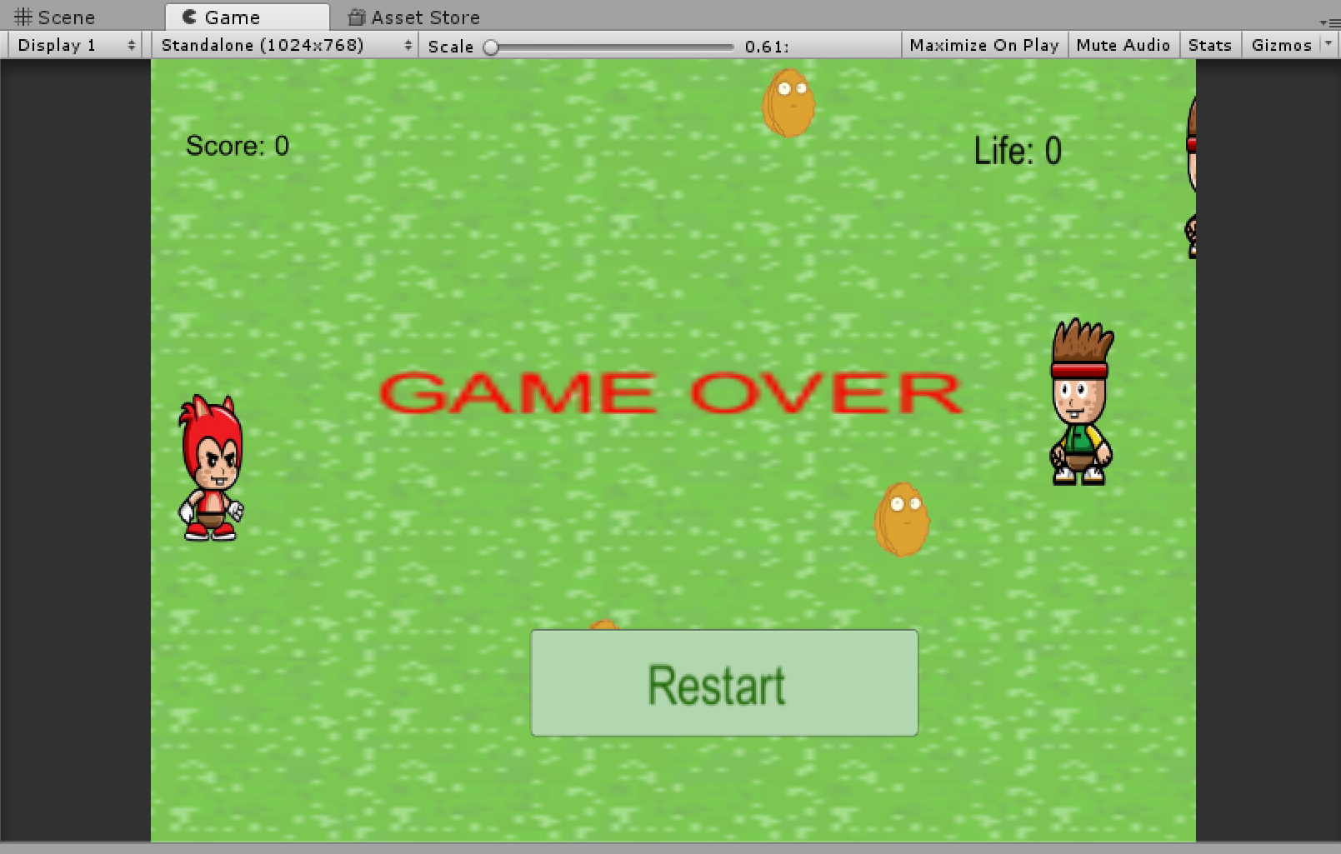

* 1. Main Scene

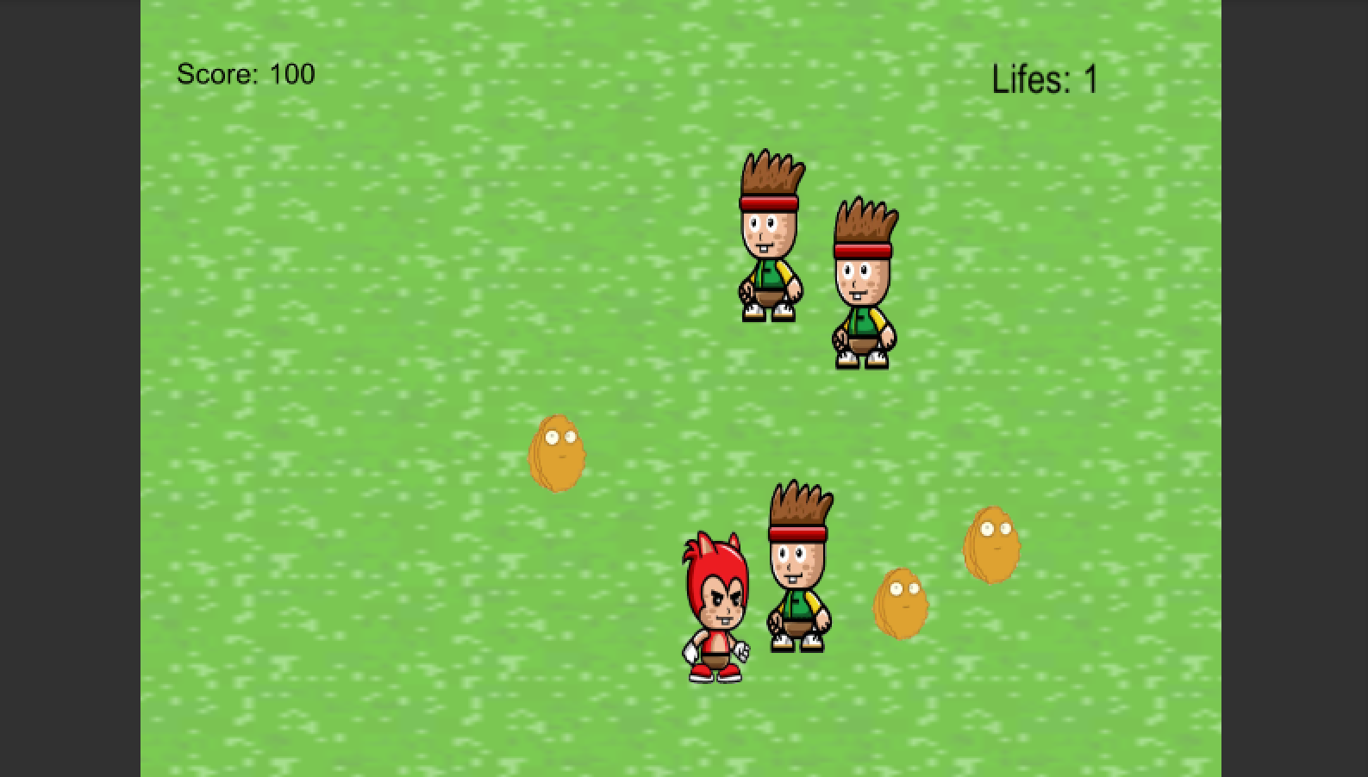

c. End Scene

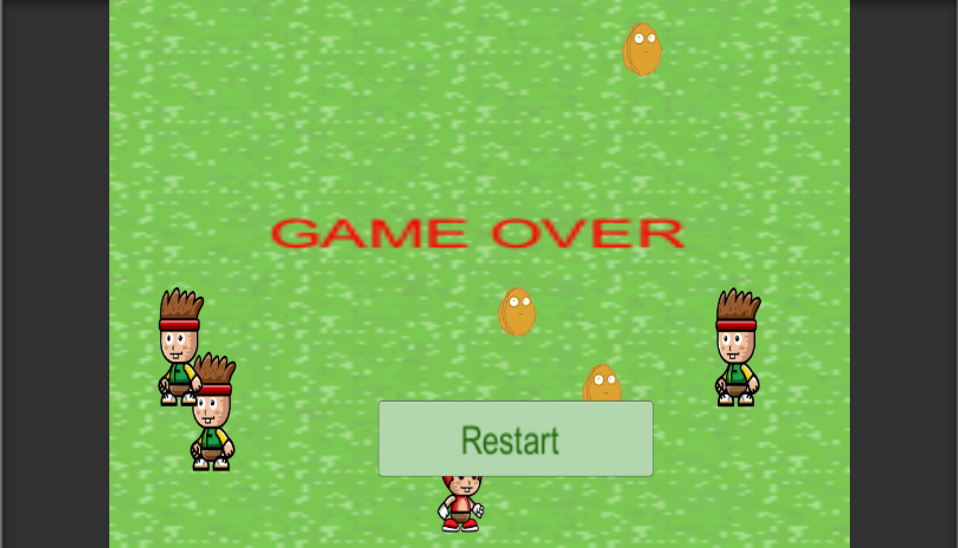

1. ENEMIES

Enemies are other green squirrels. Some squirrel is placed inside the screen and some is place outside the screen. They will randomly show up on the screen with random speed. They will be reset if it get hit or out of boundary.

1. SCORING

Player will get point while the red squirrel touch the nut. Each nut is collect he/she will get 100 points.

1. SOUND INDEX
   1. Explosion Sound Effect -while touch the enemy squirrel



* 1. Collecting Nut Sound Effect



* 1. Background Sound Effect
  2. 

1. ART
   1. Player Squirrel

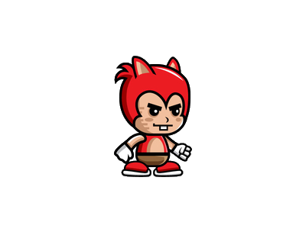

* 1. Enemy Squirrel

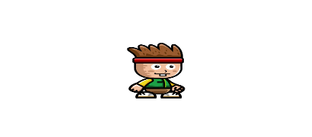

* 1. Nuts

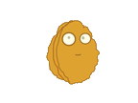

* 1. Explosion



* 1. Background

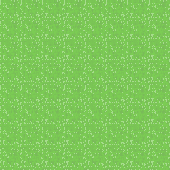

https://github.com/lovelise/SquirrelNuts.git