Student
- Error while creating Demo request from home page
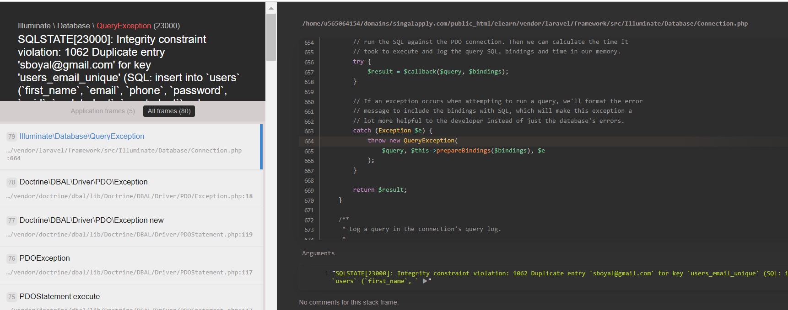

- No recording visible after Demo class
- FAQs on student page not available
- Spelling and sentence to be corrected for Course purchase as below:

Course Purchase Successful
Thank you for choosing VaaGa Academy. Kindly visit dashboard to view you all purchased courses.
- Subscription model to handle monthly payments from Student for particular course:
  - Payments done
  - Payment due amount and due date
  - Balance payment
  - Reminders after each month

Tutor
- Su is coming in Name at dashboard
- Subject not showing on Tutor dashboard
- Tutor Registration –
  - Unable to register with my email although that is not already present
  - Bank details should be added and visible on Tutor’s card (all fields required for payment)
  - Able to register user without selecting terms & conditions, which should not be.
  - Sentence on tutor registration welcome page to be updated as below:

Thank you for registering at VaaGa Academy
Your account is under Review
- Option to upload multiple documents (Photo ID proof, Aadhar card, Pan)
- Tutor Avatar to be shown in the tutor information

Admin
- Student –
  - Edit option for student information (for both Student and Admin)
  - Option to upload photo in Avatar (for both Student and Admin)
- Password saving popup appears every time we login
- Change Teachers to Tutors and Student to Students
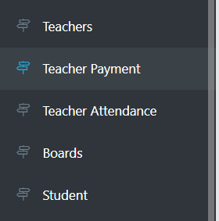
- Error while creating subject modules
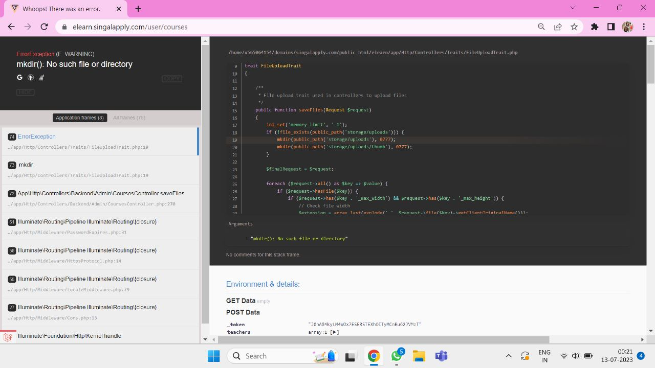
- User Management - Sorting is not working in User Management
- Courses:
  - Teacher to be replaced by Tutor
  - Default Tutor from backend, not to select from front end
  - Date format to be corrected, coming in YYYY-MM-DD
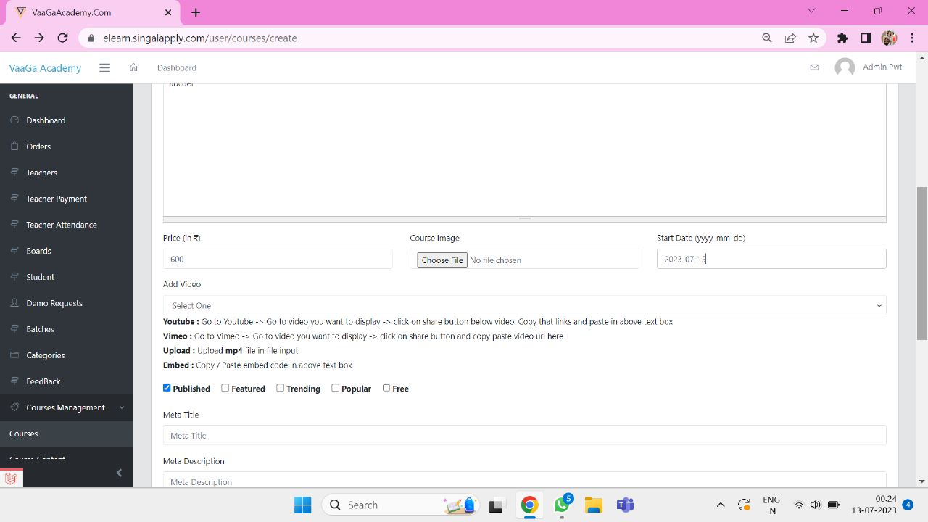
  - Usage of below is not working


- Document download option in course once it is purchased.
- While schedule the demo, teacher needs to be replaced by Tutor.
- Terms & conditions separate for Tutor, company and Student.

General
- Categories on home page: Not in Sync with course module (multiple levels)
- Automatic Tutor Scheduling
- Reports – How many Students/Tutor linked with subject (active-cousre-list)
- No image coming for the categories and where to set these as default?
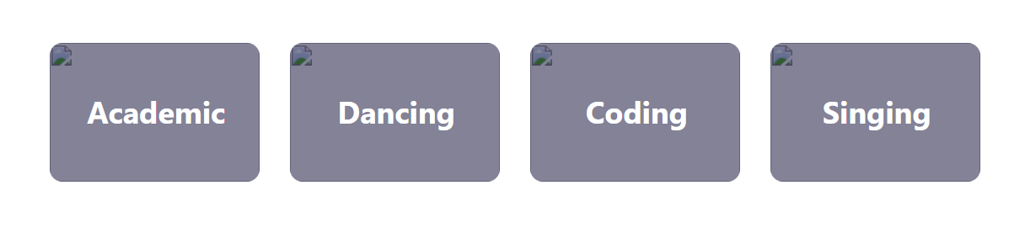
- Orders:
  - Order should be linked with student i.e all the orders placed by single students can be seen together
  - In order list Name and Invoice number should be visible
  - In order list order date in the format of date| time

- Tutor fees:
- To be linked with the batch and the payment page ex- in case of single tutor with multiple classes and different fees.
- Tutor’s attendance should be linked with batch and automatic calculated based on the estimated duration of class (1 hr) and completion status.
- Payment due calculation will be based on different batches.
- Detailed breakup needed for payment calculation (hours taught) vs payment done.

- Teacher attendance linked with Tutor

- Quiz
  - After submitting the quiz, it should be visible along with the answers selected by the student to the tutor, student and admin in non- editable format for later reference
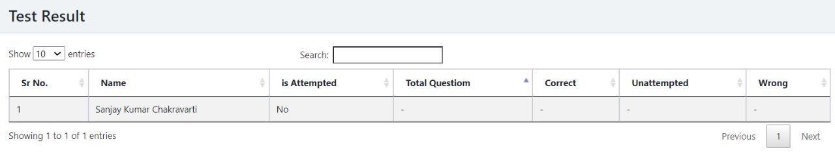
  - Option for subjective quiz should be included in the same exam module
  - Student not have any option to upload document for assignment and quiz

