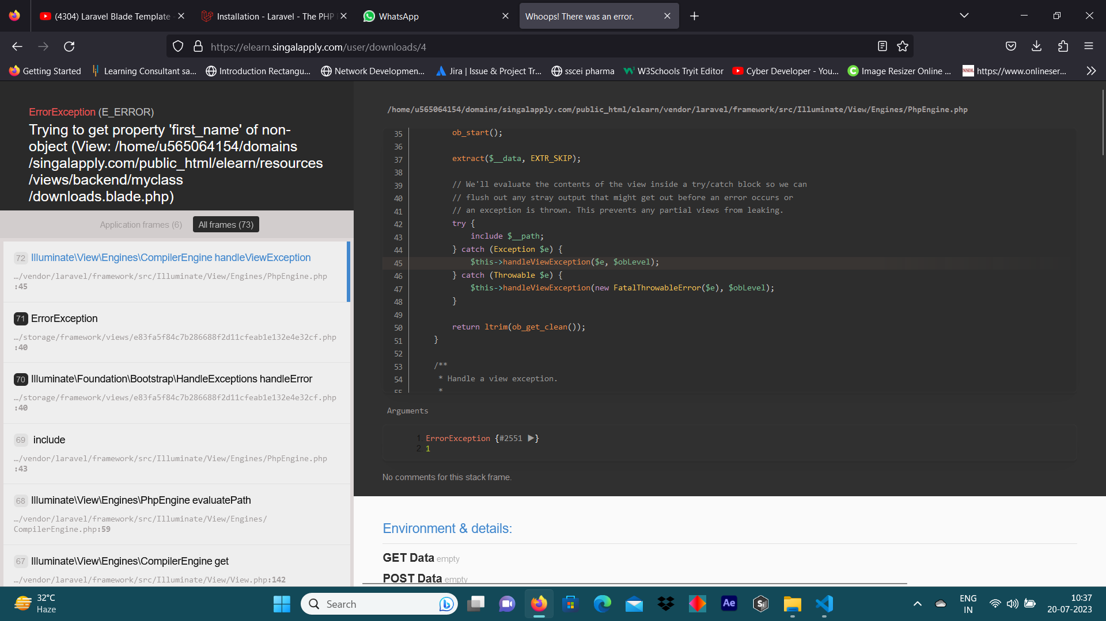

This error occurs when the student checks his course material
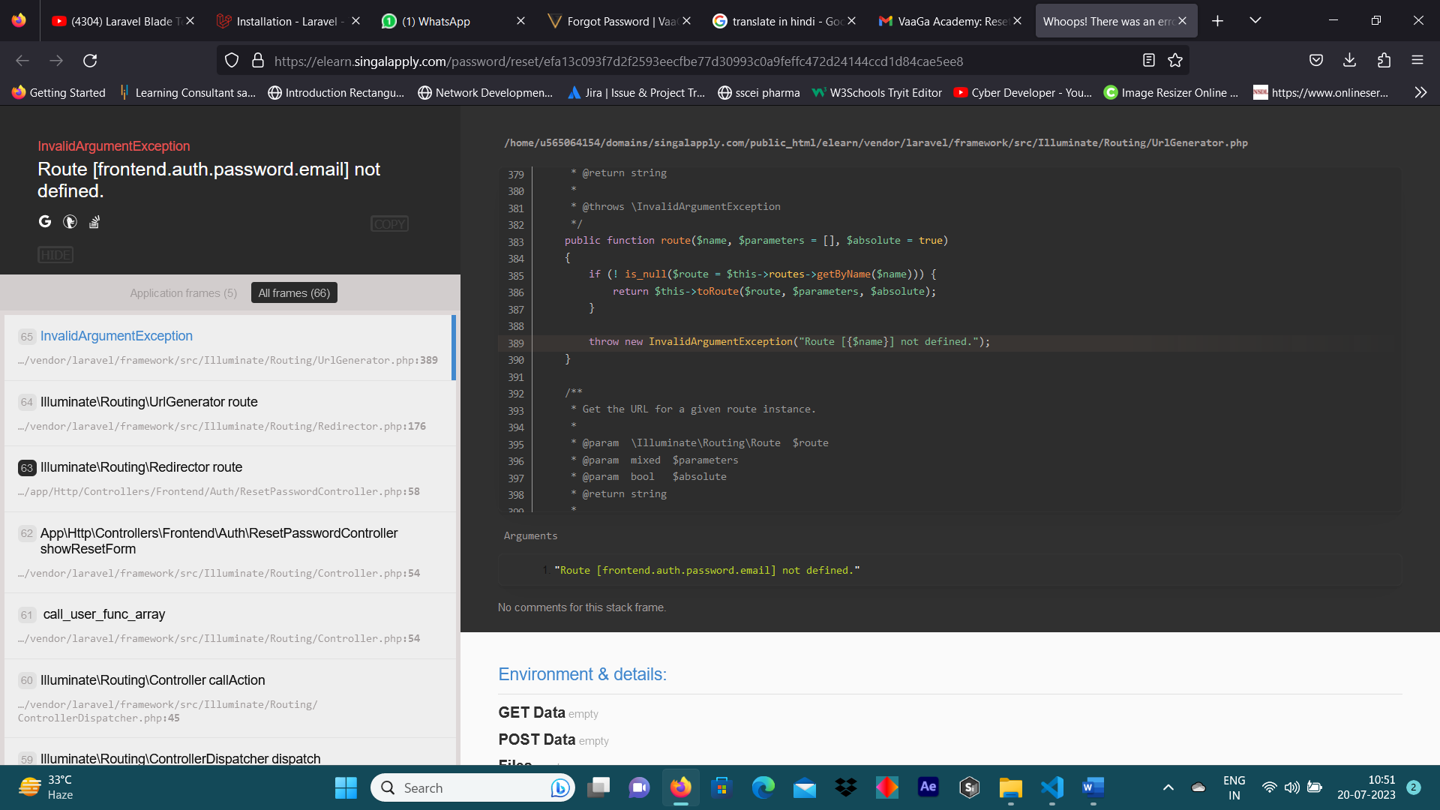
This error comes when the user clicks on the reset button which comes on the email.
and this error is only on desktops not in the smart phone.
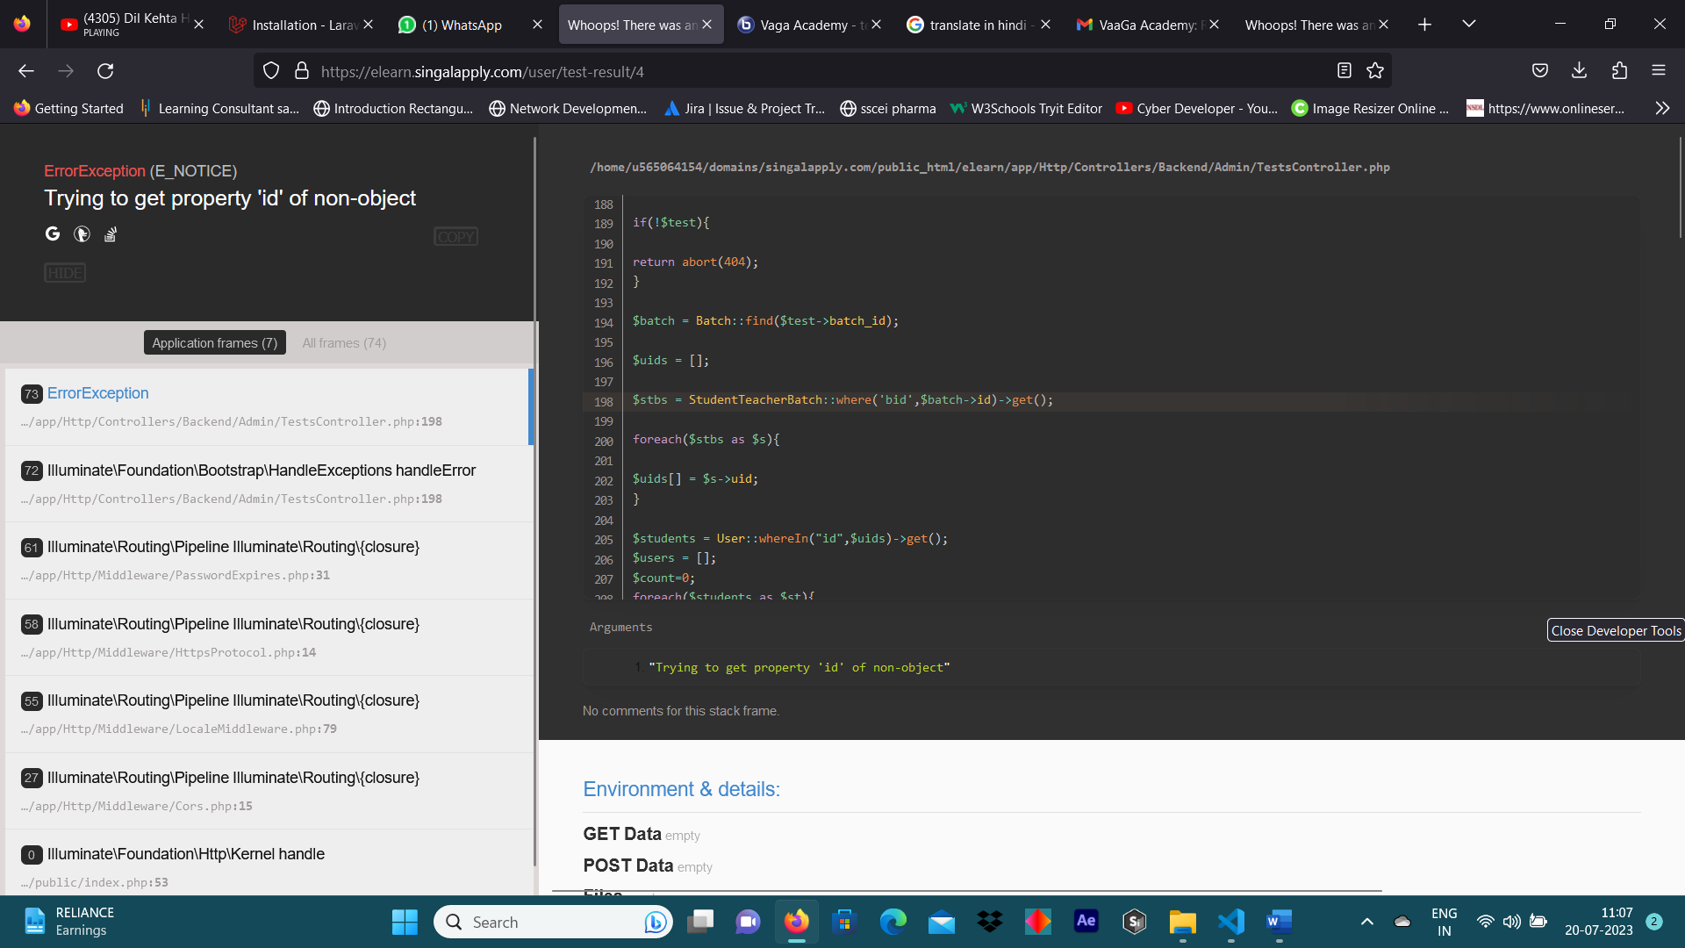
This error occurs when the teacher checks on the view result button which is available on the test option.

