Student
- Demo requests
  - Unable to create demo request
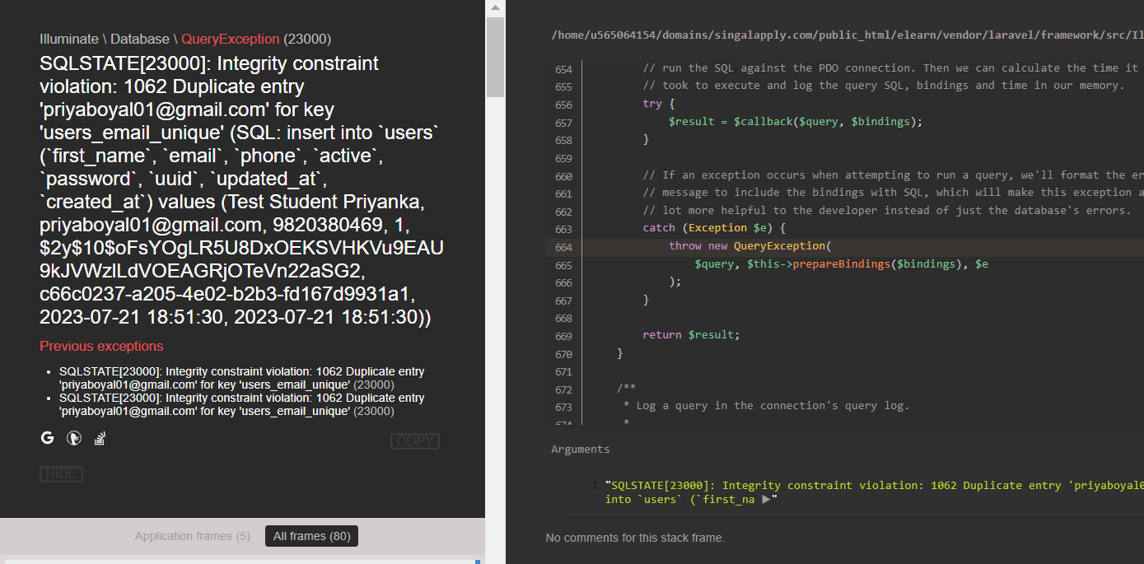
  - No SMS coming for demo request confirmation (will be done after API with MSG91)
- Logo should come instead of only Text in mail received
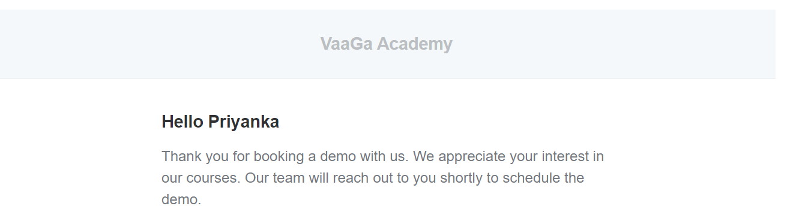

- Add website link in the mail to directly access from mail

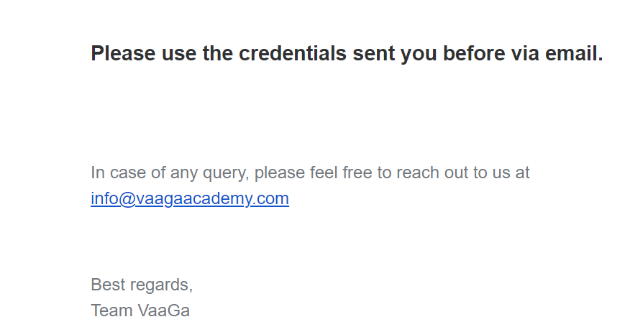
- Avatar not visible in student list after upload
- FAQs on student page not available
- Spelling and sentence to be corrected for Course purchase as below:

Course Purchase Successful
Thank you for choosing VaaGa Academy. Kindly visit dashboard to view you all purchased courses.
- Subscription model to handle monthly payments from Student for particular course:
  - Payments done
  - Payment due amount and due date
  - Balance payment
  - Reminders after each month
- Related course while purchasing the course – from where it is coming? Link not working.
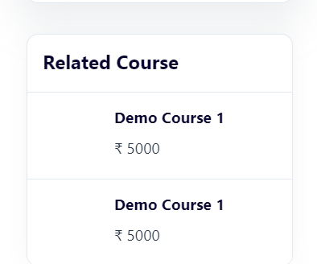

- Live streaming - During live streaming no option to writing for student
- Pop up duration for feedback confirmation message is very short. Cant read the full message in that duration.

Tutor
- Subject not showing on Tutor dashboard
- Tutor Registration –
  - Unable to register with my email although that is not already present
  - IN tutor registration form ‘Subject you would like to teach’ should be dynamic cant add another subject
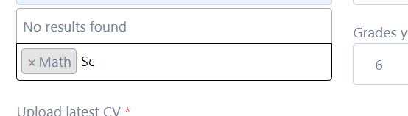
  - Error coming if uploading Avatar
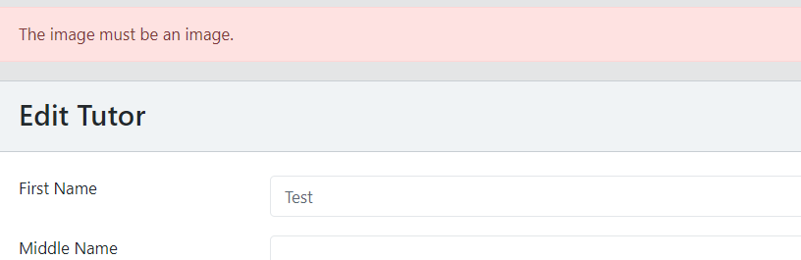
  - Sentence on tutor registration welcome page to be updated as below:

Thank you for registering at VaaGa Academy
Your account is under Review
- Option for tutorial in Tutor & Student page to upload the training video for them to refer after joining

Admin
- Student –
  - Edit option for student information (for both Student and Admin)
  - Option to upload photo in Avatar (for Admin)
- Courses:
  - Date format to be corrected, coming in YYYY-MM-DD
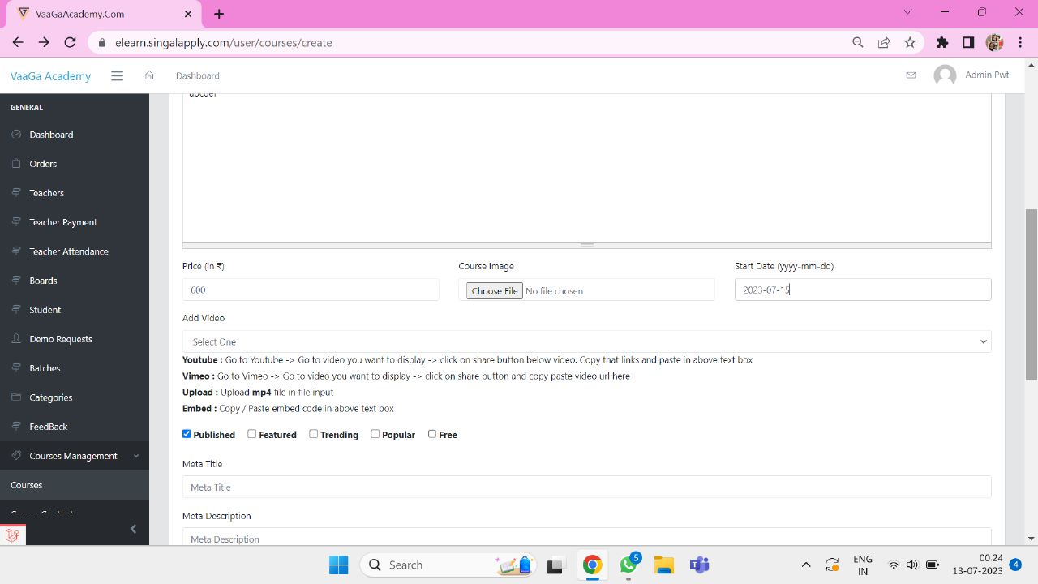

- Wrong message- On adding course content, it is showing course content deleted.
- Spelling of course is wrong.
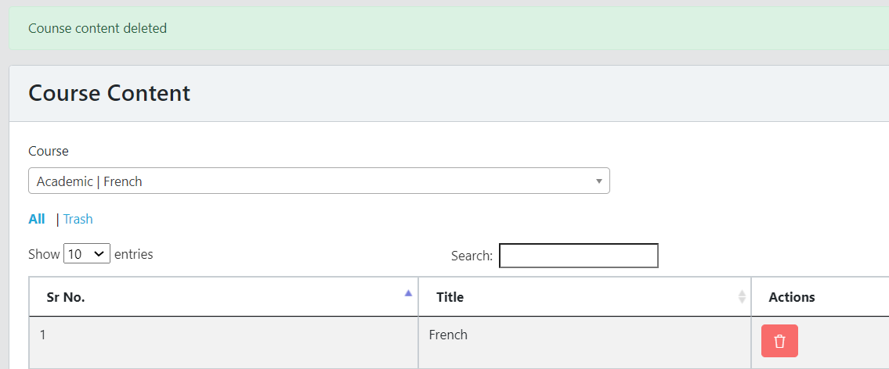

- Should not be able to create duplicate course content in same course
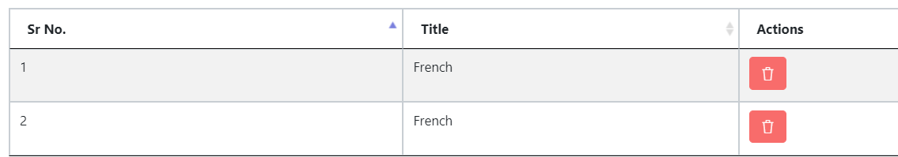

- Document download option in course once it is purchased.
- Terms & conditions
  - Terms & Condition to store in Tutor dashboard to refer later
  - Header is coming twice, need to remove in the body

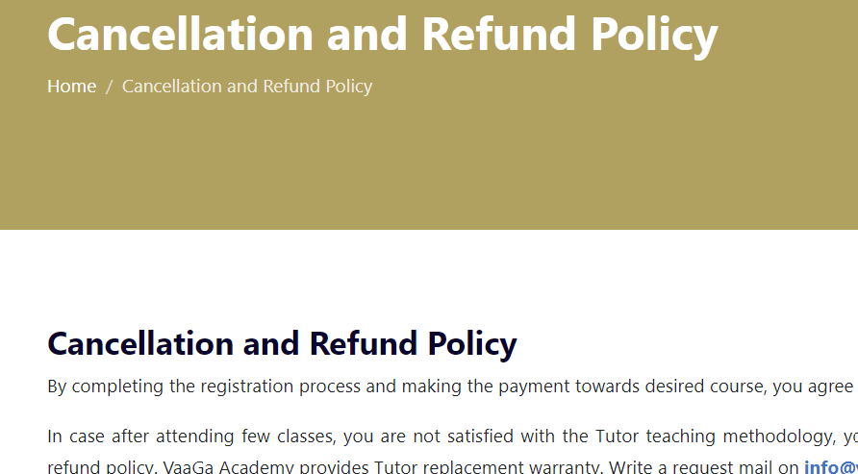

  - Header is coming twice, need to remove in the body
  - Font type change option not working

General
- Categories on home page: Not in Sync with course module (multiple levels)
- Automatic Tutor Scheduling
- Tutor fee –
  - On adding fees to the course, cant see the course list
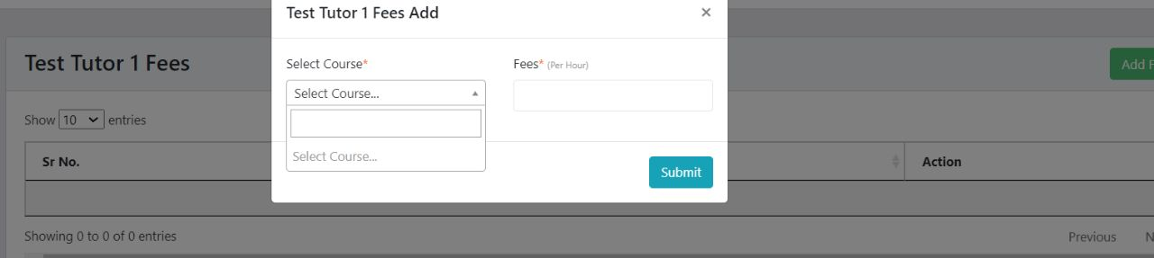
  - To be linked with the batch and the payment page ex- in case of single tutor with multiple classes and different fees.
  - Tutor’s attendance should be linked with batch and automatic calculated based on the estimated duration of class (1 hr) and completion status.
  - Payment due calculation will be based on different batches.
  - Detailed breakup needed for payment calculation (hours taught) vs payment done.
- Teacher attendance linked with Tutor
- Quiz
  - After submitting the quiz, it should be visible along with the answers selected by the student to the tutor, student and admin in non- editable format for later reference
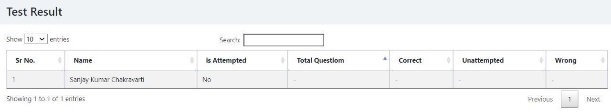
  - Option for subjective quiz should be included in the same exam module
  - Student not have any option to upload document for assignment and quiz

- Message/Notification
  - Message option from Students/Tutor to admin
  - How to send messages/Notifications internally to Tutor or Student
  - Details not showing for total earning, paid and due while click on it.
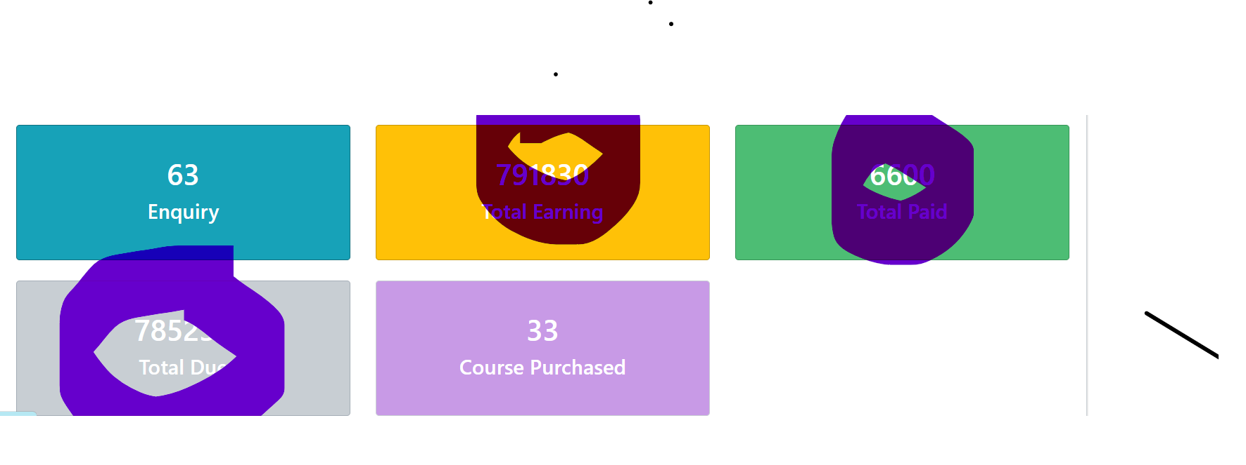
- Trash option is not available for Student 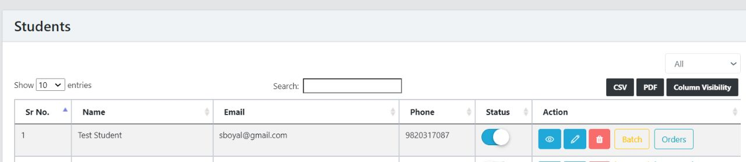

- On triggering email for Teacher feedback its sending email to Student only instead of Teacher
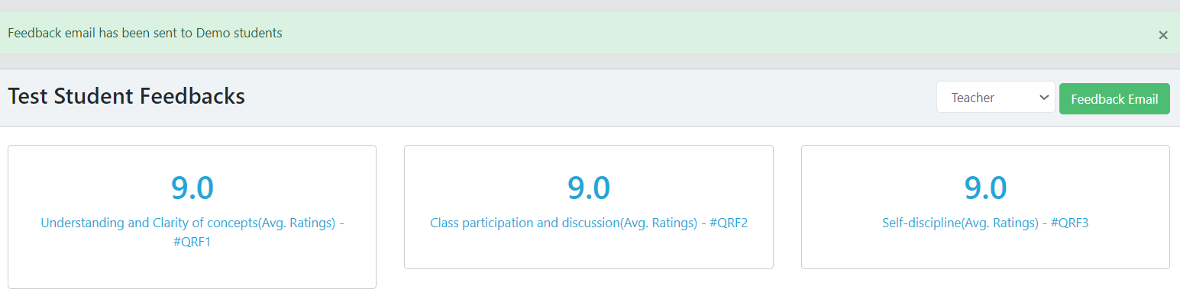

- Feedback given through the mail is not getting recorded in the feedback in website
- Batch
  - Need view option which is missing
  - Need link in batch to see Student and Tutor assigned to that batch

- Cant see the list of Tutor while assigning under a new batch

