- Creating Course button at this page doesn’t update at homepage-> we need to click academy and then create course. In this case, remove course button from this page and add sub category button which will open the same page when click on main category (academy).
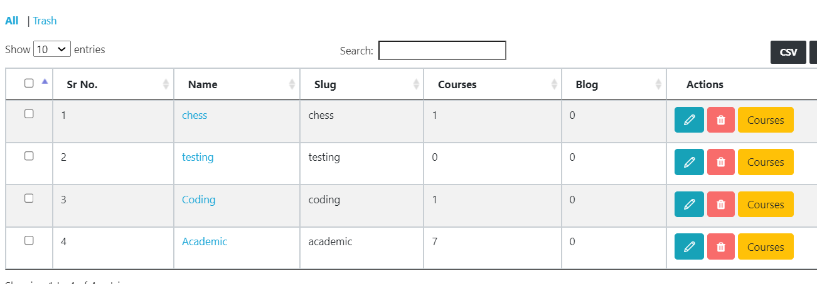

- If we modify the course, it is not showing in the hierarchy.

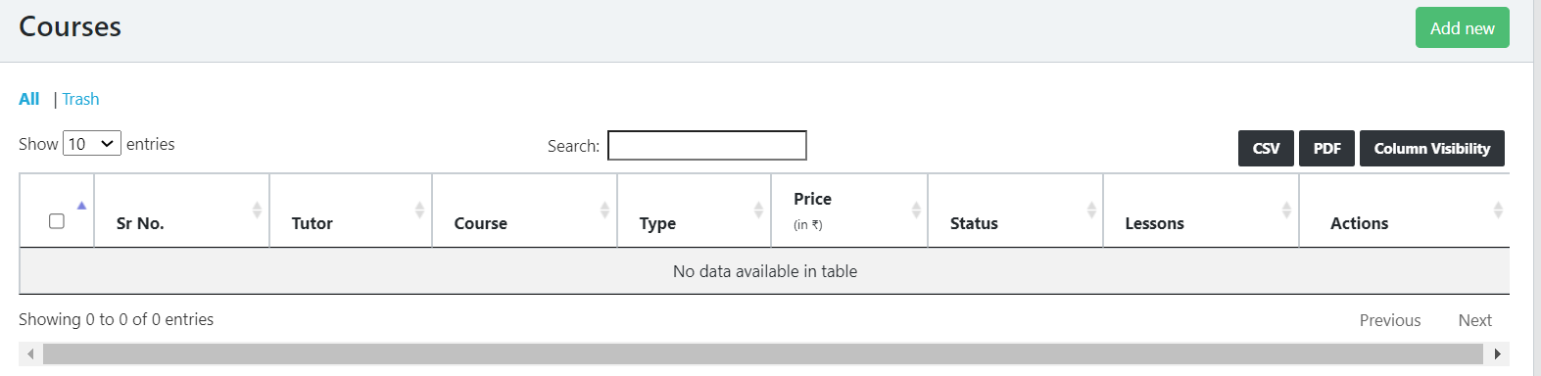

- We cannot create lessons directly from Courses as content is mandatory. For this, can we give content button here and then lesson inside that instead of creating content from outside?
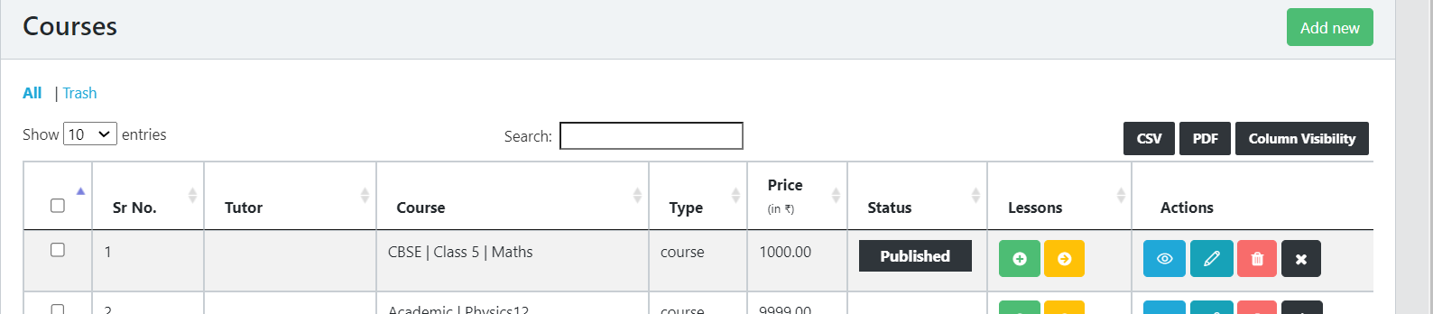
- Lessons are not visible outside on home page hierarchy although created.
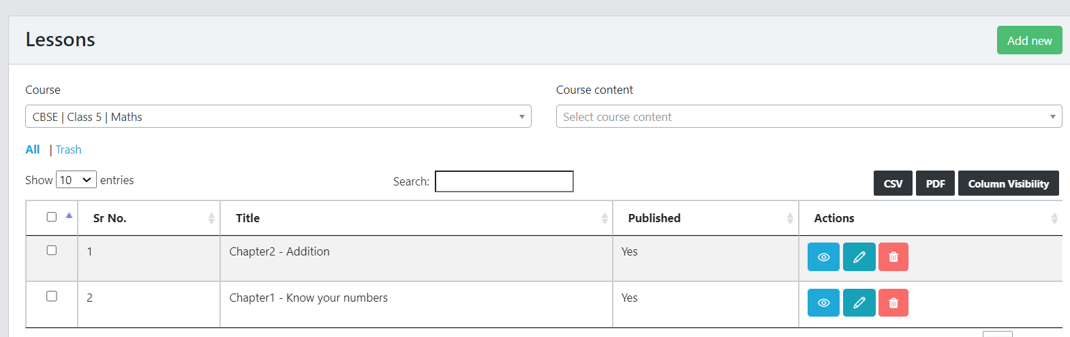

- Courses:
  - Date format to be corrected, coming in YYYY-MM-DD
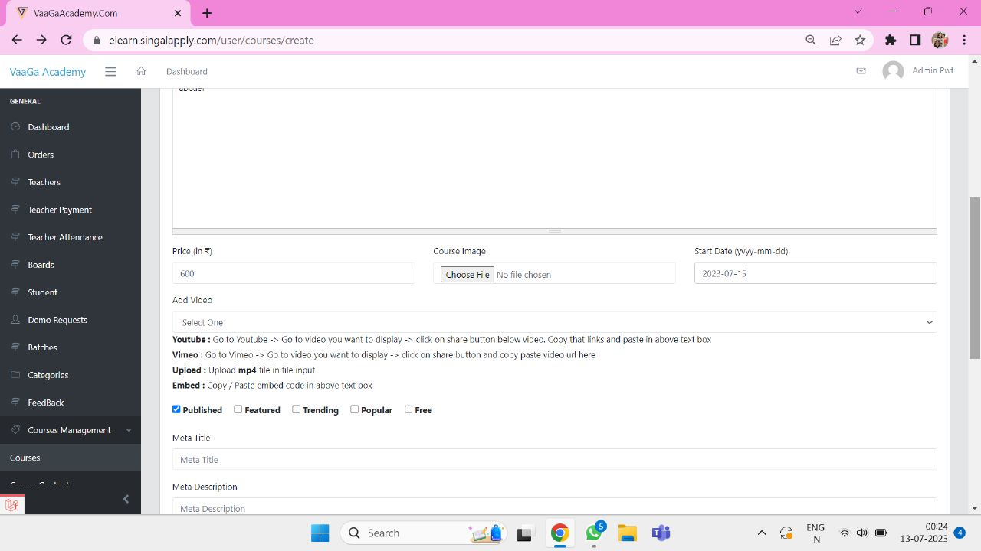

- Wrong message- On adding course content, it is showing course content deleted.
- Spelling of course is wrong.
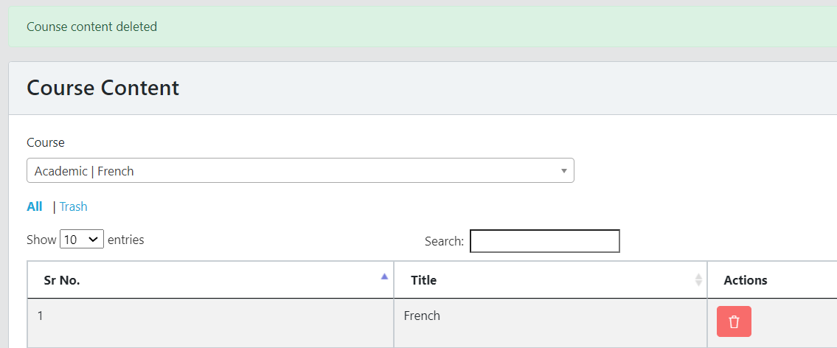

- Should not be able to create duplicate course content in same course
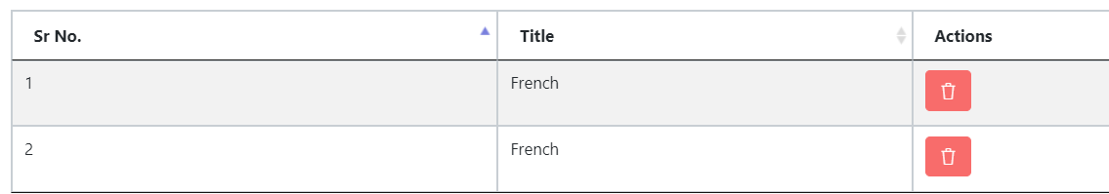
- Instead of image, pls add the list with link for next hierarchy and in sequence order (alphabetical)
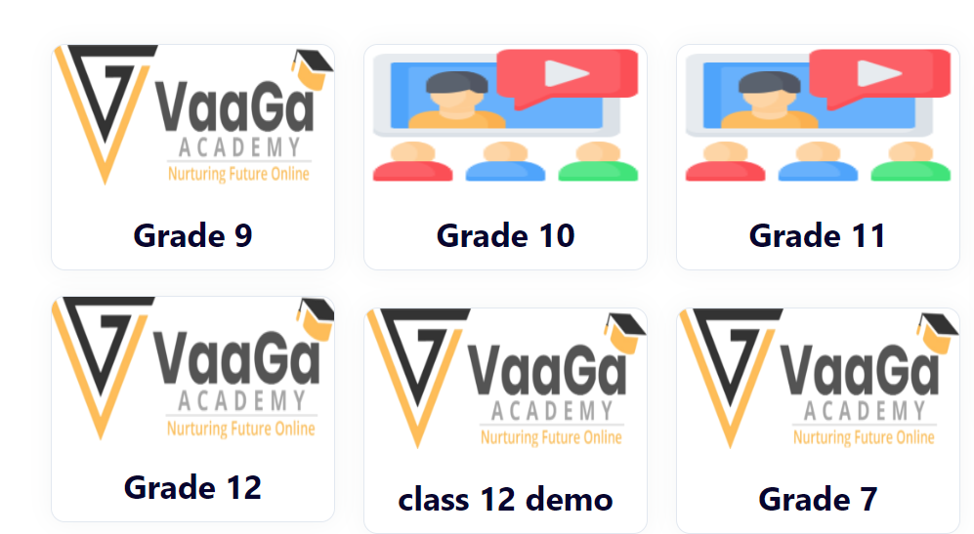

- Add the arrow for 2nd level CBSE, IB…
- Remove the arrow at last level (Grade6, 10..) if opening folder directly
