Student
- Subscriptions
  - When exporting in csv, rupee is not coming correctly.
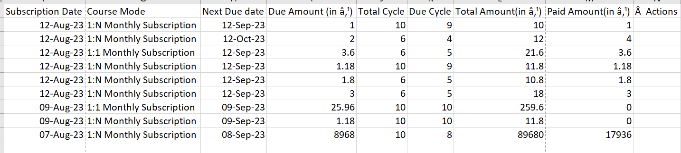

Tutor
- Option for tutorial in Tutor & Student page to upload the training video for them to refer after joining

Home page
- Rename “Experience VaaGa Academy Live Classes” to “Trending Courses”

- Images on the picture slider on home pages looks too big, if possible to make it smaller



- Self-alignment of below images, row should start from center instead of left
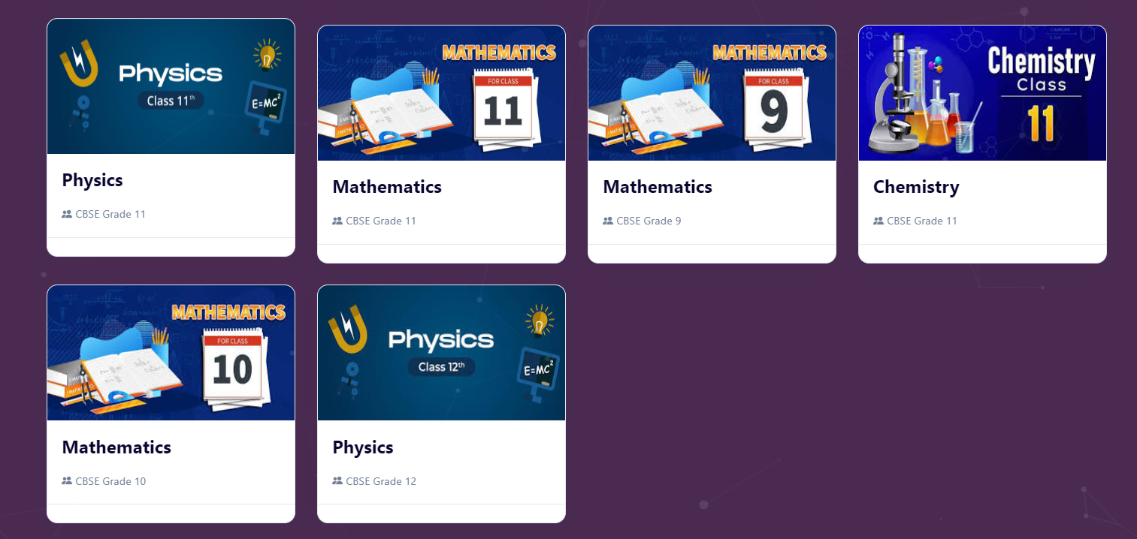
- Courses image? How can we handle it dynamically? Finding in google for each image will be challenging.
- Course price & Course duration should not be visible on home page
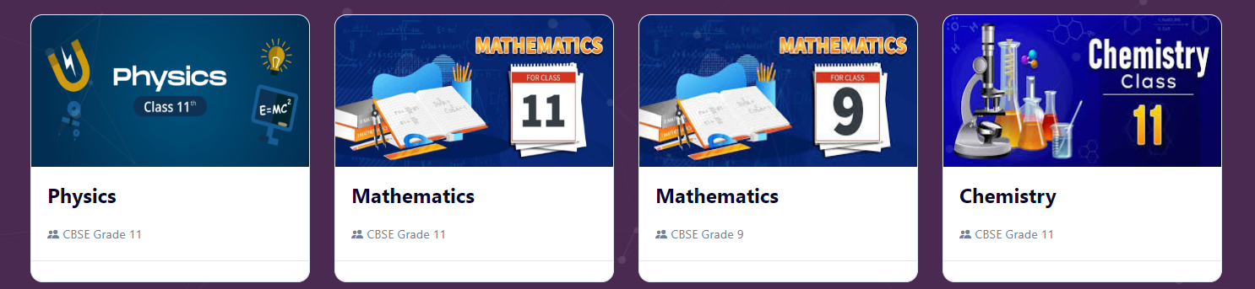
- Rename Course Duration (in Months) -> Course Duration and option to choose duration in Months, Weeks, Hours, No. of Sessions

- Course price need to show only when Student registration is done and below page should open after registration. Tutor can see the courses but should not be able to see Course price even after registration.

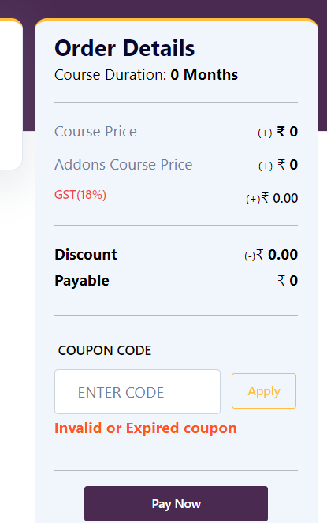

- Rename ONE-TO-MANY to GROUP
  - Below Group, it will be written “(Upto 5 students)”.
  - Pls give the option in Course setup to mention the line for max. batch size as it may vary course wise.


- Error is coming if click on pay for the course with no price
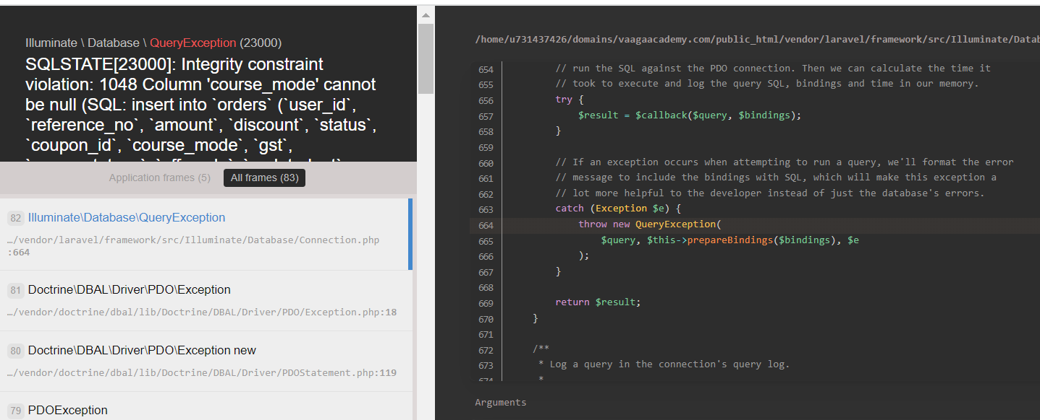

- Rename “Tutor” to “Join as Tutor”
Tutor Attendance
- Option to filter based on date range to see monthly hr taught
- Add another total in Hours along with Mins.

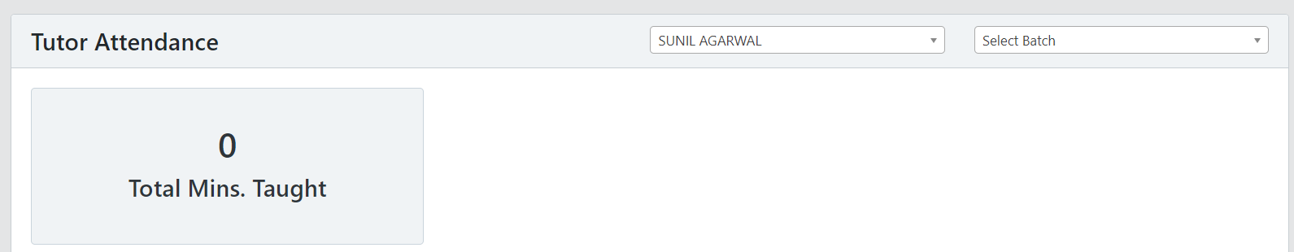
Batch fee
- Need additional fields for “Tutor fee/hr” and “No. of hrs/batch” in batch fee page. Batch fee need to be calculated based on Tutor fee/hr * No. of hrs/batch.
- Tutor Payment page:
  - Add additional fields
    - Tutor fee/hr
    - No. of hrs/batch
    - No. of hrs. taught/Total hrs.
    - Payment release need to be done based on No. of hrs. taught/Total hrs. instead of Course progress
Terms & Conditions
- Unable to edit as it is disturbing bullets, pointers…
  - Option to upload Terms and Conditions in doc or pdf to update content automatically?
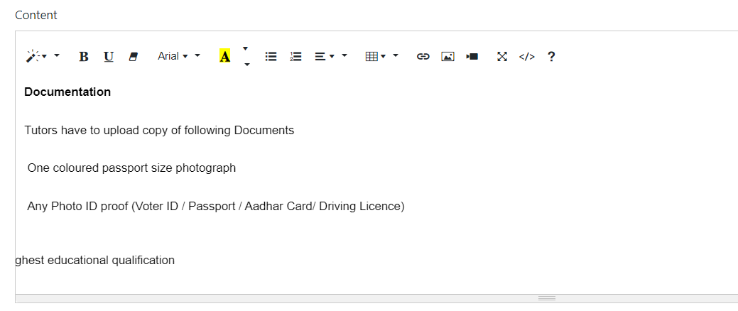

Star Tutors
- Slider needed at home page for images of best tutors with below information:
  - Photo
  - Name
  - Subject
  - Qualification
  - Experience in years
  - Start Rating (1-5 stars)
Add the slider in between these 2


- Recent Reviews from Students should be hidden in case of no active Testimonial


