Student
Along with demo schedule mail login credentials should be sent to student- on booking demo from home button its not sending for login credential
Deactivate GST
Coupon not active
Entry is getting deleted after completing Demo class. No history for Demo classes taken
No recording visible after Demo class
Addon course Price gets reset if any error
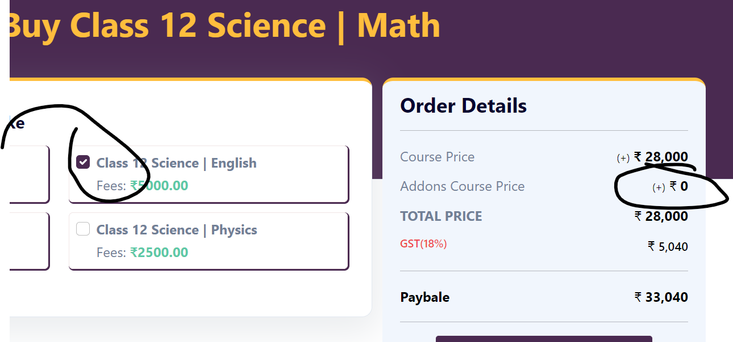
Invoice not generating after payment (need to finalise the template)
Mail not going for confirmation of purchase to student
FAQs on student page not available

Tutor
While Tutor registration in case of any error the screen goes on the top and 2 fields i.e gender, attached CV file and subject gets deleted- spelling of Kindly is wrong
Spelling on tutor registration welcome page- VaaGa is not correct
While registering Tutor, if any error it is removing Gender and Subject to be taught as block and screen is going on the top.
Name is not coming fully and the link not working
Tutor & Student registration form- add State in registration form
Teacher shown in database even without entering OTP and activation, can schedule demo without activating the teacher

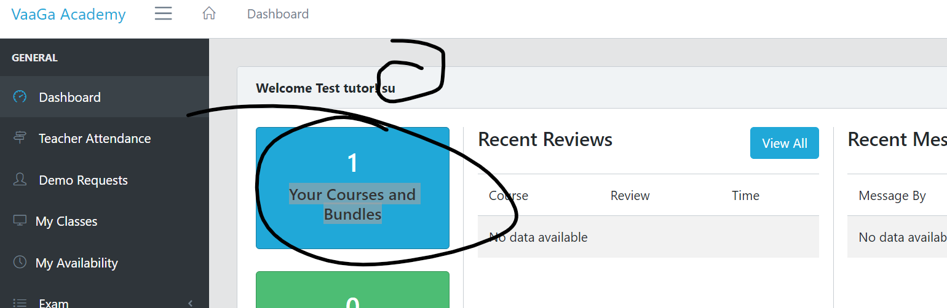
Mail not going to teacher for demo schedule
Subject not showing on Tuotor dashboard

Admin
Password saving popup appears every time we login
Student record cant be deleted
Student complete details is not visible on Student list (should be same as Tutor)
Activation/Deactivation option needed in Student list like Tutor
Search option need on all fields for Tutor/Student list to identify the active Tutor/Students
Option to see the linked batches is required on Tutor/Student list
Below details coming at bottom of page:

Error coming while searching Student or sorting on any column
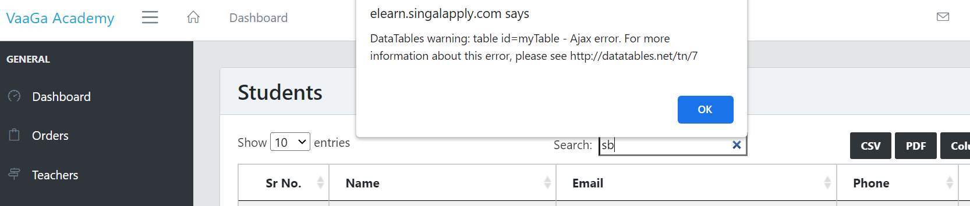

General
Courses in home tab not in sync with modules
Recordings to be saved and visible to Admin & Student (optional for tutor)
Automatic Tutor Scheduling
Design for Feedback
Feedback for demo class:
Feedback button should be next to join class. Rating from 1-10 will be displayed on a separate feedback page once click on button along with a comment box.
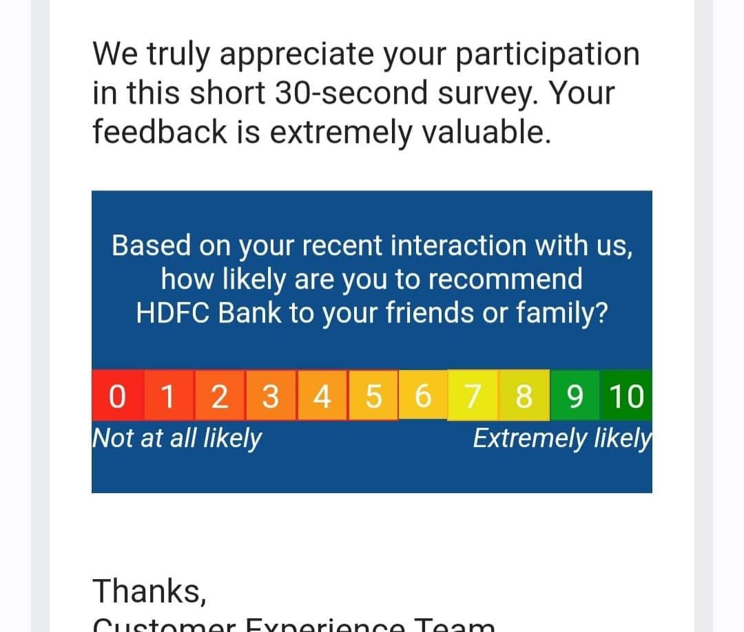
This feedback should be saved and visible to Student and Admin only.
Feedback for regular classes:
For Tutor-
- Feedback will be linked with the batch.
- Email will be triggered on registered email (used while student’s registration) card for parents and student feedback. It will be done in 2 ways:
  - Manual – If Admin wants to trigger manually, can be done at batch level
  - Automatic – Frequency needs to be defined at configuration level (in Admin control) and based on that mail to go to all students for their feedback.
- Mail will have the feedback form embedded which will be updated by Parent/Student and submit there only. Below is the format:
- Notification will be sent to Admin through mail once feedback is submitted.
- Feedback will be stored in batch level visible to only Admin.
- This feedback will not be visible to Tutor and Student.
For Student-
- Separate tab for feedback on Tutor dashboard.
- Tutor should be able to see the assigned students in the drop-down list and able to put the fill the feedback and submit. Below is the template:
- Feedback should be saved and visible to Tutor & Admin only

Tutor fees:
- To be linked with the batch and the payment page ex- in case of single tutor with multiple classes and different fees.
- Tutor’s attendance should be linked with batch and automatic calculated based on the estimated duration of class (1 hr) and completion status.
- Payment due calculation will be based on different batches.
- Detailed breakup needed for payment calculation (hours taught) vs payment done.

