**Heart Disease Detection**

NAME: **LOVELY MANGAL**

CERTIFICATION CODE: **TCRIG02R11**

EMAIL: lovelymangal29@gmail.com

BATCH: **MACHINE LEARNING WITH PYTHON**

PROJECT NAME: **PREDICTION OF HEART DISEASE DETECTION**

# Importing Required Libraries

import pandas as pd

import numpy as np

import matplotlib.pyplot as plt

import seaborn as sns

%matplotlib inline

#Importing the Dataset

df = pd.read_csv('/content/heart.csv')

df.head()

|  | **age** | **sex** | **cp** | **trestbps** | **chol** | **fbs** | **restecg** | **thalach** | **exang** | **oldpeak** | **slope** | **ca** | **thal** | **target** |
| --- | --- | --- | --- | --- | --- | --- | --- | --- | --- | --- | --- | --- | --- | --- |
| **0** | 63 | 1 | 3 | 145 | 233 | 1 | 0 | 150 | 0 | 2.3 | 0 | 0 | 1 | 1 |
| **1** | 37 | 1 | 2 | 130 | 250 | 0 | 1 | 187 | 0 | 3.5 | 0 | 0 | 2 | 1 |
| **2** | 41 | 0 | 1 | 130 | 204 | 0 | 0 | 172 | 0 | 1.4 | 2 | 0 | 2 | 1 |
| **3** | 56 | 1 | 1 | 120 | 236 | 0 | 1 | 178 | 0 | 0.8 | 2 | 0 | 2 | 1 |
| **4** | 57 | 0 | 0 | 120 | 354 | 0 | 1 | 163 | 1 | 0.6 | 2 | 0 | 2 | 1 |

df.describe()

|  | **age** | **sex** | **cp** | **trestbps** | **chol** | **fbs** | **restecg** | **thalach** | **exang** | **oldpeak** | **slope** | **ca** | **thal** | **target** |
| --- | --- | --- | --- | --- | --- | --- | --- | --- | --- | --- | --- | --- | --- | --- |
| **count** | 303.000000 | 303.000000 | 303.000000 | 303.000000 | 303.000000 | 303.000000 | 303.000000 | 303.000000 | 303.000000 | 303.000000 | 303.000000 | 303.000000 | 303.000000 | 303.000000 |
| **mean** | 54.366337 | 0.683168 | 0.966997 | 131.623762 | 246.264026 | 0.148515 | 0.528053 | 149.646865 | 0.326733 | 1.039604 | 1.399340 | 0.729373 | 2.313531 | 0.544554 |
| **std** | 9.082101 | 0.466011 | 1.032052 | 17.538143 | 51.830751 | 0.356198 | 0.525860 | 22.905161 | 0.469794 | 1.161075 | 0.616226 | 1.022606 | 0.612277 | 0.498835 |
| **min** | 29.000000 | 0.000000 | 0.000000 | 94.000000 | 126.000000 | 0.000000 | 0.000000 | 71.000000 | 0.000000 | 0.000000 | 0.000000 | 0.000000 | 0.000000 | 0.000000 |
| **25%** | 47.500000 | 0.000000 | 0.000000 | 120.000000 | 211.000000 | 0.000000 | 0.000000 | 133.500000 | 0.000000 | 0.000000 | 1.000000 | 0.000000 | 2.000000 | 0.000000 |
| **50%** | 55.000000 | 1.000000 | 1.000000 | 130.000000 | 240.000000 | 0.000000 | 1.000000 | 153.000000 | 0.000000 | 0.800000 | 1.000000 | 0.000000 | 2.000000 | 1.000000 |
| **75%** | 61.000000 | 1.000000 | 2.000000 | 140.000000 | 274.500000 | 0.000000 | 1.000000 | 166.000000 | 1.000000 | 1.600000 | 2.000000 | 1.000000 | 3.000000 | 1.000000 |
| **max** | 77.000000 | 1.000000 | 3.000000 | 200.000000 | 564.000000 | 1.000000 | 2.000000 | 202.000000 | 1.000000 | 6.200000 | 2.000000 | 4.000000 | 3.000000 | 1.000000 |

df.age.plot(kind = 'hist', bins = 100, figsize = (8,8))

plt.show()

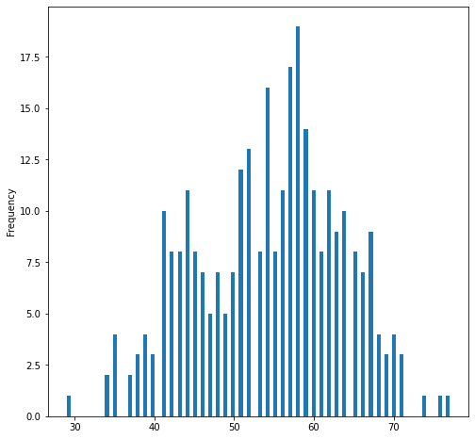

sns.barplot(df["cp"],df['target'])

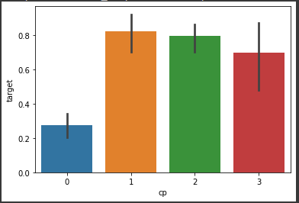

sns.heatmap(df.isnull())

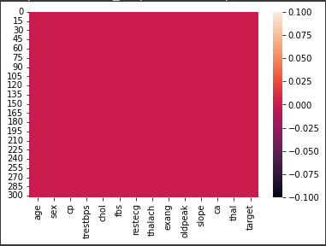

sns.pairplot(df)

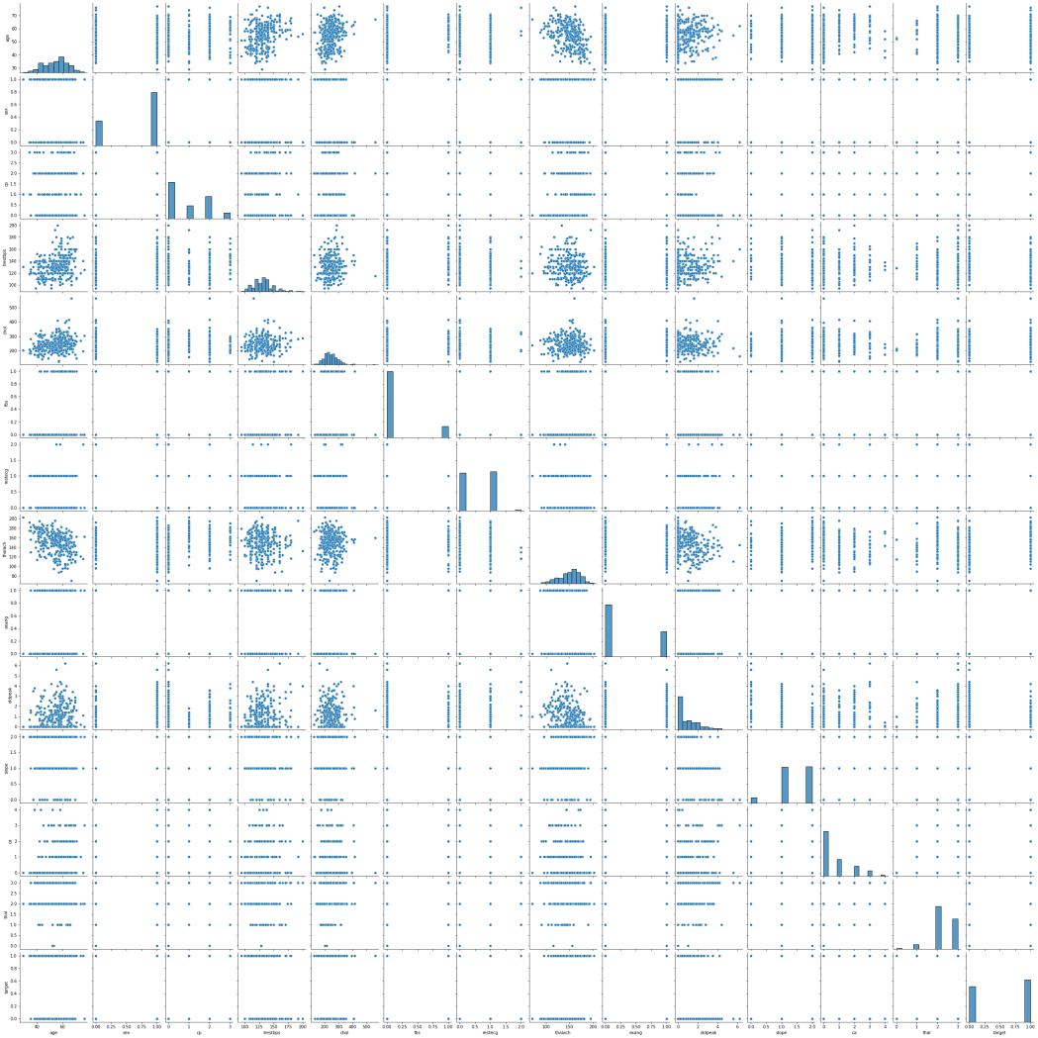

from sklearn.preprocessing import StandardScaler

scaler = StandardScaler()

scaler.fit(df.drop('target' , axis =1))

scaler_featured = scaler.transform(df.drop("target" , axis= 1))

df_feat = pd.DataFrame(scaler_featured , columns = df.columns[:-1])

df_feat

|  | **age** | **sex** | **cp** | **trestbps** | **chol** | **fbs** | **restecg** | **thalach** | **exang** | **oldpeak** | **slope** | **ca** | **thal** |
| --- | --- | --- | --- | --- | --- | --- | --- | --- | --- | --- | --- | --- | --- |
| **0** | 0.952197 | 0.681005 | 1.973123 | 0.763956 | -0.256334 | 2.394438 | -1.005832 | 0.015443 | -0.696631 | 1.087338 | -2.274579 | -0.714429 | -2.148873 |
| **1** | -1.915313 | 0.681005 | 1.002577 | -0.092738 | 0.072199 | -0.417635 | 0.898962 | 1.633471 | -0.696631 | 2.122573 | -2.274579 | -0.714429 | -0.512922 |
| **2** | -1.474158 | -1.468418 | 0.032031 | -0.092738 | -0.816773 | -0.417635 | -1.005832 | 0.977514 | -0.696631 | 0.310912 | 0.976352 | -0.714429 | -0.512922 |
| **3** | 0.180175 | 0.681005 | 0.032031 | -0.663867 | -0.198357 | -0.417635 | 0.898962 | 1.239897 | -0.696631 | -0.206705 | 0.976352 | -0.714429 | -0.512922 |
| **4** | 0.290464 | -1.468418 | -0.938515 | -0.663867 | 2.082050 | -0.417635 | 0.898962 | 0.583939 | 1.435481 | -0.379244 | 0.976352 | -0.714429 | -0.512922 |
| **...** | ... | ... | ... | ... | ... | ... | ... | ... | ... | ... | ... | ... | ... |
| **298** | 0.290464 | -1.468418 | -0.938515 | 0.478391 | -0.101730 | -0.417635 | 0.898962 | -1.165281 | 1.435481 | -0.724323 | -0.649113 | -0.714429 | 1.123029 |
| **299** | -1.033002 | 0.681005 | 1.973123 | -1.234996 | 0.342756 | -0.417635 | 0.898962 | -0.771706 | -0.696631 | 0.138373 | -0.649113 | -0.714429 | 1.123029 |
| **300** | 1.503641 | 0.681005 | -0.938515 | 0.706843 | -1.029353 | 2.394438 | 0.898962 | -0.378132 | -0.696631 | 2.036303 | -0.649113 | 1.244593 | 1.123029 |
| **301** | 0.290464 | 0.681005 | -0.938515 | -0.092738 | -2.227533 | -0.417635 | 0.898962 | -1.515125 | 1.435481 | 0.138373 | -0.649113 | 0.265082 | 1.123029 |
| **302** | 0.290464 | -1.468418 | 0.032031 | -0.092738 | -0.198357 | -0.417635 | -1.005832 | 1.064975 | -0.696631 | -0.896862 | -0.649113 | 0.265082 | -0.512922 |

from sklearn.model_selection import train_test_split

X_train, X_test, y_train, y_test = train_test_split(df_feat, df['target'], test_size=0.33, random_state=42)

from sklearn.neighbors import KNeighborsClassifier

error_rate = []

for i in range(1,40):

    knn = KNeighborsClassifier(n_neighbors=i)

    knn.fit(X_train,y_train)

    pred_i = knn.predict(X_test)

    error_rate.append(np.mean(pred_i != y_test))

plt.plot(range(1,40) , error_rate)

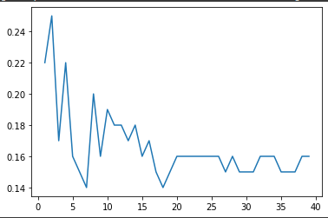

knn = KNeighborsClassifier(n_neighbors = 24)

knn.fit(X_train , y_train)

pred = knn.predict(X_test)

from sklearn.metrics import classification_report,confusion_matrix

print(confusion_matrix(y_test,pred))

print(classification_report(y_test,pred))

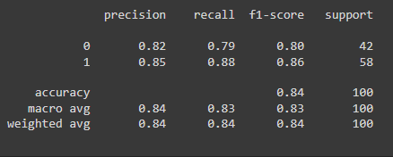

#The accuracy achieved is 84%

Credits- Lovely mangal