HTML
TUGAS 1 : CATSHOP
Nama /Nim | : | Lovelya Nicolle Caroline Rupilu (2518023)
Kelas | : | B
Pengajar | : | Budi Priyonggo (2518026)

Tujuan
- Praktikan dapat
- Praktikan dapat
- Praktikan dapat
- Alat dan Bahan

Alat dan Bahan
- Laptop/pc
- Modul Praktikum Web 2026
- TextEditor (Visual Studio Code / Sublime Text)

Langkah-langkah
- Buat folder transaction, categories dan css pada folder CatShop yang telah dibuat sebelumnya
Hasil tampilan :
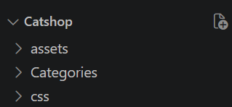

1.1 Tampilan Folder
- Buat file baru dengan nama style.css, dan letakkan dalam folder css yang telah dibuat.
Source code :

* {
margin: 0;
padding: 0;
box-sizing: border-box;
}

.container {
width: 80%;
margin: 0 auto;
}

body {
font-family: "Poppins", sans-serif;
}

/* new nav */
nav {
display: flex;
height: 80px;
width: 100%;
align-items: center;
justify-content: space-between;
flex-wrap: wrap;
}
nav ul {
display: flex;
flex-wrap: wrap;
list-style: none;
}
nav ul li {
margin: 0 5px;
}
nav ul li a {
color: #111;
text-decoration: none;
font-weight: 500;
padding: 8px 15px;
transition: all 0.3s ease;
}
nav ul li a.active,
nav ul li a:hover {
color: #ffb72b;
}
nav .menu-btn i {
color: #000;
font-size: 22px;
cursor: pointer;
display: none;
}
input[type="checkbox"] {
display: none;
}

.btn_login {
background-color: #ffb72b;
width: 100%;
padding: 8px 16px;
border-radius: 10px;
border: none;
cursor: pointer;
color: white;
}

.btn_login:hover {
background-color: #eba416;
color: #fff;
}

/* style jumbotron */
.jumbotron {
display: flex;
background-color: #ffb72b;
border-radius: 20px;
padding: 20px 0;
justify-content: space-around;
align-items: center;
margin-bottom: 50px;
}

.jumbotron-text {
width: 30%;
font-weight: 500;
}

.jumbotron-text p {
color: white;
margin: 20px 0;
}

.jumbotron-text button {
padding: 10px 18px;
border: none;
border-radius: 10px;
background-color: white;
color: #ffb72b;
cursor: pointer;
}

/* style card-categories */
.cards-categories {
display: flex;
flex-direction: column;
align-items: center;
}

.cards-categories h2 {
font-family: "Roboto", sans-serif;
font-size: 24px;
margin-bottom: 20px;
text-align: center;
}

.card-categories {
display: grid;
gap: 1.5rem;
grid-template-columns: repeat(auto-fit, minmax(20rem, 1fr));
}

.card {
box-shadow: 0 10px 20px rgba(0, 0, 0, 0.1);
border-radius: 15px;
overflow: hidden;
transition: transform 0.3s ease-in-out;
}

.card:hover {
transform: scale(1.05);
}

.card .card-image {
overflow: hidden;
border-radius: 15px 15px 0 0;
}

.card img {
width: 100%;
height: auto;
object-fit: cover;
border-radius: 15px 15px 0 0;
}

.card-content {
padding: 20px;
}

.card h5 {
margin-bottom: 10px;
font-family: "Roboto", sans-serif;
font-size: 22px;
font-weight: 600;
color: #333;
}

.card p.description {
font-size: 14px;
color: #666;
margin-bottom: 15px;
}

.card p.price {
font-size: 18px;
font-weight: bold;
color: #ffb72b;
margin-bottom: 15px;
}

.card .btn_belanja {
background-color: #ffb72b;
padding: 12px 20px;
border-radius: 8px;
border: none;
cursor: pointer;
color: white;
font-size: 16px;
transition: background-color 0.3s ease;
}

.card .btn_belanja:hover {
background-color: #eba416;
}

/* footer */
footer {
display: flex;
justify-content: center;
align-items: center;
margin: 40px 0;
}

/* style page login */

.center {
display: flex;
justify-content: center;
align-items: center;
height: 500px;
}

.form-login {
display: flex;
flex-direction: column;
align-items: center;
width: 30%;
background-color: white;
padding: 30px;
margin: 0 auto;
box-shadow: 0 6px 12px 4px rgba(0, 0, 0, 0.15);
border-radius: 10px;
}

.input {
width: 100%;
margin: 10px 0;
padding: 10px;
border-radius: 10px;
border: 1px solid rgb(148, 148, 148);
}

.link-register {
text-decoration: none;
margin-top: 10px;
}

/* responsive */
@media screen and (max-width: 1023px) {
.container {
width: 100%;
margin: 0 auto;
}
/* navbar responsive */
nav {
padding: 0 40px 0 50px;
position: relative;
}

nav .menu-btn i {
display: block;
}
#click:checked ~ .menu-btn i:before {
content: "\f00d";
}
nav ul {
position: absolute;
top: 80px;
left: -100%;
background: rgba(0, 0, 0, 0.85);
width: 100%;
text-align: center;
display: block;
transition: all 0.3s ease;
}
#click:checked ~ ul {
left: 0;
}
nav ul li {
width: 100%;
margin: 40px 0;
}
nav ul li a {
width: 100%;
margin-left: -100%;
display: block;
font-size: 20px;
color: #fff;
transition: 0.6s cubic-bezier(0.68, -0.55, 0.265, 1.55);
}
#click:checked ~ ul li a {
margin-left: 0px;
}
nav ul li a.active,
nav ul li a:hover {
color: #ffb72b;
}

/* jumbotron responsive */
.jumbotron {
flex-direction: column-reverse;
border-radius: 0px !important;
justify-content: center;
}
.jumbotron-img img {
width: 100% !important;
}

.jumbotron-text {
width: 100% !important;
padding-left: 20px;
}

/* card-categories responsive */
.card-categories {
flex-direction: column;
gap: 20px;
margin: 0 10px;
}

.card {
width: 100% !important;
}

/* form-login responsive */
.form-login {
width: 80%;
}
.modal-content {
width: 80%; /* Sesuaikan ukuran modal untuk layar kecil */
}
}
Hasil tampilan :
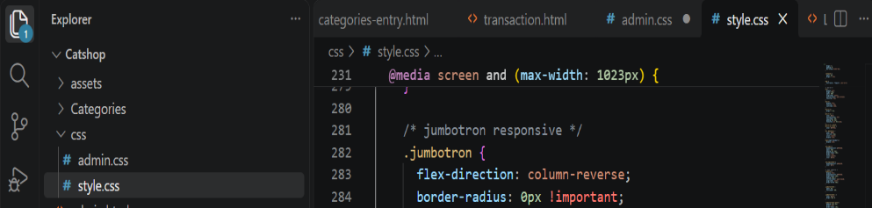

1.2 Tampilan Folder
- Ubah isi dari file index.html
Source code:
<!DOCTYPE html>
<html lang="en">
<head>
<link rel="icon" href="assets/icon.png" />
<title>Home</title>
<link rel="stylesheet" href="css/style.css" />
<link rel="preconnect" href="https://fonts.googleapis.com" />
<link rel="preconnect" href="https://fonts.gstatic.com" crossorigin />
<link
href="https://fonts.googleapis.com/css2?family=Poppins:wght@400;500;700&family=Roboto:wght@500;700&display=swap"
rel="stylesheet"
/>
<link
rel="stylesheet"
href="https://cdnjs.cloudflare.com/ajax/libs/font-awesome/5.15.3/css/all.min.css"
/>
<link rel="stylesheet" href="style.css" />
</head>

<body>
<div class="container">
<header>
<nav>
<div class="logo">
<img src="assets/logo.png" alt="" />
</div>
<input type="checkbox" id="click" />
<label for="click" class="menu-btn">
<i class="fas fa-bars"></i>
</label>
<ul>
<li><a href="#">Home</a></li>
<li><a href="#">Categories</a></li>
<li><a href="login.html" class="btn_login">Login</a></li>
</ul>
</nav>
</header>
<main>
<div class="jumbotron">
<div class="jumbotron-text">
<h1>Find Your New Little Cat, Make a New Friend</h1>
<p>
Teman barumu yang lucu menunggu mu, ayo temukan mereka sekarang
</p>
<button type="button" class="btn_getStarted">Get Started</button>
</div>
<div class="jumbotron-img">
<img src="assets/jumbotron.png" alt="" />
</div>
</div>
<div class="cards-categories">
<h2>Cat Categories</h2>
<div class="card-categories">
<div class="card">
<div class="card-image">
<img src="assets/anggora.png" alt="gambar tidak ditemukan" />
</div>
<div class="card-content">
<h5>Anggora</h5>
<p class="description">
Anggora turki adalah salah satu ras kucing domestik alami
tertua. Ras ini berasal dari Ankara, Turki. Kucing ini sangat
populer dan terkenal di Indonesia.
</p>
<p class="price"><span>Rp.</span>50,000</p>
<button class="btn_belanja" type="submit">Beli</button>
</div>
</div>
<div class="card">
<div class="card-image">
<img src="assets/persia.png" alt="gambar tidak ditemukan" />
</div>
<div class="card-content">
<h5>Persia</h5>
<p class="description">
Kucing persia adalah ras kucing domestik berbulu panjang
dengan karakter wajah bulat dan moncong pendek. Namanya
mengacu pada Persia.
</p>
<p class="price"><span>Rp.</span>50,000</p>
<button class="btn_belanja" type="submit">Beli</button>
</div>
</div>
<div class="card">
<div class="card-image">
<img src="assets/british.png" alt="gambar tidak ditemukan" />
</div>
<div class="card-content">
<h5>British Shorthair</h5>
<p class="description">
Kucing bulu pendek britania adalah salah satu ras kucing
tertua di inggris. Kucing ini adalah kucing berbadan sedang
dengan bulu yang pendek.
</p>
<p class="price"><span>Rp.</span>50,000</p>
<button class="btn_belanja" type="submit">Beli</button>
</div>
</div>
</div>
</div>
</main>
<footer>
<h4>&copy; Lab Pemrograman Komputer 2026</h4>
</footer>
</div>
</body>
</html>
Hasil tampilan :
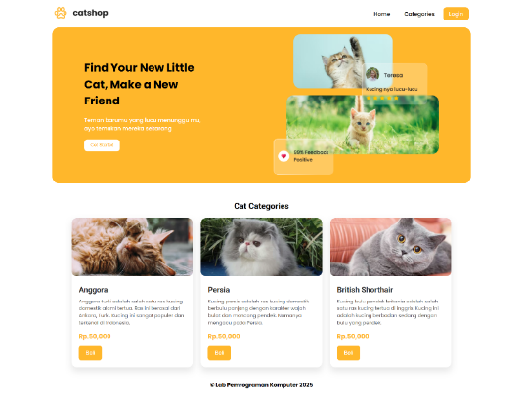

1.3 Tampilan file index html

- Ubah isi dari file login.html
Source code login.html :
<!DOCTYPE html>
<html lang="en">
<head>
<title>Login</title>
<link rel="icon" href="assets/icon.png" />
<link rel="stylesheet" href="css/style.css" />
<link rel="preconnect" href="https://fonts.googleapis.com" />
<link rel="preconnect" href="https://fonts.gstatic.com" crossorigin />
<linkhref="https://fonts.googleapis.com/css2?family=Poppins:wght@400;500;700&family=Roboto:wght@500;700&display=swap"
rel="stylesheet"
/>
<link
rel="stylesheet"
href="https://cdnjs.cloudflare.com/ajax/libs/font-awesome/5.15.3/css/all.min.css"
/>
<link rel="stylesheet" href="style.css" />
</head>
<body>
<div class="container">
<header>
<nav>
<div class="logo">
<img src="assets/logo.png" alt="" />
</div>
<input type="checkbox" id="click" />
<label for="click" class="menu-btn">
<i class="fas fa-bars"></i>
</label>
<ul>
<li><a href="index.html">Home</a></li>
<li><a href="#">Categories</a></li>
<li><a href="login.html" class="btn_login">Login</a></li>
</ul>
</nav>
</header>
<main>
<div class="center">
<div class="form-login">
<h3>Login</h3>
<form action="">
<input
class="input"
type="text"
name="username"
placeholder="Username"
/>
<input
class="input"
type="password"
name="password"
placeholder="Password"
/>
<button type="submit" class="btn_login" name="login" id="login">
Login
</button>
</form>
<a href="register.html" class="link-register"> Register Disini</a>
</div>
</div>
</main>
<footer>
<h4>&copy; Lab Pemrograman Komputer 2026</h4>
</footer>
</div>
</body>
</html>
Hasil tampilan :

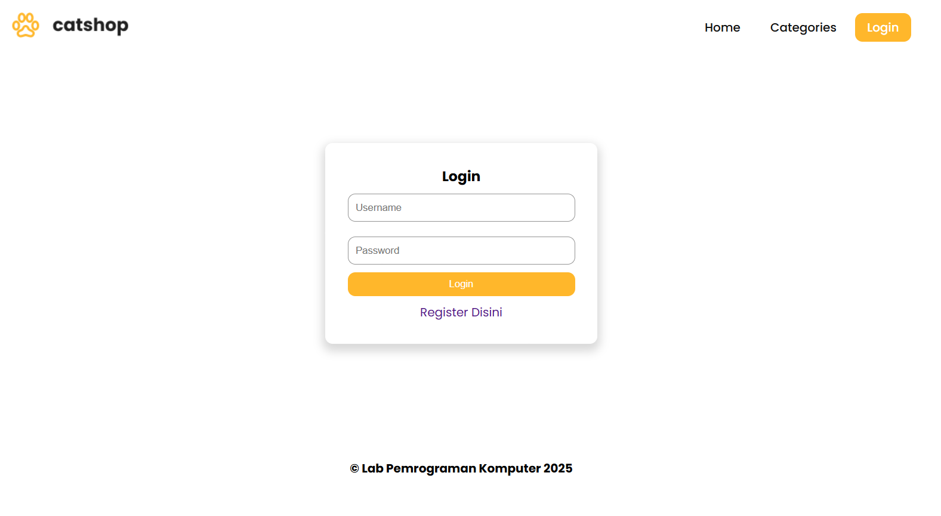

1.4 Tampilan login
- Ubah isi register.html
Source code :
<!DOCTYPE html>
<html lang="en">
<head>
<title>Register</title>
<link rel="icon" href="assets/icon.png" />
<link rel="stylesheet" href="css/style.css" />
<link rel="preconnect" href="https://fonts.googleapis.com" />
<link rel="preconnect" href="https://fonts.gstatic.com" crossorigin />
<link
href="https://fonts.googleapis.com/css2?family=Poppins:wght@400;500;700&family=Roboto:wght@500;700&display=swap"
rel="stylesheet"
/>
<link
rel="stylesheet"
href="https://cdnjs.cloudflare.com/ajax/libs/font-awesome/5.15.3/css/all.min.css"
/>
<link rel="stylesheet" href="style.css" />
</head>
<body>
<div class="container">
<header>
<nav>
<div class="logo">
<img src="assets/logo.png" alt="" />
</div>
<input type="checkbox" id="click" />
<label for="click" class="menu-btn">
<i class="fas fa-bars"></i>
</label>
<ul>
<li><a href="index.html">Home</a></li>
<li><a href="#">Categories</a></li>
<li><a href="login.html" class="btn_login">Login</a></li>
</ul>
</nav>
</header>
<main>
<div class="center">
<div class="form-login">
<h3>Register</h3>
<form action="">
<input
class="input"
type="email"
name="email"
placeholder="Email"
/>
<input
class="input"
type="text"
name="username"
placeholder="Username"
/>
<input
class="input"
type="password"
name="password"
placeholder="Password"
/>
<button
type="submit"
class="btn_login"
name="register"
id="register"
>
Register
</button>
</form>
</div>
</div>
</main>
<footer>
<h4>&copy; Lab Pemrograman Komputer 2026</h4>
</footer>
</div>
</body>
</html>
Hasil tampilan :
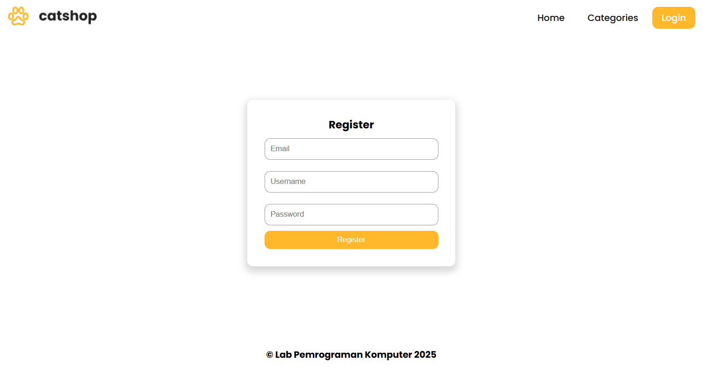

1.5 Tampilan resgister
- Buatlah file css baru dengan nama admin.css dan simpan kedalam folder css yang telah dibuat sebelumnya. Kemudian tambahkan baris code dibawah ini
Source code admin.css:
@import url("https://fonts.googleapis.com/css2?family=Poppins:wght@200;300;400;500;600;700&display=swap");
* {
margin: 0;
padding: 0;
box-sizing: border-box;
font-family: "Poppins", sans-serif;
}
/* sidebar */
.sidebar {
position: fixed;
height: 100%;
width: 240px;
background: #ffb72b;
transition: all 0.5s ease;
}
.sidebar.active {
width: 60px;
}
.sidebar .logo-details {
height: 80px;
display: flex;
align-items: center;
}
.sidebar .logo-details i {
font-size: 28px;
font-weight: 500;
color: #fff;
min-width: 60px;
text-align: center;
}
.sidebar .logo-details .logo_name {
color: #fff;
font-size: 24px;
font-weight: 500;
}
.sidebar .nav-links {
margin-top: 10px;
}
.sidebar .nav-links li {
position: relative;
list-style: none;
height: 50px;
}
.sidebar .nav-links li a {
height: 100%;
width: 100%;
display: flex;
align-items: center;
text-decoration: none;
transition: all 0.4s ease;
}
.sidebar .nav-links li a.active {
background: #eba416;
}
.sidebar .nav-links li a:hover {
background: #eba416;
}
.sidebar .nav-links li i {
min-width: 60px;
text-align: center;
font-size: 18px;
color: #fff;
}
.sidebar .nav-links li a .links_name {
color: #fff;
font-size: 15px;
font-weight: 400;
white-space: nowrap;
}

/* main content */
.home-section {
position: relative;
background: #f5f5f5;
min-height: 100vh;
width: calc(100% - 240px);
left: 240px;
transition: all 0.5s ease;
}
.sidebar.active ~ .home-section {
width: calc(100% - 60px);
left: 60px;
}
.home-section nav {
display: flex;
justify-content: space-between;
height: 80px;
background: #fff;
display: flex;
align-items: center;
position: fixed;
width: calc(100% - 240px);
left: 240px;
z-index: 100;
padding: 0 20px;
box-shadow: 0 1px 1px rgba(0, 0, 0, 0.1);
transition: all 0.5s ease;
}
.sidebar.active ~ .home-section nav {
left: 60px;
width: calc(100% - 60px);
}
.home-section nav .sidebar-button {
display: flex;
align-items: center;
font-size: 24px;
font-weight: 500;
}
nav .sidebar-button i {
font-size: 35px;
margin-right: 10px;
}

.home-section nav .profile-details {
display: flex;
align-items: center;
justify-content: center;
background: #f5f6fa;
border: 2px solid #efeef1;
border-radius: 6px;
height: 50px;
min-width: 190px;
}
.table-data {
text-align: center;
border-collapse: collapse;
width: 100%;
overflow-x: auto;

}

.btn-edit,
.btn-delete {
padding: 8px 16px;
margin-right: 8px;
border: none;
border-radius: 4px;
cursor: pointer;
font-size: 14px;
transition: background-color 0.3s;
}

.btn-edit {
background-color: #4caf50; /* Green */
color: white;
}

.btn-delete {
background-color: #f44336; /* Red */
color: white;
}

.btn-edit:hover,
.btn-delete:hover {
background-color: #45a049; /* Darker green */
}

nav .profile-details .admin_name {
font-size: 15px;
font-weight: 500;
color: #333;
white-space: nowrap;
}
.home-section .home-content {
position: relative;
padding-top: 104px;
padding-left: 20px;
padding-right: 20px;
}

.btn {
background-color: #ffb72b;
color: white;
padding: 10px 20px;
border: none;
border-radius: 5px;
cursor: pointer;
}

.btn a {
text-decoration: none;
color: white;
}

.btn-tambah {
margin: 10px 0;
}

.btn-simpan {
width: 100%;
}

.btn:hover {
background-color: #eba416;
}

.table-data {
text-align: center;
border-collapse: collapse;
width: 100%;
}
th, td {
border: 1px solid black;
padding: 5px 20px;
}
.form-login {
display: flex;
flex-direction: column;
align-items: center;
background-color: white;
padding: 30px;
margin: 10px auto;
border-radius: 10px;
}
.input {
width: 100%;
margin: 10px 0;
padding: 10px;
border-radius: 10px;
border: 1px solid rgb(148, 148, 148);
}
/* waran status transaksi */
.success {
background-color: #4CAF50; /* Green */
color: white;
border-radius: 5px;
padding: 5px 10px;
}

.pending {
background-color: #FFC107; /* Yellow */
color: black;
}

.expire {
background-color: #f44336; /* Red */
color: white;
}

.cancel {
background-color: #607D8B; /* Blue Grey */
color: white;
}

.settlement {
background-color: #2196F3; /* Blue */
color: white;
}
.btn_detail {
background-color: #2196F3; /* Blue */
color: white;
padding: 5px 10px;
border-radius: 5px;
border: none;
}
.btn_detail:hover {
background-color: #0d8bf0; /* Blue */
}

/* Responsive Media Query */
@media (max-width: 1240px) {
.sidebar {
width: 60px;
}
.sidebar.active {
width: 220px;
}
.home-section {
width: calc(100% - 60px);
left: 60px;
}
.sidebar.active ~ .home-section {
/* width: calc(100% - 220px); */
overflow: hidden;
left: 220px;
}
.home-section nav {
width: calc(100% - 60px);
left: 60px;
}
.sidebar.active ~ .home-section nav {
width: calc(100% - 220px);
left: 220px;
}
}
@media (max-width: 700px) {
nav .profile-details {
display: none !important;
}
.home-section nav .profile-details {
height: 50px;
min-width: 40px;
}
}
@media (max-width: 550px) {
.profile-details {
display: none !important;
}

}
@media (max-width: 400px) {
.sidebar {
width: 0;
}
.sidebar.active {
width: 60px;
}
.home-section {
width: 100%;
left: 0;
}
.sidebar.active ~ .home-section {
left: 60px;
width: calc(100% - 60px);
}
.home-section nav {
width: 100%;
left: 0;
}
.sidebar.active ~ .home-section nav {
left: 60px;
width: calc(100% - 60px);
}
}
Hasil tampilan :
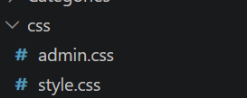

1.6 Tampilan file css
- Buat file baru dengan nama admin.html
Source Code admin.html :
<!DOCTYPE html>
<html lang="en">

<head>
<meta charset="UTF-8" />
<link rel="icon" href="assets/icon.png" />
<link rel="stylesheet" href="css/admin.css" />
<link href="https://unpkg.com/boxicons@2.0.7/css/boxicons.min.css" rel="stylesheet" />
<meta name="viewport" content="width=device-width, initial-scale=1.0" />
<title>Catshop Admin</title>
</head>

<body>
<div class="sidebar">
<div class="logo-details">
<i class="bx bx-category"></i>
<span class="logo_name">CatShop</span>
</div>
<ul class="nav-links">
<li>
<a href="#" class="active">
<i class="bx bx-grid-alt"></i>
<span class="links_name">Dashboard</span>
</a>
</li>
<li>
<a href="categories/categories.html">
<i class="bx bx-box"></i>
<span class="links_name">Categories</span>
</a>
</li>
<li>
<a href="transaction/transaction.html">
<i class="bx bx-list-ul"></i>
<span class="links_name">Transaction</span>
</a>
</li>
<li>
<a href="#">
<i class="bx bx-log-out"></i>
<span class="links_name">Log out</span>
</a>
</li>
</ul>
</div>
<section class="home-section">
<nav>
<div class="sidebar-button">
<i class="bx bx-menu sidebarBtn"></i>
</div>
<div class="profile-details">
<span class="admin_name">Catshop Admin</span>
</div>
</nav>
<div class="home-content">
<h1>Selamat Datang Admin</h1>
</div>
</section>
<script>
let sidebar = document.querySelector(".sidebar");
let sidebarBtn = document.querySelector(".sidebarBtn");
sidebarBtn.onclick = function () {
sidebar.classList.toggle("active");
if (sidebar.classList.contains("active")) {
sidebarBtn.classList.replace("bx-menu", "bx-menu-alt-right");
} else sidebarBtn.classList.replace("bx-menu-alt-right", "bx-menu");
};
</script>
</body>

</html>

Hasil tampilan :
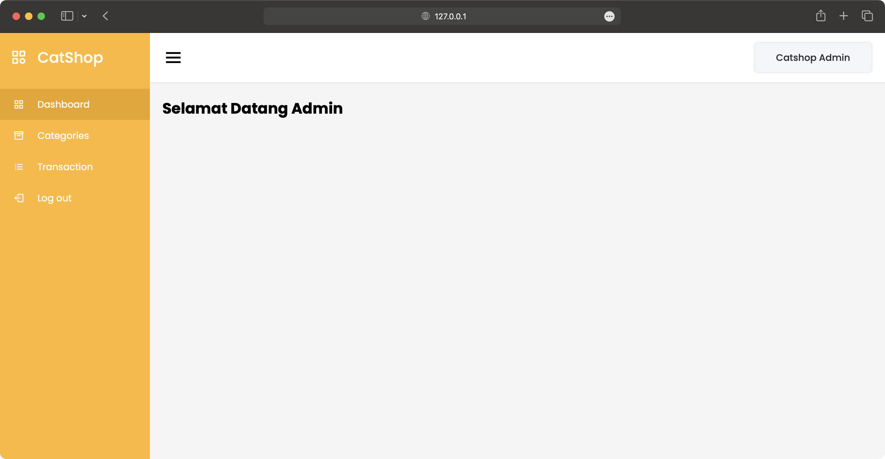

1.7 Tampilan menu admin
- Buat file baru dengan nama categories.html kemudian simpan ke dalam folder categories.
Source Code categories.html:
<!DOCTYPE html>
<html lang="en" dir="ltr">

<head>
<meta charset="UTF-8" />
<link rel="icon" href="../assets/icon.png" />
<link rel="stylesheet" href="../css/admin.css" />
<!-- Boxicons CDN Link -->
<link href="https://unpkg.com/boxicons@2.0.7/css/boxicons.min.css" rel="stylesheet" />
<meta name="viewport" content="width=device-width, initial-scale=1.0" />
<title>Catshop Admin | Categories</title>
</head>

<body>
<div class="sidebar">
<div class="logo-details">
<i class="bx bx-category"></i>
<span class="logo_name">CatShop</span>
</div>
<ul class="nav-links">
<li>
<a href="../admin.html" class="active">
<i class="bx bx-grid-alt"></i>
<span class="links_name">Dashboard</span>
</a>
</li>
<li>
<a href="../categories/categories.html">
<i class="bx bx-box"></i>
<span class="links_name">Categories</span>
</a>
</li>
<li>
<a href="../transaction/transaction.html">
<i class="bx bx-list-ul"></i>
<span class="links_name">Transaction</span>
</a>
</li>
<li>
<a href="#">
<i class="bx bx-log-out"></i>
<span class="links_name">Log out</span>
</a>
</li>
</ul>
</div>
<section class="home-section">
<nav>
<div class="sidebar-button">
<i class="bx bx-menu sidebarBtn"></i>
</div>
<div class="profile-details">
<span class="admin_name">Catshop Admin</span>
</div>
</nav>
<div class="home-content">
<h3>Categories</h3>
<button type="button" class="btn btn-tambah">
<a href="categories-entry.html">Tambah Data</a>
</button>
<table class="table-data">
<thead>
<tr>
<th scope="col" style="width: 20%">Photo</th>
<th>Categories</th>
<th scope="col" style="width: 20%">Description</th>
<th scope="col" style="width: 15%">Price</th>
<th scope="col" style="width: 30%">Action</th>
</tr>
</thead>
<tbody>
<tr>
<td><img src="../assets/thumbnail/anggora.png" alt="" /></td>
<td>Anggora</td>
<td>Anggora turki adalah salah satu ras kucing domestik alami tertua. Ras ini berasal dari
Ankara, Turki. Kucing ini sangat populer dan terkenal di Indonesia.</td>
<td>450,000</td>
<td>
<button class="btn-edit" onclick="editCategory()">Edit</button>
<button class="btn-delete" onclick="deleteCategory()">Hapus</button>
</td>
</tr>
</tbody>
</table>
</div>
</section>
<script>
let sidebar = document.querySelector(".sidebar");
let sidebarBtn = document.querySelector(".sidebarBtn");
sidebarBtn.onclick = function () {
sidebar.classList.toggle("active");
if (sidebar.classList.contains("active")) {
sidebarBtn.classList.replace("bx-menu", "bx-menu-alt-right");
} else sidebarBtn.classList.replace("bx-menu-alt-right", "bx-menu");
};
</script>
</body>

</html>

Hasil tampilan :
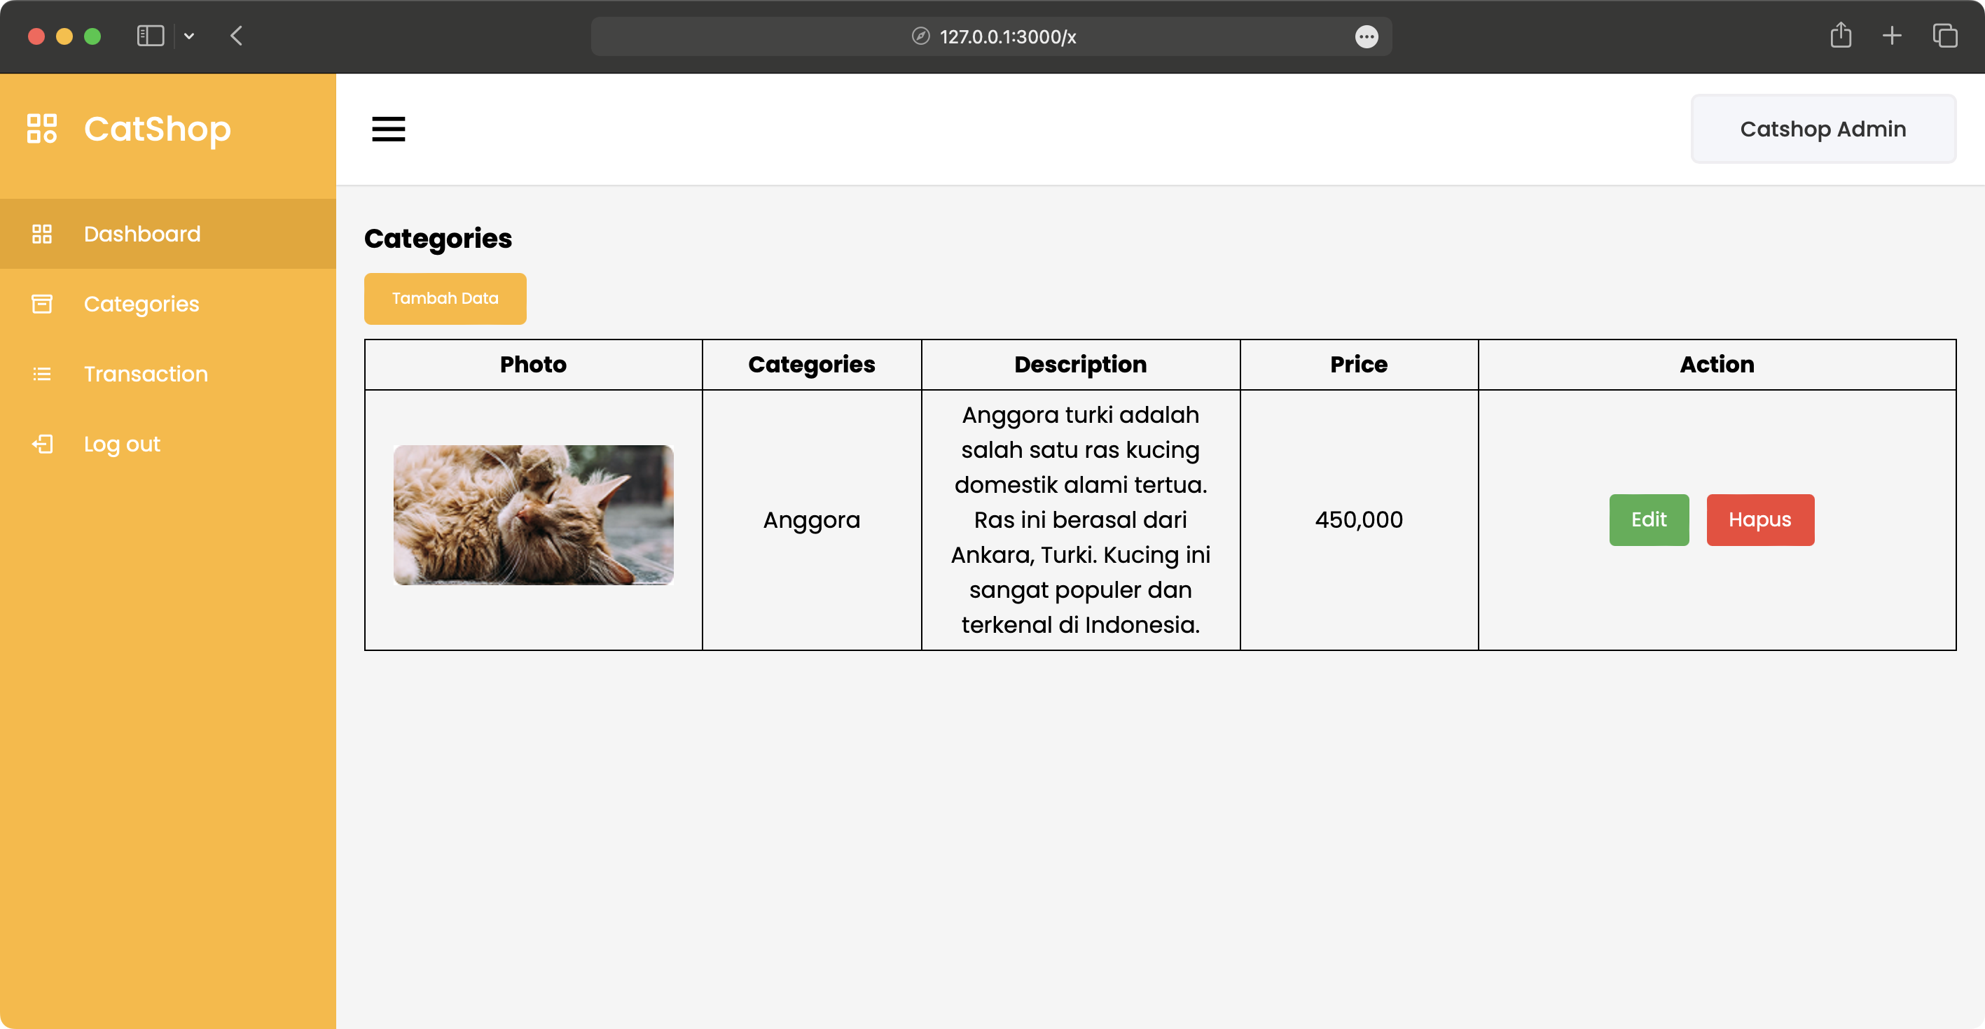

1.8 Tampilan menu categories
- Buat file baru dengan nama categories-entry.html, kemudian simpan ke dalam folder categories.
Source code categories-entry.html :
<!DOCTYPE html>
<html lang="en" dir="ltr">

<head>
<meta charset="UTF-8" />
<link rel="icon" href="../assets/icon.png" />
<link rel="stylesheet" href="../css/admin.css" />
<!-- Boxicons CDN Link -->
<link href="https://unpkg.com/boxicons@2.0.7/css/boxicons.min.css" rel="stylesheet" />
<meta name="viewport" content="width=device-width, initial-scale=1.0" />
<title>Catshop Admin | Categories Entry</title>
</head>

<body>
<div class="sidebar">
<div class="logo-details">
<i class="bx bx-category"></i>
<span class="logo_name">CatShop</span>
</div>
<ul class="nav-links">
<li>
<a href="../admin.html" class="active">
<i class="bx bx-grid-alt"></i>
<span class="links_name">Dashboard</span>
</a>
</li>
<li>
<a href="../categories/categories.html">
<i class="bx bx-box"></i>
<span class="links_name">Categories</span>
</a>
</li>
<li>
<a href="../transaction/transaction.html">
<i class="bx bx-list-ul"></i>
<span class="links_name">Transaction</span>
</a>
</li>
<li>
<a href="#">
<i class="bx bx-log-out"></i>
<span class="links_name">Log out</span>
</a>
</li>
</ul>
</div>
<section class="home-section">
<nav>
<div class="sidebar-button">
<i class="bx bx-menu sidebarBtn"></i>
</div>
<div class="profile-details">
<span class="admin_name">Catshop Admin</span>
</div>
</nav>
<div class="home-content">
<h3>Input Categories</h3>
<div class="form-login">
<form action="">
<label for="categories">Categories</label>
<input class="input" type="text" name="categories" id="categories" placeholder="Categories" />
<label for="categories">Price</label>
<input class="input" type="text" name="price" id="price" placeholder="Price" />
<label for="categories">Description</label>
<input class="input" type="text" name="Description" id="Description" placeholder="Description" />
<label for="photo">Photo</label>
<input type="file" name="photo" id="photo" style="margin-bottom: 20px" />
<button type="submit" class="btn btn-simpan" name="simpan">
Simpan
</button>
</form>
</div>
</div>
</section>
<script>
let sidebar = document.querySelector(".sidebar");
let sidebarBtn = document.querySelector(".sidebarBtn");
sidebarBtn.onclick = function () {
sidebar.classList.toggle("active");
if (sidebar.classList.contains("active")) {
sidebarBtn.classList.replace("bx-menu", "bx-menu-alt-right");
} else sidebarBtn.classList.replace("bx-menu-alt-right", "bx-menu");
};
</script>
</body>

</html>

Hasil tampilan :
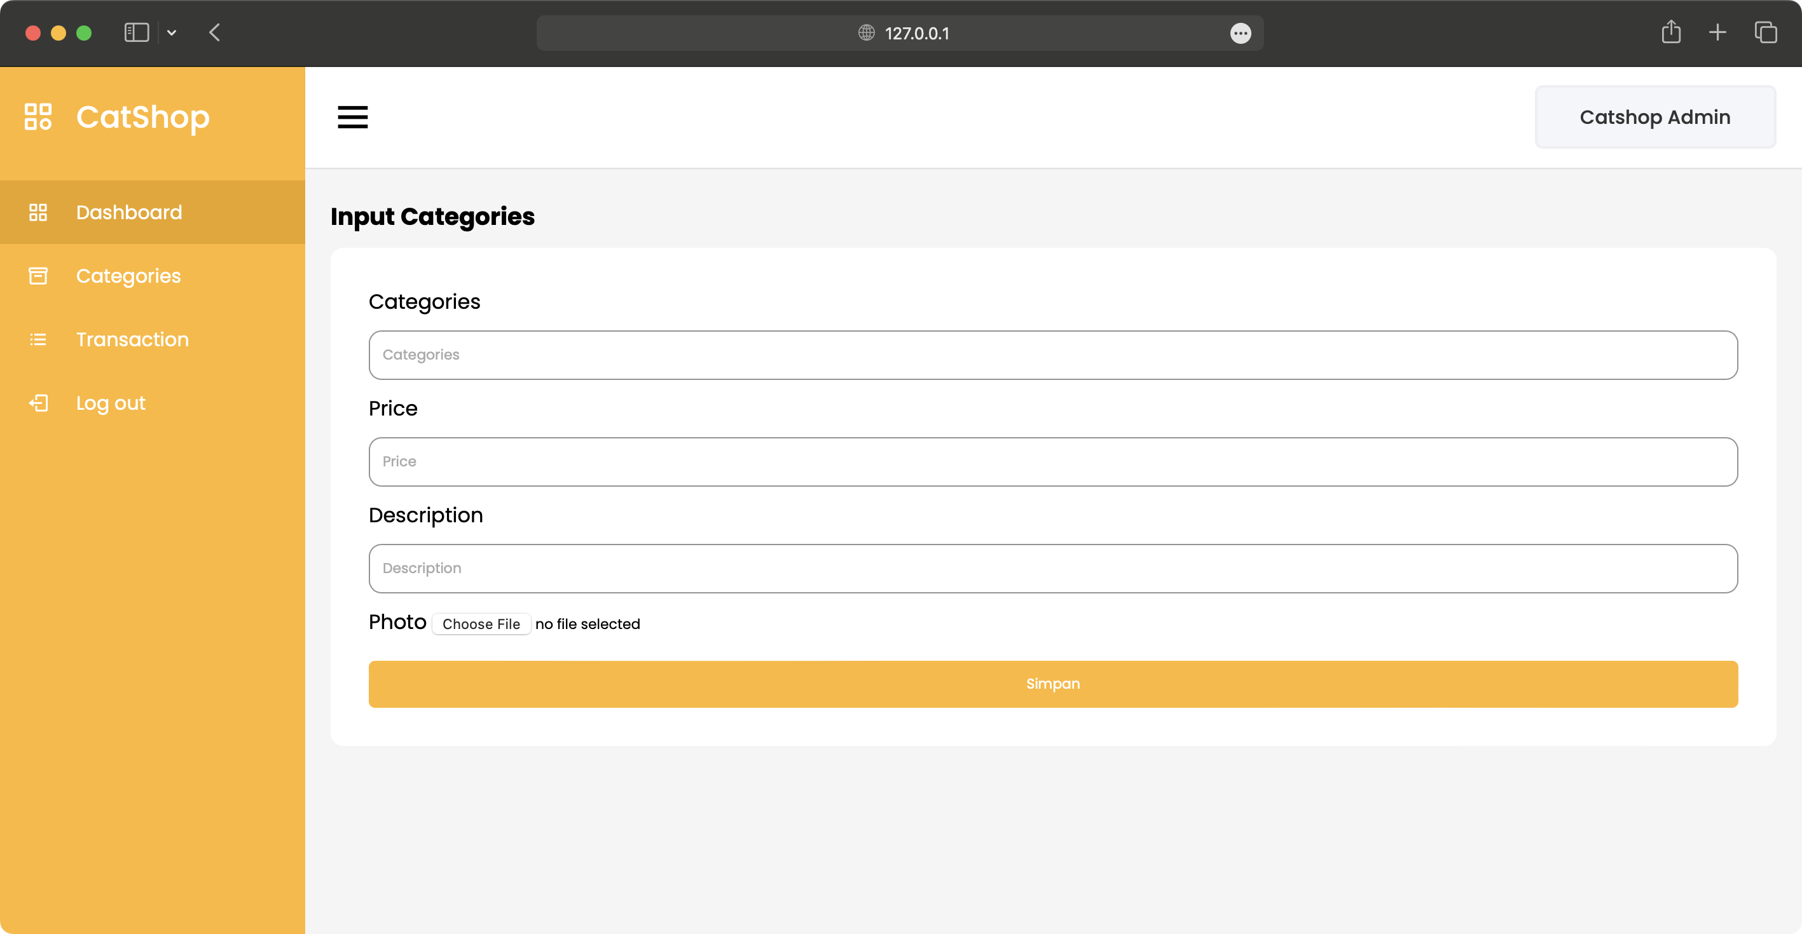

1.9 Tampilan input categories
- Buat file baru dengan nama transaction.html, dan di masukkan ke dalam folder transaction.
Source code transaction.html :
<!DOCTYPE html>
<html lang="en">

<head>
<meta charset="UTF-8" />
<link rel="icon" href="../assets/icon.png" />
<link rel="stylesheet" href="../css/admin.css" />
<!-- Boxicons CDN Link -->
<link href="https://unpkg.com/boxicons@2.0.7/css/boxicons.min.css" rel="stylesheet" />
<meta name="viewport" content="width=device-width, initial-scale=1.0" />
<title>Catshop Admin | Transaction</title>
</head>

<body>
<div class="sidebar">
<div class="logo-details">
<i class="bx bx-category"></i>
<span class="logo_name">CatShop</span>
</div>
<ul class="nav-links">
<li>
<a href="../admin.html" class="active">
<i class="bx bx-grid-alt"></i>
<span class="links_name">Dashboard</span>
</a>
</li>
<li>
<a href="../categories/categories.html">
<i class="bx bx-box"></i>
<span class="links_name">Categories</span>
</a>
</li>
<li>
<a href="../transaction/transaction.html">
<i class="bx bx-list-ul"></i>
<span class="links_name">Transaction</span>
</a>
</li>
<li>
<a href="#">
<i class="bx bx-log-out"></i>
<span class="links_name">Log out</span>
</a>
</li>
</ul>
</div>
<section class="home-section">
<nav>
<div class="sidebar-button">
<i class="bx bx-menu sidebarBtn"></i>
</div>
<div class="profile-details">
<span class="admin_name">Catshop Admin</span>
</div>
</nav>
<div class="home-content">
<h3>Transaction</h3>
<table class="table-data">
<thead>
<tr>
<th>Tanggal</th>
<th>Nama</th>
<th>Kategori</th>
<th>Harga</th>
<th>Status</th>
<th>Action</th>
</tr>
</thead>
<tbody>
<tr>
<td>02-03-2023</td>
<td>Raflizar</td>
<td>Anggora</td>
<td>450000</td>
<td>
<p class="success">Success</p>
</td>
<td>
<button class="btn_detail"
onclick="showDetails('02-03-2023', 'Raflizar', 'Anggora', '450000', 'Success')">Detail</button>
</td>
</tr>
<!-- Add more rows as needed -->
</tbody>
</table>
</div>
</section>
<script>
let sidebar = document.querySelector(".sidebar");
let sidebarBtn = document.querySelector(".sidebarBtn");
sidebarBtn.onclick = function () {
sidebar.classList.toggle("active");
if (sidebar.classList.contains("active")) {
sidebarBtn.classList.replace("bx-menu", "bx-menu-alt-right");
} else sidebarBtn.classList.replace("bx-menu-alt-right", "bx-menu");
};
function showDetails(tanggal, nama, kategori, harga, status) {
alert(`Tanggal: ${tanggal}\nNama: ${nama}\nKategori: ${kategori}\nHarga: ${harga}\nStatus: ${status}`);
}
</script>
</body>

</html>

Hasil tampilan :
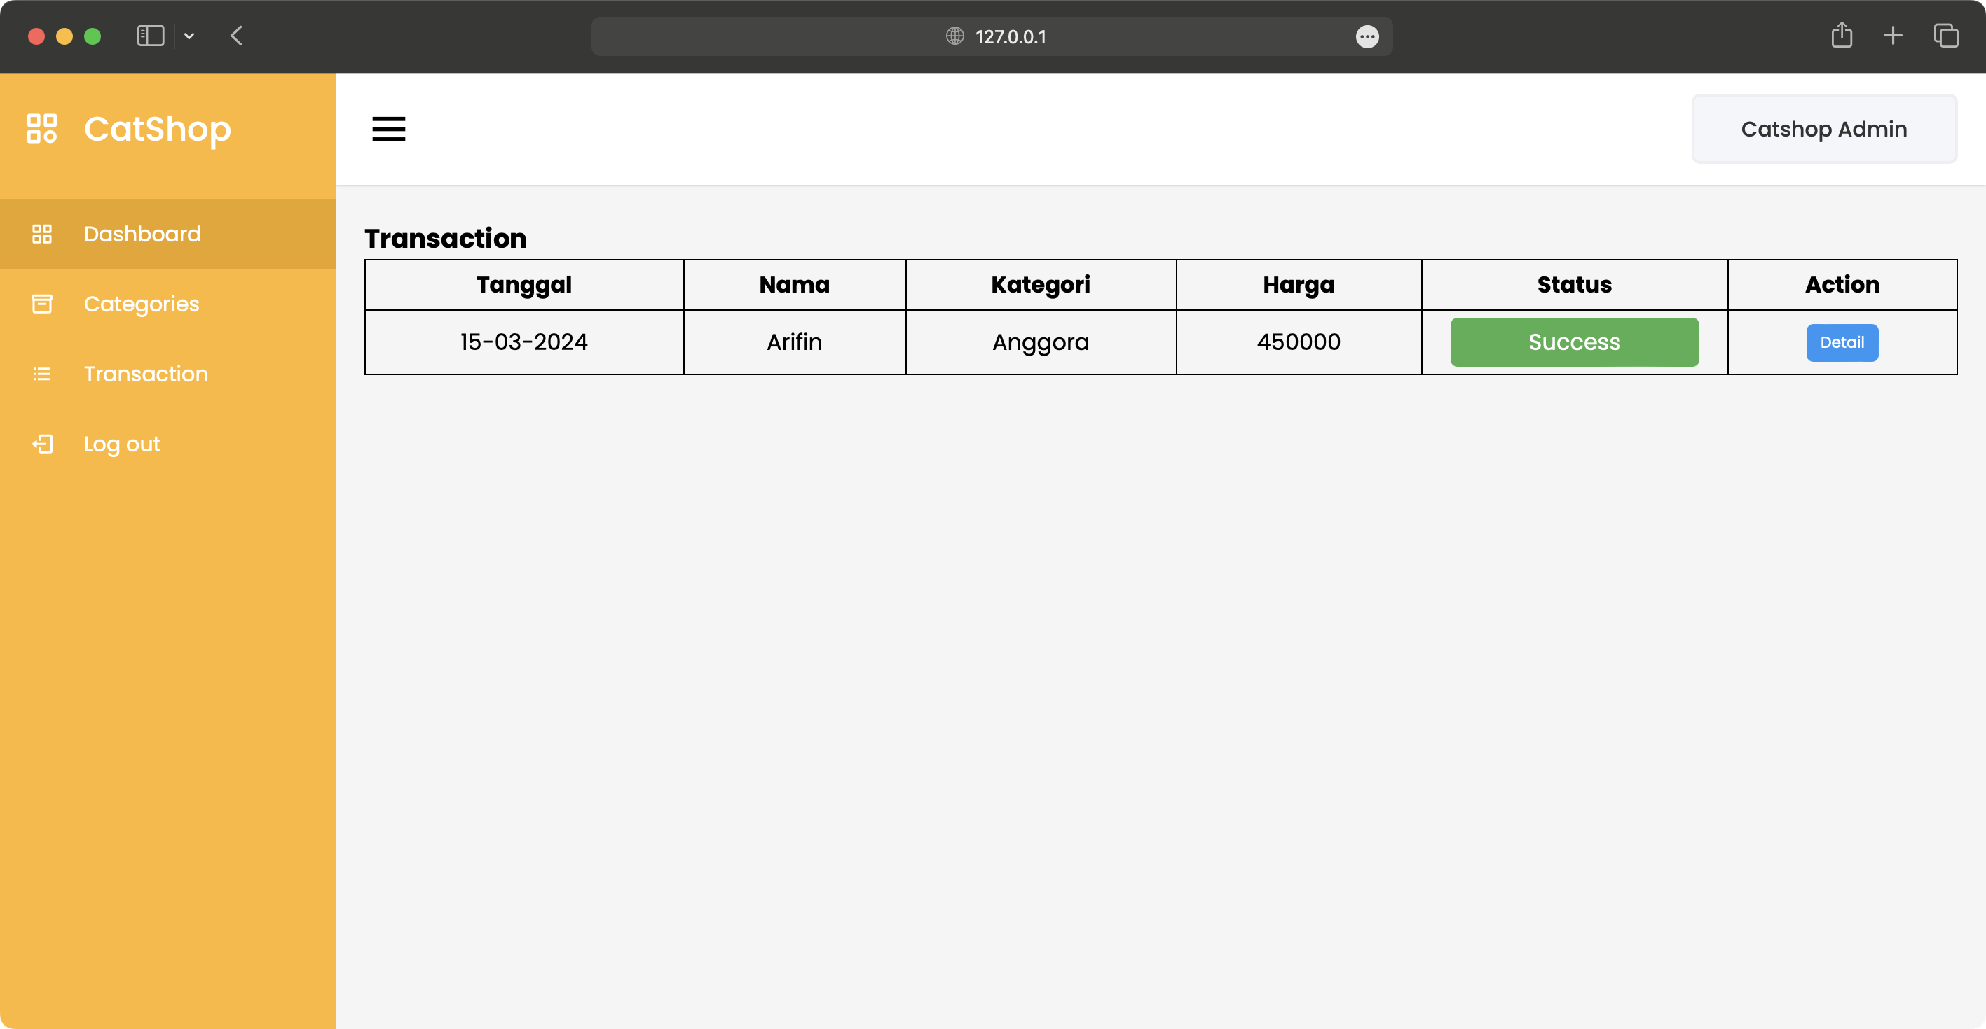

1.10 Tampilan transaction

Analisa :
CatShop ini menunjukkan proses pembuatan website sederhana dengan struktur folder, file HTML, dan CSS yang rapi. Setiap halaman seperti index.html, login.html, register.html, admin.html, categories.html, dan transaction.html sudah dilengkapi dengan tampilan responsif serta elemen interaktif seperti tombol, sidebar, dan tabel data. Secara keseluruhan, proyek ini melatih keterampilan dasar front-end web development, mulai dari desain UI hingga pengelolaan halaman admin untuk kategori dan transaksi.

