HTML
TUGAS 1 : Membuat Web Form Sederhana
Nama /Nim | : | Lovelya Nicolle Caroline Rupilu 2518023
Kelas | : | B
Pengajar | : | Ikhawaan Pratama (2418060)

Tujuan
- Praktikan dapat
- Praktikan dapat
- Praktikan dapat
- Alat dan Bahan

Alat dan Bahan
- Laptop/pc
- Modul Praktikum Web 2026
- TextEditor (Visual Studio Code / Sublime Text)

Langkah-langkah
- Buka file admin.html, tambahkan id = text pada h1 yang berada di dalam div dengan class home-content dan juga tambahkan 1 buah h1 dengan id = date, seperti script dibawah ini
Source Code :
<div class="home-content">
<h2 id="text"></h2>
<h3 id="date"></h3>
</div>

- Ubah script menjadi seperti dibawah ini
Source code :
<script>
let sidebar = document.querySelector(".sidebar");
let sidebarBtn = document.querySelector(".sidebarBtn");
sidebarBtn.onclick = function () {
sidebar.classList.toggle("active");
if (sidebar.classList.contains("active")) {
sidebarBtn.classList.replace("bx-menu", "bx-menu-alt-right");
} else sidebarBtn.classList.replace("bx-menu-alt-right", "bx-menu");
};
function myFunction() {
const months = ["Januari", "Februari", "Maret", "April", "Mei",
"Juni", "Juli", "Agustus", "September", "Oktober",
"November", "Desember"];
const days = ["Minggu", "Senin", "Selasa", "Rabu", "Kamis",
"Jumat", "Sabtu"];
let date = new Date();
jam = date.getHours();
tanggal = date.getDate();
hari = days[date.getDay()];
bulan = months[date.getMonth()];
tahun = date.getFullYear();

let m = date.getMinutes();
let s = date.getSeconds();
m = checkTime(m);
s = checkTime(s);
document.getElementById("date").innerHTML = `
${tanggal} ${bulan} ${tahun}, ${jam}:${m}:${s}`;
requestAnimationFrame(myFunction);
}
function checkTime(i) {
if (i < 10) {
i = "0" + i;
}
return i;
}
window.onload = function () {
let nama = prompt("Masukkan Nama Anda : ", "Admin");
let jam = new Date().getHours();
if (nama != null) {
if (jam >= 4 && jam <= 10) {
document.getElementById("text").innerHTML = `Selamat Pagi ${nama}`;
} else if (jam >= 11 && jam <= 14) {
document.getElementById("text").innerHTML = `Selamat Siang ${nama}`;
} else if (jam >= 15 && jam <= 18) {
document.getElementById("text").innerHTML = `Selamat Sore ${nama}`;
} else {
document.getElementById("text").innerHTML = `Selamat Malam ${nama}`;
}
}
myFunction();
};
</script>

Hasil tampilan :
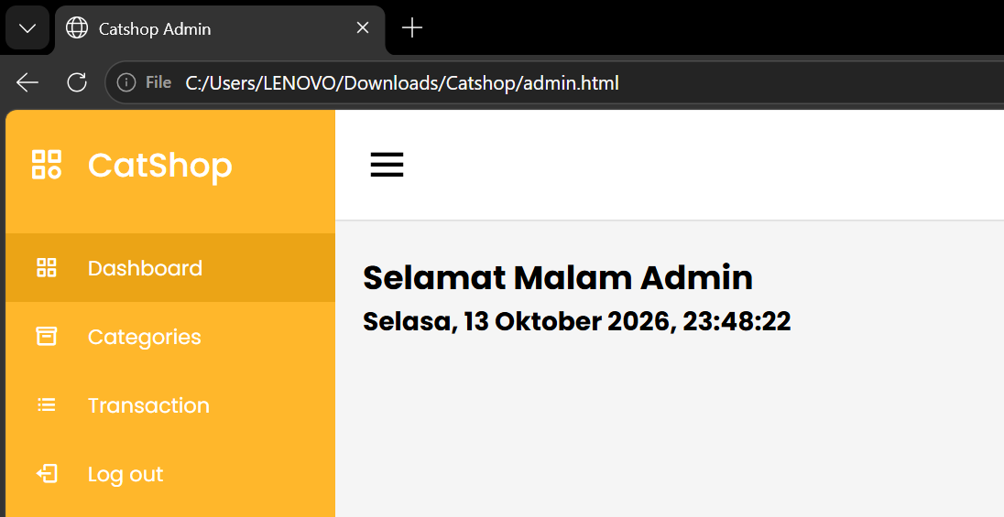
Gambar 4.1 Hasil tampilan admin
- Ubah index.html menjadi seperti dibawah ini
<!DOCTYPE html>
<html lang="en">

<head>
<meta charset="UTF-8" />
<link rel="icon" href="assets/icon.png" />
<link rel="stylesheet" href="css/admin.css" />
<link href="https://unpkg.com/boxicons@2.0.7/css/boxicons.min.css" rel="stylesheet" />
<meta name="viewport" content="width=device-width, initial-scale=1.0" />
<title>Catshop Admin</title>
</head>

<body>
<div class="sidebar">
<div class="logo-details">
<i class="bx bx-category"></i>
<span class="logo_name">CatShop</span>
</div>
<ul class="nav-links">
<li>
<a href="#" class="active">
<i class="bx bx-grid-alt"></i>
<span class="links_name">Dashboard</span>
</a>
</li>
<li>
<a href="categories/categories.html">
<i class="bx bx-box"></i>
<span class="links_name">Categories</span>
</a>
</li>
<li>
<a href="transaction/transaction.html">
<i class="bx bx-list-ul"></i>
<span class="links_name">Transaction</span>
</a>
</li>
<li>
<a href="#">
<i class="bx bx-log-out"></i>
<span class="links_name">Log out</span>
</a>
</li>
</ul>
</div>
<section class="home-section">
<nav>
<div class="sidebar-button">
<i class="bx bx-menu sidebarBtn"></i>
</div>
<div class="profile-details">
<span class="admin_name">Catshop Admin</span>
</div>
</nav>
<div class="home-content">
<h2 id="text"></h2>
<h3 id="date"></h3>
</div>
</section>
<script>
let sidebar = document.querySelector(".sidebar");
let sidebarBtn = document.querySelector(".sidebarBtn");
sidebarBtn.onclick = function () {
sidebar.classList.toggle("active");
if (sidebar.classList.contains("active")) {
sidebarBtn.classList.replace("bx-menu", "bx-menu-alt-right");
} else sidebarBtn.classList.replace("bx-menu-alt-right", "bx-menu");
};
function myFunction() {
const months = ["Januari", "Februari", "Maret", "April", "Mei",
"Juni", "Juli", "Agustus", "September", "Oktober",
"November", "Desember"];
const days = ["Minggu", "Senin", "Selasa", "Rabu", "Kamis",
"Jumat", "Sabtu"];
let date = new Date();
jam = date.getHours();
tanggal = date.getDate();
hari = days[date.getDay()];
bulan = months[date.getMonth()];
tahun = date.getFullYear();

let m = date.getMinutes();
let s = date.getSeconds();
m = checkTime(m);
s = checkTime(s);
document.getElementById("date").innerHTML = `
${hari}, ${tanggal} ${bulan} ${tahun}, ${jam}:${m}:${s}`;
requestAnimationFrame(myFunction);
}
function checkTime(i) {
if (i < 10) {
i = "0" + i;
}
return i;
}
window.onload = function () {
let nama = prompt("Masukkan Nama Anda : ", "Admin");
let jam = new Date().getHours();
if (nama != null) {
if (jam >= 4 && jam <= 10) {
document.getElementById("text").innerHTML = `Selamat Pagi ${nama}`;
} else if (jam >= 11 && jam <= 14) {
document.getElementById("text").innerHTML = `Selamat Siang ${nama}`;
} else if (jam >= 15 && jam <= 18) {
document.getElementById("text").innerHTML = `Selamat Sore ${nama}`;
} else {
document.getElementById("text").innerHTML = `Selamat Malam ${nama}`;
}
}
myFunction();
};
</script>
</body>

</html>
- Ubah style.css seperti dibawah ini
* {
margin: 0;
padding: 0;
box-sizing: border-box;
}

.container {
width: 80%;
margin: 0 auto;
}

body {
font-family: "Poppins", sans-serif;
}

/* new nav */
nav {
display: flex;
height: 80px;
width: 100%;
align-items: center;
justify-content: space-between;
flex-wrap: wrap;
}
nav ul {
display: flex;
flex-wrap: wrap;
list-style: none;
}
nav ul li {
margin: 0 5px;
}
nav ul li a {
color: #111;
text-decoration: none;
font-weight: 500;
padding: 8px 15px;
transition: all 0.3s ease;
}
nav ul li a.active,
nav ul li a:hover {
color: #ffb72b;
}
nav .menu-btn i {
color: #000;
font-size: 22px;
cursor: pointer;
display: none;
}
input[type="checkbox"] {
display: none;
}

.btn_login {
background-color: #ffb72b;
width: 100%;
padding: 8px 16px;
border-radius: 10px;
border: none;
cursor: pointer;
color: white;
}

.btn_login:hover {
background-color: #eba416;
color: #fff;
}

/* style jumbotron */
.jumbotron {
display: flex;
background-color: #ffb72b;
border-radius: 20px;
padding: 20px 0;
justify-content: space-around;
align-items: center;
margin-bottom: 50px;
}

.jumbotron-text {
width: 30%;
font-weight: 500;
}

.jumbotron-text p {
color: white;
margin: 20px 0;
}

.jumbotron-text button {
padding: 10px 18px;
border: none;
border-radius: 10px;
background-color: white;
color: #ffb72b;
cursor: pointer;
}

/* style card-categories */
.cards-categories {
display: flex;
flex-direction: column;
align-items: center;
}

.cards-categories h2 {
font-family: "Roboto", sans-serif;
font-size: 24px;
margin-bottom: 20px;
text-align: center;
}

.card-categories {
display: grid;
gap: 1.5rem;
grid-template-columns: repeat(auto-fit, minmax(20rem, 1fr));
}

.card {
box-shadow: 0 10px 20px rgba(0, 0, 0, 0.1);
border-radius: 15px;
overflow: hidden;
transition: transform 0.3s ease-in-out;
}

.card:hover {
transform: scale(1.05);
}

.card .card-image {
overflow: hidden;
border-radius: 15px 15px 0 0;
}

.card img {
width: 100%;
height: auto;
object-fit: cover;
border-radius: 15px 15px 0 0;
}

.card-content {
padding: 20px;
}

.card h5 {
margin-bottom: 10px;
font-family: "Roboto", sans-serif;
font-size: 22px;
font-weight: 600;
color: #333;
}

.card p.description {
font-size: 14px;
color: #666;
margin-bottom: 15px;
}

.card p.price {
font-size: 18px;
font-weight: bold;
color: #ffb72b;
margin-bottom: 15px;
}

.card .btn_belanja {
background-color: #ffb72b;
padding: 12px 20px;
border-radius: 8px;
border: none;
cursor: pointer;
color: white;
font-size: 16px;
transition: background-color 0.3s ease;
}

.card .btn_belanja:hover {
background-color: #eba416;
}

/* footer */
footer {
display: flex;
justify-content: center;
align-items: center;
margin: 40px 0;
}

/* style page login */

.center {
display: flex;
justify-content: center;
align-items: center;
height: 500px;
}

.form-login {
display: flex;
flex-direction: column;
align-items: center;
width: 30%;
background-color: white;
padding: 30px;
margin: 0 auto;
box-shadow: 0 6px 12px 4px rgba(0, 0, 0, 0.15);
border-radius: 10px;
}

.input {
width: 100%;
margin: 10px 0;
padding: 10px;
border-radius: 10px;
border: 1px solid rgb(148, 148, 148);
}

.link-register {
text-decoration: none;
margin-top: 10px;
}

/* Modal */
.modal-container {
display: none;
position: fixed;
top: 0;
left: 0;
width: 100%;
height: 100%;
background-color: rgba(0, 0, 0, 0.5);
justify-content: center;
align-items: center;
color: #000;
}

.modal-dialog {
width: 80%;
max-width: 500px;
background-color: #fff;
border: none;
border-radius: 10px;
box-shadow: 0 0 10px rgba(0, 0, 0, 0.2);
}

.modal-header {
border-bottom: none;
padding: 10px 20px;
display: flex;
justify-content: space-between;
align-items: center;
}

.modal-title {
margin: 0;
font-size: 1.2rem;
}

.btn-close {
font-size: 1.5rem;
background: none;
border: none;
cursor: pointer;
color: #000;
}

.modal-body {
padding: 20px;
}

.form-group {
margin-bottom: 20px;
}

.form-group .labelmodal {
display: block;
margin-bottom: 5px;
}

.form-group .inputdata,
.form-group .inputalamat {
width: 100%;
padding: 8px;
border: 1px solid #ccc;
border-radius: 5px;
}

.modal-footer {
border-top: none;
padding: 10px 20px;
display: flex;
justify-content: flex-end;
}

.btn-secondary,
.btn-yellow {
padding: 8px 16px;
border: none;
border-radius: 5px;
cursor: pointer;
color: #fff;

}

.btn-secondary {
background-color: #888;
margin-right: 10px;
}

.btn-yellow {
background-color: #ffb72b;
}

/* responsive */
@media screen and (max-width: 1023px) {
.modal-dialog {
width: 80%;
}
.container {
width: 100%;
margin: 0 auto;
}
/* navbar responsive */
nav {
padding: 0 40px 0 50px;
position: relative;
}

nav .menu-btn i {
display: block;
}
#click:checked ~ .menu-btn i:before {
content: "\f00d";
}
nav ul {
position: absolute;
top: 80px;
left: -100%;
background: rgba(0, 0, 0, 0.85);
width: 100%;
text-align: center;
display: block;
transition: all 0.3s ease;
}
#click:checked ~ ul {
left: 0;
}
nav ul li {
width: 100%;
margin: 40px 0;
}
nav ul li a {
width: 100%;
margin-left: -100%;
display: block;
font-size: 20px;
color: #fff;
transition: 0.6s cubic-bezier(0.68, -0.55, 0.265, 1.55);
}
#click:checked ~ ul li a {
margin-left: 0px;
}
nav ul li a.active,
nav ul li a:hover {
color: #ffb72b;
}

/* jumbotron responsive */
.jumbotron {
flex-direction: column-reverse;
border-radius: 0px !important;
justify-content: center;
}
.jumbotron-img img {
width: 100% !important;
}

.jumbotron-text {
width: 100% !important;
padding-left: 20px;
}

/* card-categories responsive */
.card-categories {
flex-direction: column;
gap: 20px;
margin: 0 10px;
}

.card {
width: 100% !important;
}

/* form-login responsive */
.form-login {
width: 80%;
}
}
Hasil tampilan :
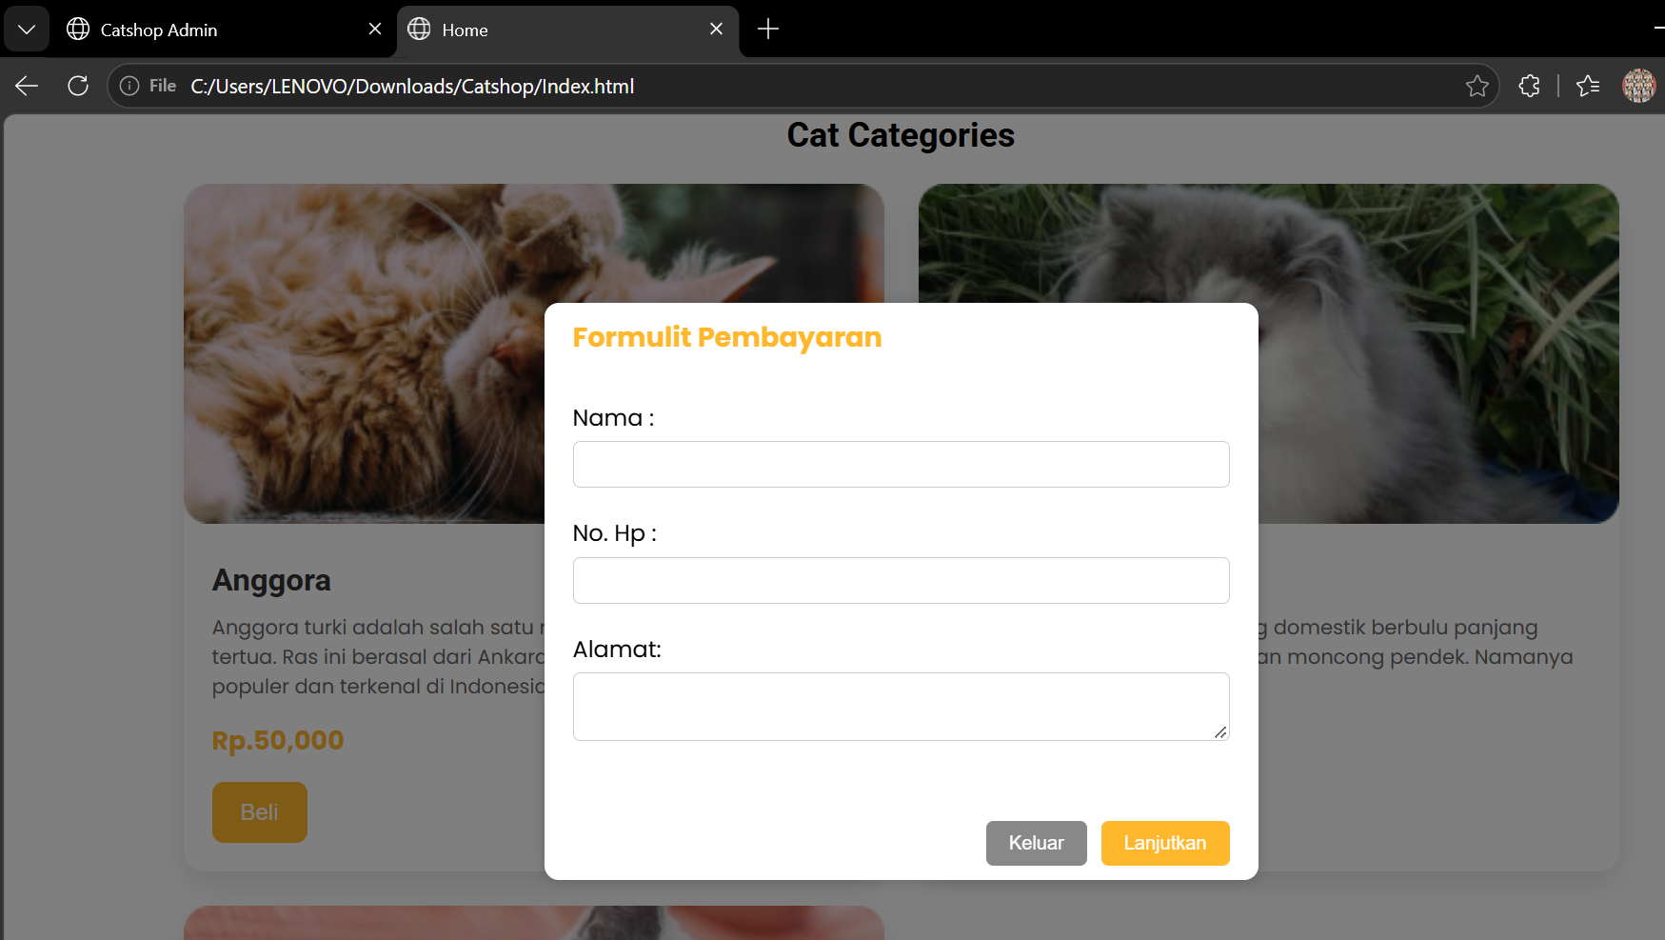
Gambar 4.1 Hasil tampilan index

Analisa :

