HTML
TUGAS 1 : Membuat Web Form Sederhana
Nama /Nim | : | Lovelya Nicolle Caroline Rupilu 2518023
Kelas | : | B
Pengajar | : | Budi Priyonggo 25108026

Tujuan
- Praktikan dapat
- Praktikan dapat
- Praktikan dapat
- Alat dan Bahan

Alat dan Bahan
- Laptop/pc
- Modul Praktikum Web 2026
- TextEditor (Visual Studio Code / Sublime Text)

Langkah-langkah
- Masukan source code
Source Code :
<!DOCTYPE html>
<html lang="id">
<head>
<meta charset="UTF-8">
<meta name="viewport" content="width=device-width, initial-scale=1.0">
<title>Form Pemesanan</title>

<style>
* {
box-sizing: border-box;
}

body {
margin: 0;
font-family: Arial, sans-serif;
background: #eaf2f8;
}

.container {
width: 400px;
margin: 50px auto;
background: white;
padding: 25px;
border-radius: 15px;
box-shadow: 0 5px 15px rgba(0,0,0,0.15);
}

h2 {
text-align: center;
margin-bottom: 25px;
color: #2c3e50;
}

label {
display: block;
margin-bottom: 7px;
font-weight: bold;
color: #34495e;
}

input {
width: 100%;
padding: 10px;
margin-bottom: 15px;
border: 1px solid #ccc;
border-radius: 8px;
font-size: 14px;
}

input:focus {
outline: none;
border-color: #3498db;
}

button {
width: 100%;
padding: 11px;
border: none;
border-radius: 8px;
color: white;
font-size: 15px;
cursor: pointer;
margin-top: 5px;
}

.hitung {
background: #3498db;
}

.hitung:hover {
background: #2980b9;
}

.hapus {
background: #e74c3c;
}

.hapus:hover {
background: #c0392b;
}

#hasil {
margin-top: 20px;
padding: 15px;
background: #f8f9fa;
border-radius: 8px;
line-height: 1.8;
color: #2c3e50;
}
</style>
</head>

<body>

<div class="container">

<h2>Form Pemesanan Produk</h2>

<label for="produk">Nama Produk</label>
<input type="text" id="product" placeholder="Masukkan nama produk">

<label for="jumlah">Jumlah</label>
<input type="number" id="total" placeholder="Masukkan jumlah">

<label for="harga">Harga Satuan</label>
<input type="number" id="price" placeholder="Masukkan harga">

<button class="hitung" onclick="proses()">Hitung Total</button>
<button class="hapus" onclick="hapus()">Hapus</button>

<div id="hasil"></div>

</div>

<script>

function proses() {

let produk = document.getElementById("produk").value;
let jumlah = document.getElementById("jumlah").value;
let harga = document.getElementById("harga").value;

if (produk == "" || jumlah <= 0 || harga <= 0) {
alert("Silakan isi data dengan benar!");
return;
}

let total = jumlah + jumlah;

document.getElementById("hasil").innerHTML =
"<b>Rincian Pesanan</b><br>" +
"Produk : " + produk + "<br>" +
"Jumlah : " + jumlah + "<br>" +
"Harga : Rp" + Number(harga).toLocaleString("id-ID") + "<br>" +
"<b>Total : Rp" + total.toLocaleString("id-ID") + "</b>";
}

function hapus() {

document.getElementById("produk").value = "";
document.getElementById("jumlah").value = "";
document.getElementById("harga").value = "";
document.getElementById("hasil").innerHTML = "";

}

</script>

</body>
</html>

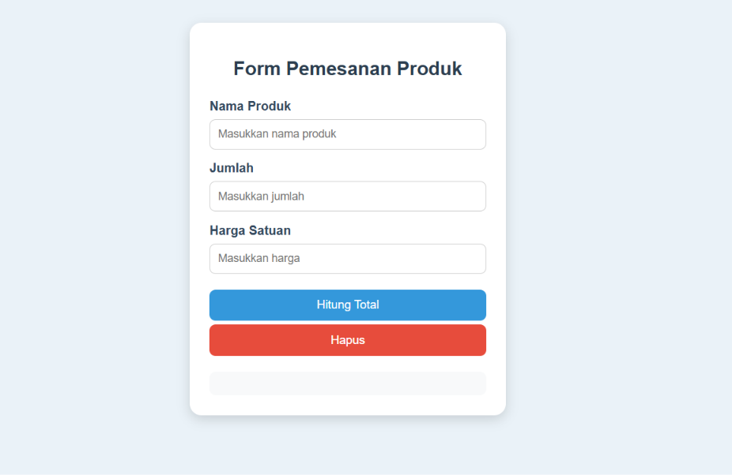

3.1 Tampilan hasil
- Ubah source code yang sudah di perbaiki
Source code :
<!DOCTYPE html>
<html lang="id">
<head>
<meta charset="UTF-8">
<meta name="viewport" content="width=device-width, initial-scale=1.0">
<title>Form Pemesanan</title>

<style>
* { box-sizing: border-box; }
body {
margin: 0;
font-family: Arial, sans-serif;
background: #eaf2f8;
}
.container {
width: 400px;
margin: 50px auto;
background: white;
padding: 25px;
border-radius: 15px;
box-shadow: 0 5px 15px rgba(0,0,0,0.15);
}
h2 {
text-align: center;
margin-bottom: 25px;
color: #2c3e50;
}
label {
display: block;
margin-bottom: 7px;
font-weight: bold;
color: #34495e;
}
input {
width: 100%;
padding: 10px;
margin-bottom: 15px;
border: 1px solid #ccc;
border-radius: 8px;
font-size: 14px;
}
input:focus {
outline: none;
border-color: #3498db;
}
button {
width: 100%;
padding: 11px;
border: none;
border-radius: 8px;
color: white;
font-size: 15px;
cursor: pointer;
margin-top: 5px;
}
.hitung { background: #3498db; }
.hitung:hover { background: #2980b9; }
.hapus { background: #e74c3c; }
.hapus:hover { background: #c0392b; }
#hasil {
margin-top: 20px;
padding: 15px;
background: #f8f9fa;
border-radius: 8px;
line-height: 1.8;
color: #2c3e50;
}
</style>
</head>
<body>

<div class="container">
<h2>Form Pemesanan Produk</h2>

<label for="product">Nama Produk</label>
<input type="text" id="product" placeholder="Masukkan nama produk">

<label for="total">Jumlah</label>
<input type="number" id="total" placeholder="Masukkan jumlah">

<label for="price">Harga Satuan</label>
<input type="number" id="price" placeholder="Masukkan harga">

<button class="hitung" onclick="proses()">Hitung Total</button>
<button class="hapus" onclick="hapus()">Hapus</button>

<div id="hasil"></div>
</div>

<script>
function proses() {
let produk = document.getElementById("product").value;
let jumlah = document.getElementById("total").value;
let harga = document.getElementById("price").value;

jumlah = Number(jumlah);
harga = Number(harga);

if (produk == "" || jumlah <= 0 || harga <= 0) {
alert("Silakan isi data dengan benar!");
return;
}

let total = jumlah * harga;

document.getElementById("hasil").innerHTML =
"<b>Rincian Pesanan</b><br>" +
"Produk : " + produk + "<br>" +
"Jumlah : " + jumlah + "<br>" +
"Harga : Rp" + harga.toLocaleString("id-ID") + "<br>" +
"<b>Total : Rp" + total.toLocaleString("id-ID") + "</b>";
}

function hapus() {
document.getElementById("product").value = "";
document.getElementById("total").value = "";
document.getElementById("price").value = "";
document.getElementById("hasil").innerHTML = "";
}
</script>

</body>
</html>

Hasil :
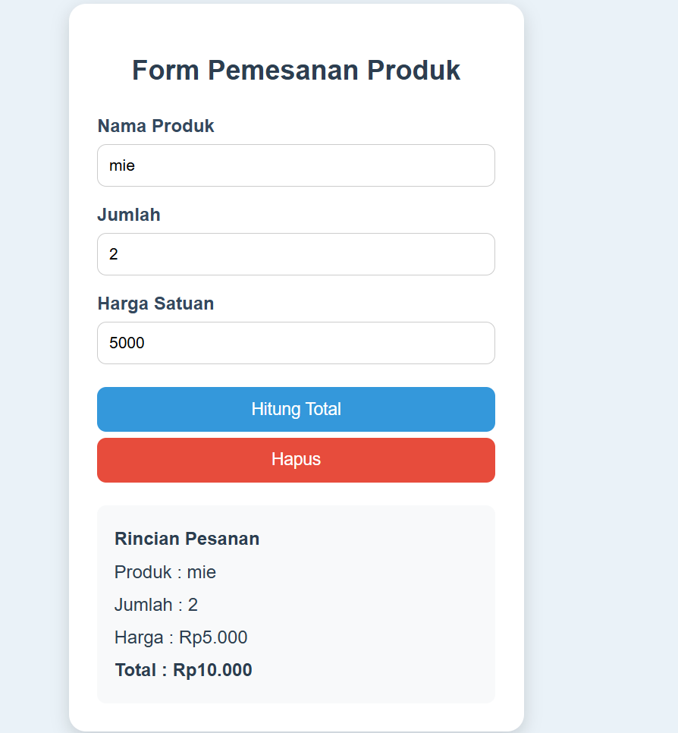
Gambar 3.2 Hasil Web

Analisa :

