**HEART DISEASE DIAGNOSTIC ANALYSIS**

# Wireframe Document

DOCUMENT VERSION CONTROL

|  |  |  |  |
| --- | --- | --- | --- |
| Date Issue | Version | Description | Author |
| 04-05-2023 | 1 | Wireframe Document | Lovely Patra |

**HEART DISEASE GENDER PERCENTAGE**

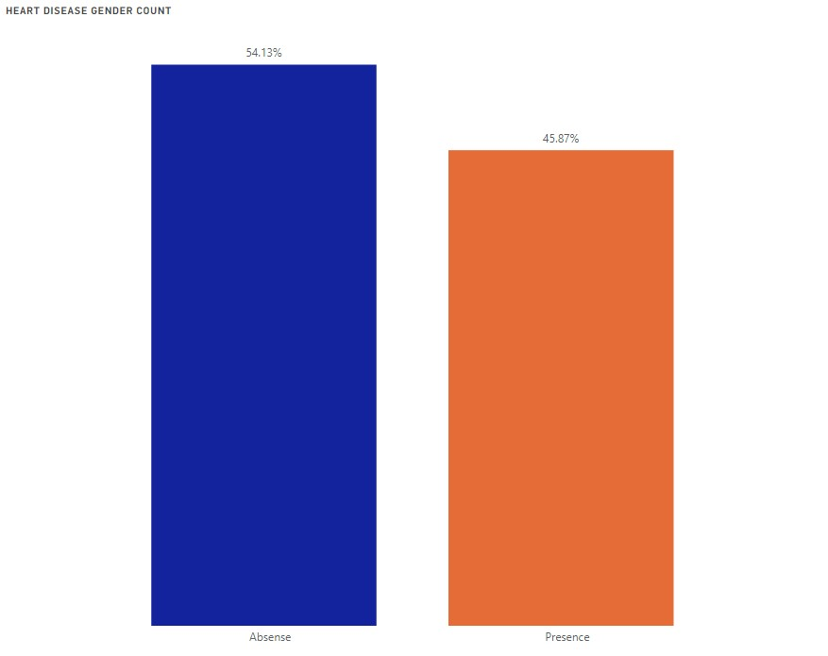

**EXERCISE INDUCED ANGINA**

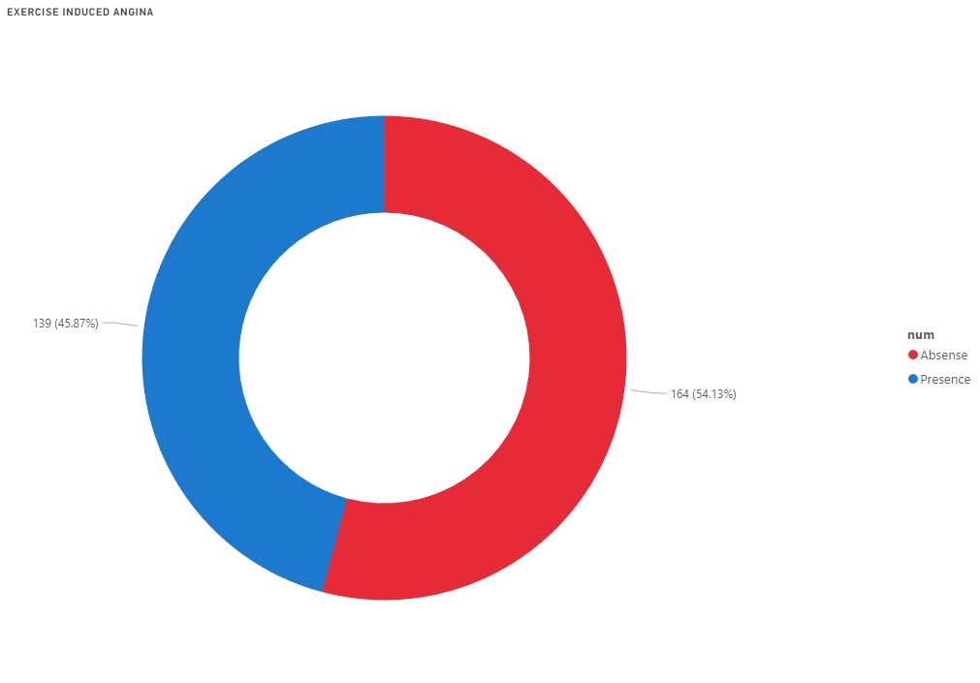

**CHEST PAIN VS AGE**

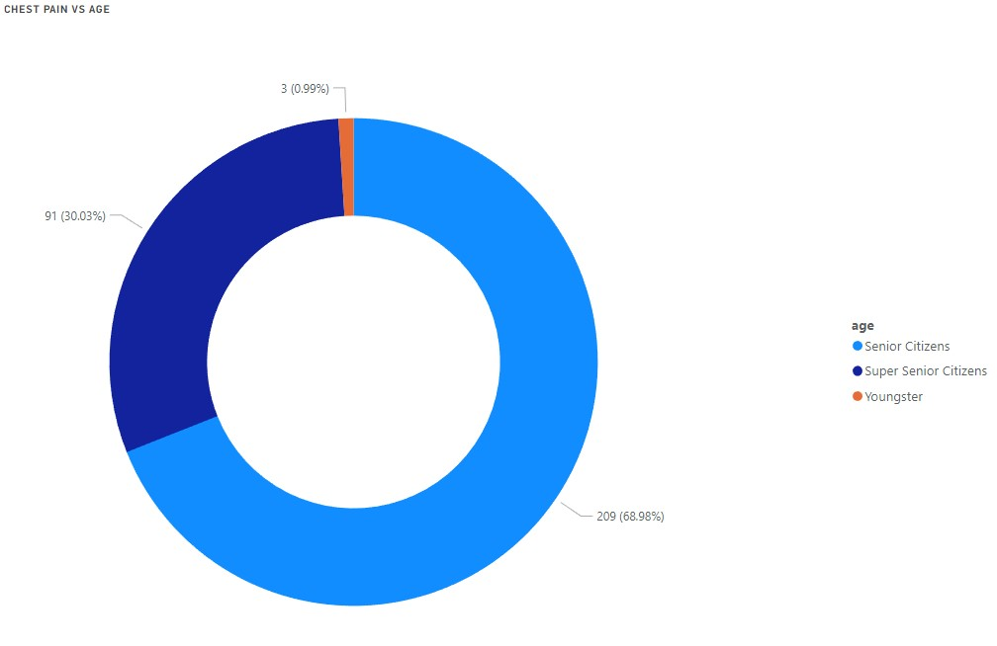

**SLOPE : NORMAL TRACE DURING EXCERCISE**

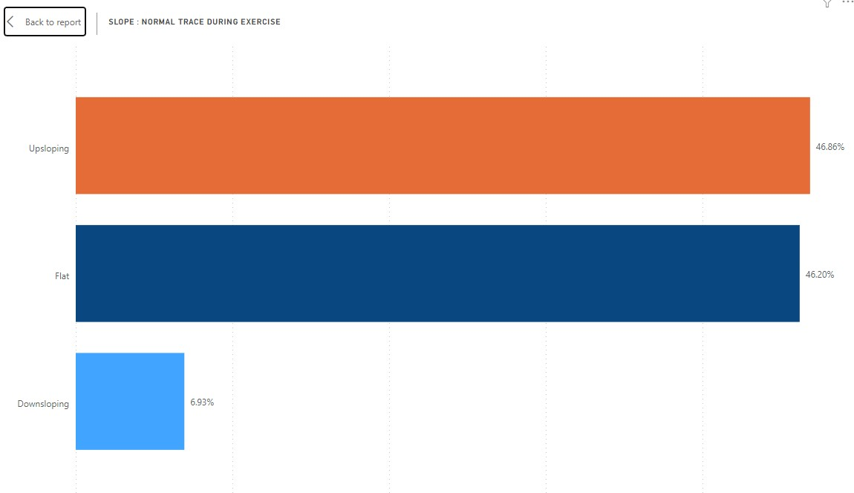

**CHEST PAIN VS GENDER**

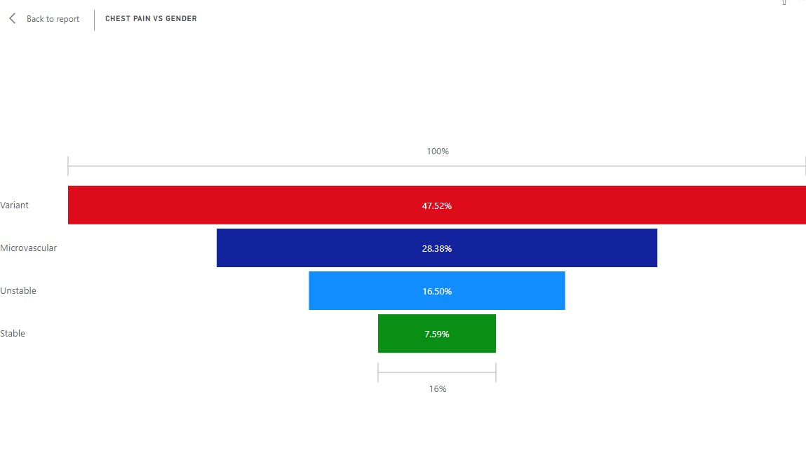

**A BLOOD DISORDER CALLED THALASSEMIA**

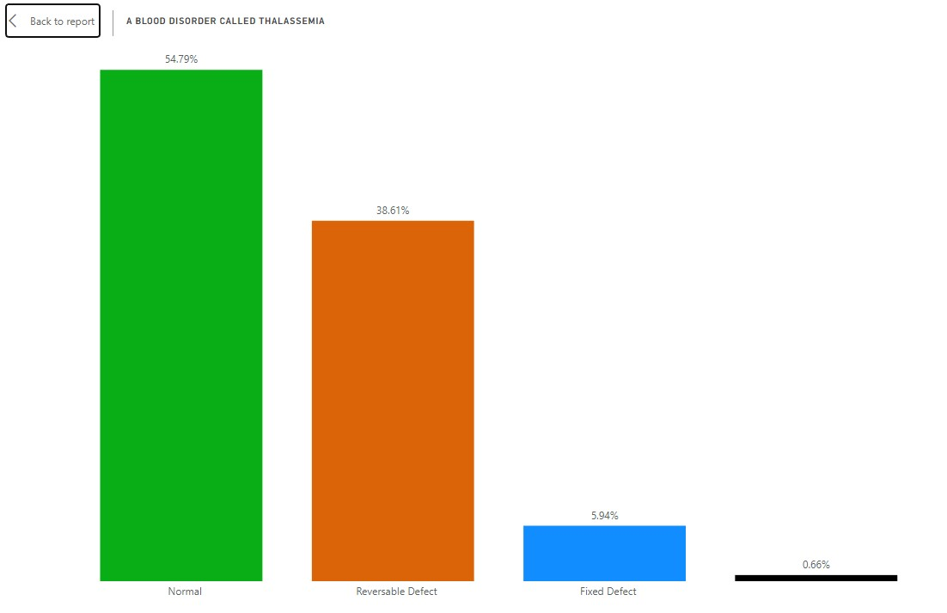

**HEART DISEASE DIAGNOSTIC DASHBOARD**

