Low Level Design (LLD)

Shipping Price Prediction

Revision Number: 1.8

Last date of revision: 05/03/2023

Lovely Patra

# Document Version Control

|  |  |  |  |
| --- | --- | --- | --- |
| Date Issued | Version | Description | Author |
| 5th March 2022 | 1.0 | Architecture | Lovely Patra |

**Contents**

Document Version Control 2

**Abstract** 4

1 Introduction 5

1.1 Why this Low-Level Design Document? 5

1.2 Scope 6

1.3 Constraints 6

1.4 1.3 Risks 6

1.5 1.4 Out of Scope 7

2 Technical specifications 7

2.1 Predicting Disease 7

2.2 Logging 7

2.3 Database 7

3 Technology stack 8

4 Proposed Solution 9

5 Model training/validation workflow 10

6 User I/O workflow 12

7 Exceptional scenarios 13

**Abstract**

Not having an exact cost standard can present a problem for setting the shipping costs on a freight brokerage platform. Transport brokers who use their high market position to charge excessive commissions can also make it difficult to set rates. In addition, due to the absence of a quantified fare policy, fares are undervalued relative to the labor input. Therefore, vehicle owners are working for less pay than their efforts. This study derives the main variables that influence the setting of the shipping costs and presents the recommended shipping cost given by a price prediction model using machine learning methods. The cost prediction model was built using five algorithms: KNN Regressor, Decision Tree Regressor , XGB Regressor, Random Forest Regressor, and AdaBoost Regressor. R-squared was used as the performance evaluation index. In view of the results of this study, Random Forest Regressor was chosen as the model with the greatest explanatory power and the fastest processing. Furthermore, the range of the predicted shipping costs was determined considering realistic usage patterns. The confidence interval was used as the method of calculation for the range of the predicted shipping costs, and, for this purpose, the dataset was classified using the K-fold cross-validation method. This paper could be used to set the shipping costs on freight brokerage platforms and to improve utilization ra

# Introduction

## Why this Low-Level Design Document?

The purpose of this document is to present a detailed description of the Deep EHR System. It will explain the purpose and features of the system, the interfaces of the system, what the system will do, the constraints under which it must operate and how the system will react to external stimuli. This document is intended for both the stakeholders and the developers of the system and will be proposed to the higher management for its approval.

The main objective of the project is to predict the shipping price that is the freight cost using available factors.

This project shall be delivered in two phases:

Phase 1: All the functionalities with PyPi packages.

Phase2: Integration of UI to all the functionalities.

## Scope

This software system will be a Web application This system will be designed to detect the shipping price at earliest for better transportation cost management . This system is designed to predict the price from available factors in the dataset.

## Risks

Document specific risks that have been identified or that should be considered.

## Out of Scope

Delineate specific activities, capabilities, and items that are out of scope for the project.

## 2.3 Logging

We should be able to log every activity done by the user.

* The System identifies at what step logging required
* The System should be able to log each and every system flow.
* Developers can choose logging methods. You can choose database logging/ File logging as well.
* System should not be hung even after using so many loggings. Logging just because we can easily debug issues so logging is mandatory to do.

## 2.4 Database

System needs to store every request into the database and we need to store it in such a way that it is easy to retrain the model as well.

1. The User chooses the disease.

2. The User gives required information.

3. The system stores each and every data given by the user or received on request to the database. Database you can choose your own choice whether MongoDB/ MySQL.

**2.5 Deployment**

1. AWS



# Proposed Solution

The proposed solution is a machine learning-based shipping cost prediction method for a domestic freight transportation environment using data from a freight brokerage platform. It also shows that predictive models can set the shipping costs appropriately, and it compares the predictive power to present the best predictive model.

# Model training/validation workflow

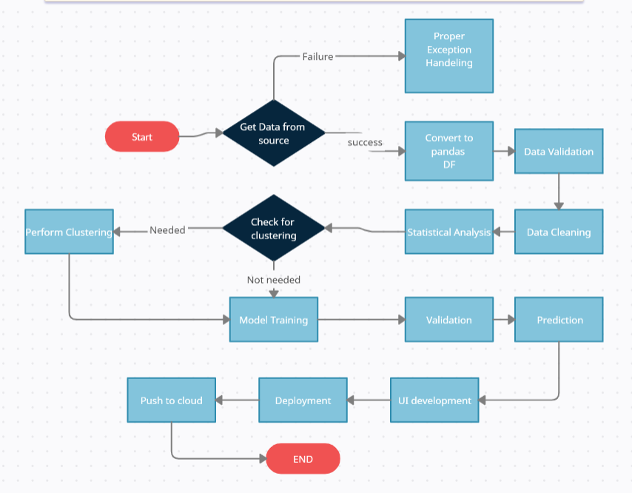

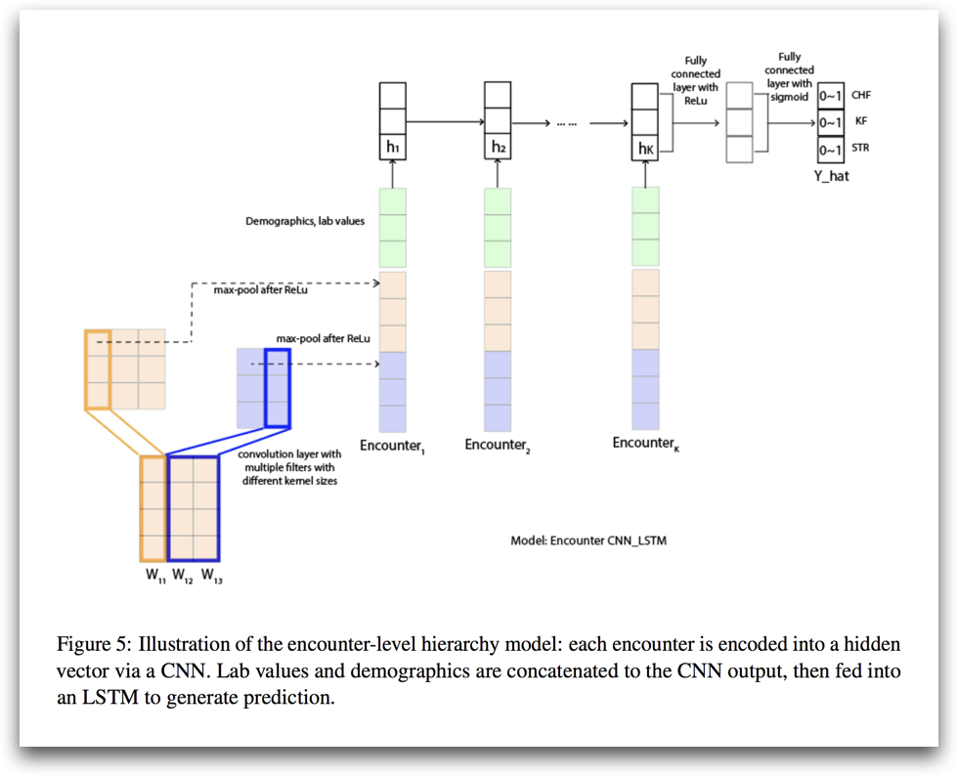

# User I/O workflow

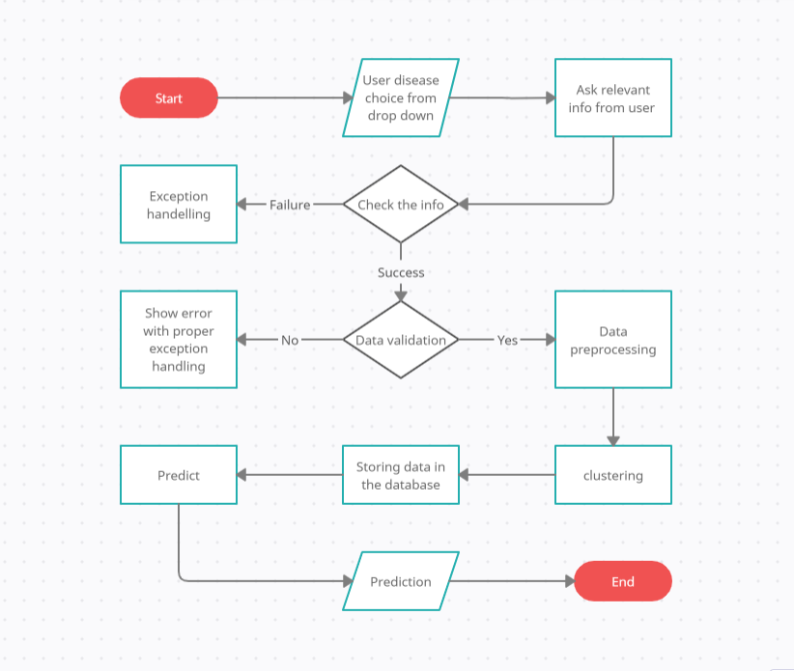

# Exceptional scenarios

|  |  |  |  |
| --- | --- | --- | --- |
| Step | Exception | Mitigation | Module |
| 05 March 2023 | 1.1 |  | LOVELY PATRA |
|  |  |  |  |

# Test cases

|  |  |  |  |
| --- | --- | --- | --- |
| Test case | Steps to perform test case | Module | Pass/Fail |
|  |  |  |  |