Summary Sheet

Fog Evolution Forecasting Based on a Unified Framework Combining CNN and Random Forest Models
Project topic: exploratory fog-image analysis and forecasting. This is a research draft using HiMCM document conventions; no 2026 contest problem or control number is claimed.

Problem and modeling route
Fog can change quickly, while a single image provides only a view of the current scene. We propose a route in which a convolutional neural network (CNN) describes images, timestamped visual and meteorological observations are aligned, and a random forest estimates the next fog state from past values. This route needs synchronized field measurements to test the complete system. The available archive permits two narrower tests: synthetic transmittance classification and regression on an ordered table of image-derived proxy values.

What the existing data show
The archived CNN correctly classified 4,230 of 4,575 balanced synthetic test maps: accuracy 92.46% and macro-F1 0.9248. A separate 100-row image-proxy table yields 95 lagged examples, with 66 for fitting and 29 held out. On those 29 records, random forest has MSE 574.20 (km⁻¹)², MAE 19.95 km⁻¹, and RMSE 23.96 km⁻¹; it is lower-error than the two selected machine-learning comparators, SVR and XGBoost. A training-mean constant of 46.98 km⁻¹ nevertheless achieves lower errors: MSE 430.79, MAE 17.51 km⁻¹, and RMSE 20.76 km⁻¹. Consequently this experiment does not establish a gain over a simple baseline.

Decision and evidence boundary
The proxy rows have no independently verified equal-interval timestamps or instrument-measured visibility. The target was calculated from image indicators, while the current regressor uses lagged table values and no CNN embeddings. File order is not proof of fog evolution through time. The results support a synthetic-domain classifier and an exploratory index-ordered benchmark, not end-to-end road visibility forecasting. The next test requires timestamped road images, paired visibility-meter measurements, aligned weather observations, and event-held-out validation.
Keywords: fog visibility; CNN; random forest; proxy index; evidence audit; baseline comparison

1. Problem Restatement and Research Objective
The research question is whether image features can contribute to short-term fog-state prediction. The proposed system has five steps: acquire timestamped road images and synchronized visibility and weather readings; extract CNN image features; align them with historical observations; split by time and fit a regressor; and evaluate against simple and learned baselines. The current archive cannot execute every step on a single paired dataset. We therefore evaluate the existing components separately and name each target precisely.
Recent road-image methods use multi-scale and fused visual information for visibility estimation [1,2], while airport and motorway studies evaluate weather-based low-visibility modeling [3,4,18]. Large-scale neural weather forecasts [5–12] show methodological promise at very different spatial and temporal scales; their published results cannot validate this road-camera setting. The open research gap here is a verified link between scene features and a measured, timestamped future visibility target. Our contribution is a reproducible integration design and a transparent audit of the available component evidence, including baseline comparisons.

2. Assumptions, Data and Provenance

2.1 Evidence streams
Stream | Archive evidence | Permitted inference
Synthetic transmittance maps | 4,575 balanced held-out images; three extinction classes | Classification within the synthetic test domain
Real-image proxy table | 100 image-indexed rows transcribed from the integrated report; raw images and paired meter labels are not in this benchmark | Descriptive and exploratory index-ordered regression only
Proposed paired road sequence | No joined image, weather, and measured-visibility table in the available archive | Design for later validation; no measured end-to-end result

The synthetic CNN result is recorded in results/model_metrics.csv and the original CNN component under src/transmittance_beta/. The 100-row benchmark is results/real_image_proxy_observations.csv, a transcription of Appendix B of paper/Integrated_Fog_Visibility_Revised.pdf. The 70/30 predictions and metrics are in results/proxy_forecast_70_30/, with its setup in config/proxy_70_30.yaml and implementation in src/fogforecast/run_experiment.py. These paths are project-source citations, not independent external validation.

2.2 Assumptions that limit interpretation
The observation field is a unique file index from 1 to 100. We retain this order solely for a reproducible holdout; neither regular sampling nor temporal continuity has been established. We also assume the transcribed rounded proxy columns accurately reflect the archived table. With no raw images in this benchmark, their feature-extraction and TOPSIS steps cannot be independently recomputed here. The proxy visibility column is calculated from a proxy attenuation scale; it is not a road visibility-meter reading.

3. Model Construction

3.1 CNN image representation
A CNN applies shared convolution kernels to local image neighborhoods, then nonlinear activation and pooling to form spatial features. The convolution and ReLU operation can be written as [13]:
z(i,j,k) = Σᵤ Σᵥ Σ꜀ W(u,v,c,k) x(i+u,j+v,c) + b(k); a(i,j,k) = max{0, z(i,j,k)}.
For C synthetic classes the network outputs softmax probabilities p(c)=exp(q(c))/Σᵣ exp(q(r)), and minimizes the cross-entropy L=−Σ꜀ y(c) ln p(c). The archived compact classifier accepts grayscale synthetic transmittance maps. A separate code path can extract pretrained ResNet-18 embeddings from ordinary RGB images, but its outputs were not joined to the 100-row benchmark. We therefore report no trained CNN–forest fusion result.

3.2 Random forest and comparator models
Random forest averages B bootstrap-trained regression trees; each split considers a random subset of inputs [14]. Its estimate is
ŷ(x) = (1/B) Σᵦ₌₁ᴮ Tᵦ(x).
This can model nonlinear interactions and is less sensitive to input scaling than SVR. We use an RBF-kernel support vector regressor as one comparator [15] and gradient-boosted trees as the other [16]. Hyperparameters were fixed for this archive run; there was no nested tuning or event-wise cross-validation.

3.3 Intended technical route and current implementation
Stage | Complete-system plan | This paper
1. Acquire | Timestamped road images, weather and visibility meter | Synthetic map test and archived proxy table
2. Extract | CNN embeddings for each road image | Synthetic CNN classification only
3. Prepare | Join by verified timestamp; five past intervals; chronological split | Five previous file rows; 66/29 holdout; training-only scaler
4. Estimate | RF one-step forecast with measured target | Fixed-fit proxy regression with observed lagged inputs
5. Evaluate | Event-held-out MAE, MSE and RMSE against baselines | One index-held-out block of 29 rows

A complete test would align CNN features, weather and visibility at each timestamp before lagging and splitting. The archived implementation instead uses the previous five rows of the proxy target and six image-derived indicators, a total of 35 lag features. At held-out row i, all lagged values are already observed in the table. Models are fitted once to the first 66 usable rows and predict all 29 test rows without recursive extrapolation or online refitting.
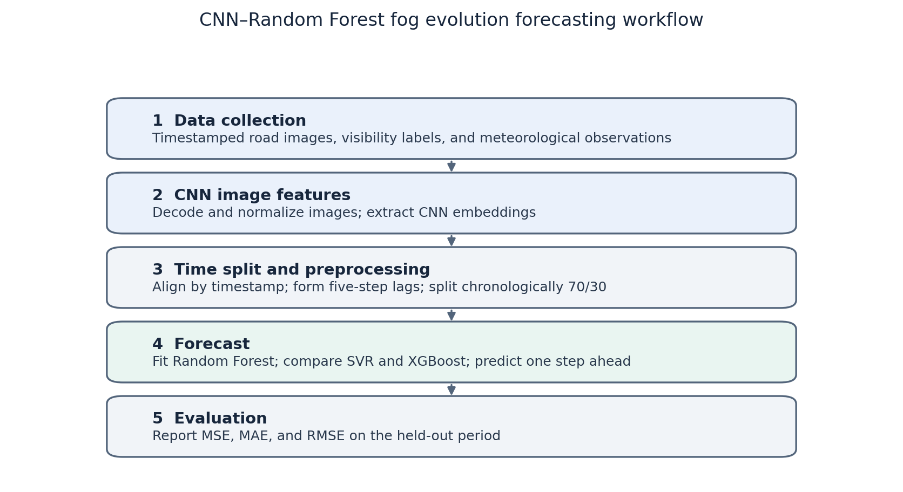
Figure 1. Proposed future CNN–random-forest route. The synchronized input in the figure was not available for the experiment below.

3.4 Evaluation measures
For n held-out values yᵢ and estimates ŷᵢ, the metrics are
MSE = (1/n) Σᵢ (yᵢ − ŷᵢ)²; MAE = (1/n) Σᵢ |yᵢ − ŷᵢ|; RMSE = √MSE.
The proxy target has units km⁻¹, so MSE has units (km⁻¹)² while MAE and RMSE have units km⁻¹. Synthetic classification accuracy is correct predictions divided by test count; macro-F1 averages the per-class F1 scores with equal class weight. None of these measures alone demonstrates physical visibility calibration.

4. Image Features and Synthetic CNN Results

4.1 Source and indicator construction
Foggy Cityscapes offers controlled synthetic fog and transmittance products [17]. The project classifier used three attenuation labels derived from those synthetic maps, not measured RGB road-camera visibility. The separate real-image table records brightness, contrast, saturation, dark channel, edge density and an archived severity score. Its integrated report describes entropy weighting, a provisional AHP weighting step and TOPSIS. We retain the reported composite score Cᵢ; without the original image assets and intermediate weighting outputs in this benchmark, we do not claim to have reproduced it.
The legacy table approximately maps Cᵢ to βproxy=3.912+74.328 Cᵢ in km⁻¹ and Vproxy=3912/βproxy in meters. Rounding in the stored table explains small deviations from these equations. The endpoints and weighting are design choices in that archive. Vproxy is an algebraic transformation of the score, not a field measurement; an error in βproxy cannot be described as measured-visibility error.

4.2 CNN result and boundary
The recorded test set contains 4,575 synthetic maps, 1,525 for each class. The classifier labeled 4,230 correctly, giving 4,230/4,575=92.459% accuracy, reported as 92.46%; its macro-F1 is 0.9248 and test cross-entropy is 0.23637 (results/model_metrics.csv). These numbers concern the held-out synthetic classification set. They do not establish classification accuracy on real road RGB images, nor do they show that CNN features improve the proxy regression.

5. Exploratory Proxy Regression

5.1 Description and index plot
Five past rows leave 95 supervised examples indexed 6–100. The following sample statistics refer to those 95 rows; “record index” denotes file order only.
Variable | Mean | SD | Min | Max
Proxy attenuation (km⁻¹) | 48.19 | 21.67 | 3.91 | 78.24
Brightness | 0.765 | 0.107 | 0.443 | 0.937
Contrast | 55.04 | 14.74 | 30.58 | 88.65
Saturation | 0.061 | 0.066 | 0.000 | 0.311
Dark channel | 0.748 | 0.120 | 0.382 | 0.934
Edge density | 0.200 | 0.001 | 0.195 | 0.200
Severity score | 0.596 | 0.292 | 0.000 | 1.000

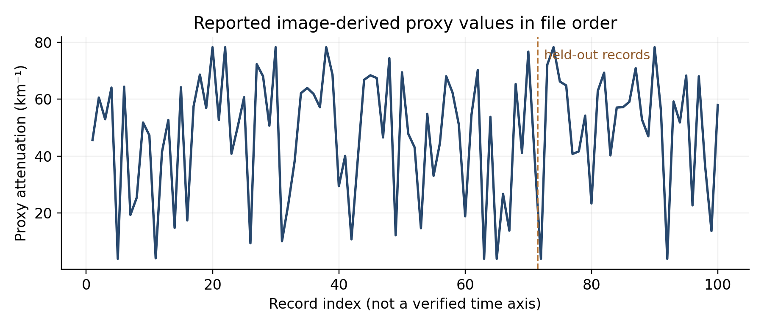
Figure 2. Reported proxy attenuation by file index. The dashed line marks the train/test boundary, not an elapsed-time event.

5.2 Holdout and preprocessing
Rows 6–71 are the 66 fitting examples; rows 72–100 are the 29 held-out examples (69.5%/30.5% of 95). Each predictor at row i is a lag-1 through lag-5 value of the target or one of six image-derived columns. StandardScaler parameters for inputs are fitted only on training rows. SVR also scales the training target internally and inversely transforms predictions. Random forest and XGBoost receive training-fitted input scaling although trees do not require it. The published configuration clips every predicted attenuation to a minimum of 3.912 km⁻¹, while the stored targets are rounded to two decimals. This detail is retained in all reported model metrics.
The adjacent-record baseline copies the immediately preceding observed target, and the constant baseline predicts the 66-row training mean, 46.9767 km⁻¹, for every test row. Neither baseline is a measured-time forecast because physical intervals are unknown. They test whether learned regressors add value beyond simple rules on the same table.

5.3 Parameters, predictions and errors
Method | Fixed setting
SVR | RBF kernel; C=10; ε=0.1; scaled inputs and target
Random forest | 500 trees; min_samples_leaf=2; max_features=0.8; seed=42
XGBoost | 500 trees; max_depth=5; learning_rate=0.03; subsample=0.8; colsample_bytree=0.8; λ=1; seed=42

Method | MSE (km⁻²) | MAE (km⁻¹) | RMSE (km⁻¹)
Training mean | 430.79 | 17.51 | 20.76
Adjacent record | 903.38 | 23.99 | 30.06
SVR | 971.23 | 24.98 | 31.16
Random forest | 574.20 | 19.95 | 23.96
XGBoost | 647.75 | 21.30 | 25.45

The three trained regressors rank random forest, XGBoost, then SVR on all three metrics. However, the training-mean baseline performs better than all three on this held-out block. This reverses the stronger interpretation of the earlier three-model-only table: the observed RF advantage is relative to the selected learned comparators, not to a simple constant. Extreme proxy lows and highs contribute large prediction errors. With only 29 held-out, possibly unordered images, no claim of generalization or real road forecasting follows.
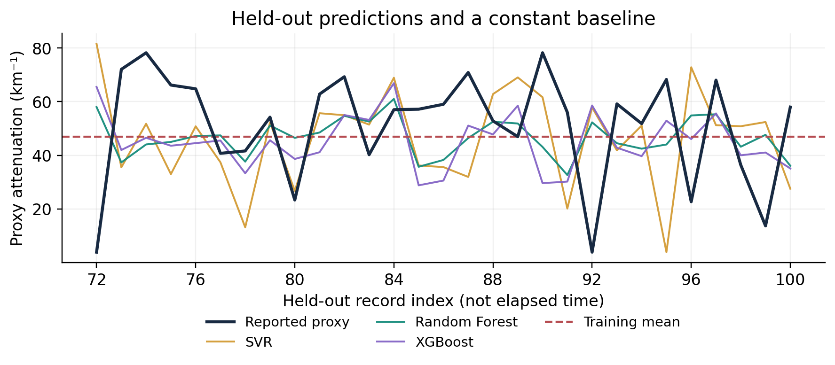
Figure 3. Proxy targets, three model outputs and the training-mean baseline for held-out file indices 72–100. Source: archived predictions.csv; baseline recomputed from the 66 training targets.
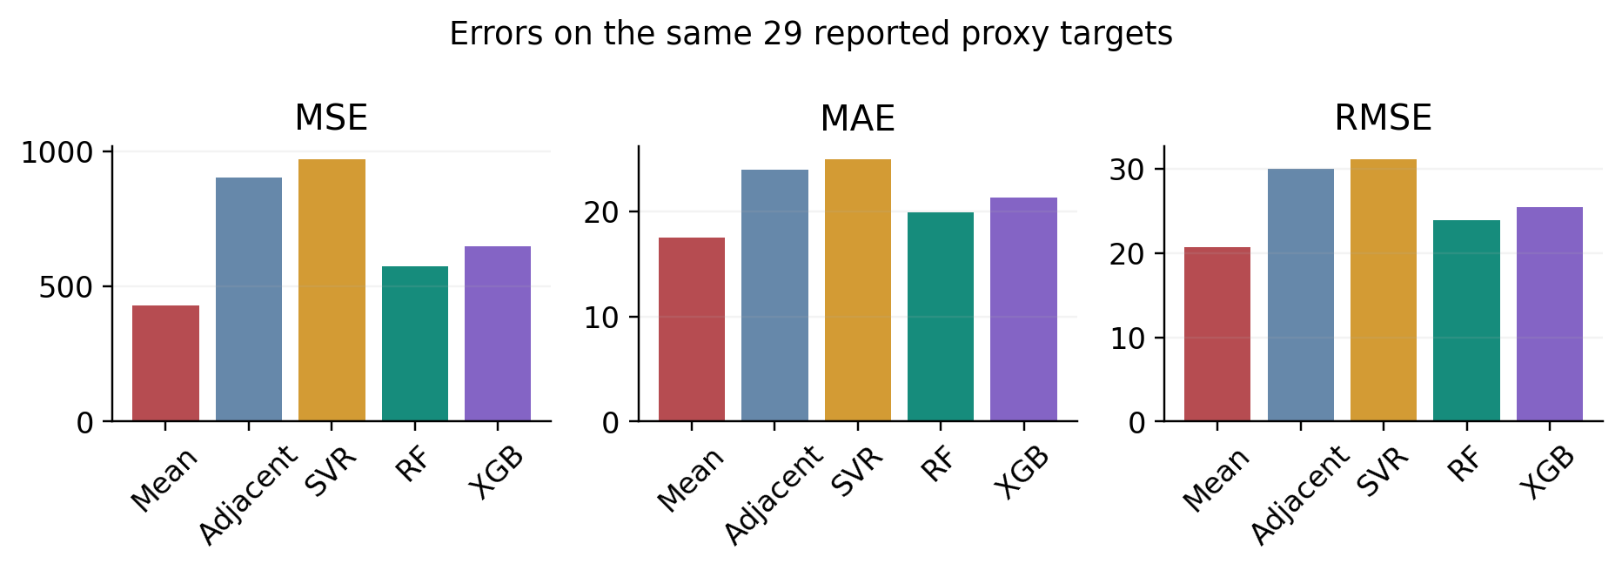
Figure 4. Same-block errors. The training-mean constant is the lowest-error method in this experiment; adjacent-record copying is a separate simple comparator.

6. Strengths, Weaknesses and Validation Plan
The work keeps synthetic classification, image-derived scores and proposed field prediction separate, and applies the same held-out rows to every tabulated method. Storing the index, configuration, predictions and metrics makes the numerical comparison auditable. The main weaknesses are more consequential: the proxy target is derived from image features rather than meter readings; source images and some scoring intermediates are not independently available in this benchmark; the file sequence is not a verified time series; there are only 66 fitting examples; and the learned model does not beat the training mean. The full CNN-plus-forest claim remains a design hypothesis.
A meaningful next experiment should collect regularly timestamped road RGB images, independent visibility-meter targets and synchronous weather observations across several fog events. It should check camera drift and measurement units, split entire events or sites into held-out partitions, fit feature extraction and all scalers without test leakage, and compare persistence and train-only climatology with the learned models. An ablation of CNN features would then quantify whether the visual branch improves a measured target.

7. Conclusions
The archived CNN reaches 92.46% accuracy on a balanced synthetic transmittance test set. On a different 100-row image-derived table, a 66/29 split yields lower RF errors than SVR or XGBoost, but a training-mean constant has lower error than RF. The index-ordered data contain neither verified intervals nor paired field visibility, and the regressors do not use CNN embeddings. The proposed integration is therefore ready as a testable workflow, while end-to-end fog evolution forecasting remains unverified.

References
[1] Xiao P, et al. Highway Visibility Estimation in Foggy Weather via Multi-Scale Fusion Network. Sensors. 2023;23(24):9739. doi:10.3390/s23249739.
[2] Yang W, et al. Multi visual feature fusion based fog visibility estimation for expressway surveillance using deep learning network. Expert Systems with Applications. 2023;234:121151. doi:10.1016/j.eswa.2023.121151.
[3] Penov N, Guerova G. Sofia Airport Visibility Estimation with Two Machine-Learning Techniques. Remote Sensing. 2023;15(19):4799. doi:10.3390/rs15194799.
[4] Cornejo-Bueno L, et al. Statistical Analysis and Machine Learning Prediction of Fog-Caused Low-Visibility Events at A-8 Motor-Road in Spain. Atmosphere. 2021;12(6):679. doi:10.3390/atmos12060679.
[5] Lam R, et al. Learning skillful medium-range global weather forecasting. Science. 2023;382(6677):1416–1421. doi:10.1126/science.adi2336.
[6] Bi K, et al. Accurate medium-range global weather forecasting with 3D neural networks. Nature. 2023;619:533–538. doi:10.1038/s41586-023-06185-3.
[7] Nguyen T, et al. ClimaX: A foundation model for weather and climate. Proceedings of the 40th International Conference on Machine Learning. PMLR. 2023;202:25904–25938. https://proceedings.mlr.press/v202/nguyen23a.html.
[8] Rasp S, et al. WeatherBench 2: A benchmark for the next generation of data-driven global weather models. Journal of Advances in Modeling Earth Systems. 2024;16:e2023MS004019. doi:10.1029/2023MS004019.
[9] Kochkov D, et al. Neural general circulation models for weather and climate. Nature. 2024;632:1060–1066. doi:10.1038/s41586-024-07744-y.
[10] Price I, et al. Probabilistic weather forecasting with machine learning. Nature. 2025;637:84–90. doi:10.1038/s41586-024-08252-9.
[11] Lang S, et al. AIFS: a new ECMWF forecasting system. ECMWF Newsletter. 2024;178. https://www.ecmwf.int/en/newsletter/178/news/aifs-new-ecmwf-forecasting-system.
[12] Chen L, et al. FuXi: a cascade machine learning forecasting system for 15-day global weather forecast. npj Climate and Atmospheric Science. 2023;6:190. doi:10.1038/s41612-023-00512-1.
[13] He K, Zhang X, Ren S, Sun J. Deep residual learning for image recognition. Proceedings of the IEEE Conference on Computer Vision and Pattern Recognition. 2016:770–778. doi:10.1109/CVPR.2016.90.
[14] Breiman L. Random forests. Machine Learning. 2001;45:5–32. doi:10.1023/A:1010933404324.
[15] Smola AJ, Schölkopf B. A tutorial on support vector regression. Statistics and Computing. 2004;14:199–222. doi:10.1023/B:STCO.0000035301.49549.88.
[16] Chen T, Guestrin C. XGBoost: A scalable tree boosting system. Proceedings of the 22nd ACM SIGKDD International Conference on Knowledge Discovery and Data Mining. 2016:785–794. doi:10.1145/2939672.2939785.
[17] Sakaridis C, Dai D, Van Gool L. Semantic foggy scene understanding with synthetic data. International Journal of Computer Vision. 2018;126:973–992. doi:10.1007/s11263-018-1072-8.
[18] Yabra MS, Ruiz JJ, de Elia R, et al. Predictability of fog using surface observation-based machine learning models: evaluation at Argentinean airport. CEAS Aeronautical Journal. 2026. doi:10.1007/s13272-026-01003-8.
Project data provenance: paper/Integrated_Fog_Visibility_Revised.pdf, Appendix B; results/model_metrics.csv; results/real_image_proxy_observations.csv; config/proxy_70_30.yaml; src/fogforecast/run_experiment.py; results/proxy_forecast_70_30/metrics.csv and predictions.csv. These internal records are distinct from references [1]–[18].
AI use in preparation: OpenAI ChatGPT Work (18 October 2026) assisted with manuscript drafting, literature lookup, presentation and numerical cross-checks. The project data and computed baselines were checked against the named archived files. See the disclosure after the solution text.

Report on Use of AI Tools
OpenAI ChatGPT Work (Codex, GPT-6 model family), accessed 18 October 2026. The user requested revision of a fog-forecasting paper, HiMCM-style formatting, a check for fabricated data or logical and citation errors, and repository upload. The assistant helped draft and edit English prose, verify the current contest-format guidance and cited article metadata, recalculate two baseline metrics from the archived CSV, generate figures, and format the document. The mathematical and empirical claims that remained in the paper were traced to the project paths listed above. This preparatory research draft is not a solution to an announced 2026 HiMCM problem. If used in an actual contest, the team must provide its assigned control number, official problem, and a full AI-use disclosure compliant with the current COMAP policy.

