Integrated Fog Visibility Estimation
and Evolution Forecasting
A unified framework combining atmospheric optics, CNN calibration, interpretable visual features, TOPSIS, ARIMA, Random Forest, XGBoost, and meteorological validation

Revised integrated report - October 2026

Core empirical results
Synthetic CNN test accuracy | 92.46%
Macro F1 | 0.9248
Best proxy forecasting model | ARIMA(0,1,1)
Primary limitation | No synchronized real-road visibility labels for the 100-image proxy set

Abstract
This study consolidates the project into one coherent fog-visibility modeling framework instead of treating the machine-learning comparison as an appendix. The framework separates four evidence streams according to what they can actually support: (i) synthetic transmittance images with known extinction-coefficient labels for supervised CNN calibration; (ii) 100 real fog images without synchronized visibility labels for interpretable visual-feature and TOPSIS severity modeling; (iii) an independent 100-frame highway sequence for relative visual-trend analysis; and (iv) AMOS meteorological observations with measured MOR for out-of-event validation of meteorological and short-term temporal models. The compact CNN is evaluated on 4,575 balanced synthetic test images and reaches 92.46% accuracy and Macro F1 = 0.9248. Five real-image indicators - Brightness, Contrast, Saturation, Dark Channel, and Edge Density - are combined through entropy weighting, a provisional AHP prior, combined weighting, TOPSIS, and sensitivity analysis. For the 100-image proxy attenuation sequence, ARIMA(0,1,1), Random Forest, and XGBoost are evaluated with the same chronological 80/20 split. ARIMA yields the lowest hold-out MAE (16.3759 km^-1) and RMSE (19.5360 km^-1), while all three models have negative R² and approximately 70% directional accuracy. The AMOS experiments provide a useful reality check: nonlinear or higher-fit models do not automatically generalize across fog events, and a persistence baseline can outperform a more elaborate short-term predictor. The integrated conclusion is therefore methodological rather than deployment-ready: CNN perception, interpretable feature aggregation, and temporal forecasting can occupy one pipeline, but physical calibration requires consecutive real-road data with timestamps, camera information, and independent visibility measurements.
Keywords: fog visibility; CNN; extinction coefficient; visual features; entropy weighting; AHP; TOPSIS; ARIMA; Random Forest; XGBoost; AMOS; time-series forecasting

Contents
1. Introduction and Literature Review
1.1 Problem and Research Objective
1.2 Literature Review
1.3 Research Gap and Contributions
1.4 Data Sources and Evidence Boundaries
2. Methodology
2.1 Atmospheric Image Formation and Visibility Conventions
2.2 Synthetic Fog-Density CNN
2.3 CNN Evaluation
2.4 Five Real-Image Visual Indicators
2.5 Entropy + AHP + TOPSIS
2.6 CNN/TOPSIS Fusion and Calibration
2.7 ARIMA Temporal Model
2.8 Random Forest and XGBoost Forecasting
2.9 AMOS Meteorological and Temporal Validation
2.10 Highway Relative-Visibility Analysis
3. Results
3.1 CNN Results
3.2 Multi-Indicator and TOPSIS Results
3.3 ARIMA Proxy Forecast
3.4 Forecasting Experimental Setup
3.5 ARIMA vs Random Forest vs XGBoost
3.6 Integrated Result Interpretation
4. Discussion
4.1 How the Components Form One System
4.2 Role of Machine Learning in the Overall Framework
4.3 Why ARIMA Is Currently Best
4.4 Physical Meaning of β and Visibility
4.5 Model Selection and Future Improvement
4.6 Limitations
5. Conclusion
6. References
Appendix A. Unified Equations
Appendix B. 100 Real-Image Proxy Observations
Appendix C. Reproducible Model-Comparison Protocol

1. Introduction and Literature Review
Road fog reduces contrast and suppresses scene structure through atmospheric scattering and attenuation. A practical road-safety system must answer two different questions: what is the current visibility state, and how is that state likely to evolve. The project therefore treats fog monitoring as a sequence of linked estimation problems rather than as a single classifier.

1.1 Problem and Research Objective
The original project can be expressed as four connected tasks: derive visibility relationships from meteorological observations; estimate current fog state from visual information; construct a visibility or attenuation sequence from road imagery; and predict whether the sequence will intensify, dissipate, or cross a safety threshold. The unified latent state is atmospheric attenuation, represented by the extinction coefficient β whenever a physical calibration is available and by a clearly labeled proxy when it is not.
The central methodological principle of this revision is evidence separation. Synthetic images with exact β labels can supervise a CNN, but they cannot by themselves validate real-road visibility. Real images can reveal brightness, contrast, color, dark-channel, and edge changes, but without synchronized meter readings those quantities remain relative or proxy evidence. Time-series methods require verified temporal order; when continuity is uncertain, forecasting metrics must be interpreted as benchmark demonstrations rather than physical forecasts.

1.2 Literature Review
Prior work provides three complementary foundations. First, atmospheric image-formation research explains how direct transmission and airlight alter scene radiance. Nayar and Narasimhan [1] establish the bad-weather imaging framework, while Tan [3] shows why a single degraded image contains useful fog information. These works support the physical interpretation of contrast, brightness, and scene-depth effects but do not themselves solve time evolution.
Second, camera-based visibility estimation connects image degradation to measurable road visibility. Hautière et al. [2] use road-scene structure and Koschmieder-type contrast attenuation to estimate visibility distance. More recent highway systems use richer image information: Xiao et al. [7] combine structural, spectral, and depth-related features, while Yang et al. [8] fuse RGB, dark-channel, and edge information in a coarse-to-fine deep network. These studies support the present use of both learned and interpretable visual representations.
Third, fog evolution is fundamentally temporal. Miao et al. [5] motivate sequence models for short-term fog forecasting; Penov and Guerova [9] show the value of meteorological variables for visibility estimation; Cornejo-Bueno et al. [6] directly study fog-caused low-visibility events on a motorway; and later machine-learning nowcasting work [11] reinforces the importance of comparing complex models against simple persistence or climatological baselines. Together, these sources imply a pipeline in which an image model estimates the current state and a temporal model predicts the future state.
Synthetic fog datasets are useful for controlled calibration but introduce a domain gap. Sakaridis, Dai, and Van Gool [4] demonstrate the value of synthetic fog for learning under limited real-fog data. In the present project, the synthetic transmittance branch is therefore treated as a supervised calibration benchmark rather than as proof of real-highway MOR accuracy.

1.3 Research Gap and Contributions
The literature often separates present-state visibility estimation from future fog forecasting. The main research gap addressed here is the interface between them: converting image evidence into a state representation that is interpretable enough to audit and structured enough to forecast. This report contributes a unified architecture in which the CNN provides learned density evidence, the five-indicator TOPSIS module provides interpretable severity evidence, and ARIMA / Random Forest / XGBoost provide alternative temporal models.
- A supervised CNN benchmark with exact β labels and a full confusion-matrix error analysis.
- An interpretable five-indicator severity model using entropy weighting, AHP, TOPSIS, and sensitivity analysis.
- A corrected fusion formulation that explicitly converts CNN β from m⁻¹ to km⁻¹ before any provisional state-level combination.
- A formal chronological comparison of ARIMA, Random Forest, and XGBoost in the main Results section rather than as an appendix extension.
- Independent AMOS and highway-sequence evidence used to test generalization claims and to prevent proxy results from being overstated.

1.4 Data Sources and Evidence Boundaries
Dataset / stream | Scale | Supervision | Valid use
Synthetic transmittance test set | 4,575 test images; 1,525 per β class | Exact β class from filename / synthetic generation | CNN classification performance in synthetic domain
Real Fog image set | 100 images (page01_001.png ... page10_100.png) | No synchronized field visibility label | Five features, entropy/AHP/TOPSIS, proxy attenuation sequence
Highway screenshot sequence | 100 time-ordered frames | No meter label; timestamps partially recoverable | Relative contrast trend only; no absolute MOR claim
AMOS meteorological observations | 2,878 valid minute records across two event periods | Measured MOR plus T/RH/wind/pressure | Cross-event meteorological and temporal validation
Table 1. Data streams are deliberately kept separate because their labels and validation strength differ.
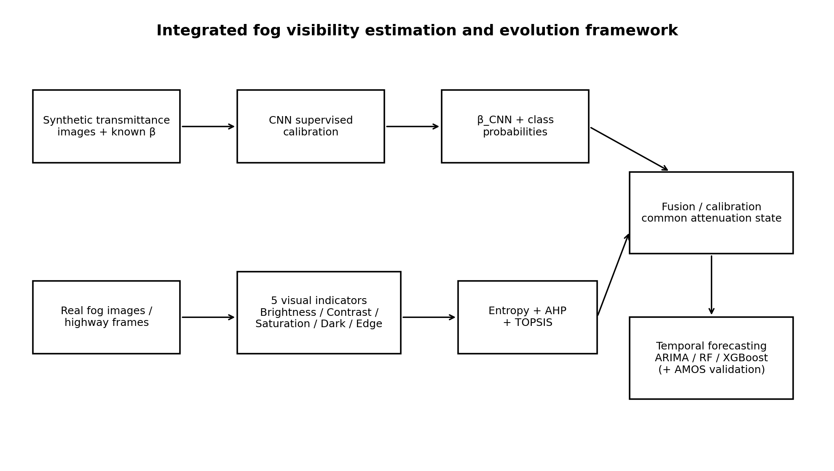
Figure 1. Integrated framework. Perception, interpretable severity, calibration, and temporal forecasting are linked without treating all datasets as interchangeable training samples.

2. Methodology

2.1 Atmospheric Image Formation and Visibility Conventions
Under a spatially homogeneous attenuation approximation, a foggy image can be represented as the sum of attenuated scene radiance and atmospheric airlight:
I_t(x) = J(x) τ_t(x) + A_t [1 - τ_t(x)]
τ_t(x) = exp[-β_t d(x)]
The quantity β is the extinction coefficient. If a visibility convention defines the threshold transmittance as 5%, then:
V_5% = -ln(0.05) / β = 2.995732 / β
The synthetic CNN labels follow this 5% convention, giving reference visibilities of approximately 599.15, 299.57, and 149.79 m for β = 0.005, 0.010, and 0.020 m⁻¹. The legacy real-image proxy branch was originally mapped with the Koschmieder 2% constant 3.912. This revision does not silently mix the two. Forecasting comparisons on the proxy sequence preserve the original proxy scale for reproducibility, while any future physical fusion must be recalibrated against one common field convention.

2.2 Synthetic Fog-Density CNN
The CNN operates on grayscale transmittance PNGs resized to 32 × 64. Its compact architecture contains three stride-2 convolutional blocks (1→8, 8→16, 16→24 channels), adaptive average pooling, dropout 0.1, and a 24→3 linear classification head. The model has 4,803 trainable parameters. Training uses cross-entropy loss and AdamW; the uploaded run contains five epochs, with the best validation accuracy at epoch 5.
Stage | Output | Operation
Input | 1 × 32 × 64 | Normalized transmittance image
Conv 1 | 8 × 16 × 32 | 3×3, stride 2, padding 1, ReLU
Conv 2 | 16 × 8 × 16 | 3×3, stride 2, padding 1, ReLU
Conv 3 | 24 × 4 × 8 | 3×3, stride 2, padding 1, ReLU
Adaptive AvgPool | 24 × 1 × 1 | Global spatial aggregation
Classifier | 3 logits | Dropout 0.1 + Linear(24,3)
Table 2. Compact CNN architecture used for the synthetic transmittance classification benchmark.
Instead of converting each frame to a hard class immediately, the class probabilities can define a continuous learned density representation:
β_CNN,t = 0.005 P_1,t + 0.010 P_2,t + 0.020 P_3,t (m⁻¹)
β_CNN,t^(km⁻¹) = 1000 β_CNN,t
The second line is important for unit consistency: the TOPSIS proxy is expressed in km⁻¹, so a provisional numerical fusion must not add m⁻¹ and km⁻¹ values directly.

2.3 CNN Evaluation
The synthetic test set contains 4,575 images, exactly 1,525 per class. The evaluation includes accuracy, classwise precision / recall / F1, test cross-entropy, a confusion matrix, and a discrete visibility-mapping MAE using the nominal 600/300/150 m class values. A separate 30-image random check is retained as a sanity check but is not treated as an external test set.

2.4 Five Real-Image Visual Indicators
Indicator | Operational definition | Interpretation | TOPSIS direction
Brightness | Mean image intensity | Higher value treated as more severe | Benefit
Contrast | Global structural distinguishability | Fog tends to reduce contrast | Cost
Saturation | Color preservation | Fog tends to desaturate | Cost
Dark Channel | Local minimum-channel statistic | Scattering raises the dark-channel statistic | Benefit
Edge Density | Fraction of visible edge pixels | Fog suppresses fine structure | Cost
Table 3. Five interpretable indicators extracted from the 100 real fog images.
Each indicator is standardized over the 100-image set. These directions are modeling conventions for the composite severity index, not universal physical laws. Their purpose is to turn visible degradation into an auditable feature vector that can complement the CNN rather than compete with it.

2.5 Entropy + AHP + TOPSIS
Entropy weighting supplies a data-driven objective baseline. A provisional AHP matrix provides a transparent prior scenario, with consistency ratio CR = 0.026. Combined weights are defined with α = 0.5:
w_j,comb = α w_j,AHP + (1 - α) w_j,Entropy
Indicator | Entropy | AHP | Combined
Brightness | 0.0214 | 0.1814 | 0.1014
Contrast | 0.0485 | 0.3188 | 0.1836
Saturation | 0.0128 | 0.1282 | 0.0705
Dark Channel | 0.0217 | 0.2748 | 0.1482
Edge Density | 0.8956 | 0.0968 | 0.4962
Table 4. Indicator weights. Edge Density dominates the entropy weights but is moderated by the AHP prior in the combined scheme.
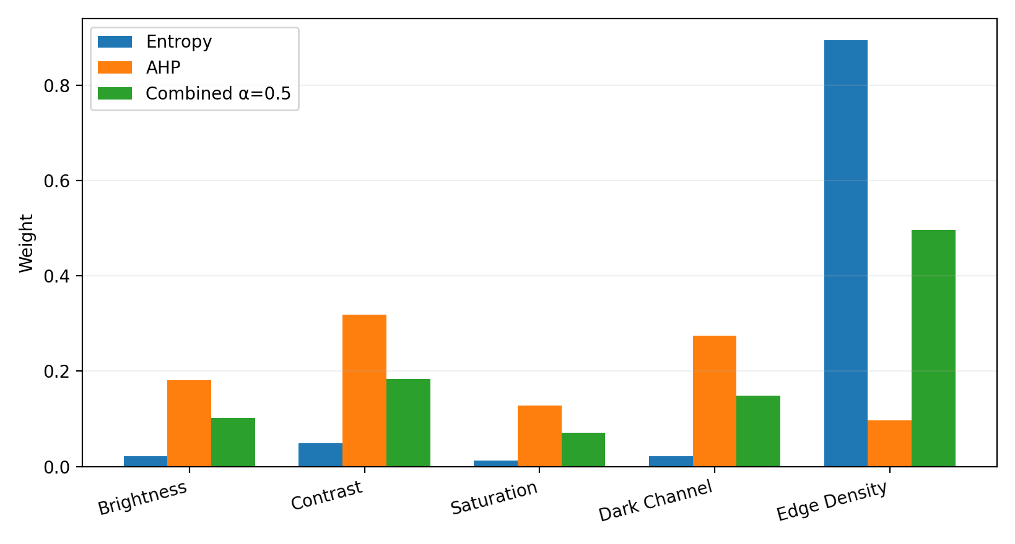
Figure 2. Entropy, provisional AHP, and combined weights.
TOPSIS converts the weighted normalized indicators into a relative severity score C_i by comparing each observation with severe-fog and opposite ideals:
C_i = D_i⁻ / (D_i⁺ + D_i⁻)
A larger C_i means greater similarity to the adopted severe-fog ideal. Sensitivity analysis perturbs each weight by ±20% and also varies α from 0 to 1. This tests whether the severity ranking is an artifact of a single arbitrary weight choice.

2.6 CNN/TOPSIS Fusion and Calibration
The CNN and TOPSIS branches represent different evidence. The CNN is supervised by synthetic β labels; TOPSIS is interpretable but unlabeled with respect to physical visibility. The legacy proxy mapping is:
β_TOPSIS,t = 3.912 + 74.328 C_t (km⁻¹, legacy proxy scale)
A provisional common-state fusion can only be written after converting CNN β to the same units:
β_state,t = λ β_CNN,t^(km⁻¹) + (1 - λ) β_TOPSIS,t
This state is not claimed to be a physically validated extinction coefficient because the two branches use different calibration conventions and the real images lack synchronized visibility-meter labels. In deployment, the correct procedure is to regress both branch outputs against the same field β or MOR measurements and estimate λ from held-out real-road data.

2.7 ARIMA Temporal Model
For the current 100-image proxy sequence, the first 80 observations form the training set and the final 20 form the hold-out set. Candidate ARIMA orders use p = 0–3, d = 0–2, q = 0–3, with AIC selection. The selected model is ARIMA(0,1,1). The chronological split is retained to avoid future-to-past leakage. Because the temporal continuity of the 100-image proxy set is not independently verified, this experiment is a model-comparison demonstration rather than a physically validated road forecast.

2.8 Random Forest and XGBoost Forecasting
Random Forest and XGBoost are moved into the main methodology rather than being treated as an appendix extension. Both nonlinear models use the previous three proxy β observations as predictors for the next value. The same first-80 / last-20 split used by ARIMA is retained, no random shuffling is permitted, and random seed 42 is used for reproducibility. Evaluation uses MAE, RMSE, R², and directional accuracy.
x_t = [β_{t-1}, β_{t-2}, β_{t-3}] → β_t
The goal is not to assume that machine learning must outperform a statistical model. Rather, the comparison asks whether nonlinear tree ensembles extract additional predictive structure from this small proxy sequence.

2.9 AMOS Meteorological and Temporal Validation
A separate AMOS dataset provides measured meteorological optical range (MOR), temperature, relative humidity, wind speed, and pressure. After minute aggregation and quality control, 2,878 valid minute observations remain across two event periods. The first period is used for fitting and the second for independent testing, making the experiment a deliberately difficult cross-event generalization check.
For meteorological estimation, Ridge and Random Forest predict log attenuation from standardized T, RH, wind, and pressure. For short-term forecasting, a temporal Ridge model uses current and lagged log-visibility values together with current meteorological variables at 5- and 15-minute horizons. A persistence baseline, V̂_(t+h) = V_t, is always reported because high-frequency visibility can be strongly autocorrelated.

2.10 Highway Relative-Visibility Analysis
An independent 100-frame highway screenshot sequence is used to study visual evolution without claiming absolute MOR. Five fixed road ROIs are summarized by a robust contrast statistic based on the 90th and 10th grayscale percentiles. The median across ROIs is then smoothed with a causal seven-frame median. Because camera geometry and clear-scene reference distances are unavailable, the result is a dimensionless visual trend, not a meter-scale visibility curve.
c_t,j = [Q90(I_t,j) - Q10(I_t,j)] / [Q90(I_t,j) + Q10(I_t,j) + ε]

3. Results

3.1 CNN Results
The CNN correctly classifies 4,230 of 4,575 synthetic test images, giving accuracy = 92.46% and Macro F1 = 0.9248. Test cross-entropy is 0.23637. Validation accuracy increases from 83.47% in epoch 1 to 93.00% in epoch 5 while validation loss decreases from 0.4857 to 0.2331.
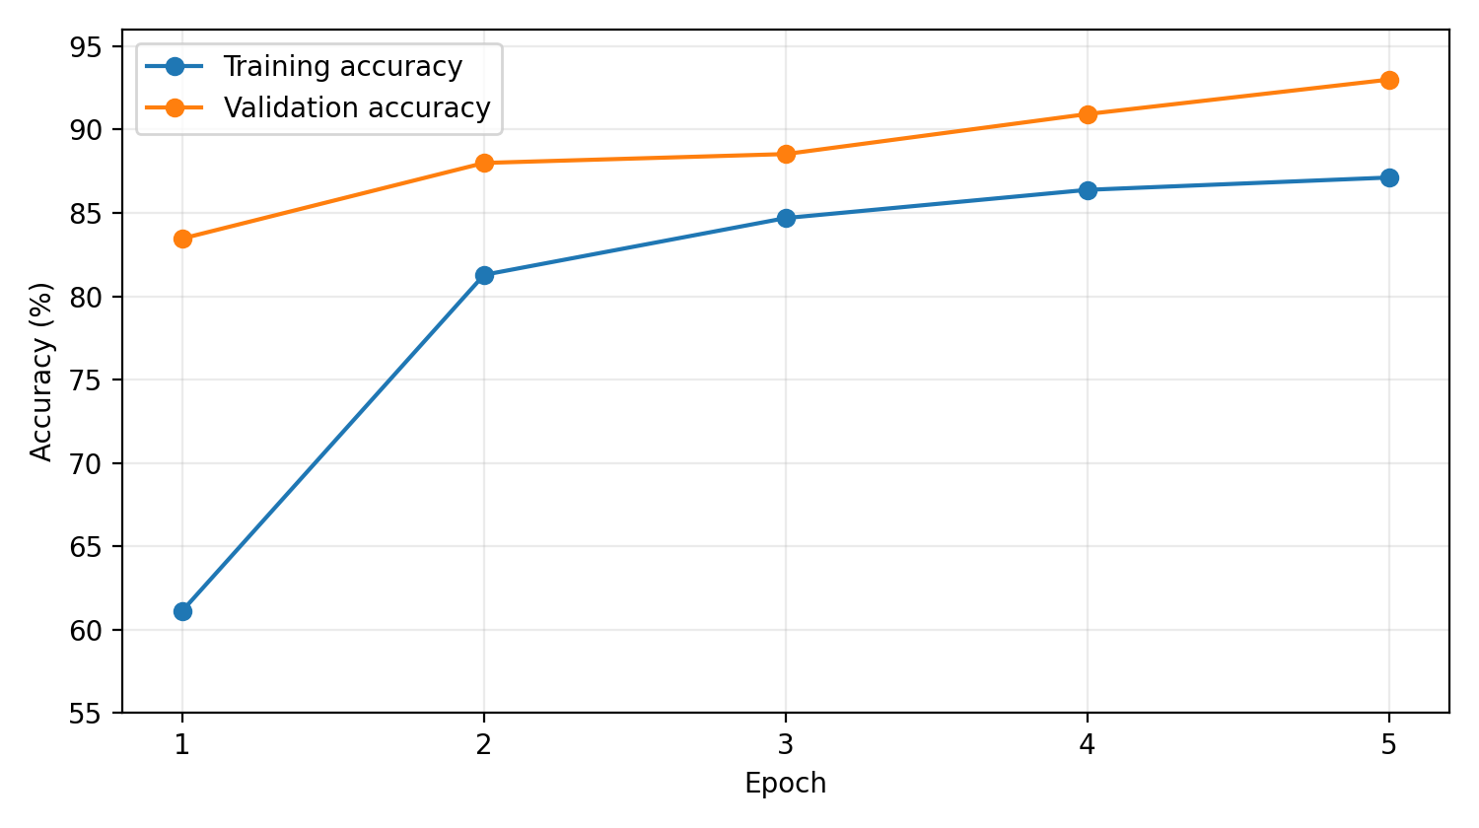
Figure 3. Training and validation accuracy over the five recorded epochs.
β class | Precision | Recall | F1
0.005 | 0.9358 | 0.8984 | 0.9167
0.010 | 0.8715 | 0.9075 | 0.8892
0.020 | 0.9691 | 0.9679 | 0.9685
Macro / overall | 0.9255 | 0.9246 | 0.9248
Table 5. Classwise CNN performance on the balanced synthetic test set.
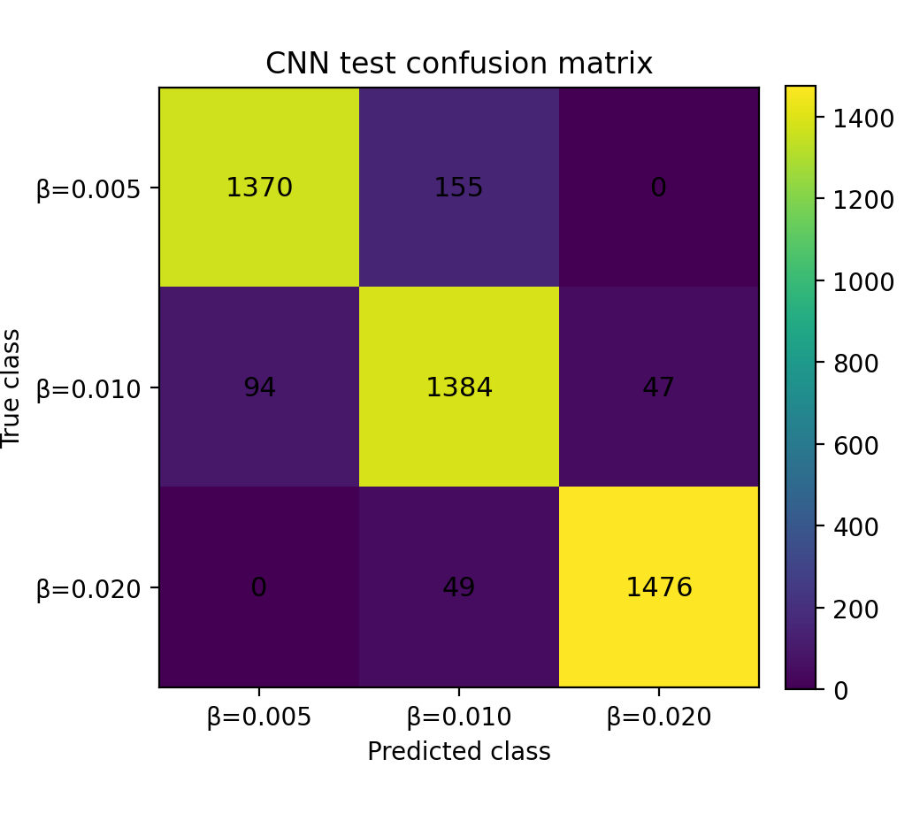
Figure 4. Confusion matrix. All observed errors are between adjacent β classes; no 0.005↔0.020 direct confusion occurs in this test set.
Using nominal class visibilities 600, 300, and 150 m, the discrete visibility-mapping MAE is 19.48 m. A safety-relevant error direction is the strong-fog class β = 0.020 being predicted as β = 0.010: 49 of 1,525 strong-class samples (3.21%) are shifted from approximately 150 m to approximately 300 m. The 30-image random check yields 28/30 correct, but it is only a subset of the same test domain and is not an external validation set.

3.2 Multi-Indicator and TOPSIS Results
The weighting schemes produce strongly concordant severity rankings: ρ(AHP, Entropy) = 0.881, ρ(AHP, Combined) = 0.929, and ρ(Entropy, Combined) = 0.975. When each combined weight is perturbed by ±20%, the Spearman correlation with the baseline ranking remains at or above 0.997. Varying α from 0 to 1 produces ρ = 0.975, 0.991, 1.000, 0.996, and 0.929 for α = 0, 0.25, 0.5, 0.75, and 1.0, respectively.
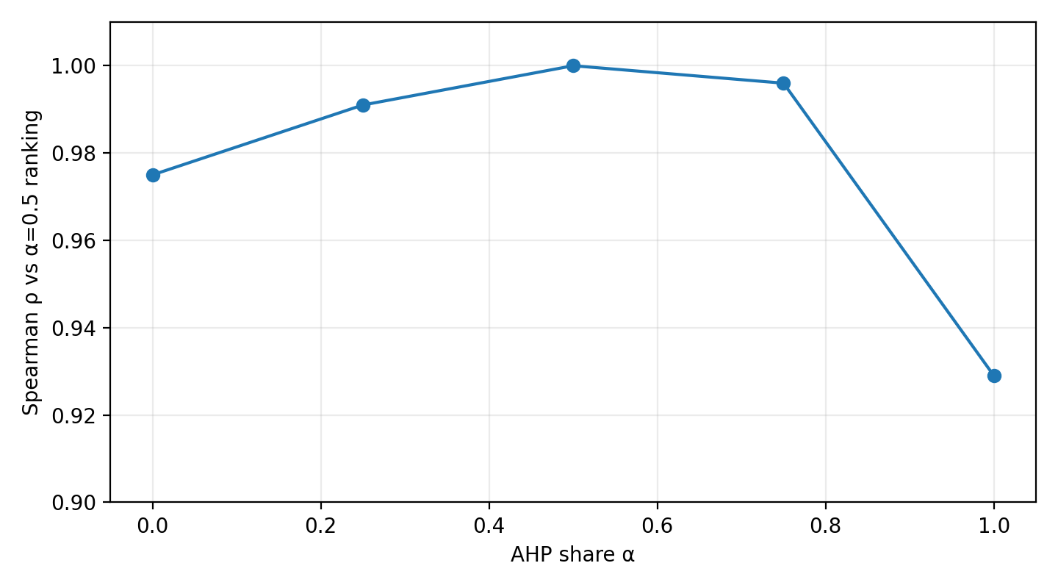
Figure 5. Sensitivity of the TOPSIS ranking to the AHP/entropy mixing ratio.
The main caution is not ranking instability but weight interpretation. Edge Density receives entropy weight 0.8956 because its normalized distribution is especially dispersed in this particular dataset. The number should therefore be interpreted as a dataset property, not as a universal physical statement that edge density explains 89.56% of fog severity.

3.3 ARIMA Proxy Forecast
AIC selection chooses ARIMA(0,1,1), with AIC = 722.484. On the 20-point hold-out segment, MAE = 16.376 km⁻¹ and RMSE = 19.536 km⁻¹. A 30-step illustrative forecast is essentially flat at approximately β_proxy = 48.055 km⁻¹, corresponding to about 81.41 m under the legacy proxy visibility convention. The flat forecast does not cross the legacy 150 m threshold, but this behavior must not be read as a claim that real road fog will remain constant because the proxy sequence is not independently verified as a continuous physical time series.
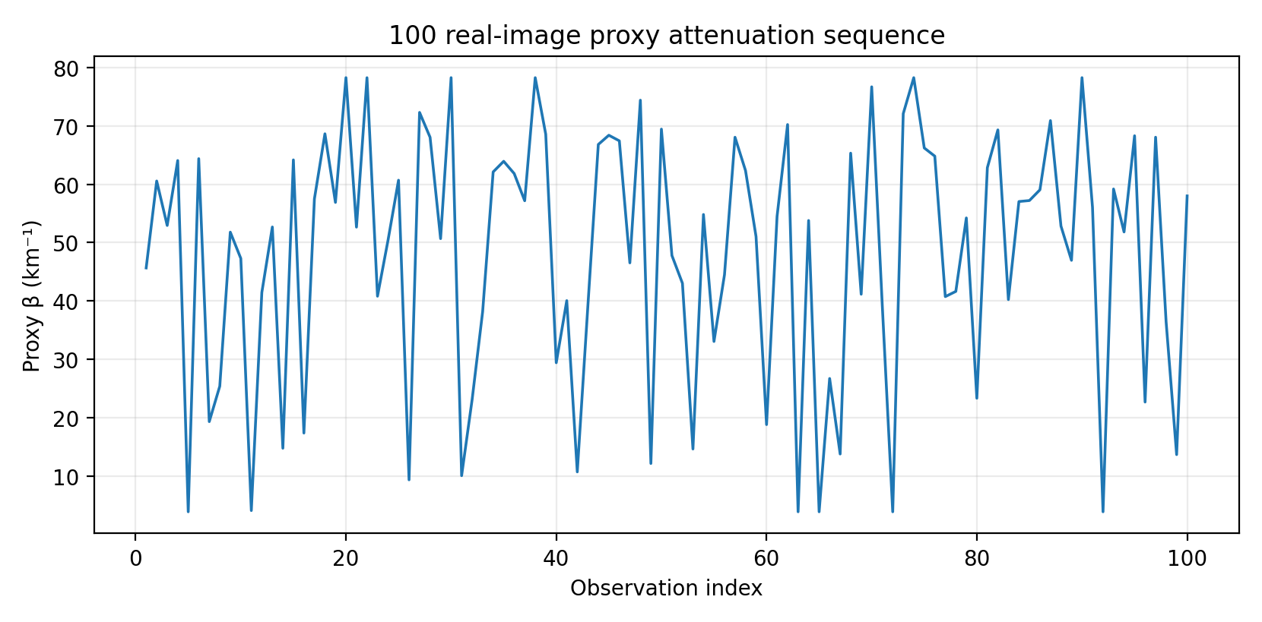
Figure 6. Existing 100-image proxy attenuation sequence. Observation index is not treated as physical time unless continuity is verified.

3.4 Forecasting Experimental Setup
Item | Specification
Training / test split | Observations 1–80 / 81–100
ARIMA candidates | p=0–3, d=0–2, q=0–3; selected by AIC
RF / XGBoost predictors | Previous three proxy β values
Shuffling | None
ML random seed | 42
Metrics | MAE, RMSE, R², directional accuracy
Table 6. Common chronological model-comparison protocol.

3.5 ARIMA vs Random Forest vs XGBoost
Model | MAE | RMSE | R2 | Directional Accuracy
ARIMA(0,1,1) | 16.3759 | 19.5360 | -0.0554 | 70.0%
Random Forest | 17.3133 | 21.9277 | -0.3296 | 70.0%
XGBoost | 17.5265 | 22.5801 | -0.4099 | 70.0%
Table 7. Formal hold-out comparison on the same proxy sequence.
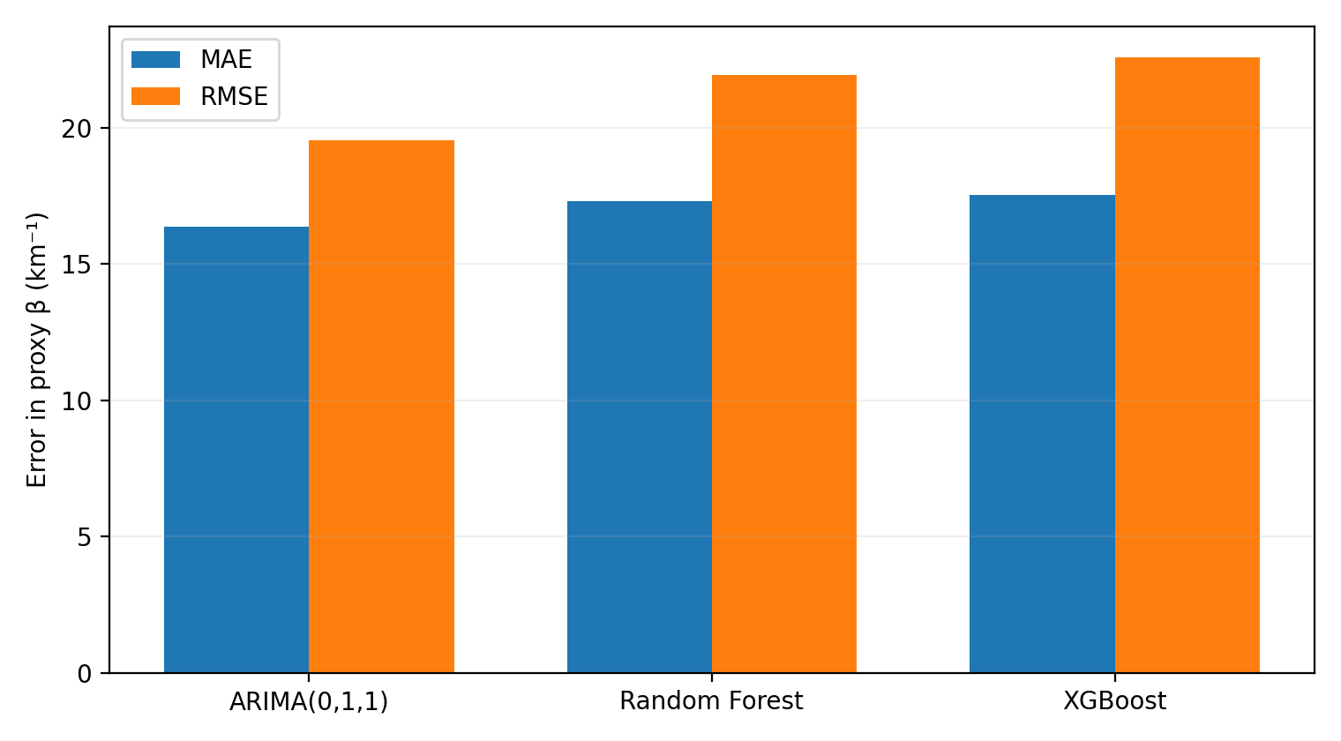
Figure 7. Hold-out MAE and RMSE. ARIMA has the lowest error among the three tested forecasting models.
ARIMA remains the strongest current benchmark: its MAE is about 5.4% lower than Random Forest and 6.6% lower than XGBoost; its RMSE is about 10.9% lower than Random Forest and 13.5% lower than XGBoost. All three models obtain approximately 70% directional accuracy. The negative R² values for every model show that the 20-point hold-out segment is difficult to predict from the available proxy history and that none of the models should be described as high-quality physical forecasters.

3.6 Integrated Result Interpretation
The project contains several kinds of machine learning, but they solve different subproblems. The CNN has strong evidence for synthetic-domain perception; RF and XGBoost provide nonlinear forecasting benchmarks; and a separate meteorological RF experiment tests whether nonlinear fitting transfers across real fog events. These results should not be compressed into one generic statement that “machine learning works” or “machine learning fails.”
The AMOS cross-event results are especially useful as a reality check. On the training event, meteorological Random Forest reaches R² ≈ 0.993, yet on the independent event its R² falls below -1. This is a textbook example of why training fit is not equivalent to generalization. Likewise, for 5- and 15-minute AMOS forecasts, the temporal Ridge model has high overall R² but substantially higher MAE than the persistence baseline. The correct lesson is that any future XGBoost, LSTM, or hybrid model must beat a simple deployable baseline on unseen fog events, not merely fit historical data well.
Model / split | N | MAE (m) | RMSE (m) | R²
Ridge - training day | 1440 | 1681.23 | 2057.17 | 0.3876
Ridge - independent test day | 1438 | 3125.61 | 4260.71 | -0.4736
Random Forest - training day | 1440 | 134.11 | 222.12 | 0.9929
Random Forest - independent test day | 1438 | 4045.58 | 5119.92 | -1.1278
Table 8. Independent-event AMOS meteorological validation demonstrates severe generalization loss despite excellent in-event Random Forest fit.
Horizon | Method | N | MAE (m) | RMSE (m) | R²
5 min | Temporal Ridge | 1410 | 515.95 | 784.34 | 0.9507
5 min | Persistence baseline | 1410 | 154.01 | 430.42 | 0.9852
15 min | Temporal Ridge | 1400 | 918.39 | 1374.65 | 0.8497
15 min | Persistence baseline | 1400 | 299.43 | 720.31 | 0.9587
Table 9. AMOS short-term forecast comparison. Persistence outperforms the tested temporal Ridge model at both horizons.
For the independent highway sequence, the seven-frame smoothed contrast proxy changes from approximately 0.09497 to 0.09605, only about +1.13%, and the Spearman correlation between frame order and raw contrast is approximately 0.055. This does not support a strong monotonic dissipation claim. Because the sequence lacks a meter-scale camera calibration, the result remains a relative visual trend rather than absolute MOR.

4. Discussion

4.1 How the Components Form One System
The final architecture is not a bag of unrelated models. It is a staged inference chain: image evidence → current attenuation representation → interpretable severity evidence → calibration/fusion → temporal forecasting → operational visibility interpretation. The synthetic CNN and the real-image feature branch should be fused at the state/calibration level, not by pretending that their images come from the same supervised distribution.

4.2 Role of Machine Learning in the Overall Framework
Machine learning occupies three distinct positions. First, the CNN learns a perception mapping from synthetic transmittance appearance to fog-density classes. Second, Random Forest and XGBoost test whether nonlinear temporal relationships improve one-step prediction of the proxy attenuation state. Third, meteorological Random Forest serves as an external generalization stress test. The interpretable TOPSIS module remains valuable because it exposes how visible image characteristics contribute to the current severity representation and provides an auditable companion to black-box predictions.

4.3 Why ARIMA Is Currently Best
ARIMA should remain the primary benchmark in the present version for empirical rather than ideological reasons. The available forecasting sequence has only 100 observations, and RF/XGBoost receive only three lagged predictors. Under such conditions, flexible tree ensembles have little data with which to estimate stable nonlinear partitions, while a low-order integrated moving-average model can represent short-memory changes with far fewer effective degrees of freedom. The result is consistent with the general principle that additional model complexity does not guarantee additional out-of-sample information.
This does not imply that ARIMA is inherently superior for fog. With longer continuous sequences, verified timestamps, meteorological exogenous variables, and field visibility labels, XGBoost, Random Forest, LSTM, or other sequence models may improve. The correct selection criterion is rolling-origin or event-level hold-out performance, especially near low-visibility thresholds.

4.4 Physical Meaning of β and Visibility
The extinction coefficient is useful because it connects physical attenuation, synthetic labels, and visibility. However, the constant used to convert β to a visibility distance is convention-dependent. Under the 5% transmittance convention, a 150 m threshold corresponds to β ≈ 19.97 km⁻¹; under a 2% Koschmieder convention it corresponds to β ≈ 26.08 km⁻¹. A physically deployed system must select one operational definition and calibrate every branch against it. This revision therefore keeps the legacy proxy results reproducible while explicitly preventing their numerical visibility conversion from being mixed with the synthetic CNN convention without calibration.

4.5 Model Selection and Future Improvement
The highest-value next improvement is not a more complicated algorithm; it is better synchronized ground truth. A future dataset should contain consecutive real-road video frames, precise timestamps, camera configuration, known or calibratable road distances, independent visibility-meter measurements, and meteorological variables. Model development should then proceed in stages: validate the image observation model; calibrate CNN and TOPSIS outputs to a shared β; compare ARIMA/ARIMAX, Random Forest, XGBoost, and sequence neural networks with rolling-origin validation; and finally evaluate threshold-crossing error and low-visibility false-negative rates.
- Use event-level or camera-level splits rather than random neighboring-frame splits.
- Report low-visibility metrics separately for V < 500 m, V < 300 m, and near the operational threshold.
- Calibrate Softmax probabilities before interpreting them as confidence.
- Use ARIMAX or tree models with meteorological exogenous variables only after timestamp alignment is verified.
- Evaluate against persistence and other simple baselines before claiming benefit from a more complex model.

4.6 Limitations
Limitation | Consequence
Synthetic-to-real domain gap | The 92.46% CNN accuracy is a synthetic-domain result, not real-road MOR accuracy.
No real-image ground truth | The 100-image feature/TOPSIS set lacks synchronized field visibility labels.
Temporal ambiguity | The proxy observation order is not independently verified as a continuous physical time series.
Convention mismatch | CNN and legacy proxy use different visibility constants; final fusion is not physically calibrated.
Small forecasting sample | Only 80 training and 20 test observations are available for ARIMA/RF/XGBoost comparison.
Highway scale missing | The independent highway sequence supports relative contrast trends but not absolute meter-scale MOR.
Limited AMOS events | Two event periods are insufficient to characterize seasonal and mechanism-level generalization.
Table 10. Main limitations that bound the interpretation of the reported results.

5. Conclusion
This revision integrates the project into a single evidence-aware fog visibility study. The CNN supplies a supervised synthetic-domain density representation and achieves 92.46% test accuracy with Macro F1 = 0.9248. The five-indicator feature branch supplies interpretable real-image severity information, with TOPSIS rankings that remain stable under substantial weight perturbations. The temporal stage now formally includes ARIMA, Random Forest, and XGBoost in the main methods and results. On the present 100-observation proxy sequence, ARIMA(0,1,1) has the lowest hold-out error, while negative R² for all three models warns against overclaiming predictability.
The additional AMOS and highway analyses strengthen the scientific interpretation: models that fit one event extremely well may fail on another, persistence can beat a more elaborate short-term predictor, and a visual trend without geometric calibration should remain a relative index rather than being mislabeled as meter-scale visibility. The final contribution is therefore a coherent architecture and a disciplined validation framework. A true end-to-end road-visibility forecast requires synchronized real video, independent visibility measurements, verified temporal continuity, and a single calibrated β-to-visibility convention.

6. References
[1] Nayar, S. K., & Narasimhan, S. G. (1999). Vision in Bad Weather. IEEE International Conference on Computer Vision (ICCV), 820–827.
[2] Hautière, N., Tarel, J.-P., Lavenant, J., & Aubert, D. (2006). Automatic Fog Detection and Estimation of Visibility Distance through Use of an Onboard Camera. Machine Vision and Applications, 17(1), 8–20.
[3] Tan, R. T. (2008). Visibility in Bad Weather from a Single Image. IEEE Conference on Computer Vision and Pattern Recognition (CVPR), 1–8.
[4] Sakaridis, C., Dai, D., & Van Gool, L. (2018). Semantic Foggy Scene Understanding with Synthetic Data. International Journal of Computer Vision.
[5] Miao, Q., et al. (2020). Application of LSTM for Short-Term Fog Forecasting Based on Meteorological Elements. Neurocomputing.
[6] Cornejo-Bueno, L., et al. (2021). Statistical Analysis and Machine Learning Prediction of Fog-Caused Low-Visibility Events at A-8 Motor-Road in Spain. Atmosphere, 12(6), 679.
[7] Xiao, P., et al. (2023). Highway Visibility Estimation in Foggy Weather via Multi-Scale Fusion Network. Sensors, 23(24), 9739.
[8] Yang, W., et al. (2023). Multi Visual Feature Fusion Based Fog Visibility Estimation for Expressway Surveillance Using Deep Learning Network. Expert Systems with Applications, 234, 121151.
[9] Penov, N., & Guerova, G. (2023). Sofia Airport Visibility Estimation with Two Machine-Learning Techniques. Remote Sensing, 15(19), 4799.
[10] Guo, F., et al. (2025). Road Agglomerate Fog Detection Method Based on the Fusion of SURF and Optical Flow Characteristics from UAV Perspective. Entropy, 27(11), 1156.
[11] Yabra, et al. (2026). Predictability of Fog Using Surface Observation-Based Machine Learning Models. Bibliographic details retained from the project literature review.
[12] World Meteorological Organization. Guide to Meteorological Instruments and Methods of Observation (WMO-No. 8).
[13] Supplied project materials (2026): CNN training/inference scripts, model weights, metrics JSON, training history, random-test records, AMOS data analysis, highway screenshot analysis, and the unified CNN–Feature–TOPSIS–ARIMA report.

Appendix A. Unified Equations
1. Image formation: I_t(x) = J(x) τ_t(x) + A_t[1 - τ_t(x)].
2. Transmission: τ_t(x) = exp[-β_t d(x)].
3. 5% visibility convention: V_5% = 2.995732/β.
4. CNN continuous density: β_CNN,t = 0.005P_1,t + 0.010P_2,t + 0.020P_3,t (m⁻¹).
5. Unit conversion for provisional fusion: β_CNN,t^(km⁻¹) = 1000β_CNN,t.
6. Standardization: Z(X_i) = (X_i - μ_X)/σ_X.
7. Legacy feature score: S_raw = Z(Dark) + Z(Brightness) - Z(Contrast) - Z(Saturation) - Z(Edge).
8. Robust normalization: S = clip[(S_raw - P5)/(P95 - P5), 0, 1].
9. TOPSIS closeness: C_i = D_i⁻/(D_i⁺ + D_i⁻).
10. Legacy TOPSIS proxy: β_TOPSIS = 3.912 + 74.328C_i km⁻¹.
11. Provisional common-state fusion: β_state,t = λβ_CNN,t^(km⁻¹) + (1-λ)β_TOPSIS,t.
12. Legacy proxy visibility: V_proxy = 3912/β_proxy (m).
13. RF/XGBoost lag vector: x_t = [β_(t-1), β_(t-2), β_(t-3)].
14. Local threshold time in log-visibility form: Δt_H = [ln(H) - z_0]/g, when direction and g permit a future crossing.

Appendix B. 100 Real-Image Proxy Observations
The values below are model-derived image features and proxy quantities, not measured atmospheric observations. The ordering is retained exactly for reproducibility, but it should not be interpreted as a verified physical time axis unless continuity is independently established.
Obs. | Image | Bright. | Contrast | Sat. | Dark | Edge | S | βproxy (km⁻¹) | Vproxy (m)
1 | page01_001.png | 0.696 | 45.71 | 0.032 | 0.685 | 0.200 | 0.562 | 45.66 | 85.7
2 | page01_002.png | 0.860 | 53.25 | 0.020 | 0.853 | 0.200 | 0.762 | 60.55 | 64.6
3 | page01_003.png | 0.798 | 54.51 | 0.028 | 0.788 | 0.200 | 0.659 | 52.93 | 73.9
4 | page01_004.png | 0.866 | 45.31 | 0.024 | 0.857 | 0.200 | 0.809 | 64.05 | 61.1
5 | page01_005.png | 0.365 | 74.15 | 0.419 | 0.301 | 0.200 | 0.000 | 3.91 | 1000.0
6 | page01_006.png | 0.867 | 46.21 | 0.018 | 0.859 | 0.200 | 0.813 | 64.37 | 60.8
7 | page01_007.png | 0.658 | 83.40 | 0.105 | 0.635 | 0.200 | 0.208 | 19.34 | 202.3
8 | page01_008.png | 0.701 | 74.78 | 0.125 | 0.671 | 0.200 | 0.289 | 25.41 | 153.9
9 | page01_009.png | 0.805 | 61.30 | 0.029 | 0.795 | 0.200 | 0.644 | 51.79 | 75.5
10 | page01_010.png | 0.772 | 61.50 | 0.029 | 0.762 | 0.200 | 0.584 | 47.29 | 82.7
11 | page02_011.png | 0.543 | 70.18 | 0.195 | 0.488 | 0.200 | 0.003 | 4.12 | 950.5
12 | page02_012.png | 0.704 | 57.05 | 0.036 | 0.691 | 0.200 | 0.505 | 41.46 | 94.4
13 | page02_013.png | 0.765 | 46.91 | 0.027 | 0.754 | 0.200 | 0.656 | 52.67 | 74.3
14 | page02_014.png | 0.639 | 79.73 | 0.145 | 0.598 | 0.200 | 0.146 | 14.79 | 264.6
15 | page02_015.png | 0.833 | 38.86 | 0.023 | 0.823 | 0.200 | 0.811 | 64.16 | 61.0
16 | page02_016.png | 0.666 | 79.21 | 0.149 | 0.623 | 0.200 | 0.181 | 17.39 | 225.0
17 | page02_017.png | 0.771 | 38.55 | 0.022 | 0.762 | 0.200 | 0.721 | 57.48 | 68.1
18 | page02_018.png | 0.844 | 38.15 | 0.014 | 0.838 | 0.200 | 0.871 | 68.63 | 57.0
19 | page02_019.png | 0.813 | 45.29 | 0.043 | 0.795 | 0.200 | 0.713 | 56.88 | 68.8
20 | page02_020.png | 0.888 | 32.67 | 0.008 | 0.885 | 0.199 | 1.000 | 78.24 | 50.0
21 | page03_021.png | 0.729 | 39.02 | 0.024 | 0.720 | 0.200 | 0.656 | 52.65 | 74.3
22 | page03_022.png | 0.850 | 42.92 | 0.013 | 0.845 | 0.198 | 1.000 | 78.23 | 50.0
23 | page03_023.png | 0.697 | 47.80 | 0.073 | 0.672 | 0.200 | 0.497 | 40.82 | 95.8
24 | page03_024.png | 0.757 | 46.96 | 0.042 | 0.742 | 0.200 | 0.625 | 50.39 | 77.6
25 | page03_025.png | 0.783 | 35.33 | 0.015 | 0.777 | 0.200 | 0.764 | 60.68 | 64.5
26 | page03_026.png | 0.534 | 78.78 | 0.095 | 0.511 | 0.200 | 0.074 | 9.38 | 417.0
27 | page03_027.png | 0.866 | 44.82 | 0.015 | 0.860 | 0.199 | 0.920 | 72.29 | 54.1
28 | page03_028.png | 0.895 | 45.36 | 0.016 | 0.889 | 0.200 | 0.863 | 68.03 | 57.5
29 | page03_029.png | 0.773 | 71.28 | 0.019 | 0.769 | 0.199 | 0.629 | 50.68 | 77.2
30 | page03_030.png | 0.907 | 38.73 | 0.008 | 0.904 | 0.195 | 1.000 | 78.24 | 50.0
31 | page04_031.png | 0.612 | 72.44 | 0.194 | 0.552 | 0.200 | 0.083 | 10.09 | 387.8
32 | page04_032.png | 0.683 | 75.64 | 0.120 | 0.643 | 0.200 | 0.259 | 23.13 | 169.1
33 | page04_033.png | 0.643 | 49.15 | 0.041 | 0.629 | 0.200 | 0.461 | 38.18 | 102.5
34 | page04_034.png | 0.817 | 40.71 | 0.017 | 0.810 | 0.200 | 0.783 | 62.10 | 63.0
35 | page04_035.png | 0.839 | 40.58 | 0.017 | 0.832 | 0.200 | 0.807 | 63.92 | 61.2
36 | page04_036.png | 0.835 | 47.20 | 0.019 | 0.828 | 0.200 | 0.779 | 61.82 | 63.3
37 | page04_037.png | 0.842 | 53.36 | 0.035 | 0.830 | 0.200 | 0.716 | 57.16 | 68.4
38 | page04_038.png | 0.849 | 61.96 | 0.000 | 0.849 | 0.198 | 1.000 | 78.24 | 50.0
39 | page04_039.png | 0.841 | 30.58 | 0.016 | 0.835 | 0.200 | 0.870 | 68.55 | 57.1
40 | page04_040.png | 0.736 | 73.31 | 0.121 | 0.695 | 0.200 | 0.343 | 29.43 | 132.9
41 | page05_041.png | 0.737 | 63.97 | 0.054 | 0.719 | 0.200 | 0.486 | 40.06 | 97.7
42 | page05_042.png | 0.631 | 81.86 | 0.172 | 0.588 | 0.200 | 0.092 | 10.74 | 364.2
43 | page05_043.png | 0.754 | 69.25 | 0.062 | 0.737 | 0.200 | 0.471 | 38.94 | 100.5
44 | page05_044.png | 0.874 | 50.48 | 0.021 | 0.866 | 0.200 | 0.846 | 66.80 | 58.6
45 | page05_045.png | 0.883 | 42.22 | 0.013 | 0.877 | 0.200 | 0.867 | 68.38 | 57.2
46 | page05_046.png | 0.865 | 40.12 | 0.012 | 0.861 | 0.200 | 0.854 | 67.42 | 58.0
47 | page05_047.png | 0.727 | 48.27 | 0.050 | 0.712 | 0.200 | 0.573 | 46.53 | 84.1
48 | page05_048.png | 0.922 | 36.78 | 0.016 | 0.916 | 0.200 | 0.948 | 74.38 | 52.6
49 | page05_049.png | 0.611 | 75.38 | 0.159 | 0.563 | 0.200 | 0.111 | 12.18 | 321.1
50 | page05_050.png | 0.860 | 34.28 | 0.011 | 0.855 | 0.200 | 0.882 | 69.43 | 56.3
51 | page06_051.png | 0.764 | 56.00 | 0.038 | 0.751 | 0.200 | 0.590 | 47.79 | 81.9
52 | page06_052.png | 0.741 | 59.05 | 0.050 | 0.726 | 0.200 | 0.526 | 43.04 | 90.9
53 | page06_053.png | 0.677 | 78.35 | 0.212 | 0.628 | 0.200 | 0.145 | 14.66 | 266.9
54 | page06_054.png | 0.830 | 55.92 | 0.035 | 0.818 | 0.200 | 0.685 | 54.81 | 71.4
55 | page06_055.png | 0.699 | 65.26 | 0.082 | 0.676 | 0.200 | 0.392 | 33.07 | 118.3
56 | page06_056.png | 0.766 | 59.23 | 0.060 | 0.746 | 0.200 | 0.546 | 44.50 | 87.9
57 | page06_057.png | 0.876 | 38.92 | 0.023 | 0.868 | 0.200 | 0.863 | 68.04 | 57.5
58 | page06_058.png | 0.873 | 48.97 | 0.035 | 0.862 | 0.200 | 0.786 | 62.33 | 62.8
59 | page06_059.png | 0.794 | 55.55 | 0.037 | 0.781 | 0.200 | 0.634 | 51.04 | 76.6
60 | page06_060.png | 0.669 | 79.55 | 0.140 | 0.639 | 0.200 | 0.201 | 18.84 | 207.6
61 | page07_061.png | 0.845 | 55.73 | 0.056 | 0.826 | 0.200 | 0.681 | 54.49 | 71.8
62 | page07_062.png | 0.894 | 44.56 | 0.013 | 0.888 | 0.200 | 0.892 | 70.21 | 55.7
63 | page07_063.png | 0.505 | 69.53 | 0.202 | 0.452 | 0.200 | 0.000 | 3.91 | 1000.0
64 | page07_064.png | 0.829 | 64.52 | 0.018 | 0.826 | 0.200 | 0.671 | 53.78 | 72.7
65 | page07_065.png | 0.443 | 74.62 | 0.311 | 0.382 | 0.200 | 0.000 | 3.91 | 1000.0
66 | page07_066.png | 0.710 | 74.12 | 0.117 | 0.669 | 0.200 | 0.307 | 26.73 | 146.3
67 | page07_067.png | 0.581 | 66.78 | 0.156 | 0.548 | 0.200 | 0.133 | 13.80 | 283.4
68 | page07_068.png | 0.856 | 46.05 | 0.018 | 0.849 | 0.200 | 0.826 | 65.31 | 59.9
69 | page07_069.png | 0.693 | 54.82 | 0.036 | 0.680 | 0.200 | 0.501 | 41.16 | 95.1
70 | page07_070.png | 0.925 | 32.64 | 0.012 | 0.920 | 0.200 | 0.979 | 76.67 | 51.0
71 | page08_071.png | 0.663 | 48.78 | 0.048 | 0.647 | 0.200 | 0.479 | 39.48 | 99.1
72 | page08_072.png | 0.520 | 86.62 | 0.264 | 0.471 | 0.200 | 0.000 | 3.91 | 1000.0
73 | page08_073.png | 0.881 | 43.25 | 0.015 | 0.874 | 0.199 | 0.917 | 72.07 | 54.3
74 | page08_074.png | 0.782 | 68.93 | 0.027 | 0.775 | 0.196 | 1.000 | 78.24 | 50.0
75 | page08_075.png | 0.817 | 43.02 | 0.022 | 0.808 | 0.199 | 0.838 | 66.20 | 59.1
76 | page08_076.png | 0.820 | 56.16 | 0.032 | 0.810 | 0.199 | 0.819 | 64.80 | 60.4
77 | page08_077.png | 0.735 | 57.23 | 0.074 | 0.711 | 0.200 | 0.496 | 40.75 | 96.0
78 | page08_078.png | 0.731 | 57.18 | 0.063 | 0.712 | 0.200 | 0.508 | 41.64 | 94.0
79 | page08_079.png | 0.794 | 48.53 | 0.036 | 0.782 | 0.200 | 0.677 | 54.22 | 72.2
80 | page08_080.png | 0.679 | 73.95 | 0.128 | 0.651 | 0.200 | 0.262 | 23.35 | 167.5
81 | page09_081.png | 0.853 | 45.74 | 0.021 | 0.844 | 0.200 | 0.793 | 62.83 | 62.3
82 | page09_082.png | 0.901 | 44.19 | 0.016 | 0.894 | 0.200 | 0.880 | 69.30 | 56.5
83 | page09_083.png | 0.696 | 54.60 | 0.054 | 0.679 | 0.200 | 0.489 | 40.24 | 97.2
84 | page09_084.png | 0.799 | 49.64 | 0.017 | 0.794 | 0.200 | 0.715 | 57.03 | 68.6
85 | page09_085.png | 0.768 | 39.47 | 0.018 | 0.761 | 0.200 | 0.717 | 57.20 | 68.4
86 | page09_086.png | 0.844 | 50.40 | 0.032 | 0.833 | 0.200 | 0.742 | 59.04 | 66.3
87 | page09_087.png | 0.883 | 38.51 | 0.017 | 0.875 | 0.200 | 0.901 | 70.89 | 55.2
88 | page09_088.png | 0.795 | 52.80 | 0.036 | 0.784 | 0.200 | 0.658 | 52.83 | 74.1
89 | page09_089.png | 0.747 | 53.14 | 0.041 | 0.734 | 0.200 | 0.579 | 46.96 | 83.3
90 | page09_090.png | 0.937 | 31.76 | 0.007 | 0.934 | 0.200 | 1.000 | 78.24 | 50.0
91 | page10_091.png | 0.787 | 46.31 | 0.019 | 0.780 | 0.200 | 0.701 | 56.03 | 69.8
92 | page10_092.png | 0.528 | 88.65 | 0.290 | 0.475 | 0.200 | 0.000 | 3.91 | 1000.0
93 | page10_093.png | 0.791 | 41.42 | 0.022 | 0.782 | 0.200 | 0.744 | 59.18 | 66.1
94 | page10_094.png | 0.773 | 50.71 | 0.029 | 0.763 | 0.200 | 0.645 | 51.82 | 75.5
95 | page10_095.png | 0.877 | 46.13 | 0.015 | 0.871 | 0.200 | 0.866 | 68.29 | 57.3
96 | page10_096.png | 0.657 | 73.51 | 0.107 | 0.623 | 0.200 | 0.253 | 22.70 | 172.4
97 | page10_097.png | 0.875 | 39.46 | 0.018 | 0.867 | 0.200 | 0.863 | 68.04 | 57.5
98 | page10_098.png | 0.708 | 60.61 | 0.077 | 0.686 | 0.200 | 0.437 | 36.42 | 107.4
99 | page10_099.png | 0.611 | 72.59 | 0.155 | 0.563 | 0.200 | 0.132 | 13.70 | 285.6
100 | page10_100.png | 0.843 | 53.34 | 0.028 | 0.833 | 0.200 | 0.728 | 57.99 | 67.5

Appendix C. Reproducible Model-Comparison Protocol
1. Preserve chronological order; do not randomly shuffle the proxy sequence.
2. Use observations 1–80 for training and 81–100 for testing.
3. Select ARIMA order only from the training portion using AIC over p=0–3, d=0–2, q=0–3.
4. Build Random Forest and XGBoost predictors only from the previous three β values available at prediction time.
5. Use the same 20 test targets for every model and random seed 42 for machine-learning reproducibility.
6. Report MAE, RMSE, R², and directional accuracy. Do not hide negative R².
7. Do not interpret the proxy benchmark as a validated physical road forecast unless sequence continuity and field labels are independently verified.
8. For future continuous field data, replace one fixed hold-out split with rolling-origin or event-level validation and add meteorological exogenous variables only after timestamp alignment is verified.

