Summary Sheet

Fog Evolution Forecasting Based on a Unified Framework Combining CNN and Random Forest Models
Preparatory research paper in HiMCM document format. No announced contest problem or assigned team control number is claimed.

Research question and approach
Can image features support a reliable forecast of changing road fog? We specify a pipeline from synchronized road images and weather measurements through CNN features to random-forest prediction. The available archive tests two components separately: a synthetic transmittance classifier and regression on an ordered, image-derived proxy table. The proxy records have no verified equal-interval timestamps or paired field visibility labels, so they cannot establish physical road forecasting performance.

Principal quantitative findings
The CNN labels 4,230/4,575 balanced synthetic test maps correctly (92.46% accuracy; macro-F1 0.9248). Five lags of each of seven archived proxy-table columns yield 95 examples, with 66 fitting and 29 held out. Random forest has MSE 574.20 (km⁻¹)², MAE 19.95 km⁻¹ and RMSE 23.96 km⁻¹, outperforming SVR and XGBoost on this holdout. A training-only mean of 46.98 km⁻¹ performs better than all learned methods (MAE 17.51 km⁻¹; RMSE 20.76 km⁻¹).

Conclusion
The synthetic image classifier is supported within its test domain. The held-out proxy comparison does not show improvement over a simple constant, and the current regressor contains no CNN embeddings. The proposed unified framework is a testable design rather than an empirically validated end-to-end road-fog forecast. A decisive study needs synchronized images, independently measured visibility, weather records and event-level validation.
Keywords: fog visibility; convolutional neural network; random forest; image indicators; proxy attenuation; baseline evaluation

Fog Evolution Forecasting Based on a Unified Framework Combining CNN and Random Forest Models

Abstract
This paper studies the link between visual fog estimation and the prediction of subsequent fog states. The proposed system uses a convolutional neural network (CNN) for image representation and a random forest for regression, with support vector regression (SVR) and XGBoost as comparators. Existing evidence consists of a labeled synthetic transmittance-map test and a separate 100-row table of visual indicators and derived attenuation proxies. We distinguish these sources rather than treating their observations as synchronized road measurements. The CNN classified 4,230 of 4,575 balanced synthetic test maps correctly (92.46% accuracy; macro-F1 0.9248). On the proxy table, five preceding rows of the proxy and six indicators formed 35 lagged inputs. An ordered 66/29 fit–holdout split gave random-forest MAE 19.95 km⁻¹ and RMSE 23.96 km⁻¹, lower than SVR and XGBoost. A constant based only on the fitting-set mean achieved MAE 17.51 km⁻¹ and RMSE 20.76 km⁻¹, however. The archived visual-score weighting results are reported with explicit provenance; source images and scoring intermediates do not permit their independent re-estimation here. Because file order is not a verified time axis and the target is not measured visibility, these results support component testing and an exploratory ordered-table benchmark. They do not validate the complete CNN–forest road forecast.
Keywords: fog evolution; CNN; random forest; visual indicators; support vector regression; XGBoost; proxy validation

1. Introduction

1.1 Background and research question
Fog changes the contrast, color and visibility of distant scene structure. Camera observations can describe what a driver sees now, while road management also needs to know whether conditions may worsen soon. A forecast requires reliable order, elapsed time, and a target that reflects an independently observed future state. Classifying fog in isolated images and forecasting an index-ordered image score are therefore related but distinct tasks.
Atmospheric image formation describes direct scene transmission and light scattered toward the camera. Road-image studies have estimated visibility from multiscale and fused cues [1,2]. Airport and motorway work has used meteorological observations to model low-visibility conditions [3,4,18]. These lines of research motivate a combined visual and temporal approach; neither substitutes for field labels in the present camera dataset.

1.2 Related AI methods and the gap in this archive
Modern data-driven weather systems illustrate how learned representations can model large-scale atmospheric dynamics [5–12]. Their spatial scales, labels and validation regimes differ markedly from a road camera. For image representation, residual networks [13] and synthetic fog data [17] offer useful techniques. Random forest [14], SVR [15] and XGBoost [16] supply regression approaches with different assumptions about nonlinear structure. The specific gap addressed here is whether the archived components are linked by shared, timed and measured road observations. They are not yet; an empirical claim of a complete CNN–forest forecasting system would outrun the available data.

1.3 Contributions and scope
We formalize a five-stage CNN–random-forest route; audit the target and units of the existing visual indicators; report the synthetic CNN test; reproduce a 70/30 ordered proxy-regression comparison; and add two usable baselines. We also separate archived indicator-weight claims from results that can be recalculated from the repository. The comparison addresses mathematical behavior on a derived score, not safety thresholds or measured meteorological optical range (MOR).

2. Data and Research Methods

2.1 Data sources, targets and assumptions
Evidence stream | Available record | What it supports
Synthetic transmittance maps | Three known extinction classes; 4,575 balanced test maps | Held-out classification within the synthetic domain
Real-image derived table | 100 indexed rows; five visual indicators, score, proxy β and proxy visibility | Feature description and index-ordered regression
Desired road field dataset | Timestamped RGB images, meter MOR, weather and camera metadata not jointly available | Prospective end-to-end validation only

Table 1. Evidence streams and their distinct validation targets.
The proxy table was transcribed from Appendix B of paper/Integrated_Fog_Visibility_Revised.pdf into results/real_image_proxy_observations.csv. The source report calls the observations real fog images but does not provide synchronized field MOR for those rows. The classifier artifacts are under results/transmittance_beta/v1.0.0/. The predictive run is specified in config/proxy_70_30.yaml and implemented in src/fogforecast/run_experiment.py; its predictions and metrics are archived under results/proxy_forecast_70_30/. These project artifacts support the reported numbers, while the external literature in the reference list supports the methodological setting.
The column observation is treated as a unique file index, not a timestamp. The synthetic β labels are in m⁻¹, whereas the legacy proxy β is in km⁻¹. A value obtained from an image-derived severity score is called βproxy throughout; Vproxy is an algebraic inverse of that score and not a visibility-meter observation. Rounding of the stored table and the absence of original images limit independent reconstruction of the visual score.

2.2 CNN image feature model
Convolution shares a filter across neighboring pixels and retains local structure; nonlinear activations and pooling produce higher-level descriptors [13]. For input x and filter W, a representative layer computes
zᵢⱼₖ = ΣᵤΣᵥΣ꜀ Wᵤᵥ꜀ₖ xᵢ₊ᵤ,ⱼ₊ᵥ,꜀ + bₖ; aᵢⱼₖ = max(0,zᵢⱼₖ).
A classifier maps the final features to class probabilities pₖ=exp(qₖ)/Σᵣexp(qᵣ) and minimizes L=−Σₖ yₖln(pₖ). The archived compact CNN accepts a normalized 1×32×64 grayscale transmittance map; three stride-2 convolutional blocks use 8, 16 and 24 channels, followed by adaptive average pooling, dropout 0.1 and a three-logit head. It has 4,803 trainable parameters and was trained with AdamW for five epochs. Its 0.005, 0.010 and 0.020 m⁻¹ labels come from synthetic construction, which permits supervised testing but not automatic transfer to RGB highway images [17].
A prospective real-image branch may extract pretrained ResNet-18 embeddings and align them to measured visibility. The repository contains an extraction script but no such embeddings joined to the 100-row proxy experiment. Thus the CNN and forecast outcomes below are two component evaluations; there is no measured benefit from CNN features in the current regressors.

2.3 Random forest trend model
For a training sample of lagged vectors, each regression tree is fitted on a bootstrap sample while a random subset of features is considered at splits [14]. If T_b(x) is the prediction of tree b, the forest prediction is
ŷ(x) = (1/B) Σᵦ₌₁ᴮ Tᵦ(x).
A split minimizes within-child squared error; averaging across B trees reduces variability. Nonlinear interactions and mixed feature scales are useful properties for image and weather descriptors, although 66 fitting rows cannot support broad generalization claims. We compare an RBF-kernel SVR [15] and boosted trees [16]. The selected hyperparameters are fixed values from the archived run, not the result of a nested search. The RF advantage described later is confined to the two learned comparators on this particular holdout.

2.4 Technical route and reproducible benchmark
Data collection is followed by CNN feature extraction, timestamp alignment and lag construction, train/test partitioning with training-only standardization, model fitting, and held-out evaluation. In the implemented proxy benchmark, xᵢ concatenates lags 1–5 of seven columns: βproxy, brightness, contrast, saturation, dark channel, edge density and severity score. This yields 35 inputs per row, with usable indices 6–100. The target is current βproxy at index i. Only past indexed values enter xᵢ; no current-row target or current-row indicator is passed into the regressor.
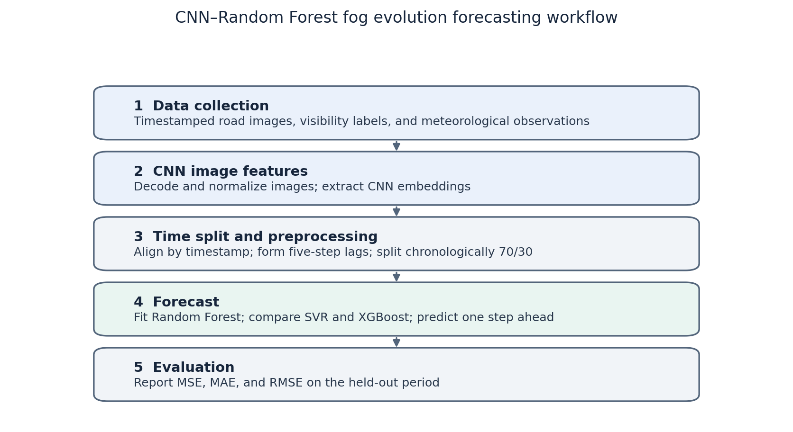
Figure 1. Five-stage proposed route. Synchronized road labels and CNN embeddings in the diagram are requirements for a future complete-system test.
The first 66 usable examples, indices 6–71, fit the models, and the remaining 29, indices 72–100, are held out. Test features use observed earlier rows from the same archived table. Models fit once and predict one indexed row from observed lags; the implementation does not recursively feed earlier predictions into later inputs, refit online, or establish a physical lead time. Input StandardScaler parameters are learned on the fitting subset only. The SVR target is also standardized within the training pipeline and inverse-transformed at prediction. Reported model outputs are clipped at 3.912 km⁻¹ according to the configuration.

2.5 Evaluation measures
For n held-out targets yᵢ and predictions ŷᵢ, all three regression measures use the same 29 rows:
MSE = n⁻¹Σᵢ(yᵢ−ŷᵢ)²; MAE = n⁻¹Σᵢ|yᵢ−ŷᵢ|; RMSE = √MSE.
MAE and RMSE retain the target unit km⁻¹; MSE has unit km⁻². Classification accuracy is the proportion correct. For class k, precisionₖ=TPₖ/(TPₖ+FPₖ), recallₖ=TPₖ/(TPₖ+FNₖ), and F1ₖ=2precisionₖrecallₖ/(precisionₖ+recallₖ); macro-F1 is the arithmetic mean over three classes. These are domain-specific measures: a small error on βproxy is not evidence of a small error on physical road visibility.

3. Image Feature Extraction and Indicator Synthesis

3.1 Sources and visual indicators
The synthetic transmittance experiment has controlled β labels and supports the CNN benchmark. The separate 100-row real-image table contains brightness, contrast, saturation, a dark-channel statistic, edge density and a severity score. In the supplied integrated report, higher brightness and dark-channel values are treated as greater fog severity, while lower contrast, saturation and edge density are treated as greater severity. These directions are modeling choices; scene content, exposure and illumination can change the same features without a change in fog.
Indicator | Operational meaning | Archived severity direction
Brightness | Average image intensity | Higher
Contrast | Structural intensity difference | Lower
Saturation | Colorfulness of image | Lower
Dark channel | Local low-channel intensity | Higher
Edge density | Fraction of detected edges | Lower

Table 2. Reported visual indicators. Indicator direction is a heuristic, not field calibration.

3.2 CNN classification results
The stored metrics.json records 1,525 held-out maps in each synthetic class. Its confusion matrix has 4,230 correct predictions, so accuracy is 4,230/4,575=92.459%. Macro-F1 is 0.9248 and test cross-entropy is 0.23637. The fifth training epoch is the recorded best validation epoch at 93.00% accuracy. Those values arise from the synthetic-domain test; the 30-image random check in the archive samples the same domain and is not a separate real-road evaluation.
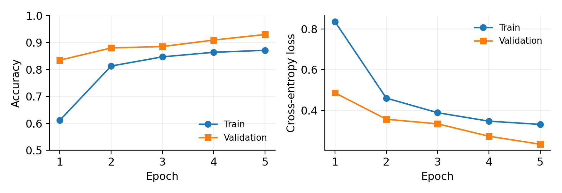
Figure 2. Recorded training and validation histories for five CNN epochs. Source: archived training_history.csv.
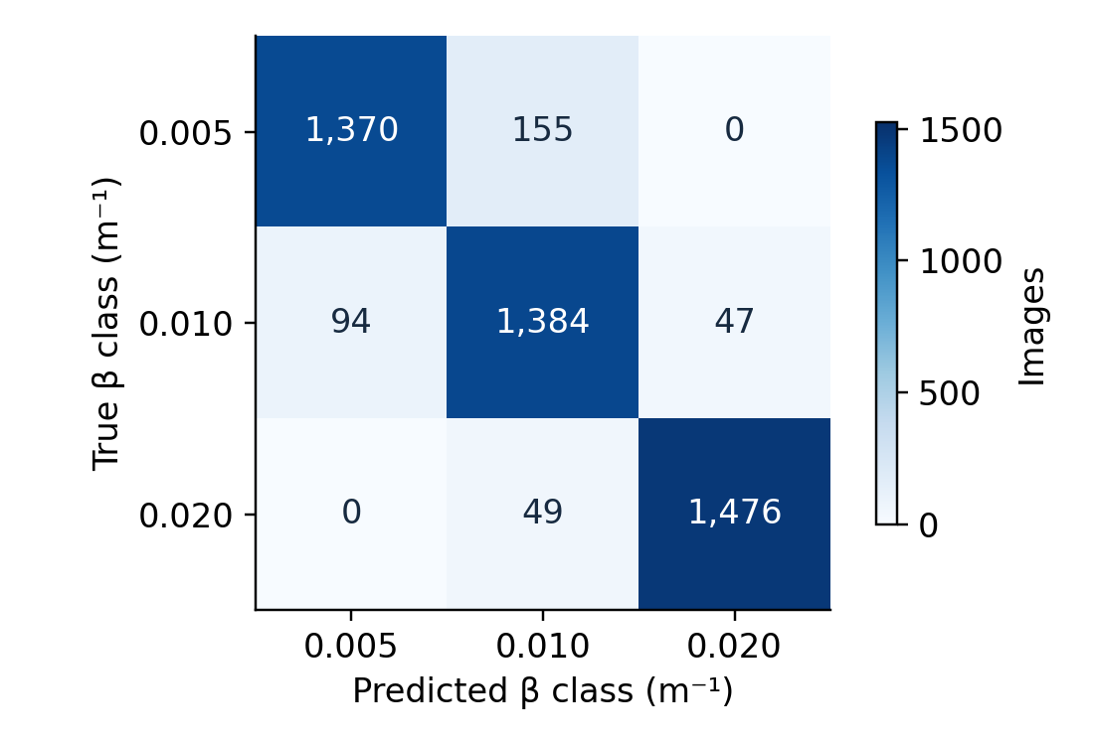
Figure 3. Held-out synthetic-map confusion matrix, rows true and columns predicted. All recorded misclassifications are between neighboring β classes.
True β (m⁻¹) | Precision | Recall | F1
0.005 | 0.9358 | 0.8984 | 0.9167
0.010 | 0.8715 | 0.9075 | 0.8892
0.020 | 0.9691 | 0.9679 | 0.9685
Macro | 0.9255 | 0.9246 | 0.9248

Table 3. Synthetic held-out CNN classwise metrics recalculated from the archived confusion matrix.
At the stronger synthetic fog class (0.020 m⁻¹), 49 of 1,525 maps are predicted as 0.010 m⁻¹. Under the nominal 5% contrast convention, the two classes correspond to approximately 150 and 300 m, so this error direction matters if a model is later applied to safety decisions. The benchmark itself contains no independent road MOR labels, and a transmittance map does not identify β separately from scene depth without additional information.

3.3 Composite score and provenance
The reference report describes standardization of the five indicators, entropy-derived weights, a provisional analytic hierarchy process (AHP) judgment with consistency ratio 0.026, and Technique for Order Preference by Similarity to Ideal Solution (TOPSIS). For normalized weighted indicators vᵢⱼ and positive/negative ideals vⱼ⁺ and vⱼ⁻, define Dᵢ⁺=[Σⱼ(vᵢⱼ−vⱼ⁺)²]¹ᐟ² and Dᵢ⁻ analogously. Its relative closeness is Cᵢ=Dᵢ⁻/(Dᵢ⁺+Dᵢ⁻). A larger Cᵢ is oriented toward the chosen severe-fog ideal. The report states that combined weights use wⱼ=0.5wⱼ,AHP+0.5wⱼ,entropy; 0.5 was chosen, not fitted.
Indicator | Entropy | Provisional AHP | Combined
Brightness | 0.0214 | 0.1814 | 0.1014
Contrast | 0.0485 | 0.3188 | 0.1836
Saturation | 0.0128 | 0.1282 | 0.0705
Dark channel | 0.0217 | 0.2748 | 0.1482
Edge density | 0.8956 | 0.0968 | 0.4962

Table 4. Weights quoted from the supplied integrated report; original image inputs and calculation intermediates were not available for independent recomputation.
The archived report also states Spearman rank correlations of 0.881 for AHP versus entropy, 0.929 for AHP versus combined, and 0.975 for entropy versus combined, with correlations at least 0.997 under the tested ±20% single-weight perturbations of the combined scheme. These are source-reported robustness results, not newly verified statistics in this paper. Edge density is almost constant after rounding in the CSV, and its large reported entropy weight should not be interpreted as a physical share of fog formation.
The stored severity_score is mapped to βproxy≈3.912+74.328C in km⁻¹. The legacy inverse Vproxy≈3912/βproxy gives a conventional 2% contrast scale in meters. These are deterministic transformations of an image score; they do not create a new independent response variable. The synthetic CNN labels use a 5% convention for nominal visibility (V≈2.996/β, with β in m⁻¹). A unified physical state would require reconciling conventions, converting units and calibrating both components against actual measurements. No mixing coefficient or calibrated fused result is estimated here.

4. Empirical Proxy Prediction

4.1 Descriptive analysis
The descriptive sample comprises the 95 rows for which five preceding records exist. Its minimum proxy attenuation is close to 3.91 km⁻¹, and the upper bound is 78.24 km⁻¹ by construction. The wide range does not imply observed road visibility from 50 to 1,000 m: those endpoints follow the chosen proxy transformation.
Column | Mean | SD | Minimum | Maximum
βproxy (km⁻¹) | 48.19 | 21.67 | 3.91 | 78.24
Brightness | 0.765 | 0.107 | 0.443 | 0.937
Contrast | 55.04 | 14.74 | 30.58 | 88.65
Saturation | 0.061 | 0.066 | 0.000 | 0.311
Dark channel | 0.748 | 0.120 | 0.382 | 0.934
Edge density | 0.200 | 0.001 | 0.195 | 0.200
Severity score | 0.596 | 0.292 | 0.000 | 1.000

Table 5. Descriptive statistics for the 95 lag-eligible indexed rows, computed from the archived CSV.
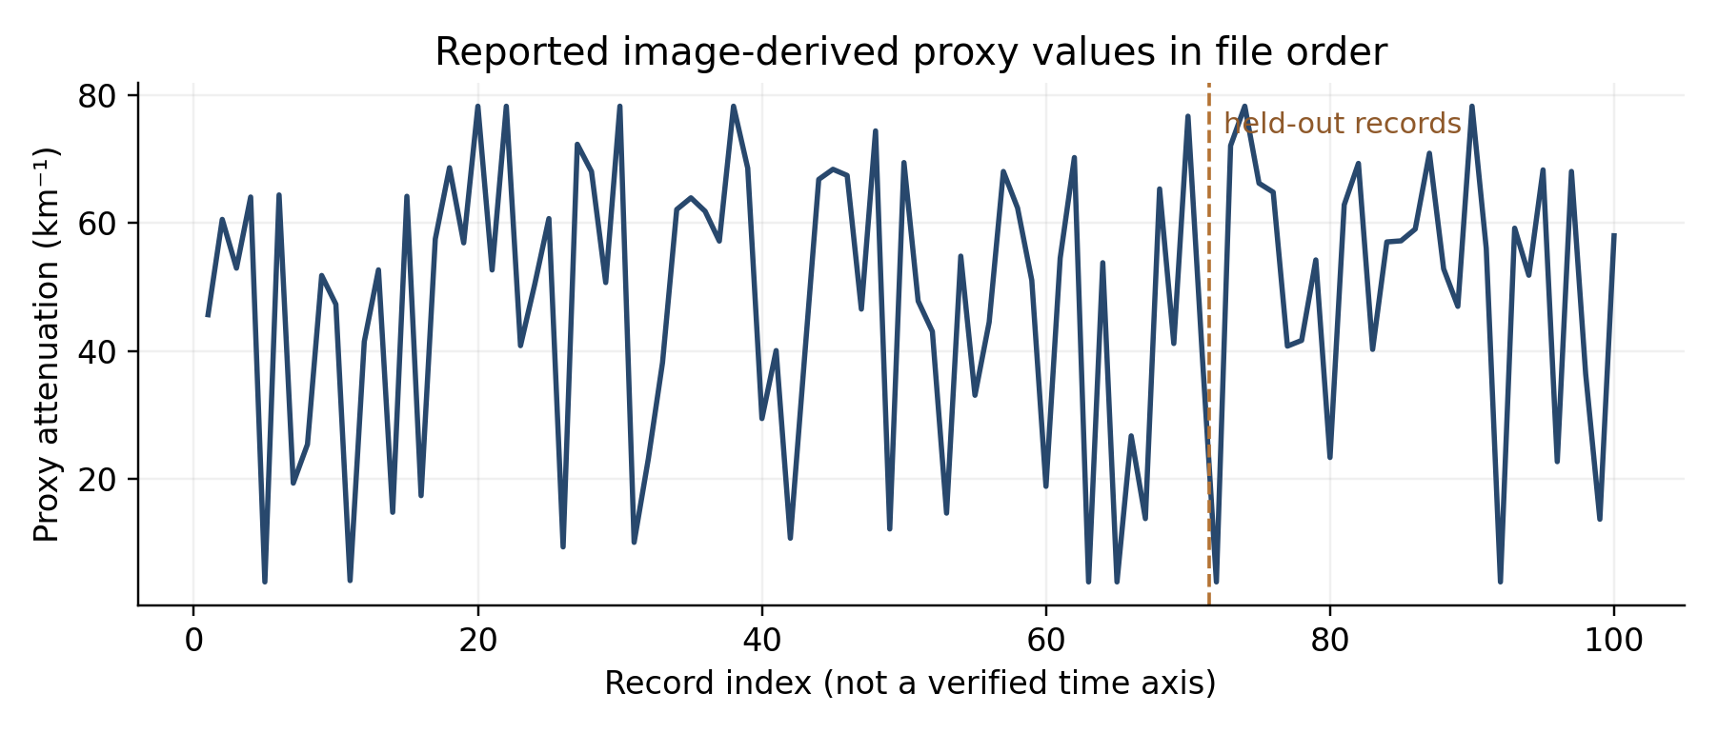
Figure 4. Proxy attenuation plotted against file index. Alternating extremes do not establish physical fog evolution because timestamps and continuity are unverified.

4.2 Partition, preprocessing and baselines
The 95 eligible examples are divided at index 71, giving 66 for fitting and 29 for held-out evaluation, or 69.5%/30.5% after lagging. No sample is shuffled. Each model sees the same observed lagged rows and the same target column. For fairness, input scaling is fitted only on the training partition and then applied to the test partition. RF and XGBoost do not require scaling for tree splits, but the shared pipeline uses it. Hyperparameters were fixed before this report; there is no evidence of cross-event tuning or repeated holdouts.
Two reference predictions are recomputed from the table. The training-mean baseline outputs the mean of target rows 6–71, 46.9767 km⁻¹, for every held-out row. The adjacent-record baseline outputs the immediately preceding observed target. Both use information that would be available in an ordered stream, but neither establishes a timed forecast because the source order has no verified physical cadence.

4.3 SVR, random forest and XGBoost comparison
Regressor | Fixed experiment configuration
SVR | RBF; C=10; epsilon=0.1; training-only scaling of x and y
Random forest | 500 trees; minimum leaf size 2; max_features=0.8; seed 42
XGBoost | 500 trees; maximum depth 5; learning rate 0.03; row and column sampling 0.8; regularization λ=1; seed 42

Table 6. Recorded regressor settings from run_experiment.py and proxy_70_30.yaml.

Method | MSE (km⁻²) | MAE (km⁻¹) | RMSE (km⁻¹)
Training-mean baseline | 430.79 | 17.51 | 20.76
Adjacent-record baseline | 903.38 | 23.99 | 30.06
SVR | 971.23 | 24.98 | 31.16
Random Forest | 574.20 | 19.95 | 23.96
XGBoost | 647.75 | 21.30 | 25.45

Table 7. Identical 29-row holdout. Learned-model outputs are archived; both baselines were recalculated from the archive.
Random forest has the lowest MSE, MAE and RMSE among the three fitted regressors, followed by XGBoost and then SVR. The training-mean constant has still lower error on every measure. Its MAE is 2.44 km⁻¹ below RF and its RMSE is 3.21 km⁻¹ below RF. Thus the evidence supports a ranking within the tested learned methods, but no advantage for the leading learned method over the simplest included constant.
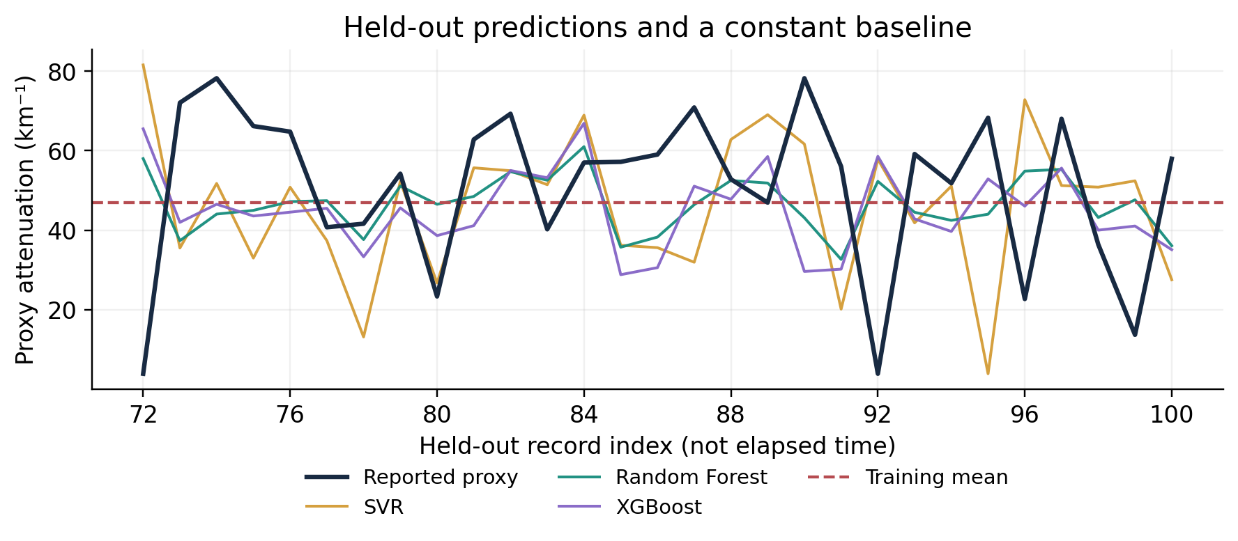
Figure 5. Actual proxy values, fitted-model predictions and the training-only mean at held-out file indices 72–100. Lines connect indices, not measured elapsed time.
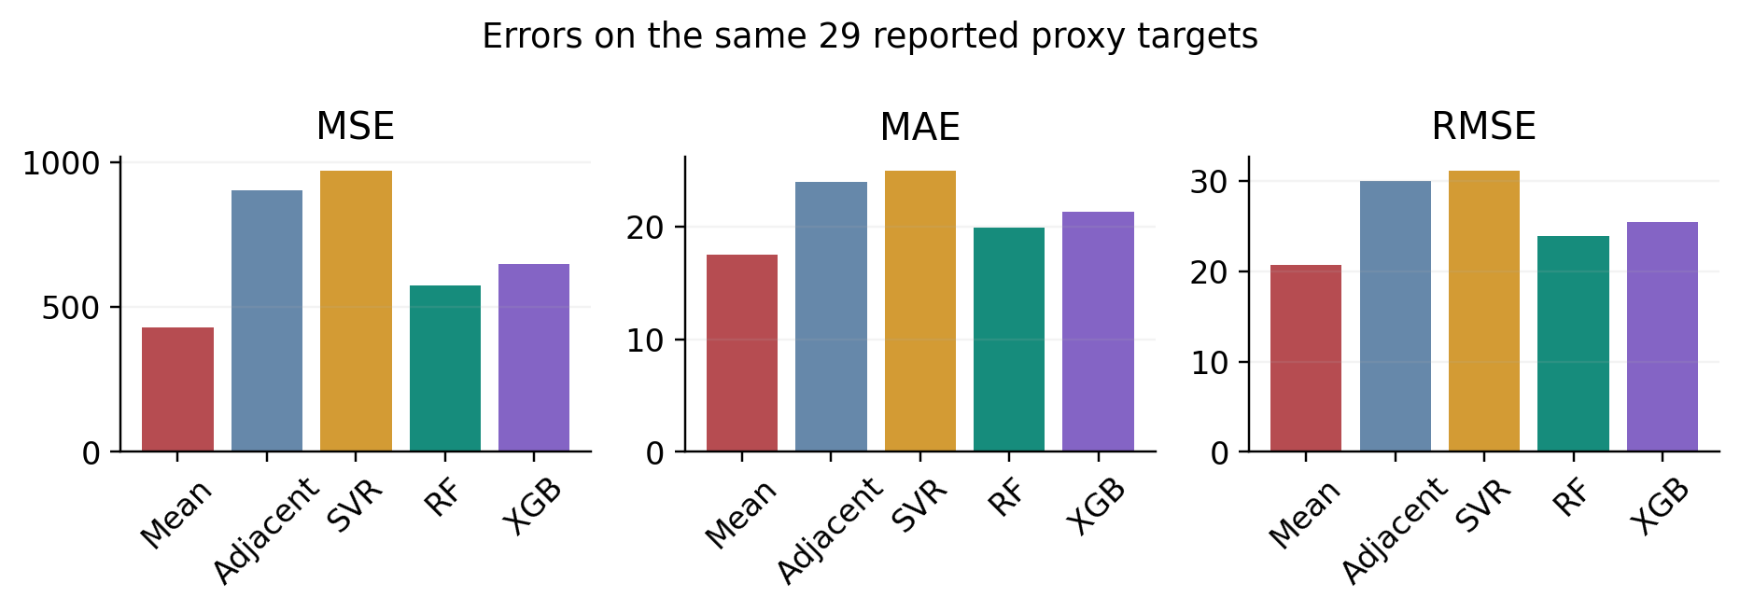
Figure 6. MSE, MAE and RMSE on the same 29 proxy targets. The constant based only on training rows has the lowest error.

4.4 Error patterns and model interpretation
Several low-proxy rows in the holdout are followed by high-proxy rows, so copying the preceding record can be a poor benchmark for this order. RF predictions tend toward the interior of the training target range and miss some extremes. SVR, particularly on the first held-out low value, makes a large error; the plotted values are from the archived prediction file rather than an invented illustrative series. A single block of 29 observations cannot estimate the uncertainty of these rankings across different cameras or fog events.
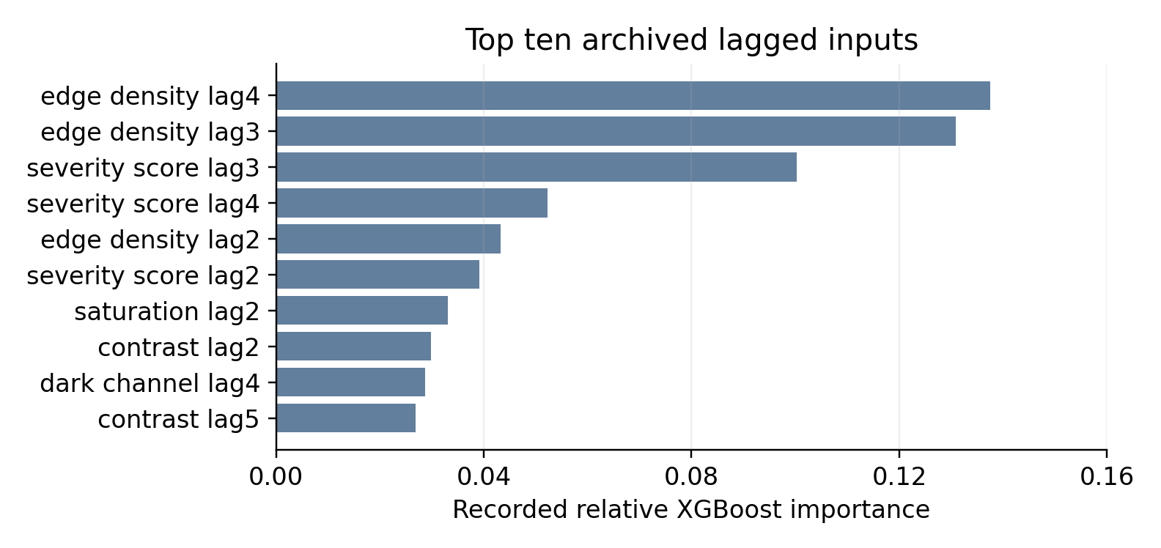
Figure 7. Ten largest archived XGBoost feature-importance values. These describe this fitted proxy-table model, not causal effects or CNN contributions.
The archive attributes comparatively high XGBoost importance to edge-density lags 3–4 and severity-score lag 3. Edge density changes only in the third decimal place for many rows, and the severity score also defines the target transformation. A high importance therefore cannot be read as a stable meteorological mechanism. This figure is a diagnostic for the fitted proxy experiment; it cannot establish the value of a CNN image representation.

5. Discussion

5.1 What is and is not unified
The unified aspect of the study is its proposed route from perception to prediction and a clear interface between components: a timestamped image descriptor and independently measured response at a common time and unit. In the present archive, the CNN classifier uses synthetic maps and the regressors use legacy image-score lags. The two empirical branches do not share paired observations, and no calibrated CNN-plus-RF forecast has been estimated. Calling them a trained end-to-end system would conceal the missing join.

5.2 Measurement and validation limitations
The largest obstacle is measurement, not model capacity. βproxy is a transformed visual score, so the regressor can at most learn persistence or patterns in that score. File index lacks verified spacing and does not define a five-minute or one-hour horizon. Original images and intermediate weighting records for the archived TOPSIS calculation are not independently available within this benchmark. The synthetic transmittance label is related to β through generated attenuation and cannot transfer its test accuracy directly to real RGB road images. Results from one small ordered holdout provide no confidence interval for new events.
The supplied integrated report contains other AMOS and highway analyses with their own targets. The existing AMOS summaries indicate a large decline when a meteorological model is tested on a different event and show that persistence can outperform a more complex temporal regression. They are useful context, but those rows are neither joined to this 100-image table nor included in the present 70/30 model comparison. We do not pool or restate their distinct errors as evidence of the CNN–RF workflow.

5.3 Next validation study
A field study should collect repeated images from fixed cameras alongside visibility-meter MOR, temperature, humidity, wind and pressure with explicit clocks and camera geometry. It should fix one visibility convention and calibrate image-derived values against meter readings. Entire events or cameras should be held out before choosing preprocessing and hyperparameters. Train-only mean and physical-time persistence must be evaluated beside SVR, RF and XGBoost; a CNN-feature ablation can then test whether learned visual features add information beyond interpretable indicators. Error near low-visibility decision thresholds should be reported separately after the basic measured-target error is established.

6. Conclusions and Outlook
The archived CNN achieved 92.46% accuracy and 0.9248 macro-F1 on 4,575 balanced synthetic transmittance maps. The separate real-image indicator archive supports description of a 100-row severity proxy, but its reported TOPSIS weights lack the raw intermediates needed for independent re-estimation here. On the 29-row index-held-out proxy target, RF outperformed SVR and XGBoost (MAE 19.95 km⁻¹), while a training-mean constant performed better (MAE 17.51 km⁻¹). No current result establishes a real-time or field-calibrated road visibility forecast, and the current regressors do not use CNN embeddings.
The practical next step is a timestamped, field-labeled dataset spanning multiple events. Its common measurements will make it possible to calibrate image features, test the full CNN–RF chain, and judge whether it improves on simple operational baselines.

References
[1] Xiao P, et al. Highway Visibility Estimation in Foggy Weather via Multi-Scale Fusion Network. Sensors. 2023;23(24):9739. doi:10.3390/s23249739.
[2] Yang W, et al. Multi visual feature fusion based fog visibility estimation for expressway surveillance using deep learning network. Expert Systems with Applications. 2023;234:121151. doi:10.1016/j.eswa.2023.121151.
[3] Penov N, Guerova G. Sofia Airport Visibility Estimation with Two Machine-Learning Techniques. Remote Sensing. 2023;15(19):4799. doi:10.3390/rs15194799.
[4] Cornejo-Bueno L, et al. Statistical Analysis and Machine Learning Prediction of Fog-Caused Low-Visibility Events at A-8 Motor-Road in Spain. Atmosphere. 2021;12(6):679. doi:10.3390/atmos12060679.
[5] Lam R, et al. Learning skillful medium-range global weather forecasting. Science. 2023;382(6677):1416–1421. doi:10.1126/science.adi2336.
[6] Bi K, et al. Accurate medium-range global weather forecasting with 3D neural networks. Nature. 2023;619:533–538. doi:10.1038/s41586-023-06185-3.
[7] Nguyen T, et al. ClimaX: A foundation model for weather and climate. Proceedings of the 40th International Conference on Machine Learning. PMLR. 2023;202:25904–25938. https://proceedings.mlr.press/v202/nguyen23a.html.
[8] Rasp S, et al. WeatherBench 2: A benchmark for the next generation of data-driven global weather models. Journal of Advances in Modeling Earth Systems. 2024;16:e2023MS004019. doi:10.1029/2023MS004019.
[9] Kochkov D, et al. Neural general circulation models for weather and climate. Nature. 2024;632:1060–1066. doi:10.1038/s41586-024-07744-y.
[10] Price I, et al. Probabilistic weather forecasting with machine learning. Nature. 2025;637:84–90. doi:10.1038/s41586-024-08252-9.
[11] Lang S, et al. AIFS: a new ECMWF forecasting system. ECMWF Newsletter. 2024;178. https://www.ecmwf.int/en/newsletter/178/news/aifs-new-ecmwf-forecasting-system.
[12] Chen L, et al. FuXi: a cascade machine learning forecasting system for 15-day global weather forecast. npj Climate and Atmospheric Science. 2023;6:190. doi:10.1038/s41612-023-00512-1.
[13] He K, Zhang X, Ren S, Sun J. Deep residual learning for image recognition. Proceedings of the IEEE Conference on Computer Vision and Pattern Recognition. 2016:770–778. doi:10.1109/CVPR.2016.90.
[14] Breiman L. Random forests. Machine Learning. 2001;45:5–32. doi:10.1023/A:1010933404324.
[15] Smola AJ, Schölkopf B. A tutorial on support vector regression. Statistics and Computing. 2004;14:199–222. doi:10.1023/B:STCO.0000035301.49549.88.
[16] Chen T, Guestrin C. XGBoost: A scalable tree boosting system. Proceedings of the 22nd ACM SIGKDD International Conference on Knowledge Discovery and Data Mining. 2016:785–794. doi:10.1145/2939672.2939785.
[17] Sakaridis C, Dai D, Van Gool L. Semantic foggy scene understanding with synthetic data. International Journal of Computer Vision. 2018;126:973–992. doi:10.1007/s11263-018-1072-8.
[18] Yabra MS, Ruiz JJ, de Elia R, et al. Predictability of fog using surface observation-based machine learning models: evaluation at Argentinean airport. CEAS Aeronautical Journal. 2026. doi:10.1007/s13272-026-01003-8.

Appendix A. Held-out proxy predictions
For audit, Table A1 records every held-out target and the three archived model outputs. Decimal values are rounded for display; all errors in Table 7 were calculated from unrounded prediction-file values. The record number denotes file index.
Index | Target | SVR | RF | XGBoost
72 | 3.91 | 81.58 | 58.02 | 65.52
73 | 72.07 | 35.54 | 37.37 | 41.99
74 | 78.24 | 51.77 | 44.07 | 46.54
75 | 66.20 | 33.01 | 45.00 | 43.58
76 | 64.80 | 50.82 | 47.20 | 44.55
77 | 40.75 | 37.40 | 47.44 | 45.52
78 | 41.64 | 13.16 | 37.66 | 33.31
79 | 54.22 | 52.29 | 51.12 | 45.62
80 | 23.35 | 26.74 | 46.53 | 38.65
81 | 62.83 | 55.70 | 48.51 | 41.16
82 | 69.30 | 54.96 | 54.73 | 55.03
83 | 40.24 | 51.46 | 52.58 | 53.20
84 | 57.03 | 68.94 | 61.03 | 66.90
85 | 57.20 | 36.23 | 35.74 | 28.82
86 | 59.04 | 35.62 | 38.28 | 30.59
87 | 70.89 | 31.95 | 46.43 | 51.08
88 | 52.83 | 62.83 | 52.52 | 47.80
89 | 46.96 | 69.05 | 51.88 | 58.53
90 | 78.24 | 61.68 | 43.13 | 29.63
91 | 56.03 | 20.16 | 32.66 | 30.22
92 | 3.91 | 57.87 | 52.30 | 58.59
93 | 59.18 | 41.86 | 44.52 | 42.85
94 | 51.82 | 51.10 | 42.49 | 39.70
95 | 68.29 | 3.91 | 44.04 | 52.92
96 | 22.70 | 72.83 | 54.88 | 46.06
97 | 68.04 | 51.24 | 55.31 | 55.64
98 | 36.42 | 50.84 | 43.21 | 40.02
99 | 13.70 | 52.43 | 47.66 | 41.06
100 | 57.99 | 27.55 | 36.11 | 35.11

Table A1. Twenty-nine archived holdout predictions in km⁻¹; full-precision values are in predictions.csv.

Appendix B. Reproduction and evidence boundaries
The proxy benchmark can be regenerated with python -m fogforecast.run_experiment --config config/proxy_70_30.yaml from the repository root after installing requirements and setting PYTHONPATH=src. The routine sorts on observation, forms only past-row lags, splits the 95 eligible examples at floor(0.70×95)=66, fits each model once and saves predictions, metrics and plots. It does not fit a CNN to the proxy data. Reproducing the archived TOPSIS weights from images requires the omitted original images, scoring implementation and intermediate weight calculations; any apparently exact reconstruction from the rounded CSV alone would be unsupported.
Project evidence: paper/Integrated_Fog_Visibility_Revised.pdf, especially Appendix B; repository results/transmittance_beta/v1.0.0/metrics.json and training_history.csv; results/real_image_proxy_observations.csv; config/proxy_70_30.yaml; src/fogforecast/run_experiment.py; results/proxy_forecast_70_30/predictions.csv, metrics.csv and xgboost_feature_importance.csv. Project files are distinguished from the external publications [1]–[18].
AI assistance disclosure: OpenAI ChatGPT Work (Codex, GPT-6 model family) assisted with prose, source lookup, numerical cross-checks, figures, formatting and reference verification on 18 October 2026. This statement and the fuller report below identify its role. The paper is preparatory research and does not claim a solution to an announced 2026 HiMCM problem.

Report on Use of AI Tools
OpenAI ChatGPT Work (Codex, GPT-6 model family), accessed 18 October 2026, was used to draft and edit the English paper, reorganize the supplied integrated report, check article metadata and contest format guidance, generate charts, recompute summary and baseline statistics from the archived CSV files, and render and inspect the final Word/PDF. The supplied report and GitHub project files were treated as evidence with the limitations stated in the text. AI did not supply new road measurements, verified timestamps, source-image reconstructions, or fitted CNN–forest results. This preparatory draft requires an assigned control number, an actual problem statement, and an updated full AI-use report before submission to a real HiMCM contest.

