**Git**

## ****Source Code Management****

## Git

Git is Management tool to store in source in Git...

Git is a modern and widely used **distributed version control** system in the world.

Git via the command line as well as with [GitHub](https://www.javatpoint.com/what-is-github).

## What is Git

**Git** is an **open-source distributed version control system**. It is designed to handle minor to major projects with high speed and efficiency. It is developed to co-ordinate the work among the developers

Git is foundation of many services like **GitHub** and **GitLab**, but we can use Git without using any other Git services. Git can be used **privately** and **publicly**.

Git was created by **Linus Torvalds** in **2005** to develop Linux Kernel. It is also used as an important distributed version-control tool for **the DevOps**.

Git is easy to learn, and has fast performance

## Features of Git

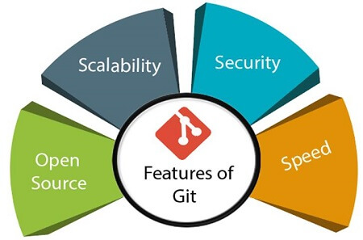

## Benefits of Git

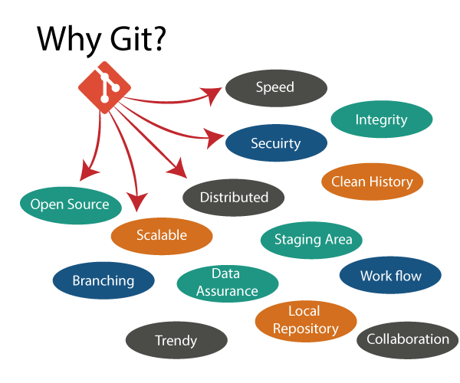

# How to Install Git on Windows

To download the Git installer, visit the Git's official site and go to download page. The link for the download page is <https://git-scm.com/downloads>

## Install Git:

Select **yes** to continue.

After the selecting **yes** the installation begins, and the screen

Click on **next** to continue.

Default components are automatically selected in this step. You can also choose your required part

Click on **next** to continue.

The default Git command-line options are selected automatically. You can choose your preferred choice.

Click **next** to continue.

The default transport backend options are selected in this step.

Click **next** to continue.

Select your required line ending option and

click **next** to continue.

Select preferred terminal emulator

clicks on the **next** to continue.

This is the last step that provides some extra features like system caching, credential management and symbolic link. Select the required features

click on the **next** option.

The files are being extracted in this step.

**The Git installation is completed.**

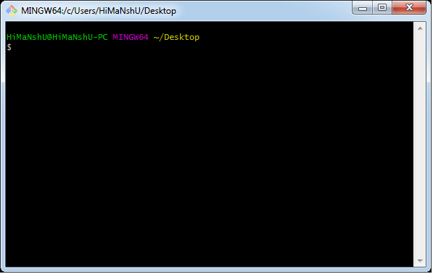The **Git Gui** looks like as