Fundamentals computer and Photoshop

Unit 1

(Introduction of computer)

1. **Write about the generations of computers?**
2. There are 5 types of generations of computers

* First generation
* Second generation
* Three generation
* 4th generation
* Fifth generation

**First generation** (**1946-1959)**:

1. The computers of first generation used
2. Vacuum tubes as the basic components for memory and circuitry for Central Processing Unit.
3. These tubes, like electric bulbs, produced a lot of heat, were very expensive and could be afforded only by very large organizations.
4. Punched cards, paper tape, and magnetic tape were used as input and output devices.
5. This generation used machine code as programming language.

**ii.) Second generation (1959-1965)**:

1. In this generation transistors were used
2. were cheaper, consumed less power, more compact in size, more reliable
3. Faster than the first generation machines made of vacuum tubes.
4. In this generation assembly language and high-level programming languages like FORTRAN, COBOL was used

**III.)Third Generation (1965-1971):**

1. Third generation used integrated circuits (IC's) in place of transistors.
2. A single IC has many transistors, resistors.
3. The IC was invented by Jack Kirby.
4. In this generation remote processing, time-sharing, multiprogramming operating system was used.
5. High-level languages (FORTRAN-II TO IV, COBOL, PASCAL PL/1, BASIC, ALGOL-68 etc.) were used during this generation.

**VI.) Fourth Generation (1971-1980):**

1. Very Large Scale Integrated (VLSI) circuits. VLSI circuits having about 5000 transistors and  other circuit elements and their associated circuits on a single microcomputers of fourth generation.
2. Fourth generation computers became more powerful, compact, reliable, and affordable. As a result, it gave rise to personal computer (PC) revolution.
3. In this generation time sharing, real time, networks, distributed operating system were used.
4. the high-level languages like C, C++, etc., were used in this generation.

**V.) Fifth Generation (1980 to till date**):

1. In the fifth generation, the VLSI technology became ULSI (Ultra Large Scale Integration) technology.
2. Microprocessor chips having ten million electronic components.
3. This generation is based on parallel processing hardware and AI (Artificial Intelligence) software in computer science
4. All the high-level languages like C and C++, Java, .Net etc., are used in this generation

**Q2. Explain the characteristics of a computer?**

***Characteristics of a Computer*:**

**Speed**:

1. As you know computer can work very fast. It takes only few seconds for calculations that we take hours to complete.
2. You will be surprised to know that computer can perform millions of Instructions and even more per second.
3. Therefore, we determine the speed of computer in terms of microsecond 10-6and nanosecond 10-9.

**Accuracy**:

1. Computer always gives accurate results. The accuracy of Computer does not go down when they are used continuously for hours together.
2. It always gives accurate results.

**Diligence**:

1. A computer is free from tiredness, lack of concentration, etc. It can work for hours without creating any error.
2. If millions of calculations are to be performed, a computer will perform every calculation with the same accuracy.

**Versatility**:

1. It means the capacity to perform a completely different type of work.
2. You may use your computer to prepare payroll slips. Next moment you may use it for inventory management or to prepare electric bills.

**Storage:**

1. The Computer has an in-built memory where it can store a large amount of data.
2. You can also store data in secondary storage devices such as floppies, which can be kept outside your computer and can be carried to other computers.

**Automation:**

1. Computers are quite capable of functioning automatically, once the process is given to the computer.
2. They do not require any instruction from the operator at any stage of the process.
3. Computers can be programmed to perform a series of complex tasks involving multiple program

**Q3. Explain the types of computers?**

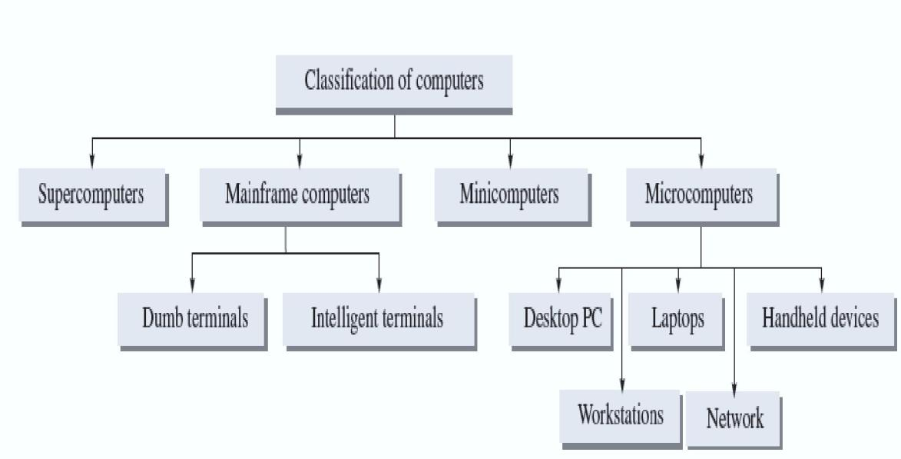

**(i) Supercomputers**

1. These are fastest, most powerful, and most expensive computers.
2. These are first developed in the 1980s to process large amount of data to solve complex scientific problems.
3. Supercomputers uses parallel processing technology and can perform more than one trillion calculations in a second. Such computers are mainly used for weather forecasting, nuclear energy research, aircraft design, automotive design, and online banking ext.

Examples: CRAY-1, CRAY-2, control Data CYBER 205, and ETA A-10

**(ii)Mainframe computers**

1. Large-scale computers, but smaller than Supercomputers
2. Very expensive
3. Need a very large clean room with air conditioning
4. Used as servers on the World Wide Web

Some examples are IBM S/390, Control Data CYBER 176, and Amdahl 580

**(iii) Microcomputers**.

1. Another type of popular PC is designed by Apple.
2. PCs designed by IBM and other PC-compatible computers have a different architectures from that of Apple computers.
3. Moreover, PCs and PC-compatible computers commonly use the windows operating system, while Apple computers use the Macintosh operating system (Mac OS).
4. **Desktop**
5. **Laptops**
6. **Workstations**
7. **Network computers**
8. **Handheld computers**
9. **Desktop:**
10. A desktop PC is the most popular model of PCs.
11. The system unit of the desktop PC can be placed flat on a desk or table.
12. It is widely used in home and offices.
13. **Laptops:**
14. Laptops are small microcomputers that can easily fit inside a briefcase.
15. They are very handy and can easily be carried from one place to another place.
16. Laptops operate on a special battery and do not always have to be plugged in like desktop computers.

**(C)Workstation:**

1. Workstation is a special computer designed for technical or [scientific](https://en.wikipedia.org/wiki/Computational_science) applications.
2. Intended primarily to be used by one person at a time, they are commonly connected to a [local area network](https://en.wikipedia.org/wiki/Local_area_network) and run [multi-user](https://en.wikipedia.org/wiki/Multi-user) [operating systems](https://en.wikipedia.org/wiki/Operating_system).
3. The term workstation has also been used loosely to refer to everything from a [mainframe computer](https://en.wikipedia.org/wiki/Mainframe_computer) terminal to a PC connected to a [network](https://en.wikipedia.org/wiki/Computer_network), but the most common form refers to the class of hardware offered by several current and defunct companies such as [Sun Microsystems](https://en.wikipedia.org/wiki/Sun_Microsystems),
4. **Handheld computers:**
   1. Single-user computers
   2. Can fit in one hand
   3. Have small-sized screens and keyboards
   4. Some examples of handheld computers are Personal Digital Assistants (PDA)
   5. Cellular Phones

**Q4. What is the application Computers?**

**Business**:

 A computer has high speed of calculation, diligence, accuracy, reliability, or versatility which made it an integrated part in all business organizations. Computer is used in

business organizations

**Banking:**

 Today banking is almost totally dependent on computer. Banks provide following facilities:

1. Banks provide online accounting facility, which includes current balances, deposits, overdrafts, interest charges, shares, and trustee records.
2. ATM machines are making it even easier for customers to deal with banks

**Insurance**:

Insurance companies are keeping all records up-to-date with the help of computers. The Insurance companies are maintaining a database of all clients with information showing

* procedure to continue with policies
* next due installment of a policy
* maturity date

**Education**:

The computer has provided a lot of facilities in the education system. The computer provides a tool in the education system known as CBE (Computer Based Education) which involves control, delivery, and evaluation of learning. The computer education is rapidly increasing the graph of number of computer students.

**Marketing**:

 In marketing, uses of computer are following:

1. **Advertising** - With computers, advertising professionals create art and graphics, write and revise copy, and print and disseminate ads with the goal of selling more products.
2. **At Home Shopping** - Home shopping has been made possible through the use of computerized catalogues that provide access to product information and permit direct entry of orders to be filled by the customers.

**Health Care**:

Computers have become an important part in hospitals, labs, and dispensaries.It is also used in scanning and diagnosing different diseases. ECG, EEG, Ultrasounds and CT Scans etc.

1. **Diagnostic System** - Computers are used to collect data and identify the cause of illness.
2. **Patient Monitoring System** - These are used to check patient's signs for abnormality such as in Cardiac Arrest, ECG etc.

**Engineering Design**:

Computers are widely used in engineering purpose. One of major areas is CAD (Computer aided design). That provides creation and modification of images. Some fields are:

1. **Structural Engineering** - Requires stress and strain analysis for design of Ships, Buildings, Budgets, and Airplanes etc.
2. **Architectural Engineering** - Computers help in planning towns, designing buildings, determining a range of buildings on a site using both 2D and 3D drawings

**Military:**

Computers are largely used in defense. Modern tanks, missiles, weapons etc. Military also employs computerized control systems. Some military areas where a computer has been used are:

1. Missile Control
2. Military Communication

**Communication:**

 Communication means to convey a message, an idea, a picture or speech that is received and understood clearly and correctly by the person for whom it is meant for. Some

Main areas in this category are:

1. E-mail
2. Chatting
3. Video-conferencing

**Government**:

 Computers play an important role in government. Some Major fields in this category are:

1. Budgets
2. Male/Female ratio
3. Computerization of voters lists

**Q5. Draw the Block diagram of a Computer? Explain its parts in detail?**

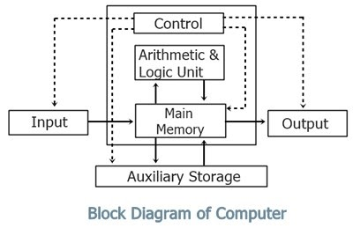

A computer performs basically five major computer operations or functions irrespective of their size and make. These are

1) It accepts data or instructions by way of input

2) It stores data

3) It can process data as required by the user

4) It gives results in the form of output

5) It controls all operations inside a computer

**Input Unit**:

This is the process of entering data and programs in the computer system. Therefore, the input unit takes data from us to the computer in an organized manner for processing with the help of some input devices like Keyboard, mouse, trackball, etc.

**Output Unit**:

This is the process of producing results from the data for getting useful information. The examples of Output devices are Monitor, speaker, printer, etc.

**Central Processing Unit**:

The ALU and the CU of a computer system are jointly known as the central processing unit. You may call CPU as the brain of any computer system.

**Arithmetic & Logic Unit**:

 After you enter data through the input device it is stored in the primary storage unit. The actual processing of the data and instruction are performed by Arithmetic Logical Unit. The major operations performed by the ALU are addition, subtraction, multiplication, division, logic and comparison.

**Control Unit**:

The next component of computer is the Control Unit, which acts like the supervisor. Control Unit is responsible for coordinating various operations. It coordinates the

activities of computer‘s peripheral equipment as they perform the input and output.

**Storage**:

The process of saving data and instructions permanently is known as storage. A personal Computer has two types of memories they are Primary memory and secondary memory. Primary memory is temporary memory and main memory of the computer, primary memory includes RAM and ROM. The secondary memory is permanent memory it includes Hard disk, floppy disk, etc.

**Q6 Definition of computer. Write limitations of computers?**

*Define a Computer***:** Computer is an  electronic device that takes raw data as input from the user and processes these data under the control of set of instructions and giving perfect output

1. accepts :data Input
2. processes :data Processing
3. produces output: Output
4. stores :Results Storage

**Limitations of a Computer System**:

**Computers can‘t think**: Computers cannot think and they can‘t do any job unless they are first programmed with specific instructions for same. They work as per stored instructions. Algorithms are designed by humans to make a computer perform a special task. This is also called artificial intelligence

**Computers can‘t decide**: Computers are incapable of decision making as they do not possess the essential elements necessary to take a decision i.e. knowledge, information, wisdom, intelligence and the ability to judge.

**Computers can‘t express their Ideas**: In any type of research ideas plays a vital role. In this context, computers can‘t express their ideas.

**Computers can‘t implement**: Though computers are helpful in storage of data and can contain the

contents of encyclopedias even, but only humans can decide and implement the policies.

**Explain the types of input devices?**

**Input:** An input device is any hardware device that sends data to a computer, allowing you to interact with and control the computer. The most commonly used input devices on a computer are the keyboard and mouse. Below is a list of computer input devices

1. Keyboard
2. Mouse
3. Joystick
4. Light pen
5. Track Ball
6. Scanner
7. Microphone
8. Audio input device
9. Video input device

**Keyboard:**

Keyboard is the most common and very popular input device which helps in inputting data to the computer. The keys on the keyboard are as

**1 Typing Keys**:

 These keys include the letter keys (A-Z) and digit keys (0-9) which generally give the same layout as that of typewriters.

**2 Numeric Keypad**

It is used to enter numeric data or cursor movement.

**3 Function Keys:**

The twelve function keys are present on the keyboard which is arranged in a row at the top of the keyboard. Each function key has unique meaning and is used for some specific purpose

**4. Control keys:**

These keys provide cursor and screen control. It includes four directional arrow keys. Control keys also include Home, End, Insert, Delete, Page Up, Page Down, Control(Ctrl), Alternate(Alt), Escape(Esc).

**5. Special Purpose Keys :**

Keyboard also contains some special purpose keys such as Enter, Shift, Caps Lock, Num Lock, Space bar, Tab, and Print Screen.

**Mouse**:

 Mouse is the most popular pointing device. It is a very famous cursor-control device having a small palm size box with a round ball at its base which senses the movement of

mouse and sends corresponding signals to CPU when the mouse buttons are pressed.

**Joystick**:

Joystick is also a pointing device which is used to move cursor position on a monitor screen.  It is mainly used in Computer Aided Designing (CAD) and playing computer games.

**Light Pen**:

 Light pen is a pointing device which is similar to a pen. It is used to select a displayed menu item or draw pictures on the monitor screen. It consists of a photocell and an optical system placed in a small tube

**Track Ball**:

A trackball is a pointing device that is used to control the position of the cursor on the screen. It is usually used in notebook computers.

**Scanner**:

A scanner is a device that captures images, printed text, handwriting, from different sources such as photographic prints, posters, and magazines and converts them into digital images for editing and display on computers

**Audio input Devices**:

Audio devices are used to either capture or create sound. They enable computers to accept music, speech, or sound effects for recording and/or editing. Microphones and CD players are examples of two widely used audio input devices. A microphone feeds audio input to the computer.

**Video Input Devices**:

Video input devices are used to capture video from the outside world into the computer. Here, the term video means moving picture along with sound. Digital camera and web camera are popular examples of video input devices.

**Explain the types of Output devices?**

**Output**: Any device that gives information from a computer can be called an output device. Monitors and speakers are two widely used output devices.

For example,

1. Monitors
2. Printers
3. Speakers
4. Projectors

**Soft copy output devices**:

Soft copy output devices produce an electronic version of an output, for example, a file that is stored on a hard disk, CD, or pen drive and is displayed on the computer screen

**Monitors**:

The monitor is a soft copy output device used to display video and graphics information generated by the computer through the video card. Computer monitors are similar to television screens but they display information at a much higher quality.

1. **CRT Monitors:** CRT (Cathode Ray Tube) monitors work by firing charged electrons at a phosphorus film. When electrons hit the phosphor-coated screen, they glow, thereby enabling the user to see the output. The size of CRT monitors is big and high power consumption.
2. **LCD Monitors:** LCD (Liquid Crystal Display) monitor is a thin, flat, electronic visual display unit that uses the light modulating properties of liquid crystals, which do not emit light directly
3. **LED Monitor:** LED (Light Emitting Diode) (LED) is a semiconductor device that emits light when an electric current is passed through it. Light is produced when the particles that carry the current (known as electrons and holes) combine together within the semiconductor material.

**Printers:**

A printer is a device that takes the text and graphics information obtained from a computer and prints it on to a paper.

 Types of printers

1. **Dot matrix printer:** A dot matrix printer prints characters and images of all types as pattern of dots (hence the name).

**2. Inkjet printer**: The inkjet printers have succeeded in making color printing an affordable option even for home users

**3. Laser jet printer**: A laser printer is a non-impact printer that works at very high speeds and produces high-quality text and graphics. It uses the technology used in photocopier machines. When a document is sent to the printer

**Speakers**:

By using speakers, the user can enjoy music, movie, or a game, and the voice will be spread through the entire room with good quality speakers.

**Projectors**:

A projector is a device that takes an image from a video source and projects it onto a screen or another surface. These days, projectors are used for a wide range of applications, varying from home theatre systems for projecting movies and television programmers onto a screen much larger than even the biggest available television.

**Q what is software and classification of software?**

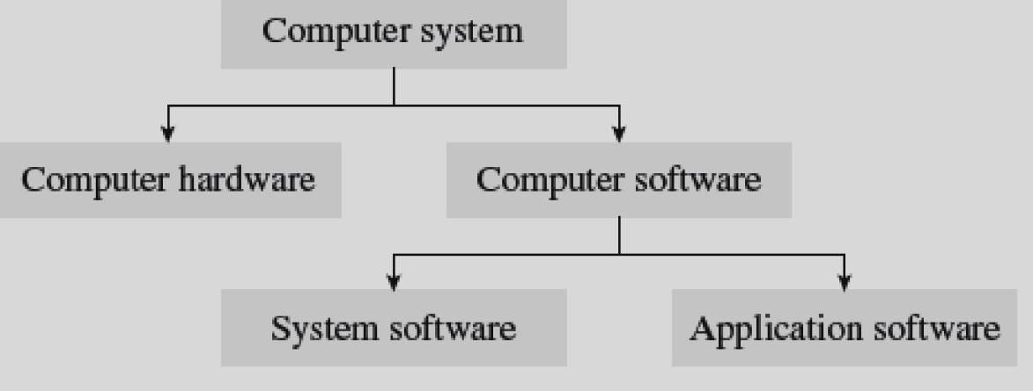**Software**: This is the programs inside the computer, which tells the hardware what to do and how to do it.

**Classification of computer software:**

1. System software
2. Application software

**System software:**

This environment provides new functions that are not available at the hardware level and performs tasks related to executing the application program. System software represents programs that allow the hardware to run properly

System software represents programs that allow the hardware to run properly. It is transparent to the user and acts as an interface between the hardware of the computer and the application software that the users need to run on the computer.

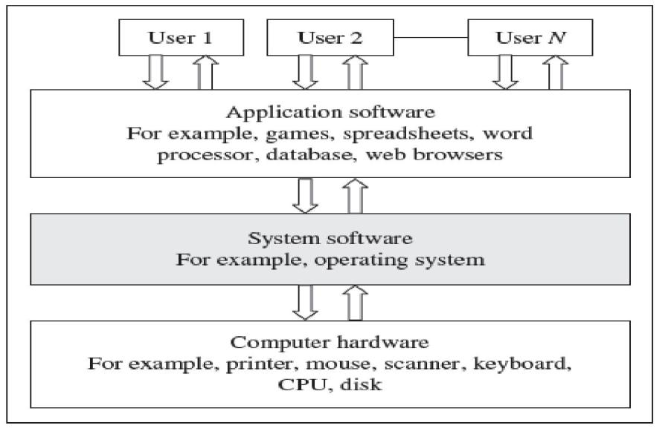



System software is computer software designed to operate the computer and to provide and maintain a platform for running the application software.

* When the computer starts, the first function that the BIOS Performs is to initialize and identify system device such as the video display card, Keyboard, mouse, hard disk, CD/ DVD drive, and other hardware.
* The BIOS is stored on a read only memory (ROM) chip built into the system. It also has a user interface, similar to that of a menu which can be accessed by pressing a certain key on the Keyboard when the personal computer (PC) starts.

|  |  |  |  |  |
| --- | --- | --- | --- | --- |
| • | Disk defragmenters | * Disk Checker | * Disk cleaners | * Disk space analyzers |
| • | Disk partitions | * Backup Utilities | * Disk Compression | * File Managers |
| • | System Profilers | * Anti – Virus | * Data compression utilities | |
| • | Orthographic Utilities | * Registry cleaners | * Network Utilities. |  |

**Application software**:

Application software is a type of computes software that employs the capabilities of a computer directly to perform a user – defined task.

Ex: - Word processors, spread sheets, media players, education software, CAO/ CAM.

**Productivity software:-**

Productivity software is any software used to attain something productive, especially in the office or home, as opposed to games software (or) entertainment software.

Word processing programs, spreadsheet applications, and graphic design software are examples of productivity software.

**(a) Microsoft Office Package :-**

Microsoft office, introduced by Microsoft in 1989, is a suite of inter related applications for Microsoft windows and Mac OS X operating systems. Initially, it included only Microsoft word, Microsoft Excel, and Microsoft power point.

**(b) Graphics Software:-**

Graphics Software (or) image editing software is a program that allows users to create and edit digital images and illustrations. Examples of such software include Adobe Photoshop Illustrator, paint shop pro, and Microsoft paint.

* 1. **Multimedia Software: -** Multimedia is a comprehensive term and means different types of media. Itincludes a combination of text, audio, still images, animation, video, and interactivity contents forms.
  2. **Database Management Software:-**
* Database Management software (or) DBMS is a collection of programs that helps users to store, edit, and extract data from a database.

Ex: - Microsoft Access, DB2, SQL server, and Oracle.

* The use of a DBMS has become so common that it has now become a part of our everyday life. DBMS is used in computerized library systems, automated teller machines (ATM’S) , flight reservation and soon.
* Information from a database is extracted in the form of a query, which is a stylized question.

**Ex: -** SELECT ALL FROM STUDENTS WHERE MARKS > 90

* The set of rules constructing queries is known as query language. The most commonly used query language is structured query language (SQL).
* A DBMS facilitates its users to control data access, enforce data integrity, manage concurrency, and restore the database from backups.

(OR)

**Difference between system software and application software**

**System software** :

1. It's collections of programs that enable the user to interact with the  hardware components
2. Its control and manager hardware components
3. Its  directly interact with hardware parts
4. For example: compare, operating system

**Application software:**

1. It is  collections of program specification purpose
2. Application software are installed according to user’s requirements
3. Application software perform specific task according to their type.
4. Some examples of application software are word processors, web browser, media player, etc.

**Q.Write about primary memory and secondary memory ?**

**OR**

**Q explains about the types of memories?**

**Primary memory**

Primary memory or main memory or internal memory is the only type of memory that is directly accessed by the CPU. The CPU continuously reeds instructions stored in the primary memory.

Primary memory is divided into two memories they are :

1. **Random Access memory (RAM).**
2. **ROM ( Read Only Memory)**

**Random Access Memory (RAM):**

RAM is a volatile memory within the computer that is typically used to store data temporarily. RAM is considered random access because any memory cell can be directly accessed if its address is known when the RAM gets full.

There are two types of RAM:

1. **Static RAM**
2. **Dynamic RAM.**

**Static RAM**:

 This type of RAM that holds data without an external refresh as long as it is powered. SRAM is occupies more space ad most expensive and is faster, more reliable.

**Dynamic RAM**:

 This is the most common type of memory used in personal computers, workstations and servers today. A DRAM chip contains millions of tiny memory cells. Each cell is made up of transistor and capacitor and can contain one bit of information. To store a bit of information in a DRAM chip, a tiny amount of power is put into a cell to charge the capacitor.

**Read only Memory (ROM):**

ROM refers to computer memory chips containing permanent data. Unlike ROM is non-volatile; that is the data is retained in it even after the computer is turned off.Most computers contain a small amount of ROM that stores critical programs such as the basic input/output system (BIOS), which is used to boot up the computer when it is turned on.

**(II).Secondary memory:**

Secondary memory is also known as external memory or auxiliary memory in that it is not directly accessible by the CPU. The secondary storage devices hold data even when the computer is switched off. An example

1. hard disk
2. floppy disk
3. magnetic tape
4. Optical drive
5. pen drives
6. memory cards

**Magnetic tape**:

Magnetic tapes are storage devices capable of backing up and retaining large volumes of data. A magnetic tape is a thin strip of plastic coated with magnetic recording material. Magnetic tapes are available in the form of cassettes, reels and cartridges. A magnetic tape drive is used to read and write data on magnetic tape. A magnetic tape is compact in size, light in weight and can be used to transfer data from one computer to another.

**Floppy disk**:

Floppy disks are data storage devices that consist of a thin magnetic storage medium encased in a square plastic shell. The storage capacity of the floppy disk is very limited, and its cost is cheap, they are much slower than other data storage devices. Floppy disks were widely used from the mid 1970s till 2000s to distribute software, transfer of data.

**Hard disk**:

The hard disk is a part of the computer that stores all the programs and files, so if the drive is damaged for some reason, all the data stored on the computer is lost. A hard disk is basically a set of disks, stacked together, that has data recorded electromagnetically on tracks. Hard disks are also called as magnetic disks; at present 1 Terra byte hard disks

**Optical Disk:**

Optical storage refers to storing data on an optical readable medium that can be read using a beam of laser light focused on a spinning disk. The most popular optical storage devices are CD, DVD, etc.

* 1. CD-ROM:-
  2. CD-R:-
  3. CD-RW:-
  4. DVD-ROM:-

Disk with storage capacity ranging from 4.7 GB to 17 GB. DVDs are widely used to store large data bases, movies, music, software, etc.

**USB flash drives**:

USB flash drives are removable and rewritable and are physically much smaller drives, weighting less than 30g. A flash drive consists of a small printed circuit board carrying the circuit elements and a USB connector that can be carried in a pocket or on a keychain.

**Memory cards**:

A memory card is a small device that can store digital files. They are easily portable from one place to another. Today different types of memory cards are available in the market. They are:

1. Secure dig memory card (SD)
2. Mini SD card
3. Micro SD card
4. Memory stick
5. Multimedia card (MMC)
6. Memory card enables the users to add or delete files multiple times.

**Cache Memory:**

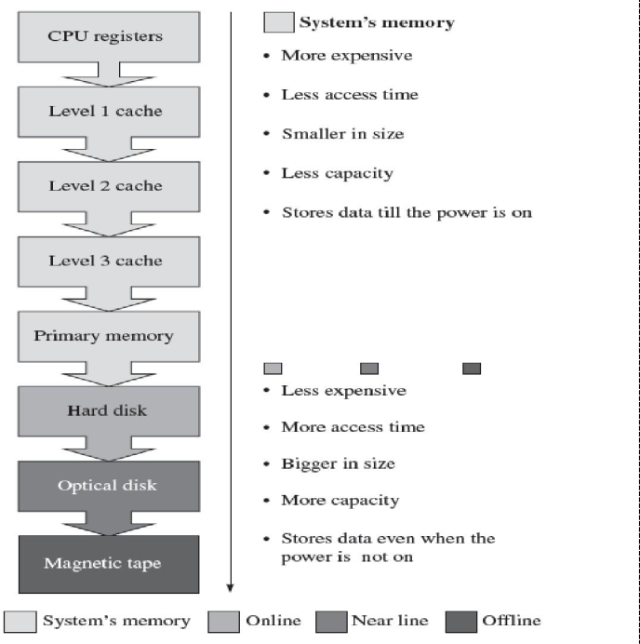

Cache Memory is an intermediate form of storage between the ultra fast registers and the RAM. The CPU uses cache memory to store instructions and data that are repeatedly required to execute programs, thereby improving the overall system speed and increasing the performance of the computer

Cache memory is basically a potation of memory made of high speed static RAM instead of slower and cheaper DRAM which is used to for main memory

**Levels of memory:**

* **Level 1 or Register –**  
  It is a type of memory in which data is stored and accepted that are immediately stored in CPU. Most commonly used register is accumulator, Program counter, address register etc.
* **Level 2 or Cache memory –**  
  It is the fastest memory which has faster access time where data is temporarily stored for faster access.
* **Level 3 or Main Memory –**  
  It is memory on which computer works currently. It is small in size and once power is off data no longer stays in this memory.
* **Level 4 or Secondary Memory –**  
  It is external memory which is not as fast as main memory but data stays permanently in this memory.

**Cache Performance:**  
When the processor needs to read or write a location in main memory, it first checks for a corresponding entry in the cache.

* If the processor finds that the memory location is in the cache, a **cache hit** has occurred and data is read from cache
* If the processor **does not** find the memory location in the cache, a **cache miss** has occurred. For a cache miss, the cache allocates a new entry and copies in data from main memory, then the request is fulfilled from the contents of the cache.

The performance of cache memory is frequently measured in terms of a quantity called **Hit ratio.**

Hit ratio = hit / (hit + miss) = no. of hits/total accesses

We can improve Cache performance using higher cache block size, higher associatively, reduce miss rate, reduce miss penalty, and reduce Reduce the time to hit in the cache.

**Q Explain the different Icons available on the Windows Desktop?**

Computer desktop contains many icons. Icon is a small graphical image that belongs to shortcut for a folder or program. By selecting the icon you can open the corresponding folder or program.  They are

1. My Computer
2. My Documents
3. Recycle Bin
4. Internet Explorer, etc.

**My Computer icon**

 This is a standard icon and is very useful; it contains all the resources available in your computer. Generally it consists of hard disk drives, removable storage devices, network drives, and user documents and shared documents folder of your computer. To open My Computer window then double-click My Computer icon on the desktop or go to start button and then select My Computer option or press keyboard shortcut keys ―Window Button W‖ then the My Computer Window will appear.

**My Documents**:

The default location where to create all types of documents, workbooks, images, presentations, databases, image files, folder in windows environment is My Documents folder. My Documents folder contains My Pictures, MyVideos, My Music, and all types of files created by the user. To open My Documents double-click My Documents icon on the desktop or go to start button and then select My Documents option then the My Documents folder will appear.

**Recycle Bin**:

The files removed by the user in the computer will go to this Recycle bin. Do you want to remove the files permanently from the computer then select ―delete‖ option in the recycle

bin. If you want to get back files from recycle bin to the original location where the file is actually deleted, then select ―restore‖ option from the recycle bin.

**Internet Explorer**:

Internet Explorer is the default browser application provided by the Microsoft Corporation in the windows operating system. Browser is application program or software it can be used to view web sites or web pages on the internet and also it allows the user to create web pages. You can open Internet Explorer by double-clicking Internet explorer icon on

the desktop or press Internet explorer option in the start button.

 UNIT - 3

         Introduction to Adobe Photoshop

**Q1 Draw a neat sketch of Photoshop application window.Explain its parts in detail ?**

**Title Bar**:

Title bar always displays the name of the program that you are currently working, title bar contains ―Adobe Photoshop

**Menu Bar**:

 Menu bar is a horizontal bar; it contains file, edit, image, layer, select, filter, view, window, an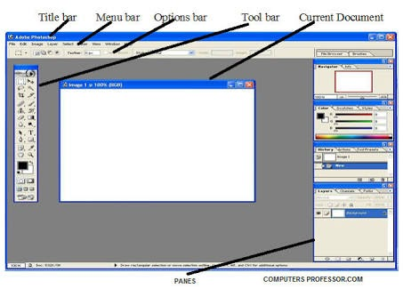d help menus. All options for working with the Photoshop are available in the menus.

**Options bar**:

Every tool in Photoshop Elements has options that you can change; options bar contains the options for your currently using tool in the toolbar.

**Toolbar**:

Tool bar is a vertical bar; it has so many tools that enable us to design an efficient image. Tool bar contains the following tools, they are: marquee tool, move tool, lasso tool, magic wand tool, crop tool, slice tool, healing brush tool, brush tool, clone stamp tool, history brush tool, eraser tool, gradient tool, blur tool, dodge tool, path selection tool, horizontal type tool, Pen tool, rectangle tool, notes tool, eye dropper tool, hand tool, zoom tool, set foreground and background tool, etc.

**Current document**:

which document you are currently working is called as current document.

**Panes**: Panes are also vital features that relay all kinds of information like tool options, layer selection, history, display location information, and text style, among others. Here is a list of panes you are most likely to encounter when you start using Photoshop: Palettes, Layers, etc.

**Q2. Explain Toolbox in Photoshop ?**

**Rectangular Marquee Tool (M):**

Use this tool to make selections on your image, in a rectangular shape. This changes the area of your image that is affected by other tools or actions to be within the defined shape.

**Move Tool (V):**

Use this tool to, well, move things. Usually you use it to move a Layer around after it has been placed. Hold the [Shift] key to limit the movements to vertical/horizontal.

**Polygon Lasso Tool (L):**

Use this to draw selections in whatever shape you would like. To close the selection, either click on the beginning point, or just double-click. When holding the [Ctrl] key, you‘ll see the

cursor change, and the next time you click, it will close your selection**.**

**Magic Wand Tool (W)**:

Use this to select a color range. It will select the block of color, or transparency, based on wherever you click. In the Options Bar at the top, you can change the Tolerance to make your selections more/less precise.

**Crop Tool (C):**

The Crop Tool works similarly to the Rectangular Marquee tool (see above if you have no short-term memory). The difference is when you press the [Enter/Return] key; it crops your image to the size of the box. Any information that was on the outside of the box is now gone. Not permanently, you can still undo.

**Slice Tool (K):**

This is used mostly for building websites, or splitting up one image into smaller ones when saving out. It‘s kind of an advanced tool, and since you're here for the basics, we‘ll kind of skip over it.

**Healing Brush Tool (J):**

You can use this tool to repair scratches and specs and stuff like that on images. It works like the Brush tool. You choose your cursor size, then holding the [Alt] key, you select a nice/clean area of your image. Let go of the [Alt] key and paint over the bad area. It basically copies the info from the first area to the second, in the form of the Brush tool.

**Brush Tool (B):**

It paints one your image, in whatever color you have selected, and whatever size you have selected. There are a lot of options for it, but this is basic, so you don‘t get to learn them.

**Clone Stamp Tool (S):**

This is very similar to the Healing Brush Tool. You use it the exact same way, except this tool doesn‘t blend at the end. It‘s a direct copy of the information from the first selected area to the second**.**

**History Brush Tool (H):**

This tool works just like the Brush Tool except the information that it paints with is from the original state of your image. The History Brush tool paints with the information from whatever

History state is selected.

**Eraser Tool (E):**

This is the anti-Brush tool. It works like an eraser and erases whatever information wherever you click and drag it. If you‘re on a Layer, it will erase the information transparent. If you are

on the background layer, it erases with whatever secondary color you have selected.

**Gradient Tool (G):**

You can use this to make a gradation of colors. Gradation doesn‘t appear to be a word, but it makes sense anyway. It creates a blending of your foreground color and background color when you click and drag it. Like a gradient.

**Blur Tool (R):**

The Blur tool is cool. It makes things blurry. Click and drag to make things blurry. The more you click and drag, the blurrier things get.

**Dodge Tool (O):**

This tool isn‘t as crappy as the car brand. It‘s actually used to lighten whatever area you use it on. As long as it is not absolute black. Absolute black won‘t lighten.

**Path Selection Tool (A):**

You use this tool when working with paths. Since this is all about the basics, I won‘t go into details. It‘s related to the Pen Tool though.

**Horizontal Type Tool (T):**

It makes type. You can click a single point, and start typing right away. There are a lot of options for the Type Tool. Just play around, it‘s fairly straight-forward.

**Pen Tool (P):**

It‘s for creating paths, in which you would use the Path Selection Tool to select the path. You use the tool by clicking to add a point. If you click and drag, it will change the shape of your path, allowing you to bend and shape the path for accurate selections and such

**Rectangle Tool (U):**

By default it draws a Shape Layer in the form of a rectangle. It fills the rectangle with whatever foreground color you have selected. It‘s pretty complicated; don‘t hurt yourself with this one.

**Notes Tool (N):**

Like post-it notes, but digital. You can use this tool to add small little note boxes to your image. These are useful if you‘re very forgetful or if you‘re sharing your Photoshop file with someone else**.**

**Eyedropper Tool (I):**

This tool works by changing your foreground color to whatever color you click on. Holding the [Alt] key will change your background color.

**Hand Tool (T):**

It‘s for moving your entire image within a window. So if you‘re zoomed in and your image area is larger than the window, you can use the Hand Tool to navigate around your image. Just click and drag. You can get to this tool at any time when using any other tool by pressing and holding the [Spacebar].

**Zoom Tool (Z):**

It allows you to zoom into your image. Hold the [Alt] key to zoom out. Holding the [Shift] key will zoom all of the windows you have open at the same time. Double-click on the Zoom Tool in the palette to go back to 100% view.

**Background colour:**

These are your color boxes. Foreground (in the front) and Background (in the back). Click on either one to bring up the color select dialog box.

**Q3. How to create a new document in Photoshop and advantage of Photoshop and saving a document in Photoshop ?**

**Create a new document:**

1. Go to file menu and select new option.
2. New‖ Dialog box will appear
3. In the above dialog box enter the name of the document.
4. Select the document size at preset sizes combo box.
5. Select colour mode (RGB color / CMYK color, etc) if required.
6. Press ―OK‖ push button
7. A new document will be created.

**Advantage of Photoshop** :

1. Adobe Photoshop is a graphics designing application software, in which you can edit photos, create art, retouch product photos, images from raster to vector, photo manipulation and many, etc. that you can do in the Adobe Photoshop easily and creatively
2. Adobe Photoshop CC 2017.1 and it is developed and published by Adobe System for macOS and Windows.
3. Adobe Photoshop is great. I started using in 2008 and till today. I like photo editing and photo manipulation. I use it for Logo Designing, creative art, blog images and for many other things professionally. Adobe Photoshop helped me a lot in my career and business

**Saving a Document in Photoshop:**

1. Go to file menu and select the save option.
2. It will display ―Save As‖ dialog box.
3. In the save as dialog box first select the location where the document will be save in your computer
4. Type the name of the file name.
5. Choose format for your image such as JPEG / TIFF / Photoshop, etc.
6. After using required options in the dialog box press  SAVE push button.
7. Photoshop file will be saved.

**Q4.Explain about the menu bar  in Photoshop ?**

Menu bar in the Photoshop contains the following menus:

* File
* Edit
* Image
* Layer
* Select
* Filter
* View
* Window, and Help.

**File Menu**:

* *New*  This option is used to create a new Photoshop.
* *Open* This command is used to open a required image file in Photoshop
* *Close* This option is used to close an open document in Photoshop.
* *Save* This option is used to save any document created or modified on Photoshop in any required format.
* *Save As*  If you want to save an image file two or more than two times with two or more than two different names or formats you can use the option named Save As.
* *Revert* This option is used to remove all the changes made in any image by the use of Photoshop.
* *Page Setup* This command is used to set the Size, Source and Orientation for the page.
* *Print* This command is used to print any selected file in as much copies as we need.
* *Exit* This command is used to close opened Photoshop window.

**Edit Menu**

* *Undo* This command is used to delete the impact of the most recently applied command on the Photoshop document.
* *Step backward* This Command is used to undo or remove the impacts of the two or more than two recently applied commands from the Photoshop document one by one.
* *Step forward* This command is used to apply back the removed impacts of the two or more than two commands on Photoshop document.
* *Cut* Through this command we can transfer any selected image or a selected part of an image temporarily from the canvas to computer‘s memory (Clip Board).
* *Copy* Through this command we can create a copy of a selected image or the selected part of an image temporarily into computer
* *Paste* This command is used to drop and display images that we have saved in the Clipboard by applying Cut, Copy commands.
* *Clear* In Adobe Photoshop 7.0 the command named Clear is used to delete the selected part of the layer that is currently selected in the layer palette.
* ***Check spelling*** Through this command you can correct the spelling mistakes made accidentally in the text, typed on the Photoshop document.
* *Find and replace text* If you have used any specific word many times in the text typed on Photoshop document and you want to replace that word with some other words in an instant,you can use the option named Find and Replace Text given in the Edit Menu.
* *Fill* This command is used to fill any desired solid color or predefined pattern inside the selected layer with desired level of Opacity.
* *Stroke*This option is used to create an outline around the selected area. Through this option you can not only create an outline around the selected area, but you can set the Width, Color, Location, Blending Mode and Opacity for that outline.
* *Free transform* Through this command you can easily resize any selected layer and rotate it in any direction.
* *Purge* This command is used to make Photoshop run faster by deleting unnecessary or corrupt files holding the record of previously applied commands on Photoshop document from the computer's memory.

**Image Menu:**

* *Mode* The first item on the Image menu is Mode. This is what you use to change the color mode and appearance on the entire image.
* Adjust You can see that the adjust option on the Image menu gives you a lot of different tools for adjusting your image make with Photoshop involve colors and brightness.
* *Image size* Another common basic feature of Photoshop that lives on the Image menu is image size. You use this function to resize an image
* *Canvas size* Canvas Size is similar to Image Size,  changes to an image's canvas size. Make a selection, go to Image and select crop, and then everything outside your selection disappears. The image size reflects the change.

**Layer menu:**

* *New* To create a new layer.
* *Duplicate layer* Creates the duplicate layer.
* *Delete* For deleting selected layer.
* *Layer properties* To know the properties of current layer like name, color, etc.
* *Layer style* For applying stroke, shadow like styles to the current layer.
* *New fill layer* For applying solid color, gradient and pattern options.

**Select Menu:**

* *All* This command selects everything on the current layer.
* *Deselect* Use this command to get rid of the marching ants around a selection.
* *Reselect* If you didn‘t mean to deselect a selection, use this command to get the selection back.
* *Modify* This option lets you tweak the edge of your current selection by expanding or shrinking it, feathering it, grabbing just its border, or smoothing it.
* *Grew* This command finds and grabs pixels that match the colors around the area you‘ve selected.
* *Similar* Like the Grow command, this option finds all the pixels in your image that match the selected area‘s colors, but it finds similar-coloured pixels anywhere in your image.
* *Transform selection* This command lets you resize the currently selected area with the handles of a bounding box

**Filter Menu**:

* *Liquefy* This filter lets you push, pull, and move pixels in all sorts of ways.
* *Blur* These filters change the focus in all or part of an image.
* *Artistic* This category includes filters that make your images look like a painting or drawing.
* *Brush strokes* The filters in this category make your image look like it was painted, penciled, or spray painted, among other effects.
* *Distort* These filters create geometric patterns based on your image, including ripple, twirl, and zigzag effects.
* *Noise* This category includes filters that can help smooth areas of your image that don‘t blend well, fix dust and scratches in photos, and remove graininess.
* *Sharpen* You can use filters in this category to make blurry or out-of-focus images appear more clear.

**View Menu:**

* *Proof setup* Use the items in this submenu to create a proof.
* *Proof colours*This option turns soft proofing on or off.
* *Pixel aspect ratio* This item lets you change the shape of your image‘s pixels for specific projects.
* *Zoom in* This command works like a magnifying glass, increasing your image‘s magnification level .
* *Zoom out* This command decreases your image‘s magnification level.
* *Print size* This item changes the size of your image to show how big or small it will be when you print it.

**Window Menu:**

Use this menu to change what you see in Photoshop; it lets you arrange your open documents, view or hide panels, and so on. Here we have options that the parts of Photoshop application window likes, Tools, options, Navigator, color, history and layers, etc are to hide or unhide.

**Help Menu**:

If you don‘t know how to do something in Photoshop, you may find the answer in this menu. It includes a link to Adobe‘s online help system, several tutorials, and options for activating and deactivating your copy of Photoshop. You need an active Internet connection to use almost every item in this menu.

**Q5. How to reverting files in Photoshop** ?

The word revert means to return to something earlier or to go back. While changing an image in the Photoshop, do you want to cancel the previous step and get the image into the previous state then you can use revert option in the file menu.

Follow the below steps to know how to use revert option:

1. Open an image.
2. Make changes in the original image.
3. To revert (kept the image in the previous state), then click revert option in the file menu.
4. You can see that the last action you have used on the image will be reverted.
5. You can use revert option until you reached the image in original stage.

**Unit 5**

**Layers and filters**

**1. What are the layers . What are the uses for layers types of layers ?**

**Layers :**

 Layers assist you in organization content in your documents you can keep background art on one layer and navigation button on another layer.you can create and edit option ID on the one layer without any effective object on another layer.

1. **Select a layer**
2. **Hide and show layers**
3. **Lock a layers**
4. **Add and name a layer**
5. **Change the layer order of the layer**
6. **Organize layer in a  folder**
7. **Add a mask layer**
8. **Add guide layer**
9. **Delete layer**

**Select a layer :**

* You place object add text and graphics and edit on the active
* In the toolbar click the selecting tool
* On the stage select an image click on the pencil icon in a timeline select the image now the active layer.
* Select the text layer in timeline since they are both on the text layer

**Hide and show layers:**

You can hide layers to view content on other layers

1. Click the eyes icon above the layers so that a red x appears in the eye column.all content disappears from the stage .
2. One by one click each red X in the column and watch the content for the layer reappear on the stage .
3. Controls to the right of each layer name let you show or hide the contents of a layer .

**Lock a Layer :**

When you're placed content as desired on a layer you can lock the layer to avoid inadvertent change to the content by you or by other's working on the documents

1. In the timeline ,click the black dot under the lock column next to the login layer.A padlock icon appears indicating the layer is now locked .
2. With the selection tool,try to drag the login that appears along the top of the stage you can't drag the login because the layer is locked .
3. If you accidentally drag something from an unlocked layer press (control + Z) to undo your change .

**Add and name a layer :**

Your now add a layer name the layer and then add a graphic symbol to the layer .

1. In the timeline click image .
2. Click the insert layer button below the timeline the new layer appears above the image layer and becomes the active layer .
3. Double click image the layer name type **BACKGROUND** as the new name for the layer and press enter or return .
4. In the library panel (window - library ) , select the background graphic symbol and drag it to the stage .

**Change the order of layer:**

You don't want the background to cover the other object on the stage.normally the background layer is the button layer on the timeline

1. In the timeline drag the background layer from the top position to the button position all objects on the stage now appear on top of the background .
2. With the background layer still selected in the property inspection enter 0 in the X text box 72 in the Y text box press enter or return to previous position the background layer on the stage .

**Organize layer in a folder** :

You can create layer folder to organize layers and reduce timeline clutter .you create a layer folder named navigation for both layers.

1. In the timeline select the button layer
2. Click the insert layer button which is below the layers names .
3. Double click the layer folder name and rename the folder **navigation.**
4. Drag the navbar layer and the button layer to the Navigation folder
5. The layer appear indented to indicate that they're within the folder .

**Add a mask layer :**

Using a mask layer provides a simple way to selectively reveal portions of the layer or layers below it :

1. On the stage with the selection tool selected click the rectangular shape below the road .
2. Drag the shape straight up and align the left edge of the shape with the left edge is the road.
3. Right click the mask layer in the timeline and select mask from the context menu .
4. In the timeline drag and image to the layer placing it below the layer mask layer and the layer it maks are automatically locked .
5. To view the mask effect select control - test movie
6. When you finish viewing the mask effect close the SWF file window to return to your documents .