# Damage Limited by the Distribution of High-Frequency Radiation in the 2015 Gorkha, Nepal, Earthquake

# J. P. Ampuero*1, S. E. Hough2, L. Meng3, E. M. Thompson4, A. Zhang3, S. S. Martin5, D. Asimaki1 and A. Inbal1

# 1California Institute of Technology, 1200 E. California Ave, Pasadena, California, 91106 USA, ampuero@gps.caltech.edu

# 2U.S. Geological Survey, 525 S. Wilson Ave, Pasadena, California, 91106 USA, hough@usgs.gov

# 3U.C. Los Angeles, 595 Charles Young Drive East, Los Angeles, California, 90095 USA, meng@ess.ucla.edu

# 4U.S. Geological Survey, 1711 Illinois Street, Golden, Colorado, 80401 USA, emthompson@usgs.gov

# 5Earth Observatory of Singapore, Singapore, 7point1@gmail.com

**Abstract**

The 25 April 2015 Mw7.8 Gorkha, Nepal, earthquake occurred along a segment of the Main Himalayan Thrust directly beneath central Nepal and Kathmandu valley. In spite of the magnitude and proximity to the rupture, shaking throughout the near-field region only in rare instances caused damage commensurate with European Macroseismic Intensity 8 (1). This surprising result has been attributed previously to gross source properties (2) and site effects (3, 4). Here we show that the distance to sources of high-frequency (HF) radiation, as imaged by back-projection using multiple teleseismic arrays with an innovative calibration method, had a first-order effect on shaking intensities throughout Nepal. We suggest that, since deep HF radiation is a common feature of subduction zone earthquakes, hazard assessments can be improved by considering the expected distribution of HF sources within megathrust ruptures, and well-calibrated back-projection imaging can provide timely constraints on potential shaking damage for rapid response.

**Introduction**  
The 25 April 2015 *Mw*7.8 Gorkha, Nepal, earthquake occurred along a segment of the Main Himalayan Thrust (MHT) directly beneath central Nepal, in between the rupture zone of the 1934 Bihar-Nepal earthquake and the central locked zone to the west (1, 2). Seismic hazard has long been recognized to be high along the Himalayan arc, with a certainty that, along with its neighbors, Nepal would inevitably experience earthquakes as large as, and even larger than, the estimated*Mw*8.1-8.41934 Nepal-Bihar event (5, 6, 7). Prior to the 2015 earthquake, loss estimation calculations suggested that a repeat of the 1934 earthquake could cause as many as 40,000 fatalities in Kathmandu valley (8). Part of the concern for Kathmandu valley stemmed from its geological setting, a former lake bed zone with an estimated fundamental resonance mode near 0.5 – 1.5 Hz (9). It was moreover clear that structural vulnerability was generally high due to limited enforcement of building codes as well as, more fundamentally, economic pressures (8).

# The 2015 earthquake was smaller than the 1934 event, but whereas the 1934 earthquake ruptured a segment of the décollement east of Kathmandu valley (6), the 2015 earthquake nucleated west of Kathmandu and ruptured the MHT segment directly beneath the valley (2). In spite of the high magnitude, proximity of the fault rupture to the valley, directivity, and site response associated with soft sediments, most buildings in Kathmandu valley experienced at most minor structural damage, commensurate with EMS intensity 6-7, rather than ≈8, as would have been expected from the regional intensity-prediction equation (1). The relatively low level of damage within Kathmandu valley was clearly due to the remarkably long-period character of the mainshock ground motions, with energy concentrated near 0.16 - 0.2 Hz, and no significant resonance at the fundamental period of amplification of valley sediments expected from previous weak-motion studies (4). *Galetzka et al.* (3) showed that source energy was peaked near 6 s, with a predominant 4-5 s basin response, and low energy at shorter periods. *Dixit et al.* (8) concluded that soft sediments within the valley experienced a pervasive non-linear response, such that the basin response fundamental frequency was shifted to ≈0.2 Hz and the amplification factor was likely reduced (e.g., 10). Non-linear response is expected to further deamplify high-frequency shaking (10), which likely contributed to the relatively low intensities in Kathmandu valley.

# Although the focus of ground motion investigations has been on Kathmandu valley, the overall level of damage reveals that shaking intensities were relatively low throughout the near-field region, with intensities only in rare instances as high as or higher than EMS 8 (1). Estimations of the teleseismic source spectrum (11) suggest that, while the distribution of high frequency energy varied over the rupture, the overall teleseismic P-wave source spectrum was not depleted in high frequency energy relative to an omega-square model for frequencies up to 2 Hz. In this study we consider additional factors, related to detailed source effects, that likely contributed to the low amplitude of high-frequency ground motions not only within Kathmandu valley, but throughout Nepal.

# High Frequency Radiation

# In any large earthquake, high frequency (HF) energy is not necessarily radiated uniformly along the rupture surface (e.g.,12). In recent years, back-projection methods have been developed to image the locations of predominant HF energy release using teleseismic waves recorded across seismic networks (13). For the Gorkha earthquake, *Avouac et al.* (2) present preliminary back-projection results imaging HF radiation (0.5-2 Hz) using the multitaper-MUSIC method (12, 14) and data from a single seismic array in Australia. From these results, they conclude that high frequency waves were radiated from a relatively narrow swath along the deeper portion of the rupture, concentrated near the transition between the locked and creeping portions of the Main Himalayan Thrust.

# 

# 

# Figure 1. (a) Cross-section across Himalayan front indicating schematically how primary decollement rupture controls low-frequency (LF) shaking, while deep high-frequency (HF) sources control HF shaking (geology section courtesy of J.-P. Avouac). (b) Smoothed EMS Intensity residuals relative to a baseline of 6.5 for point locations (1). Surface projection of mainshock rupture area is shown (dashed black contour) corresponding to slip of 1 m (16), as well as epicenters of mainshock and M7.3 aftershock (circled stars). Locations discussed in the text are indicated: Katmandu valley (KV), Tserko Ri (TS), Chisapani (CH), Barpak (BP), Archale (AR), and Tarke Gyang (TG). Average HF locations are also shown (dark circles).

# The resolution of HF sources can be assessed and improved by considering data from multiple arrays. For this study we consider high-frequency (0.5-2 Hz) teleseismic data recorded across arrays in North America (NA), Europe (EU), and Australia (AU). The three arrays are located at complementary orientations relative to the source. Independent analysis of the three data sets (Supplemental Information, Figure S1) reveals general similarity, consistently showing unilateral eastward migration of HF radiation at significant distance from Kathmandu. However, there are systematic differences: the apparent rupture length is shorter in the EU results (~ 90 km) than in the AU results (~150 km), leading to significantly different rupture speeds (2.2 km/s and 2.8 km/s, respectively), and the apparent rupture direction is roughly East in the NA results but close to the 120° strike of the MHT in the EU and AU results (Figure S1). These differences are likely due to three-dimensional path effects, especially near the source and array (15), which are not completely corrected for by waveform alignment prior to back-projection. We develop an empirical calibration method to correct for biases, using recordings of the M6.7 aftershock of April 26th, 2015 (see Supplementary Information).

# The individual array results (see Supplementary Information) provide independent estimates of HF locations. We average the results from the three arrays in common time intervals to obtain the final estimate of HF locations shown in Figure 1b. Once the empirical correction is applied, back-projection results from the three arrays are in better agreement (Figure S1). They generally confirm that HF radiation was released along the extent of the rupture as it progressed from west to east over ~ 150 km along the down-dip edge of the locked zone of the MHT (2), with nearly constant power over the extent of the rupture. The rupture direction and speed from the three arrays are consistent. The inferred rupture speed is 2.7 km/s, consistent with that derived in various finite source inversion solutions. The remaining differences between arrays can be taken as a measure of the HF location uncertainties of the back-projection method, and are small compared to their overall distance to Kathmandu.

# In the following sections we compare these results to shaking intensities across the rupture zone (1), as well as available instrumental recordings of strong ground motions in Kathmandu valley (3, 4, 17).

# Observed Shaking Intensities

While near-field instrumental data are sparse, an extensive set of macroseismic intensities was compiled, with EMS intensities assigned at over 3400 locations throughout Nepal and neighboring countries (1). In contrast to damage maps (18), intensity assignments are made with careful consideration of building type and vulnerability, and provide the only available data to constrain the spatial distribution of shaking intensities throughout Nepal. For any felt earthquake, intensities provide a reliable estimation of shaking (19, 20), with each step in intensity corresponding robustly to a factor of two increase in peak acceleration (21). Intensities further reflect relatively high-frequency shaking, ranging from 0.7-1.0 Hz for EMS 8-9 to 7-8 Hz for lower intensities (22). Intensity values can be converted to PGA with established intensity-PGA relationships (23), assuming that a relationship developed for southern California is appropriate for Nepal as well. The intensity data (1) provides an ideal basis of comparison to the HF results because 1) it is the only data set that provides a spatially rich view of the distribution of intensities across the rupture zone, and 2) intensity data provide an independent estimate of shaking over a similar frequency band as that imaged by back-projection.

To focus on the variability of near-field shaking we consider EMS residuals, calculated by subtracting a baseline value of 6.5 from all intensities (1). One expects the distribution of near-field intensities to reflect a combination of source, path, and site effects (21). For the Gorkha earthquake, topographic amplification clearly accounted for some of the locally high intensities both within Kathmandu valley and elsewhere (1, 18). For example, the Swayambunath Temple, which sits atop an isolated hill, experienced more severe damage than other locations within Kathmandu valley (1). To explore possible source effects, we smooth observed intensity values over 3-minute cells to minimize the influence of individual intensity assignments that might be amplified by local site response (Figure 1b). We use a Laplacian smoothing operator with a tension factor of 1, which ensures that no maxima or minima are possible except at control data points.

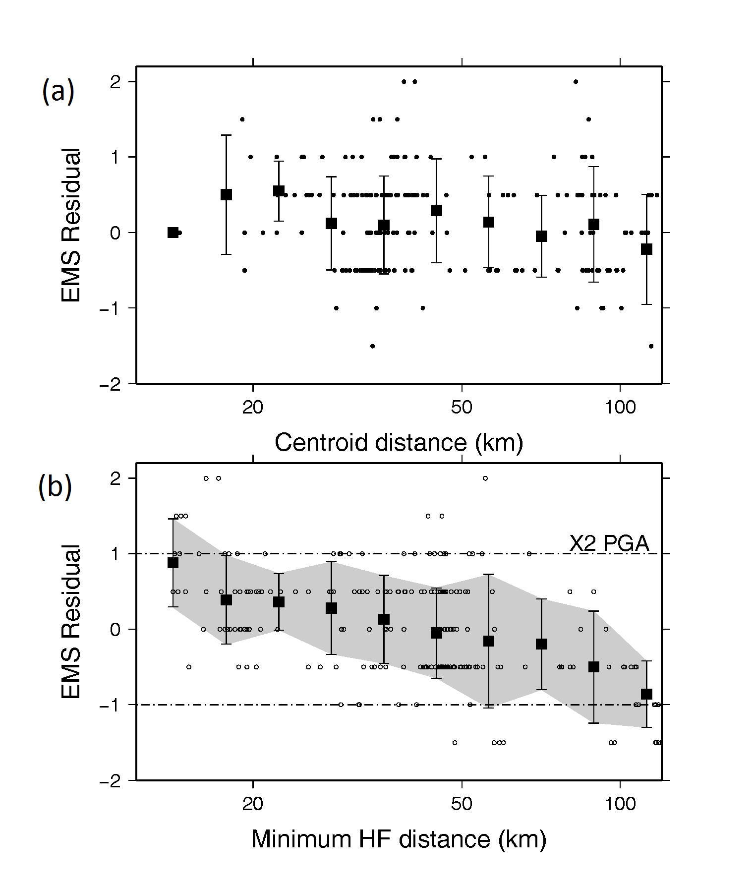

Figure 2(a, top). EMS intensity residuals versus centroid distance, with individual (black dots) and bin-averaged values (squares) shown. Dashed lines indicate corresponding amplification factor for peak ground acceleration (PGA). (b, bottom) EMS intensity residuals versus closest hypocentral distance to HF source locations. Shaded region indicates ±1 around mean of bin-averaged values.

Figure 1b suggests a good general correspondence between the HF locations and the zones of relatively stronger macroseismic intensities, with a handful of exceptions where intensities are controlled by individual assignments (Supplementary Information). Apart from these isolated locations, there is a good correlation between intensity and HF locations near the epicenter and in the middle of the rupture to the northeast of Kathmandu valley. The most prominent concentration of both HF sources and high intensities is in the central part of the rupture, where especially heavy damage occurred at villages including Tarke Gyang (labeled TG in Figure 1b).

The correspondence between intensities and HF locations is demonstrated more quantitatively by considering the correlation between EMS intensities and average HF locations (Figure 2). Whereas there is no significant correlation between near-field intensities and centroid distance (Figure 2a), there is a correlation between residuals and *Rhf*, defined to be the nearest distance to HF sources assuming a depth of 14 km (Figure 2b).

**Instrumental Data**

It is clear from initial analysis of available instrumental data (Supplementary Information) that ground motions within Kathmandu valley were controlled by a combination of source and complex, three-dimension site effects (3, 4, 17, 24). Mainshock shaking at valley sites KATNP and NAST was amplified relative to shaking at hard-rock site KKN4 at periods of 3 to 5 s (3). *Dixit et al.* (4) conclude that the absence of the weak-motion fundamental resonance mode indicates a pervasive non-linear response of sediments within the valley. *Rajaure et al.* (17) confirm this result, showing that at frequencies higher than 1 Hz, shaking in the valley was de-amplified by the inferred non-linear response (4).

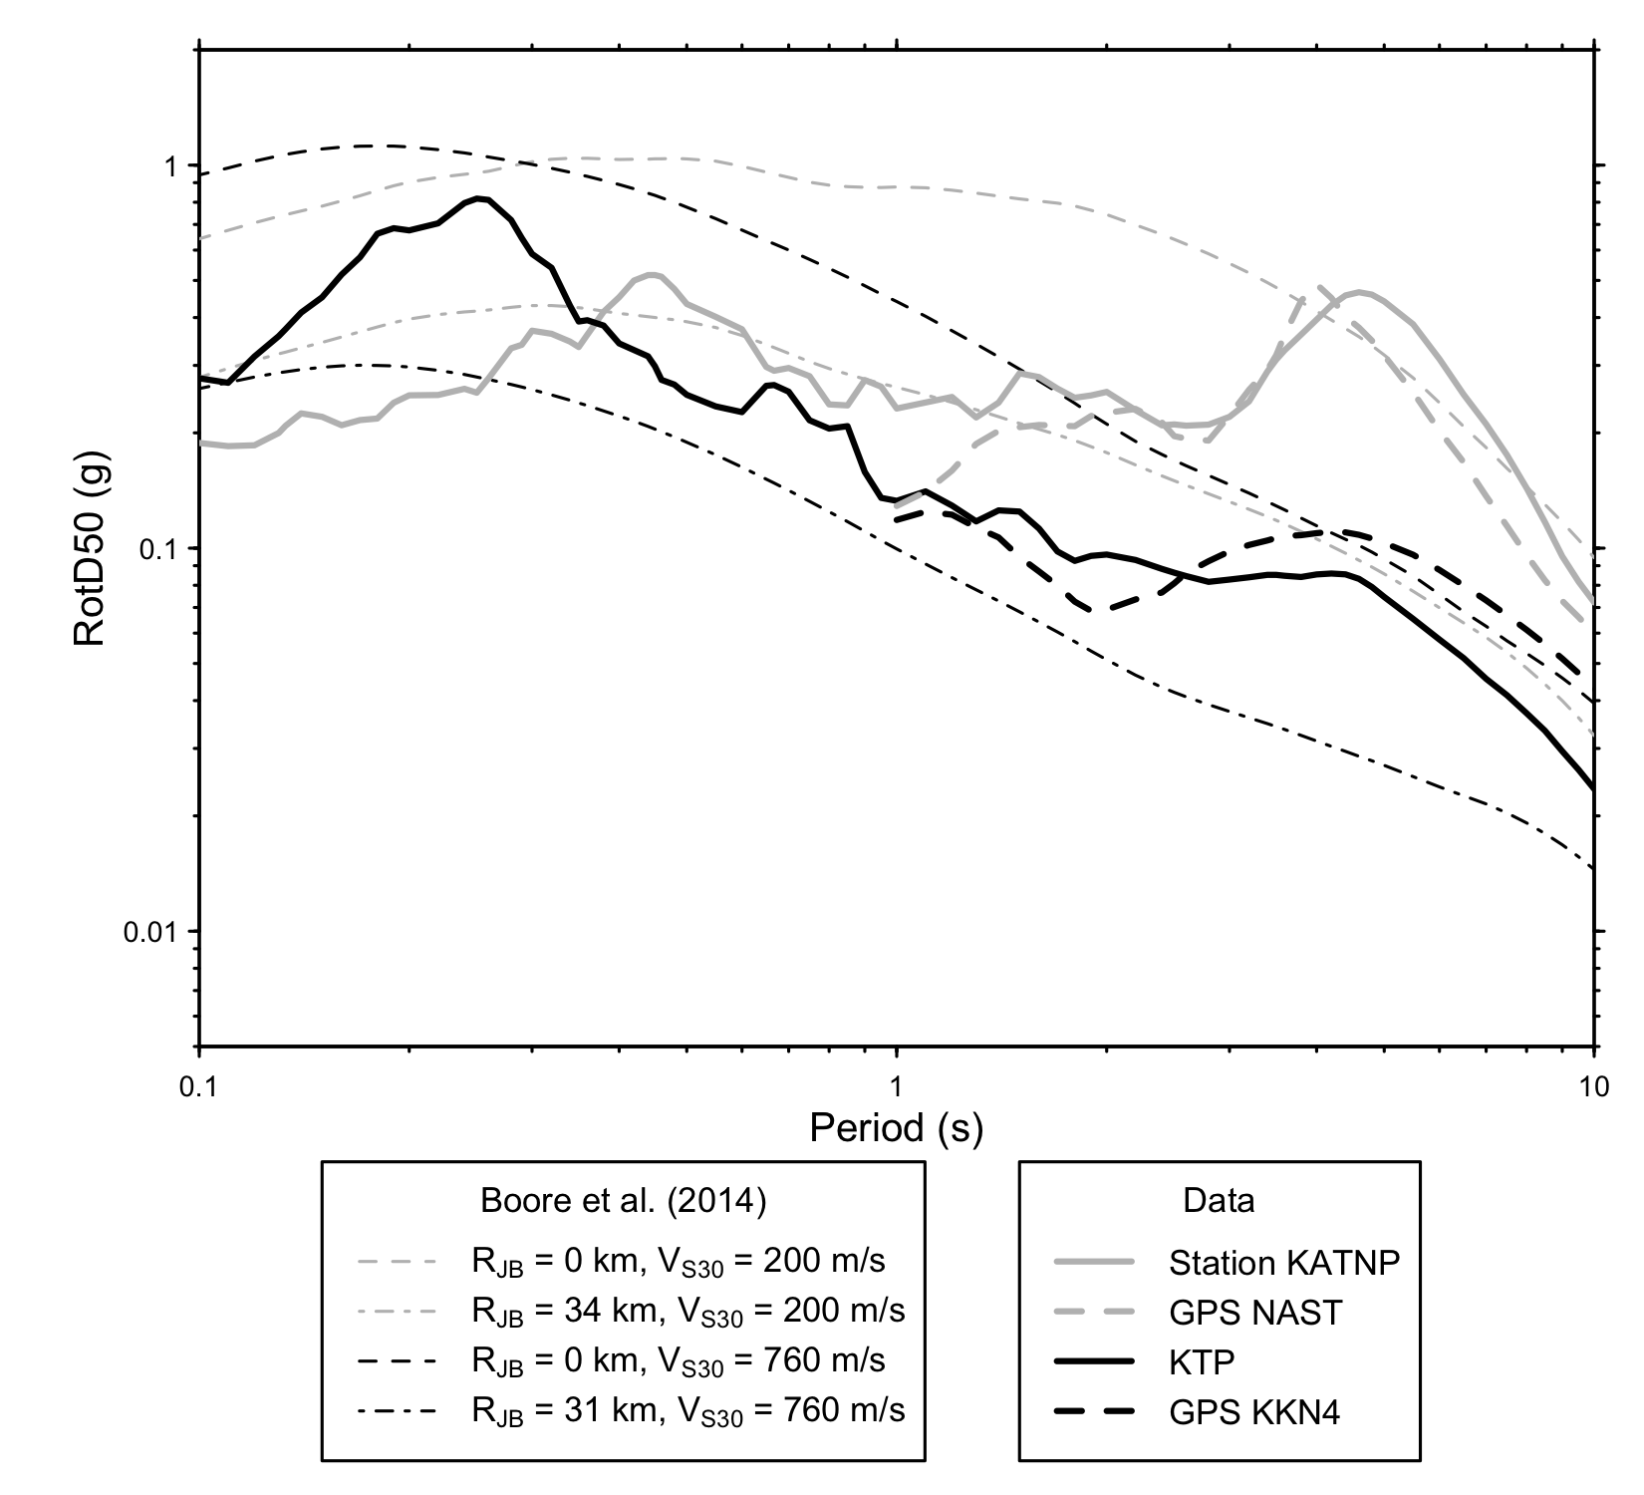

Figure 3. Rotation-independent response spectral acceleration (*Sa*) from strong motion station KATNP on sediments (light gray line), high-rate GPS station NAST (3) on sediments (thick dashed gray line), high-rate GPS station KKN4 on rock (thick black line), and strong motion station KTP on rock (dark black line) versus predictions (26) for distances of 0 and 34 km for the soil sites with VS30=200 m/s (gray dashed and dot-dashed lines, respectively) and distances of 0 and 31 km for the rock site with VS30=760 m/s (black dashed and dot-dashed lines). The KATNP recording has excellent signal-to-noise levels for periods down to 0.1 s (Supplementary Information, Figure S2). The GPS data have adequate signal-to-noise levels for periods as short as 1 s (Supplementary Information, Figure S3).

In this study we focus not on ground motions in Kathmandu valley, which were clearly controlled by multiple factors, but rather we use available data to further investigate the extent to which shaking intensities were influenced by source effects. Following *Rajaure et al.* (2016), we compare the rotation independent (25) response spectral acceleration (*Sa*) of the Mw7.8 mainshock to a recently developed ground motion prediction equation (GMPE) (26) (Figure 3). Although this GMPE was developed primarily with ground motions from the Western United States (26), it provides a reasonable analog for Nepal, and is consistent with aftershock recordings in Kathmandu (17). For this comparison, we have assumed time-averaged shear wave velocity of the top 30 m VS30=200m/s for the KATNP and NAST sites, the value estimated for Kathmandu by the Japan International Cooperation Agency, and 760 m/s for reference site KTP (27).

Ground motion prediction equations are commonly based on the nearest distance to the surface projection of fault rupture (26), defined as *RJB*. For stations in the Kathmandu valley, *RJB* is zero. Comparing the predicted versus observed *Sa* (Figure 3), we see that the records on both rock (KKN4, KTP) and soil (KATNP, NAST) are in agreement with their respective GMPEs for *RJB*=0 at long periods (T > 4 s) but there is a transition to shorter periods where the observed *Sa* are more consistent with predictions based on *RJB* values representative of the distance not to the rupture slip area, but to HF source locations. This is illustrated in Figure 3 by using *RJB* = 34 km for the soil sites and *RJB* = 31 km for the rock site. The specific location of the high-frequency radiation sources of the Gorkha mainshock explains the anomalously weak ground motions recorded near and inside the Kathmandu Valley and the spatial distribution of EMS intensities throughout the region.

# Conclusions

# Characterization of earthquake sources has long focused on the gross properties of ruptures, and relatively long-period radiation. The relatively recent recognition that HF radiation is characterized by its own distribution (12) has important implications for earthquake hazard, which the community is only beginning to explore. As the Gorkha earthquake illustrated dramatically, long-period shaking can be damaging to tall buildings and large structures, but does not necessarily contribute to the damage of small (1-10 story) structures (1, 4). In this study we have improved the characterization of HF energy release using teleseismic data recorded on three different arrays, developing and applying an empirical calibration approach to correct each data set for 3-dimensional path effects. We show that this approach improves the consistency of results from different arrays and confirms that, for the Gorkha earthquake, HF radiation was released along a swath running along the deeper portion of the rupture, towards the inferred transition between the locked and creeping parts of the plate boundary, at distances of more than 30 km to Kathmandu. We show that these results can help explain the distribution of shaking intensities across the near-field region as well as the relatively modest level of shaking and damage within Kathmandu valley (1). Our results confirm earlier suggestions (28) that rapidly determined HF results from back-projection methods will be useful to improve rapid response products and impact estimates, in particular in regions where near-field data are limited. The deep location of HF radiation is not uncommon in large thrust earthquakes and has been previously attributed to heterogeneity of fault stress and strength near the transition depth between seismic and aseismic behavior (2, 12, 29). Their spatial correlation with background seismicity suggests it is possible to identify in advance expected HF sources (30). Our results indicate that such an approach would be useful to improve earthquake hazard assessment.

**References**

(1) Martin, S. S., S. E. Hough, and C. Hung (2015). Ground motions from the 2015 Mw7.8 Gorkha, Nepal, earthquake, constrained by a detailed assessment of macroseismic data, *Seism. Res. Lett*., 86 (6), 1524-1532, doi: 10.1785/0220150138

(2) Avouac, J-P., L. Meng, S. Wei, T. Wang, and J-P Ampuero. (2015). Unzipping lower edge of locked Main Himalayan Thrust during the 2015, Mw7.8 Gorkha earthquake, *Nature Geoscience*, 8, 708–711, doi:10.1038/NGEO2518

(3) Galetzka, J., D. Melgar, J.F. Genrich, J. Geng, S. Owen, E.O. Lindsey, X. Xu, Y. Bock, J-P. Avouac, L-B. Adhikari, B.N. Upreti, B. Pratt-Sitaula, T.N. Bhattarai, B. Sitaula, A. Moore, K.W. Hudnut, W. Szeliga, J. Normandeau, M. Fend, M. Flouzat, L. Bollinger, P. Shreshta, B. Koirala, U. Gautam, M. Bhatterai, R. Gupta, T. Kandel, C. Timsina, S.N. Sapkota, S. Rajaure, N. Maharjan (2015).  Slip pulse and resonance of Kathmandu basin during the 2015 Mw7.8 Gorkha earthquake, Nepal, imaged with space geodesy, *Science,* **349**, 1091-1095, doi:10.1126/science.aac6383

(4) Dixit, A.M., A. Ringler, D. Sumy, E. Cochran, S.E. Hough, S.S. Martin, S. Gibbons, J. Luetgert, J. Galetzka, S.N. Shrestha, S. Rajaure, and D. McNamara (2015). Strong-Motion Observations of the M 7.8 Gorkha, Nepal, Earthquake Sequence and Development of the N-SHAKE Strong-Motion Network, *Seism. Res. Lett.*, 86 (6), 1533-1539, doi: 10.1785/0220150146

(5) Bilham, R., V. K. Gaur, and P. Molnar (2001). Himalayan seismic hazard, *Science*, **293**, 1442-1444.

(6) Sapkota, S. N. , L. Bollinger, Y. Klinger, P. Tapponier, Y. Gaudemer, and D. Tiwari (2013). Primary surface rupture of the great Himalayan earthquakes of 1255 and 1934, *Nature Geoscience*, **6**, 71-76, doi: 10.1038/ngeo1669.

(7) Bollinger, L., S.N. Sapkota, P. Tapponnier, Y. Klinger, M. Rizza, J. Van der Woerd, D.R. Tiwari, R. Pandey, A. Bitri, and S. Bes de Berc (2014). Estimating the return times of great Himalayan earthquakes in eastern Nepal: Evidence from the Patu and Bardibas strands of the Main Frontal Thrust, *J. Geophys. Res.* **119**, 7123-7164, doi:10.1002/2014JB010970.

(8) Dixit, A.M., L.R. Dwelley-Samant, M. Nakarmi, S.B. Pradhanang, and B.E. Tucker (2000). The Kathmandu valley earthquake management project: an evaluation, Proc. 12 *World Conf. Earthq. Eng*., doi:10.13140/2.1.4625.0244

(9) Bhandary, N. P., R. Yatabe, K. Yamamoto, and Y. R. Paudyal (2014). Use of a sparse geo-info database and ambient ground vibration survey in earthquake disaster risk study: a case of Kathmandu Valley, *Journal of Civil Engineering*,**4**(3A), 20-30, doi:10.5923/c/jce.201402.02.

(10) Seed, H.B. and I.M. Idriss (1970). Soil moduli and damping factors for dynamic response analysis, *Rep. EERC 70-10*, Earthquake Engrg Res. Ctr, Univ. of California, Berkeley, Richmond, Calif.

(11) Denolle, M.A., W. Fan, and P.M. Shearer (2015). Dynamics of the 2015 M7.8 Nepal earthquake, *Geophys. Res. Lett.*, 42 (18), 7467–7475, doi:10.1002/2015GL065336

(12) Meng, L., A. Inbal, and J. P. Ampuero (2011). A window into the complexity of the dynamic rupture of the 2011 Mw 9 Tohoku-Oki earthquake, *Geophys. Res. Lett.* 38, doi:10.1029/2011gl048118.

(13) Ishii, M., P.M. Shearer, H. Houston, and J.E. Vidale (2005). Extent, duration, and speed of the 2004 Sumatra-Andaman earthquake imaged by the Hi-Net array, *Nature* **435**, 933-936.

(14) Meng, L., J. P. Ampuero, Y. Luo, W. Wu and S. Ni (2013). Mitigating Artifacts in Back-Projection Source Imaging with Implications for Frequency-Dependent Properties of the Tohoku-Oki Earthquake, *Earth, Planets and Space*, 64 (12), 1101-1109, doi:10.5047/eps.2012.05.010.

(15) Meng, L., R. M. Allen and J. P. Ampuero (2014). Application of seismic array processing to earthquake early warning, *Bull. Seismo. Soc. Am*., 104 (5), 2553-2561, doi: 10.1785/0120130277.

(16). Lindsey, E.O., R. Natsuaki, X. Xu, M. Shimada, M. Hashimoto, D. Melgar, and D.T. Sandwell (2015). Line of sight displacement from ALOS-2 Interferometry: M7.8 Gorkha earthquake and M7.3 aftershock, *Geophys. Res. Lett.*, 42 (16), 6655–6661, doi: 10.1002/2015GL065385

(17) Rajaure, S., D. Asimaki, E. Thompson, S. Hough, J.P. Ampuero, A. Inbal, S. Bijukchhen, M.R. Dhital, M. Ichiyanagi, P.N. Maskey, L. Paudel, T. Sasatini, M. Shigefuji, and N. Takai (2016). Strong motion observations of the Kathmandu valley response during the M7.8 Gorkha earthquake sequence, in review, *Geophys. Res. Lett.*

(18) Yun, S-H, K. Hudnut, S. Owen, F. Webb, M. Simons, P. Sacco, E. Gurrola, G. Manipon, C. Liang, E. Fielding, P. Milillo, H. Hua, and A. Coletta (2015). Rapid damage mapping for 2015 M7.8 Gorkha earthquake using synthetic aperture radar data from COSMO-SkyMed and ALOS-2 satellites, *Seism. Res. Lett.,* 86 (6), 1549-1556, doi:10.1785/0220150152

(19) Atkinson, G.M. and D.J. Wald (2007). “Did You Feel It?” Intensity data: A surprisingly good measure of earthquake ground motion, *Seism. Res. Lett*., **78**, 362-368.

(20) Hough, S.E. (2012), Initial assessment of the intensity distribution of the 2011 Mw5.8 Mineral, Virginia, earthquake, *Seism. Res. Lett.,* **83,**649-657.

(21) Hough, S.E. (2000). On the scientific value of “unscientific” data, *Seism. Res. Lett.* **81**, 483-485.

(22) Sokolov, V.Y. and Y.K. Cherov (1998). On the correlation of seismic intensity with Fourier amplitude spectra, *Earthquake Spectra*, **14**, 679-694. doi: 10.1193/1.1586022

(23) Wald, D. J., V. Quitoriano, L. Dengler, and J. W. Dewey (1999). Utilization of the Internet for Rapid Community Intensity Maps, *Seismological Research Letters*, **70**, 6, 680-697, doi: 10.1785/gssrl.70.6.680.

(24). Moss, R. E. S., E. M. Thompson, D. S. Kieffer, B. Tiwari, Y. M. A. Hashash, I. Acharya, B. Adhikari, D. Asimaki, K. B. Clahan, B. D. Collins, S. Dahal, R. W. Jibson, D. Khadka, A. Macdonald, C. L. M. Madugo, H. B Mason, M. Pehlivan, D. Rayamajhi, and S. Uprety (2015). Geotechnical Effects of the 2015 Magnitude 7.8 Gorkha, Nepal,  
Earthquake and Aftershocks, *Seism. Res. Lett.,* 86 (6), 1514-1523, doi:10.1785/0220150158

(25) Boore, D.M. (2010) Orientation-independent, nongeometric-mean measures of seismic intensity from two horizontal components of motion, *Bull. Seism. Soc. Am*. **100**,1830-1835, doi:10.1785/0120090400.

(26) Boore, D.M., J.P. Stewart, E. Seyhan, and G.M. Atkinson (2014). NGA-West2 equations for predicting PGA, PGV, and 5% damped PSA for shallow crustal earthquakes, *Earthq. Spectra* **30**, 1057-1085, doi :10.1193/07011eEQS184M

(27) JICA (2002). The study on earthquake disaster mitigation in the Kathmandu Valley Kingdom of Nepal, Japan International Agency (JICA) and Ministry of Home Affairs in His Majesty’s Government of Nepal, vol 1: Summary, and vol. IV: Appendix.

(28) Meng, L.J.P. Ampuero, A. Sladen, and H. Rendon (2012). High-resolution backprojection at regional distance: application to the Haiti M7.0 earthquake and comparisons with finite source studies, *J. Geophys. Res.* 117, doi:10.1029/2011JB008702

(29) Ye, L., T. Lay, and H. Kanamori (2012). The Sanriku-Oki low-seismicity region on the northern margin of the great 2011 Tohoku-Oki earthquake rupture, *J. Geophys. Res*. **117**, B02305, doi:10.1029/2011JB008847.

(30) Ide, S., and H. Aochi (2013). Historical seismicity and dynamic rupture process of the 2011 Tohoku-Oki earthquake. Tectonophysics, 600, 1-13.

**Acknowledgments**

The authors thank Morgan Page and Jean-Phillippe Avouac for feedback that improved this manuscript

**Author Contributions**

The paper was jointly conceived by JPA, SH, and LM. Back-projection analysis undertaken by LM, AZ and JPA. SH, JPA and SM analyzed the intensity data and its correlation to HF locations. ET, JPA, DA, AI and SH analyzed and interpreted the strong motion and high-rate GPS data. Text written primarily by SH, JPA, LM and ET. All authors contributed substantively to discussions and manuscript revisions.

**Competing financial Interest Statement**

The authors hereby declare that they have no competing financial interests.