# Supplementary Information for

# Damage Limited by the Distribution of High-Frequency Radiation in the 2015 Gorkha, Nepal, Earthquake

# J. P. Ampuero, S.E. Hough, L. Meng, E. M. Thompson, A. Zhang, S. S. Martin, D. Asimaki, and A. Inbal

**Methods**

**Back-projection Analysis: Empirical Calibration Method**

# We first shift the aftershock seismograms based on the timing correction derived from the alignment of the initial P-wave of the mainshock. We then back-project the aftershock data recorded by all three arrays exactly as done for the mainshock; in particular, we take as reference point the mainshock hypocenter. This provides an estimated aftershock location for each array (blue symbols in Figure S1a), whose difference relative to the NEIC catalog location is a measure of location bias for each array. We find that the aftershock location bias is roughly along the source-array direction (Figure S1a). We calibrate the mainshock back-projection based on the observed location bias. The back-projection technique exploits the concept of “relative earthquake location”: the location of all sub-sources are determined relative to the hypocenter. Since the location bias of a sub-source depends systematically on its horizontal position ξ relative to the mainshock hypocenter, we adopt a first-order representation of the spatial bias as a linear rotation-and-stretching operation that transforms the location ξBP estimated by back-projection to the corrected source location ξ:

$$ξ=C\left[\begin{matrix}\cos{θ} & -\sin{θ} \\ \sin{θ} & \cos{θ}\end{matrix}\right]ξ_{BP}$$

# where θ is the rotation angle and *C* is the stretching factor. Both parameters are calibrated by comparing the ξBP and ξ positions of the M6.7 aftershock. We then apply such an operation to the back-projection results of the M7.8 Nepal earthquake. The empirical aftershock correction significantly mitigates the spatial bias (Figure S1b).

# 

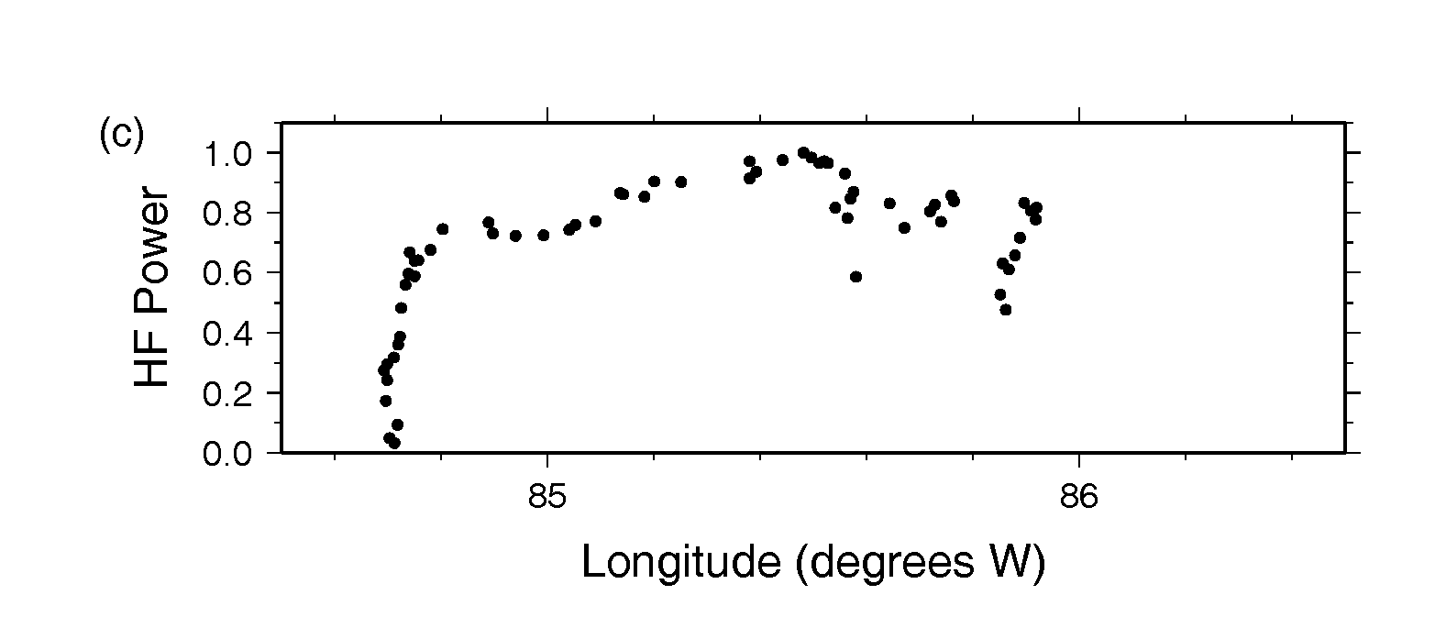

Figure S1 (a, top left) High frequency radiation estimated using the multitaper-MUSIC back-projection technique with array data from North America (squares), Europe (diamonds) and Australia (circles). Symbols are scaled according to inferred relative strength of local HF sources. The blue star is the location of the M6.7 aftershock by the International Seismological Centre and the connected blue symbols are the apparent aftershock locations imaged by each array. The color scale denotes the timing of high-frequency radiations. (b, top right) Similar results calculated with an empirical correction applied to each data set to account for systematic biases due to 3-dimensional path effects. (c, bottom) Relative power of HF sources.

**Intensity Data**

Given that intensity residuals at any location will reflect a combination of source, path, and site effects, one does not expect a perfect correspondence between residuals and HF source locations. The correspondence will potentially be poor for isolated locations, where available intensity assignments are controlled by one or a very few accounts. For example, the intensity residual map (Figure 2c) reveals an isolated high (EMS 8.5) intensity at Chisapani, which corresponds to an isolated village where heavy damage to reinforced cement concrete buildings was concentrated near the highest point along a ridge. Unlike other locations for which high intensities are assigned, there are no nearby locations with lower intensities, so the residual map is dominated by a single value. The map representation is provided for illustration; a more quantified consideration of residuals is presented in Figure 3 (main paper).

**Instrumental Data**

Available instrumental data from the near-field region are sparse, and concentrated within Kathmandu valley. Recordings of the mainshock have been available from one (GeoSIG NetQuakes) accelerometer installed by the U.S. Geological Survey prior to the earthquake (1, 2) as well as one accelerometer installed by the Nepal Department of Mines and Geology (*Bhattarai et al.* 2015). Additionally, the mainshock was recorded by a pair of permanent GPS instruments with high-rate (5 sps) sampling (*Galetzka et al.,* 2015), and by four strong motion instruments (*Rajaure et al.*, 2016).

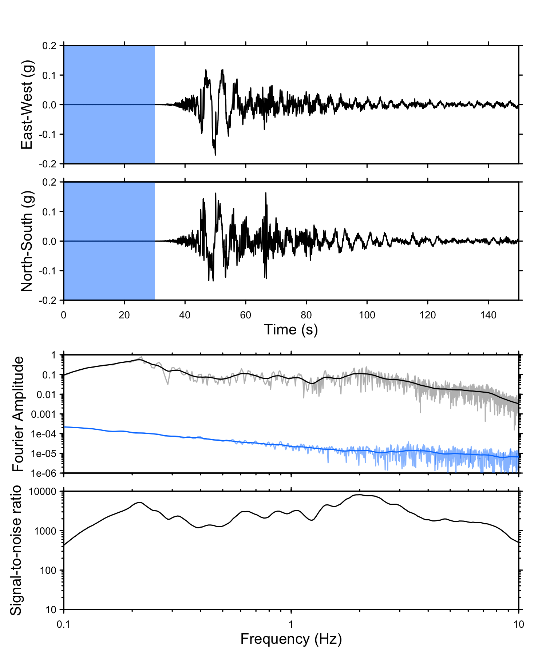

Figure S2. Horizontal components of acceleration (shown as %g) of KATNP recording (top panels) are shown along with the average horizontal spectrum for strong motion (black line) and pre-event noise (blue line), and signal-to-noise ratio (bottom panel.)

The strong motion recording from KATNP has excellent signal-to-noise levels over the entire frequency range (0.1 - 10 Hz) shown in Figure 3 of the main paper (Figure S2). For the high-rate GPS data, although the Nyquist frequency is 2.5 Hz, signal-to-noise levels are not adequate to draw conclusions about ground motions at frequencies higher than 1 Hz (Figure S3).

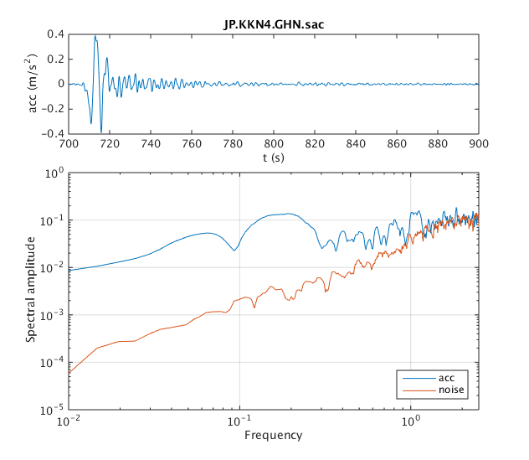

Figure S3. Inferred acceleration at high-rate GPS station KKN4 obtained by double-differentiating the displacement time history and low-pass filtering below 0.5 Hz (top); Fourier amplitude multitaper spectra of raw GPS acceleration signal (blue line) and pre-event noise (red line).

**References**

(1) Galetzka, J., D. Melgar, J.F. Genrich, J. Geng, S. Owen, E.O. Lindsey, X. Xu, Y. Bock, J-P. Avouac, L-B. Adhikari, B.N. Upreti, B. Pratt-Sitaula, T.N. Bhattarai, B. Sitaula, A. Moore, K.W. Hudnut, W. Szeliga, J. Normandeau, M. Fend, M. Flouzat, L. Bollinger, P. Shreshta, B. Koirala, U. Gautam, M. Bhatterai, R. Gupta, T. Kandel, C. Timsina, S.N. Sapkota, S. Rajaure, N. Maharjan (2015).  Slip pulse and resonance of Kathmandu basin during the 2015 Mw7.8 Gorkha earthquake, Nepal, imaged with space geodesy, *Science,* **349**, 1091-1095, doi:10.1126/science.aac6383

(2) Dixit, A.M., A. Ringler, D. Sumy, E. Cochran, S.E. Hough, S.S. Martin, S. Gibbons, J. Luetgert, J. Galetzka, S.N. Shrestha, S. Rajaure, and D. McNamara (2015). Strong-Motion Observations of the M 7.8 Gorkha, Nepal, Earthquake Sequence and Development of the N-SHAKE Strong-Motion Network, *Seism. Res. Lett.*, 86 (6), 1533-1539, doi: 10.1785/0220150146

(3) Bhattarai, M., L.B.Adhikari, U.P. Gautam, A. Laurendeau, C. Labonne, R. Hoste-Colomer, O. Sebe, and B. Hernandez (2015). Overview of the large April 25th 2015 Gorkha, Nepal, earthquake from accelerometric perspectives, *Seism. Res. Lett.,* 86 (6) 1540-1548, doi: 10.1785/0220150140

(4) Rajaure, S., D. Asimaki, E. Thompson, S. Hough, J.P. Ampuero, A. Inbal, S. Bijukchhen, M.R. Dhital, M. Ichiyanagi, P.N. Maskey, L. Paudel, T. Sasatini, M. Shigefuji, and N. Takai (2016). Strong motion observations of the Kathmandu valley response during the M7.8 Gorkha earthquake sequence, in review, *Geophys. Res. Lett.*