Emacs Lisp Basic

Mr.revolt

Table of Contents
1. basic html
import matplotlib, numpy
matplotlib.use('Agg')
import matplotlib.pyplot as plt
fig=plt.figure(figsize=(4,2))
x=numpy.linspace(-15,15)
plt.plot(numpy.sin(x)/x)
fig.tight_layout()
plt.savefig('images/python-matplot-fig.png')
return 'images/python-matplot-fig.png' # return filename to org-mode
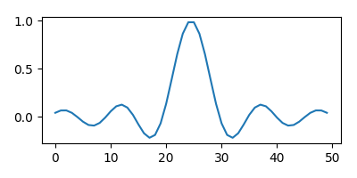
"this string is not ascii!"
Listing 1:
return data
Listing 2:
return data

basic html

