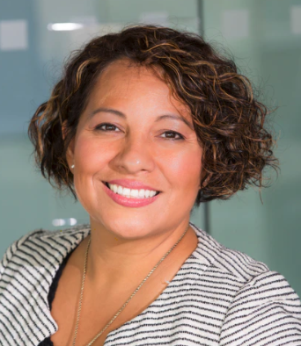

JOB TITLE



**Name SURNAME**

Dedicated and results-driven professional with over 10 years of experience in strategic leadership and operational management. Proven track record of driving business growth, optimizing operational efficiency, and enhancing team performance. Adept at developing and implementing innovative strategies.

**EDUCATION**



20XX – 20XX

+1 222 222 222

name.sn@mail.com

NY, USA

linkedIn/in/name.surname

**MBA Business Administration**

*NYU*

20XX – 20XX

**BA Business Administration**

*NYU*



**PROFESSIONAL EXPERIENCE**

**LANGUAGES**

**OPERATIONS MANAGER |** 20XX – 20XX

* English: Native
* French: Bilingual
* Spanish: Basic

DEF Solutions – NY, USA

* Led a cross-functional team to streamline operational processes, resulting in a 20% increase in overall efficiency within one year.
* Developed and implemented cost-saving initiatives, reducing operational expenses by 15% while maintaining high-quality standards.
* Collaborated with the executive team to devise and execute a market expansion strategy, leading to a 30% growth in market share.

**REGIONAL SALES MANAGER |** 20XX – 20XX

ABC Company – NY, USA

**SOFTWARE**

**SKILLS**

* Oversaw a sales team of 15 professionals and successfully exceeded quarterly sales targets by 25%.
* Implemented a training program that enhanced the sales team's product knowledge, resulting in a 15% increase in customer satisfaction and repeat business.
* Excel, Word, PowerPoint
* Salesforce CRM
* Project Management Tools
* SAP ERP

**DIRECTOR OF OPERATIONS |** 20XX – 20XX

XYZ Solutions – NY, USA

* Streamlined operational processes, resulting in a 20% increase in overall efficiency within one year.
* Developed and implemented cost-saving initiatives, reducing operational expenses by 15%.
* Sales and Marketing
* Process Optimization
* Cross-functional Collaboration
* Training and Development
* Lean Manufacturing

**HOBBIES & INTERESTS**

Outdoor Activities (hiking, cycling)

Continuous Learning (attend industry conferences, workshops)

Volunteer Work (community service, charity events).

©AZURIUS – Modeles-de-cv.com

©AZURIUS - My-resume-templates.com

**Dear Job Seeker,**

If you're having difficulty composing your resume, here are some free resources available that can assist you in creating a strong resume that highlights your suitability for the position to potential employers:

* [How to Make a Good Resume](https://www.my-resume-templates.com/how-to-make-a-resume/?utm_source=Word_Doc&utm_medium=Model_CV_Link&utm_campaign=MDC_Downloads)
* [Skills to Put on a Resume](https://www.my-resume-templates.com/skills-to-put-on-a-resume/?utm_source=Word_Doc&utm_medium=Model_CV_Link&utm_campaign=MDC_Downloads)
* [Resume Objective Examples](https://www.my-resume-templates.com/resume-objective-examples/?utm_source=Word_Doc&utm_medium=Model_CV_Link&utm_campaign=MDC_Downloads)

Also discover other free downloadable and ready-to-fill CV templates in Word format:

* [Basic Resume Templates](https://www.my-resume-templates.com/basic-resume-templates/?utm_source=Word_Doc&utm_medium=Model_CV_Link&utm_campaign=MDC_Downloads)
* [Modern Resume Templates](https://www.my-resume-templates.com/modern-resume-samples/?utm_source=Word_Doc&utm_medium=Model_CV_Link&utm_campaign=MDC_Downloads)
* [Creative Resume Templates](https://www.my-resume-templates.com/creative-cv-templates/?utm_source=Word_Doc&utm_medium=Model_CV_Link&utm_campaign=MDC_Downloads)
* [Professional Resume Templates](https://www.my-resume-templates.com/career-resume-templates/?utm_source=Word_Doc&utm_medium=Model_CV_Link&utm_campaign=MDC_Downloads)
* [Europass CV](https://www.my-resume-templates.com/europass-cv/?utm_source=Word_Doc&utm_medium=Model_CV_Link&utm_campaign=MDC_Downloads)

Best regards,

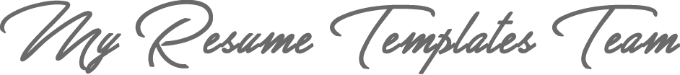

[www.my-resume-templates.com](https://www.modelos-de-curriculum.com/?utm_source=Word_Doc&utm_medium=Model_CV_Link&utm_campaign=MDC_Downloads)

**COPYRIGHT - PLEASE READ THIS MESSAGE**

©These examples of free resume templates are the property of Azurius S.L. You may   
download and modify them without any problem if they are for personal use.

Do not forget to remove this copyright notice before modifying and printing your resume or CV.

You cannot resell these examples or their derivatives. You cannot make them available on other websites without our consent. For any related questions, please write to us at contact@my-resume-templates.com

Discover more resume templates at [www.my-resume-templates.com](https://www.my-resume-templates.com/?utm_source=Word_Doc&utm_medium=Model_CV_Link&utm_campaign=MDC_Downloads)