close all;
clear;
clc;
I=imread('D:\Program Files\Polyspace\R2021a\zjc\lena.bmp');

subplot(221),imshow(I);
subplot(222),image(I);
subplot(223),image([50,200],[50,300],I);
subplot(224),imagesc(I,[60,150]);
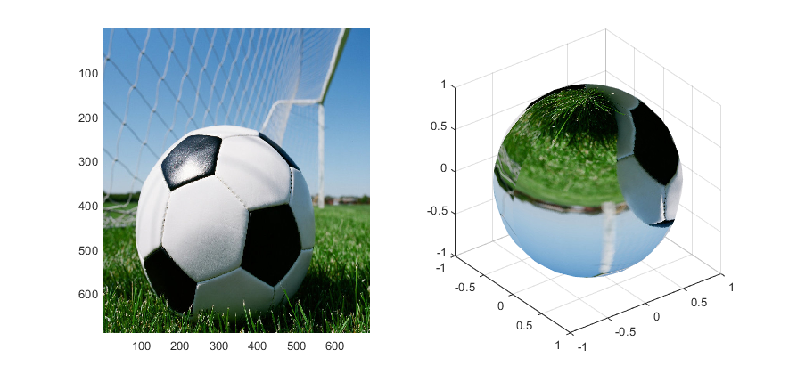close all;
clear;
clc;
I=imread('D:\Program Files\Polyspace\R2021a\zjc\football.jpg');
[x,y,z]=sphere;
figure,
subplot(121),warp(I);
subplot(122),warp(x,y,z,I);
grid;
close all;
clear;
clc;
I=imread('D:\Program Files\Polyspace\R2021a\zjc\football.jpg');
[X1,map1]=rgb2ind(I,64);
[X2,map2]=rgb2ind(I,0.2);
map3=colorcube(128);
X3=rgb2ind(I,map3);
figure,
subplot(131),imshow(X1,map1);
subplot(132),imshow(X2,map2);
subplot(133),imshow(X3,map3);
close all;
clear;
clc;
I=imread('D:\Program Files\Polyspace\R2021a\zjc\child.tif');
[X1,map1]=gray2ind(I,8);

figure,
subplot(131),imshow(I);
subplot(132),imshow(X1,map1);
close all;
clear;
clc;
I=imread('D:\Program Files\Polyspace\R2021a\zjc\child.tif');
BW1=im2bw(I,0.4);
BW2=im2bw(I,0.6);
figure,
subplot(131),imshow(I);
subplot(132),imshow(BW1);
subplot(133),imshow(BW2);

