**Project 1**

Special Instruction to run the Project 1:

* For Part 1of the project please run the file named as **SDES.Java** class. After running the main method of the above class the result will look like below image.

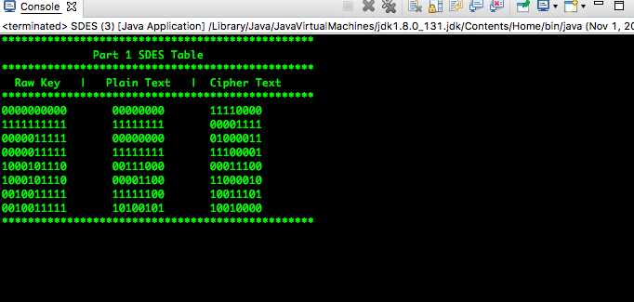

* For Part 2 of the Project, run the file with name Triple_SDES.java and output will look like below.

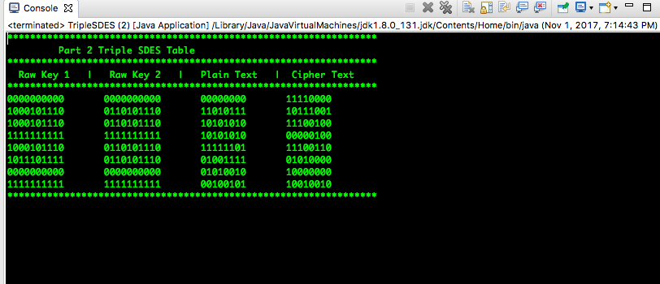

* To see the result of question 3, part 1 run the java file SDES_Encoding.java.

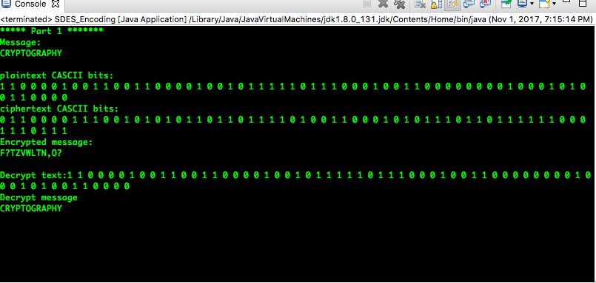

* For part 2 and 3 please run the file Message_Encoding.java file and result will be like this.

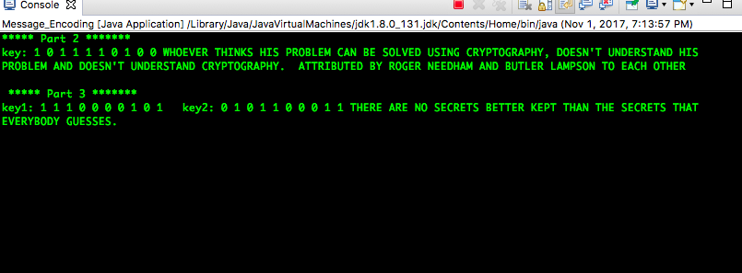

Submitted by :

LOVEPREET SINGH

(305869335)

RISHABH GAUR

(305858467)