**Phipps Conservatory Web Development Project**

**Describe three ways in which your design is specifically geared toward the college student user.**

A college user’s experience revolves around sleek aesthetics and easy, quick access to information. That being said, my design targets the college student user through:

1. Sleek, simplistic design in the headers, navigation, and information boxes throughout the website

2. The use of various forms of media and the inclusion of graphics and images in, for the most part, every section of each site page

3. The useful placement of navigation tools and information within the website. Each page within the website has many points of access not only through the navigation bar, but also through individual links throughout the website. For example, the “Plan a Visit” button on the homepage links the user quickly and easily to the Visit page. This avoids confusion in navigating the website, making it easier for the user. Additionally, highly desired information is placed in more visible locations and included multiple times throughout the website (e.g. the Hours and Location information box located on the Home Page, index.html, also provides the same information that can be found on the Visit Page; this information box not only does this, but also is embedded with links to the Visit page).

**Describe three ways in which your design evolved over several iterations of the assignment. You may want to include specific screenshots of your wireframes to illustrate your response.**

1. One of my original plans was to have the background be an opaque image; however, I soon realized that, with the amount of information I still wanted to include on each page, the user would find this design overwhelming. See below:

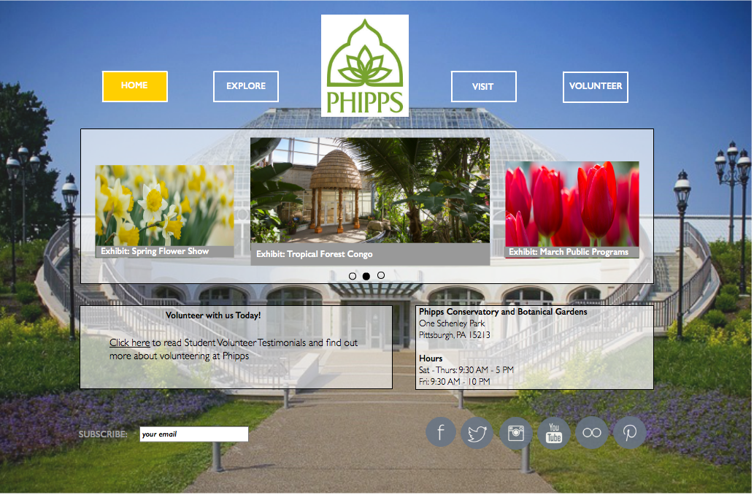

2. I added many more colors to the website to give it a more visually appealing affect.

3. Along with colors, I also added images, and different formats in which the images could be viewed so that the user might find the variation in the use of media visually appealing.