**Vulnerable Web Creator Document (User Version)**

**Vulnerable Web Creator**

**Love Sharma**

**13-08-2023**

**Version 0.0.1**

**1.  Overview**

**1.1    Purpose**

**2.  Requirements**

**2.1    Assets**

**2.1.1 Hardware**

**2.1.2 Software**

**3.  Deployment Tutorial**

**3.1    Windows**

1. **Introduction**
   1. **Purpose**

Users can easily deploy and launch the web application provided by the Admin.

1. **Requirements**

Basic minimum requirements for Windows, Linux and Mac OS can be found below.

**Note:** We **highly** recommend to use Windows.

* 1. **Assets**
     1. **Windows OS:**

1. Hardware

* 4GB system RAM
* BIOS-level hardware virtualization support must be turned on in the BIOS settings. For more information, see [Virtualization](https://docs.docker.com/desktop/troubleshoot/topics/#virtualization).

1. Software

* Download and Install WSL version 1.1.3.0 or later (always use the latest version).
* Turn on the WSL 2 feature on Windows. For detailed instructions, refer to the [Microsoft documentation](https://docs.microsoft.com/en-us/windows/wsl/install-win10).
* Download and install Docker

For more information, please visit:

* <https://docs.docker.com/desktop/install/windows-install/>

1. **Deployment Tutorial**

Once you receive the ***.exe*** file from your Admin, below tutorial can followed to deploy the web application.

* 1. **Windows**
* Make sure your Docker is up & **running**.

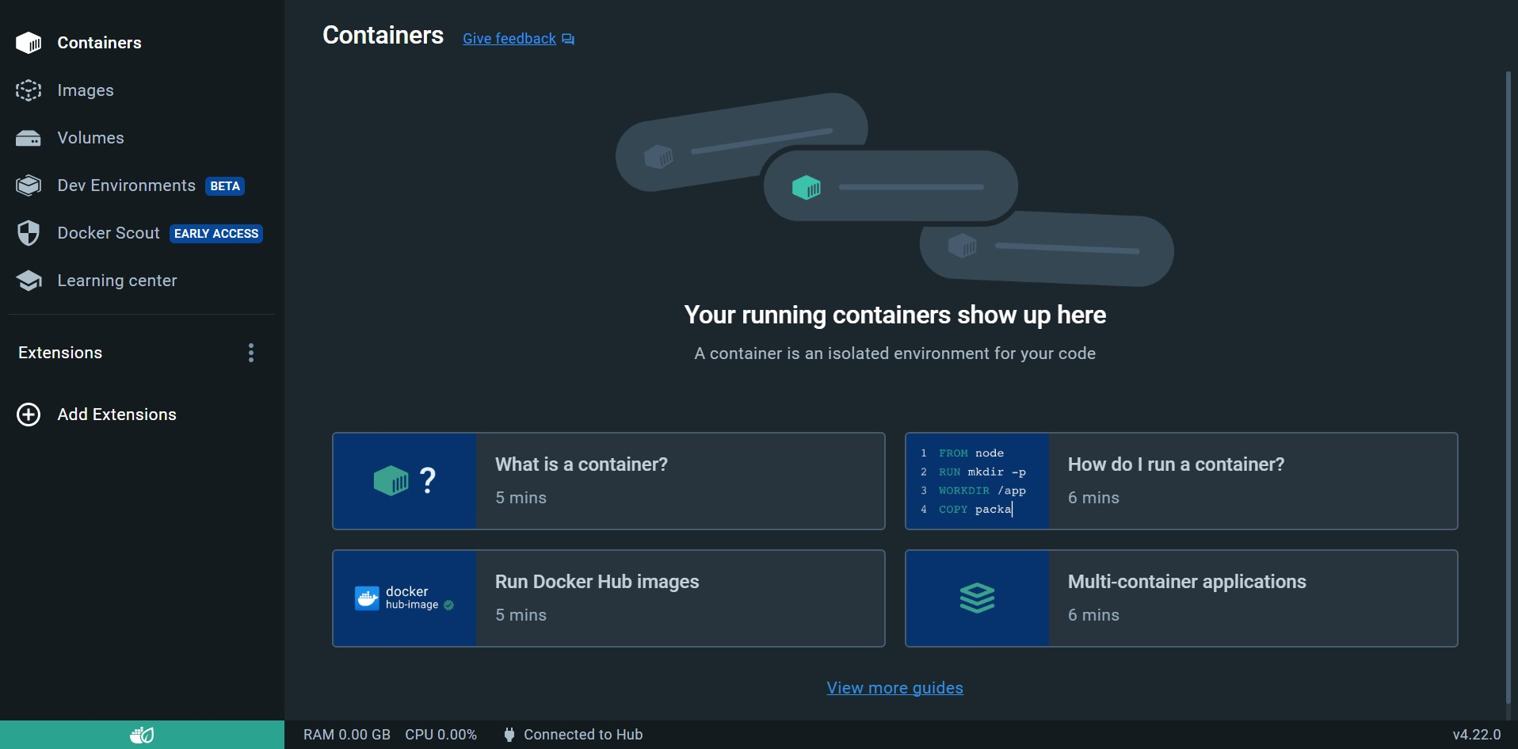

* Simply double-click the ***.exe*** file to start the application using **Docker**.

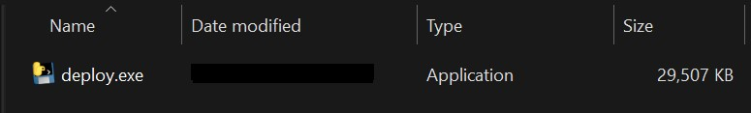

Don’t forget to give it few minutes to download and initiate the necessary services

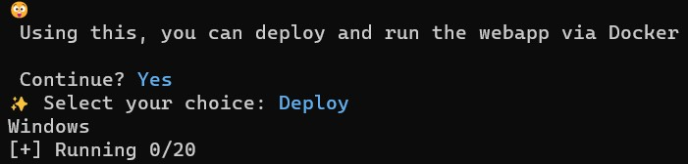

Make sure that you see the line as shown below (it will be at the end 😉):



Once you see the above line, visit [http://*localhost*](http://localhost)to access the web application for your assignment.

