**CHAPTER 3**

**SYSTEM ANALYSIS AND DESIGN**

**3.1 Introduction**

This chapter describes the design of the project. System analysis and design are the most important tasks in a project because a good design can help to reduce problems that might happen in the future. Especially, this chapter is about the structure and appearance of the software. First, it covers how speakers can use the software to practice public speaking. Second, it shows the design of the database which is made for it to work efficiently with the software. Finally, this chapter also includes the use-case diagram, flow chart, and more.

**3.2 Existing System Analysis**

There are some applications available in the market, made for users to practice public speech, and most of these are mobile applications. Table 3.1 shows the comparison of the VR Speech with other public speaking applications.

Table 3.1: Existing System Analysis

|  |  |
| --- | --- |
| **Ovation VR** | **VR Speech** |
| Cannot detect user’s heart rate and confidence level while speaking | Use wrist device SDK to implement data from user’s heart rate to measure confidence level of the user. |
| Can detect filler words that users use while speaking. | Can detect filler words that users use while speaking |
| Can detect user’s head direction via virtual reality device. | Can detect user’s head direction via virtual reality device. |
| Audiences are just a model sitting still in a room. | Can detect user’s performance and make audiences react in a related way |

**3.3 User Requirements Analysis**

This section describes how the users interact with the application. Users can do the following in this application.

**3.3.1 Functional Requirement**

* User can view main menu which includes:
  + **Start** to go into the room to start speaking
  + **Profile** showing the score of the player after each session
  + **Exit** to exit the game
* User can use hand controller to select from the menu and hold it to detect the hand gesture
* After the speaking session, player can choose either to speak again or go back to main menu; the score and concluded result will show after each session and user can choose to see their personal score.
* User can see their average heart rate during each session.

**3.3.2 Non-functional Requirements**

* User-friendly system
* Easy to learn and start
* Entertaining, fun-filled, good for health, and help educate users

**3.4 System Design**

**3.4.1.** **Player Profile**

At the beginning, players will have to select their profile. Or else, if the player

plays for the first time, they can create a new profile by clicking “Register” button.

Profile contains information as follows:

1. Name as ID for each user The interface of profile selection is shown in figure below.

**3.4.1 Architecture Diagram**



Non-verbal Analysis

Database

(table format)



Non-verbal



Verbal Analysis

Verbal

VR headset

Smartwatch

Microphone

User

Figure 3.1: The System Design VR Speech System

VR Speech is an application that uses three devices together to collect data from the user. These devices are microphone, wrist device, and VR headset. The microphone captures the user's voice and then we use Algorithms and Machine Learning to analyze information such as amount of filler words and inappropriate pauses. Also, the wrist device includes SDK for developers to use in our system. Lastly, VR headsets detect user’s head direction.

**3.4.2 Use-Case Diagram**

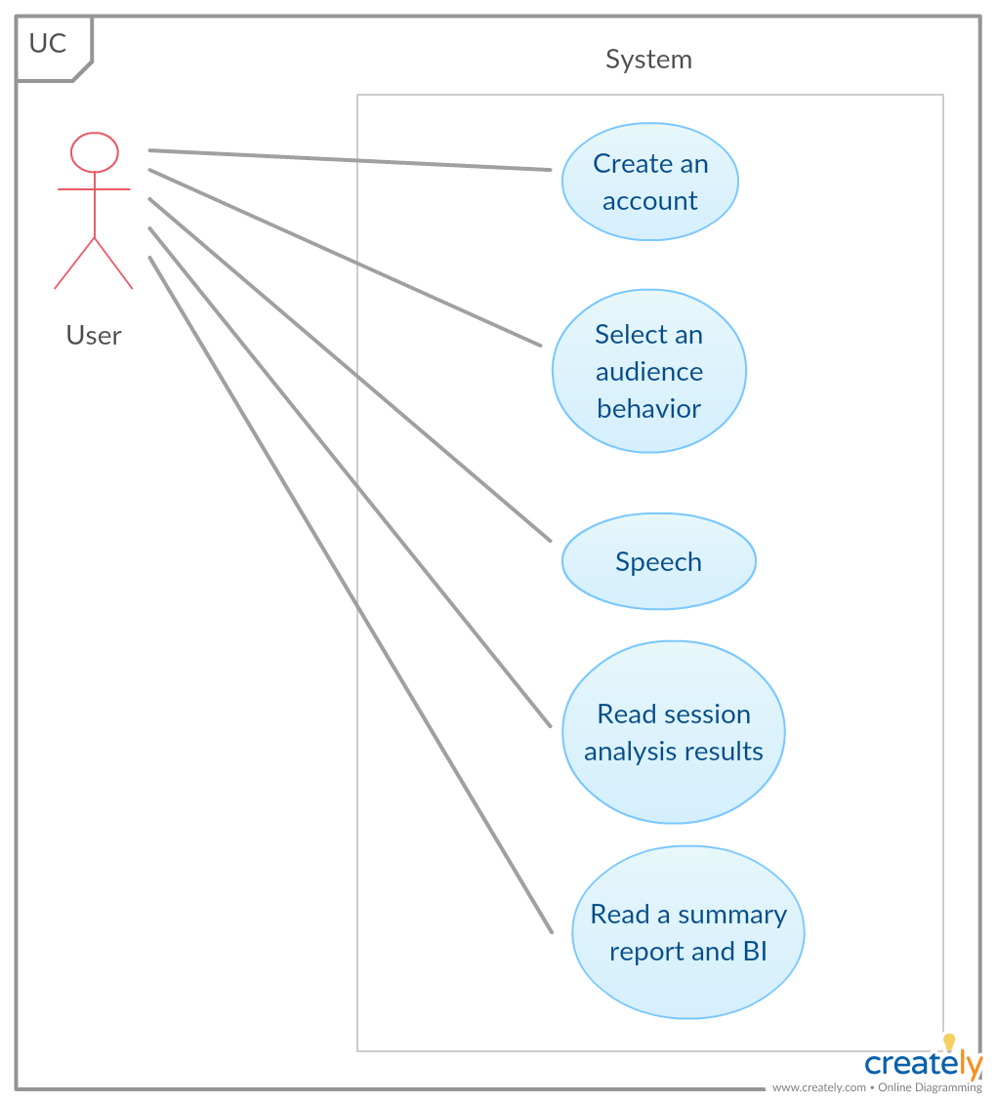

Figure 3.2: The Use-Case Diagram of VR Speech

Figure 3.2 shows how the user can interact with the system. At first, the user must register and create an account to keep track of the life time progress. Then, the user can use the account to record a speech and see the result after finishing the speech. A registered user can check one’s lifetime progress and average results in personal result menu.

Figure 3.3 Use-Case Diagram of VR Speech while speaking 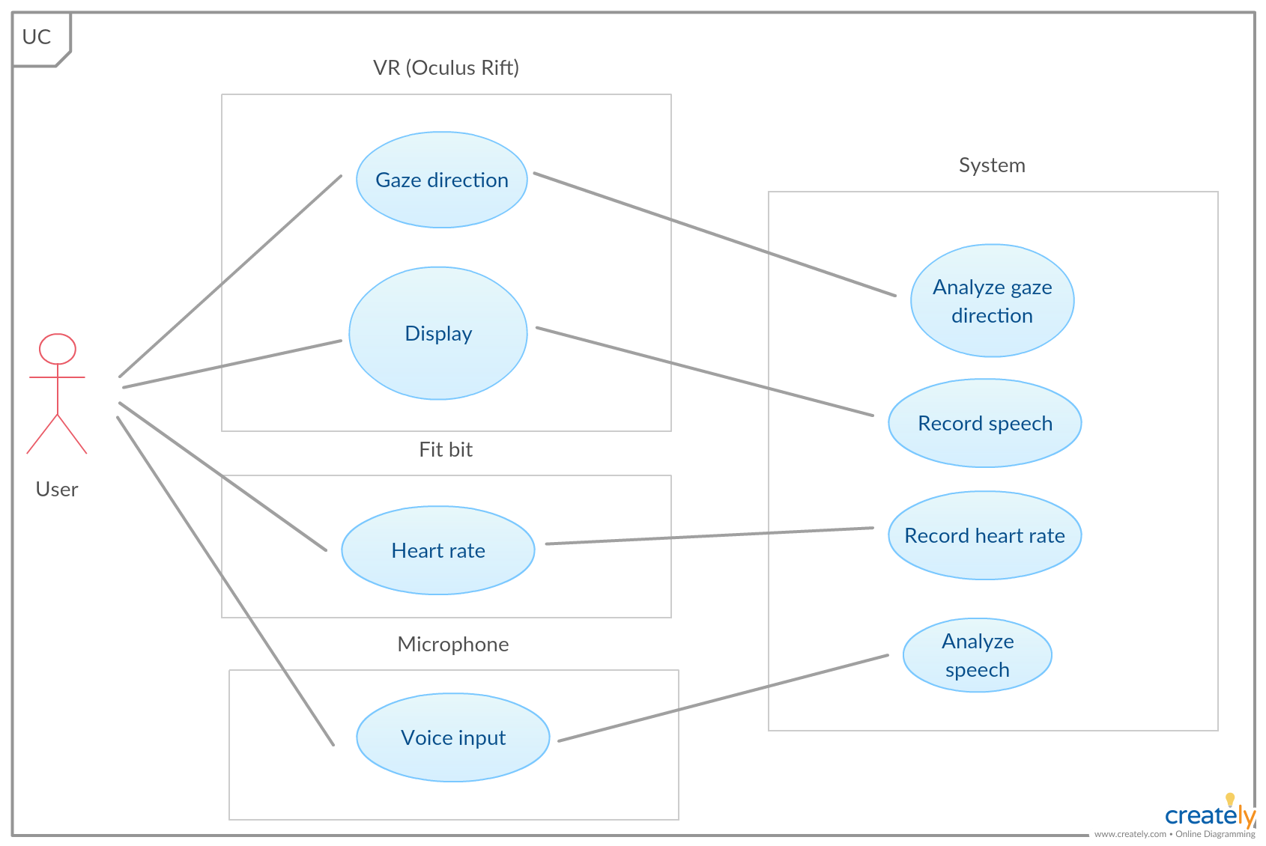

Figure 3.3 shows how user can interact with the system while speaking. At first, we use VR headset and a display device to detect user point of view and record the video. The VR headset can also be used as a gaze direction detector. Next, Fitbit is being used as a heart rate detection device to analyze the system for each speech. At last, microphone is used for recording user’s speech and then turns the words into text to further analyze them.

**3.4.3 Entity Relationship Diagram (ER diagram)**

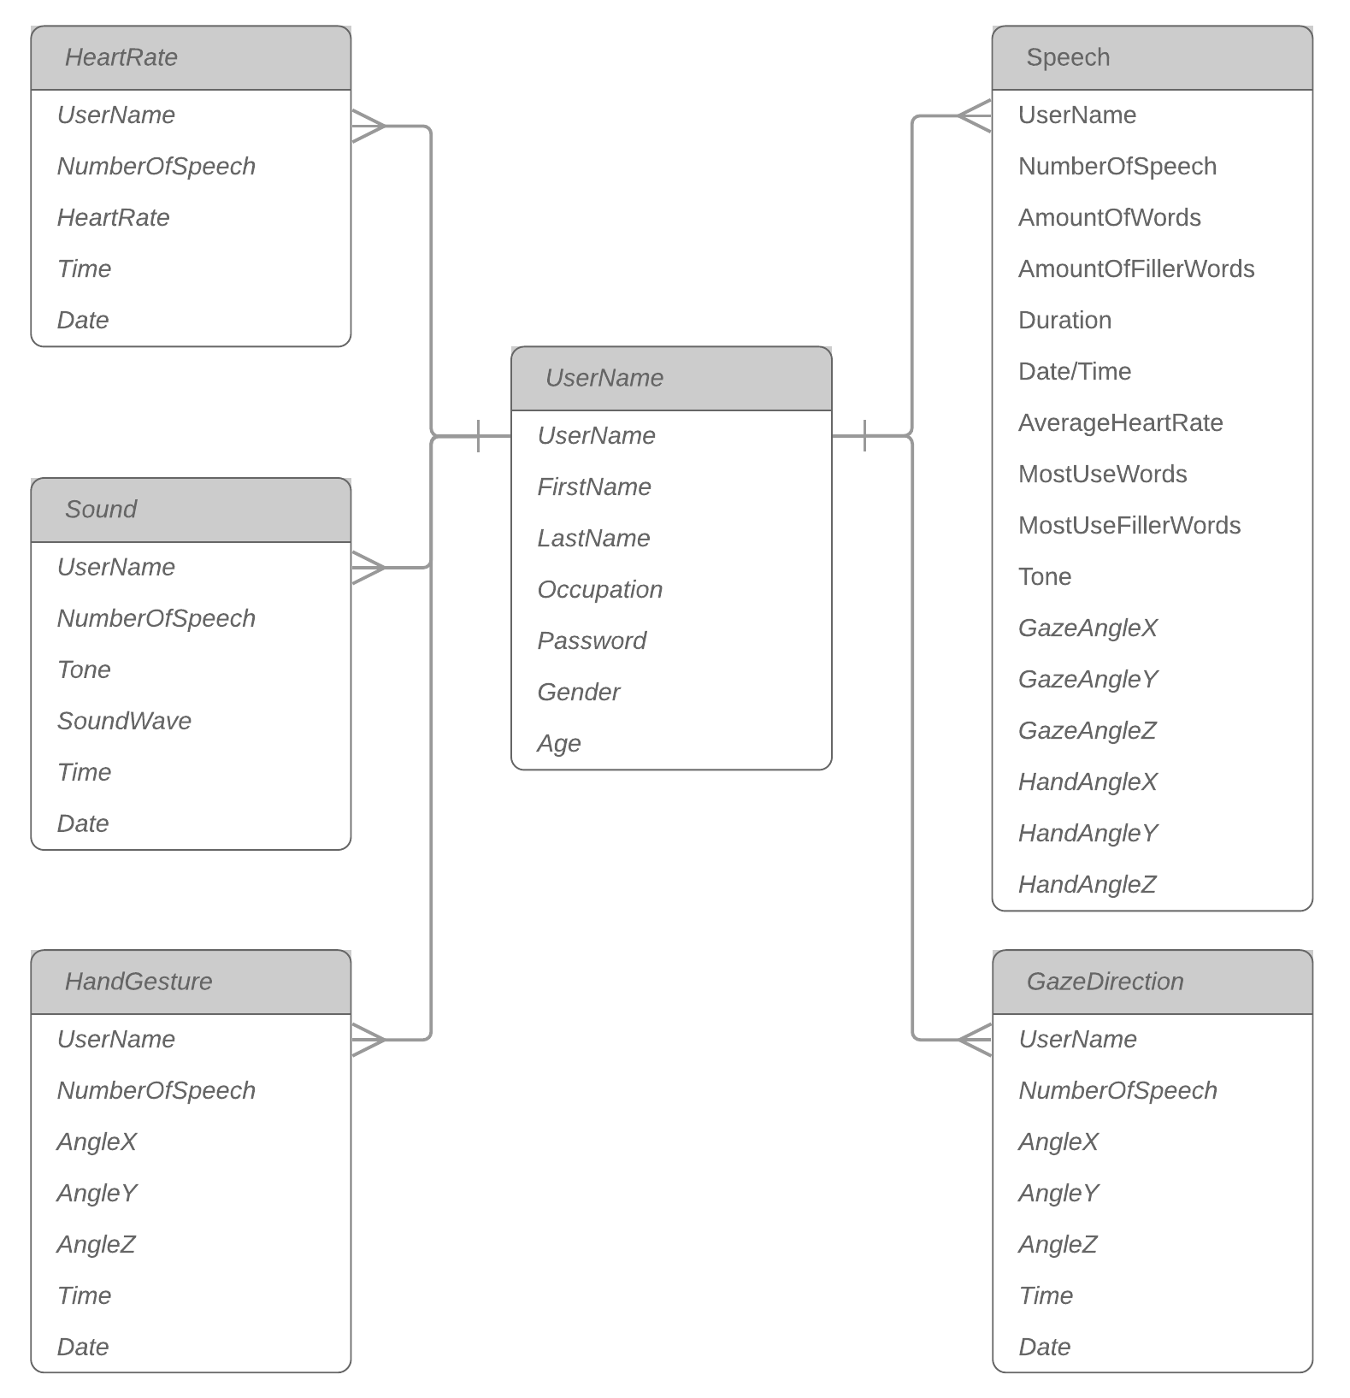

Figure 3.4: The ER Diagram of User’s Side

Figure 3.4 shows the database of the user of VR Speech, which keeps track of how many times the user speaks, the user’s average heart rate, amount of time that filler words being used and most used words in each speech.

**3.4.4 User Interface**

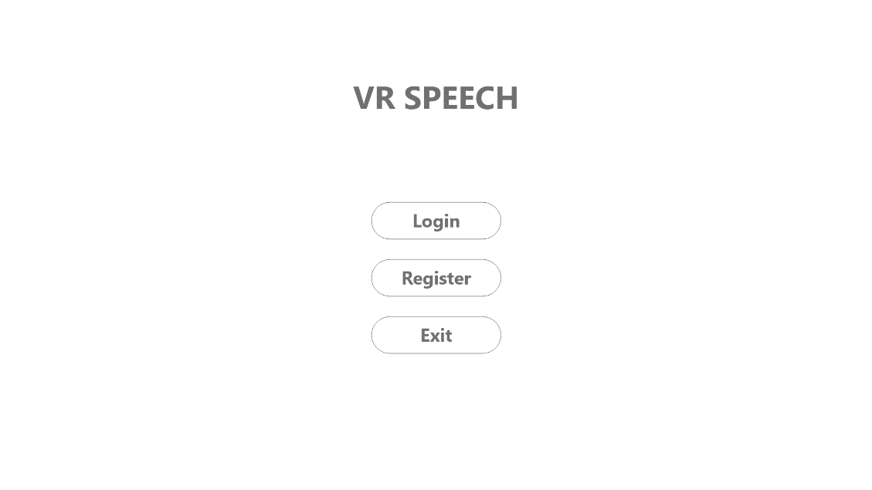

Figure 3.5: Welcome Page

Figure 3.5 shows the first page that the user will see when the software is being launched. This page has “Login”, “Register”, and “Exit” buttons and the user has to have an account in order to keep track of the progress and development. If this is the first time for the user to use this software, “register” button can be used to create an account.

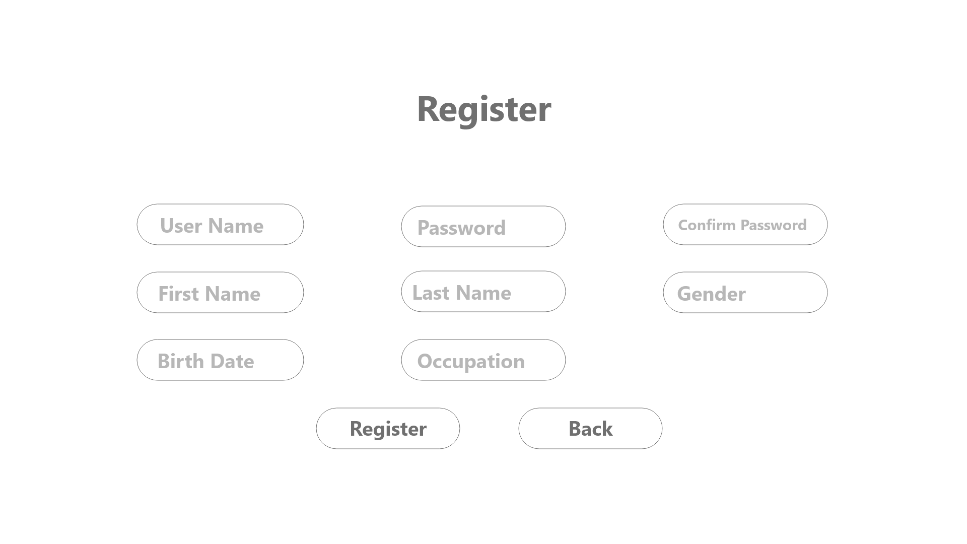

Figure 3.6: Register Page

Figure 3.6 shows the register page that the user can use to create one’s account. The user has to fill out the full name and occupation. Username cannot be the same for multiple users. The user also has to confirm one’s password for safety reason.

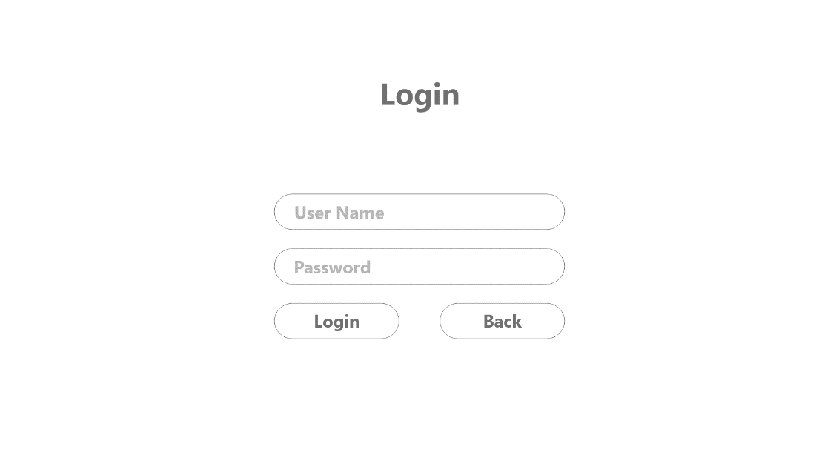

Figure 3.7: Login Page

Figure 3.7 shows the login page. User can use an account that has been created to login in this page. However, if user wants to go back or exit the software, the back button can be used to go back to the welcome page. If the user forgot password, the “forget password” button can be used to recover it.

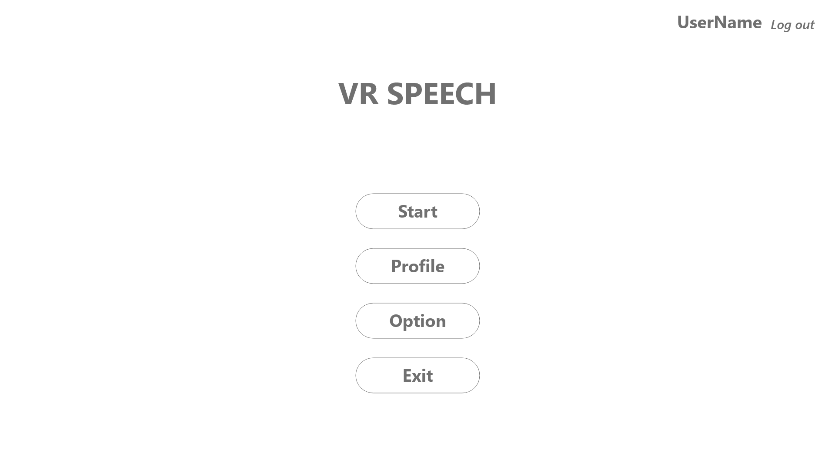

Figure 3.8: Main Menu Page

Figure 3.8 shows the main menu page that user will see after logging in successfully. The user can start recording the speech by clicking start. The audience behavior will be set to auto which mean they will react to how well the speaker performs. The setting button allows the user to set the audience behavior. Lastly, the user can click the “profile” button to go to the personal performance.

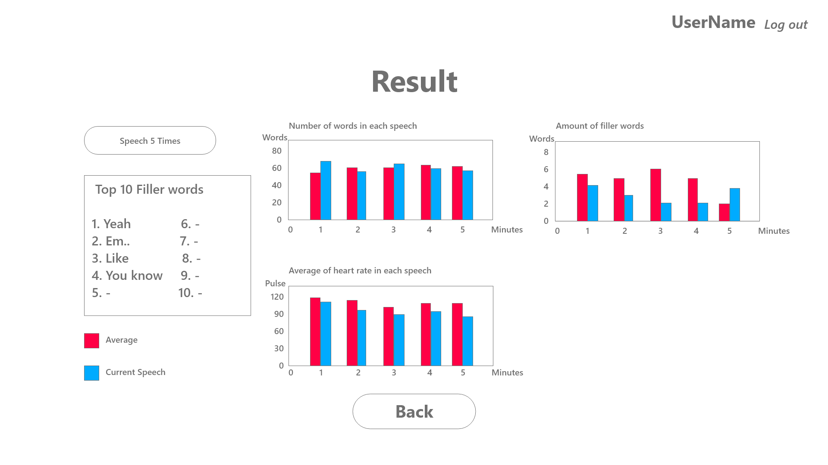

Figure 3.9: Summary Page

Figure 3.9 show cumulative results of users including amount of words, average heart rate, and amount of filler words, the amount of time that users hands are idling.

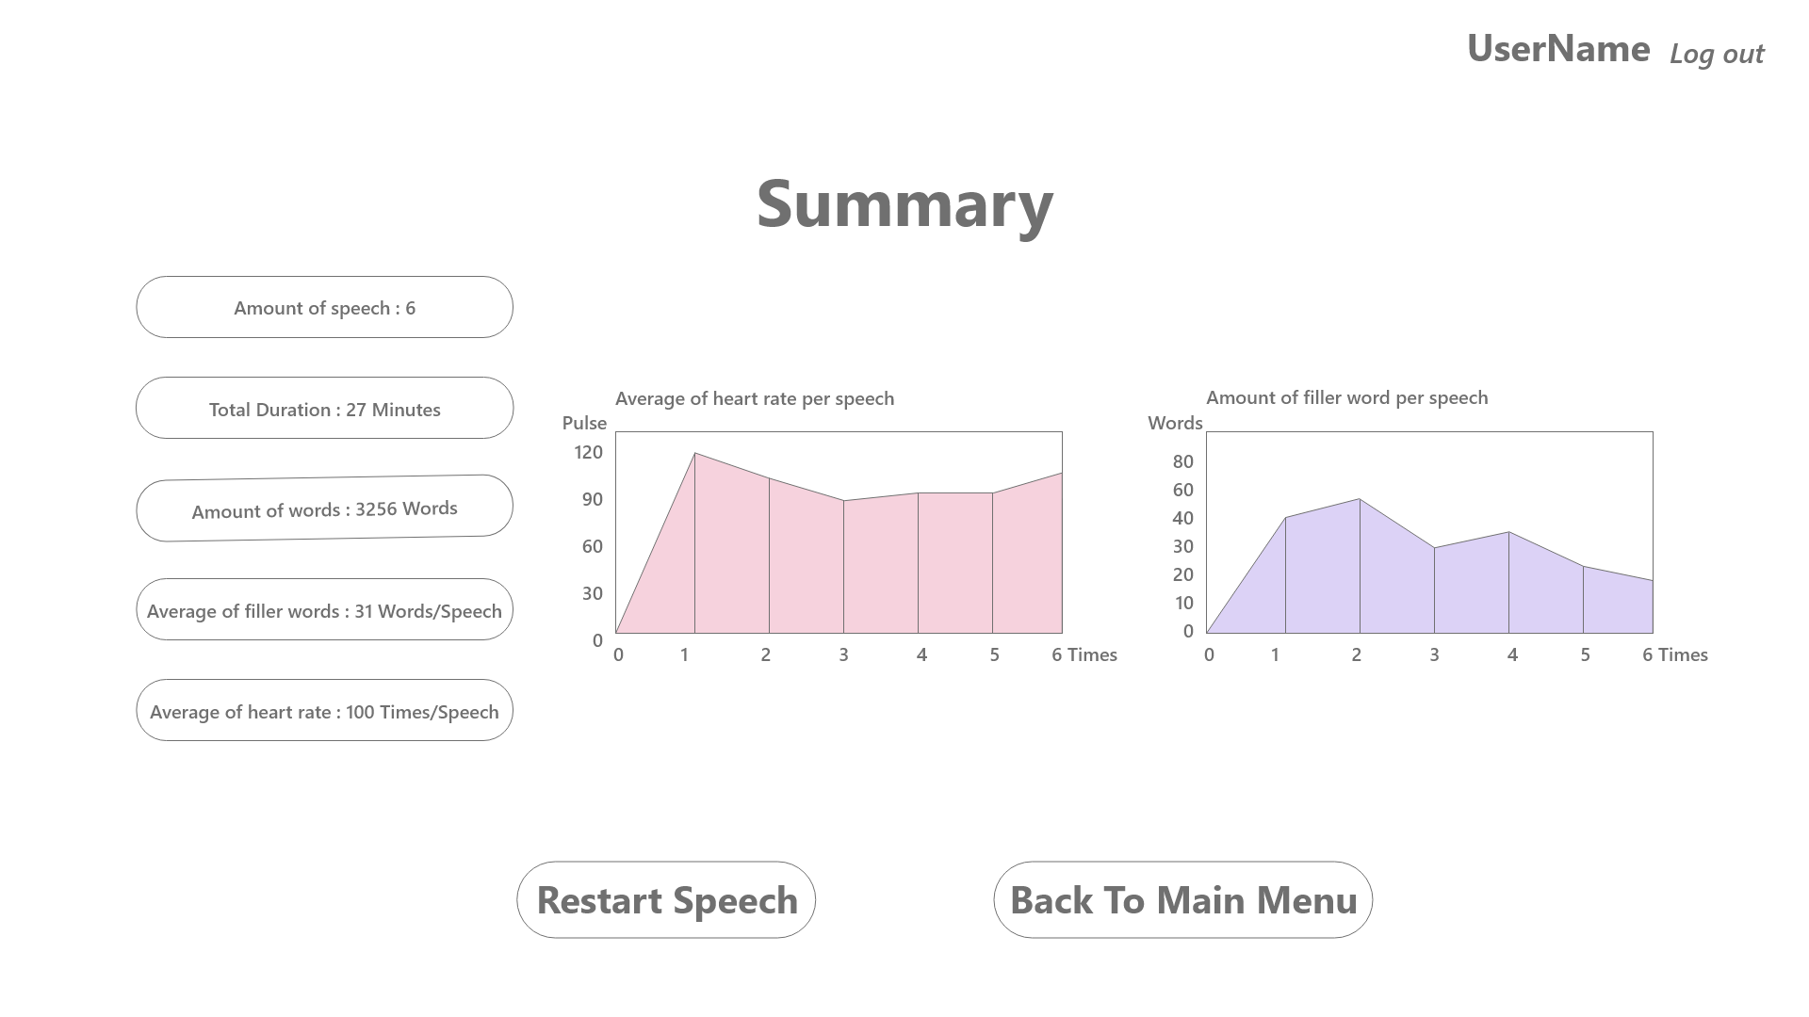

Figure 3.10: Result Page

Figure 3.10 shows the result of the previous speech including the amount of words that the user has spoken length of speech, amount of filler words, and average heart rate. There are graphs that show both heart rate and filler words for the user to understand and improve in the next speech.