**CHAPTER 4**

**SYSTEM FUNCTIONALITY**

**4.1 Introduction**

There are three sections in this chapter, which are System Architecture, Test Plan, and Test Results. The system architecture section describes the relations among the parts of the system. The test plan is used to test each function of the system. The Test Results section concludes with the results of testing the program.

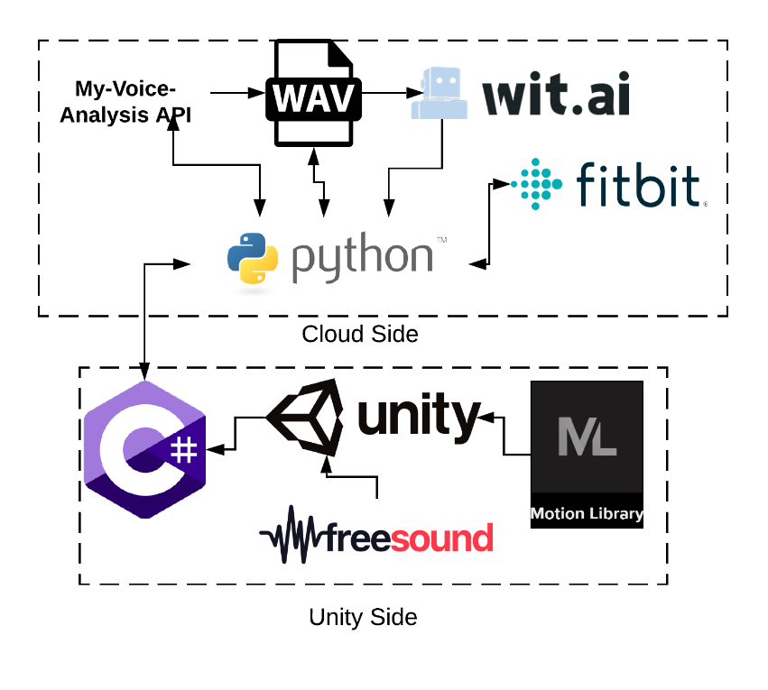**4.2 System Architecture**

Figure 4.1: System Architecture

Figure 4.1 describes the architecture in the system of VR Speech which has two main parts which are the Cloud API part and Unity part. The game is created using Unity which is a software that allows users to create game environments that can put any animation or texture. In Unity, we use two libraries which are Motion Library which responsible for audiences’ animation. Another library is Freesound which allows us to use realistic sound effects in our game. Then we use various API through python to able to analyze the user’s voice at the end of each session.

**4.2.1 System Functionality**

The VR Speech software allows the user to do a presentation following their script for many times which allow the result to be used as a comparing tool of user’s performance when they are speaking the same script for many times. This software can be beneficial for people who want to practice public speaking at home. The application will detect the voice, hand gesture, head direction and then analyze and show the results. After users finished their speech, then can press stop and see the result at the end of session.

**4.2.2 Main Functions**

The main functions are classed by their type of user, which are user and developer. The main functions are shown below in table 4.1:

Table 4.1: Main functions

|  |  |
| --- | --- |
| **User Type** | **Functions** |
| User | Filler Words and Pauses Detection |
| Heart Rate Detector |
| Hand Gesture Detection |
| Reactive Audiences |
| In-Game Script |
| History and Result |

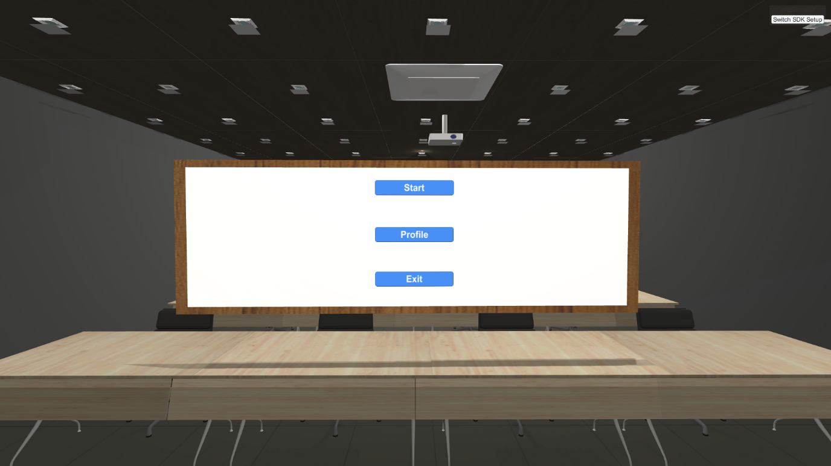**4.2.2.1 Filler Words and Pauses Detection**

Figure 4.2 Main Menu Page

Figure 4.2 shows the first page of the application. On this page, the user has options to Start a speech, view their Profile or Exit the game.

**4.3 Test Plan and Test Result**

The test plan involves checking whether the system performs all functions as stated in the features and tests if the program functions work properly.

Table 4.2: Test Plan and Test Results

|  |  |  |  |  |  |
| --- | --- | --- | --- | --- | --- |
| **Function** | **Test Case** | **Test Flow** | **Expected Output** | **Actual Output** | **Result** |
| **Filler Words and Pauses Detection** | Speak without filler words | User speak “I love to eat pizza and coke” | No Filler Words counts (0 filler words) | No Filler Words counted (0 filler words) | **CORRECT** |
| Speak with filler words | User speak “I love to um, I love to eat pizza and.…. Coke” | 1-2 times of Filler Words counted | 2 Filler Words counted | **CORRECT** |
| **Heart Rate Detector** | Speak while resting or exercising | User speak while resting on a chair | Average Heart Rate  around  60 - 80 BPM | Average Heart Rate for 5 session is  76 BPM | **CORRECT** |
| User speak while exercise standing up | Average Heart Rate  around  85 - 100 BPM | Average Heart Rate for 5 session is  93 BPM | **CORRECT** |
| **Hand Gesture Detection** | Speak while using hand gesture or hand idling | The user uses their hand gesture naturally | 0 – 5 hand idling counted | The user was used hand gesture and result are 3 hand idling times counted | **CORRECT** |
| The user idling their hands from time to time | Up to 10 hand idling counted | The user was used hand gesture and result are 25 hand idling times counted | **CORRECT** |
| **Reactive Audiences** | Lots of ambient noise | User speak in a room with many of ambient noise | A message prompt from audience: There are too many noises, I can’t understand what he is speaking | The user received the expected prompt message | **CORRECT** |
| Many Filler Words | User speaking many filler words in a short period of time | A message prompt from audience: He/She use too many filler words | The user received the expected prompt message | **CORRECT** |
| Hand Idling | User idling their hand for a long time or too many times in a short period | A message prompt from audience: I don’t think he/she is using hand gesture | The user received the expected prompt message | **CORRECT** |
| **In-Game Script** | Show In-Game script | The user press button to show/hide script | Script is shown in game | The script is shown and readable as expected | **CORRECT** |
| **History and Result** | Result at the end of session | The user presses stop button speaking and the result are shown | The scoreboard is shown at the end of speech | The results are shown correctly | **CORRECT** |
| Result/  History of a user | The user presses profile and all the result are shown | The profile is shown with graph | The profile and history of user’s performance are shown with graph correctly | **CORRECT** |