**序号: 2**

**网站名称: 新浪网**

**网站域名: www.sina.com.cn**

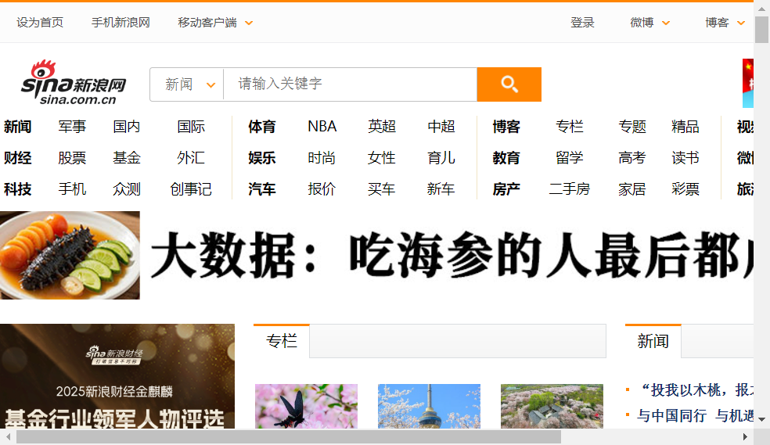

_________________________________________________________________________________________________________

**序号: 3**

**网站名称: 腾讯网**

**网站域名: www.qq.com**

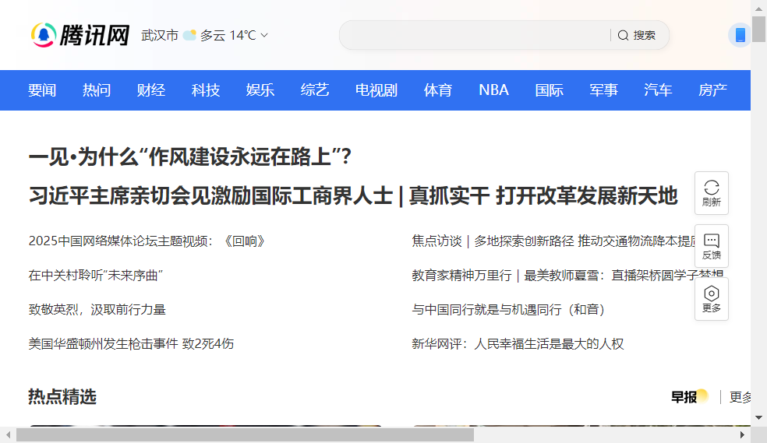

_________________________________________________________________________________________________________

**序号: 1**

**网站名称: 搜狐网**

**网站域名: www.sohu.com**



_________________________________________________________________________________________________________

**序号: 4**

**网站名称: 网易**

**网站域名: www.163.com**



