**CSCI 2150L**

**Session 12 Topics:**

**10/20/2014**

**Fall 2014**

1. We started with a brief discussion for finding out the maximum error bound of bisection method. For a given function $f(x)$ if $x_{0}$ is the exact root of the function and $c_{k}$ is the root approximated by bisection method after *k*th iteration then the following inequality will always be satisfied for bisection method.

$$\left|x_{0}-c_{k}\right|≤\frac{b-a}{2^{k}}$$

Here *a* and *b* are the initial values within which the root is expected to be found. Iteration index *k* starts from 1. If you remember for first iteration $(k=1)$ we computed the approximate root as $c =(a+b)/2$. The difference of approximated root from exact root was measured as follows $|b-c| = |b – (a+b)/2| =(b-a)/2$. After proper modification of *a* or *b* in the first step the iteration progresses and at each subsequent step the condition in the inequality above is satisfied.

1. This week we discussed two more numerical techniques to find roots of a given function. The first one was method of false position (also known as Regula-falsi method). The algorithm is quite similar to bisection method. The steps are as follows.

Regula-falsi Algorithm ($a,b,ε$):

1. Check whether *a* and *b* at satisfies the condition $f\left(a\right)f\left(b\right)<0$. If not exit from method. Otherwise proceed to next step.
2. Compute new approximate root based on these values as $c= \frac{af\left(b\right)-bf(a)}{f\left(b\right)-f(a)}$;

Evaluate $|f(c)|$

1. If $|f(c)|≤ε$ then accept *c* as new root and exit algorithm. Otherwise, go to step d).
2. If $f\left(b\right)f\left(c\right)≤0$ then set *c* as new *a* (i.e. $a←c$) otherwise set *c* as new *b* (i.e. $b←c$). Repeat step b).

The justification for finding new root c in step b) can be followed from the figure below. According to this method the new root is approximated to be the point where the secant line intersects x axis. The secant line is the one that connects initial points $(a,f(a))$ and $(b,f(b))$ at the beginning of each iteration. The point of intersection is $\left(c,0\right)$. Thus the slope of the line using points $\left(c,0\right), (a,f\left(a\right))$ and $\left(c,0\right), (b,f\left(b\right))$ would be the same expressed as follows.

$$\frac{f\left(b\right)-0}{b-c}=\frac{0-f(a)}{c-a}$$

Subsequently we find $c= \frac{af\left(b\right)-bf(a)}{f\left(b\right)-f(a)}$. After deciding whether $f\left(c\right)$ is close enough to 0 we update a or b (in step d)) for the next iteration and proceed further.

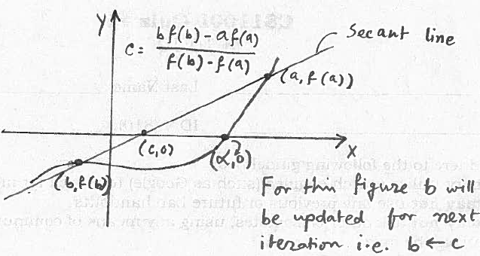

Fig. 1: Method of false position

1. The next method we discussed was Newton-Raphson method which unlike the previous methods works with one initial point instead of two. The algorithm is given below.

Newton-Raphson Algorithm ($f,x_{0},ε,d$):

1. Calculate the first derivative of the given function at $x_{0}$. i.e. $f'(x_{0})$.
2. Check whether $\left|f^{'}\left(x_{0}\right)\right|<d$; If not proceed to next step, otherwise exit algorithm.
3. Compute new approximate root $c= x_{0}-\frac{f(x_{0})}{f'(x_{0})}$; Evaluate $|f(c)|$
4. If $|f(c)|≤ε$ then accept *c* as new root and exit algorithm. Otherwise, go to step e).
5. Assign $x_{0}←c$; evaluate $f'(x_{0})$; Go to step b).

From the initial point $x_{0}$ the algorithm calculate $f'(x_{0})$ which is the slope of the tangent line $l(x)$ at $x_{0}$ as shown in the following figure. Subsequently the point $(c,0)$ where $l(x)$ intersect x- axis is of interest to the algorithm. From the equation of straight line $l(x)$ is expressed as follows.

$$l\left(x\right)=f^{'}\left(x_{0}\right)\left(x-x_{0}\right)+f(x_{0})$$

Substituting $(c,0)$ in the equation we get

$$0=f^{'}\left(x_{0}\right)\left(c-x_{0}\right)+f(x_{0})$$

Or



$$c= x_{0}-\frac{f(x_{0})}{f'(x_{0})}$$

Fig. 2: Newton Raphson method

Now $x=c$ is a more accurate approximation of the initial point $x_{0}$. Then based on the value of $|f(x_{ })|$ at $x=c$ the algorithm proceeds further.