**CSCI 2150L**

**Session 5 Topics:**

1. We discussed on generating a graphical visualization of HW #1 where you had to find the maximum value of x for which the following inequality holds.

$$\left|x-\sin\left(x\right)\right|<0.2$$

We plotted in 3D the values of *x*, sin(*x*) and $\left|x-\sin\left(x\right)\right|$ along X, Y and Z axis respectively. We found the value of x (in degree) to be 61.22o using a new functionality (named Data cursor) in the plot menu. [We used the conversion formula between radian and degrees; x(degree) = x(radian)*180/π]

1. We discussed briefly the general operators (+, -, *, /, ^) and element wise operators (.*, ./, .^). Note that element wise operators are preceded by a dot (.).
2. The following similarity measure to find similarity between two row vectors x and y were discussed.

$$\cos\left(θ\right)= \frac{X.Y}{||X||*||Y||}$$

In the numerator **X.Y** suggests the dot product between X and Y. To find the dot product in MATLAB we used command **dot(x,y)**.

In the denominator of the previous equation **L2** norm of X and Y were used. Related to this the notion of **Lp** norm, ${||X||}_{p}$ were introduced as follows:

$${||X||}_{p}= {(x_{1}^{p}+x_{2}^{p}+…+x_{N}^{p})}^{\frac{1}{p}}$$

According to the formula of similarity above we are using L2 norm as follows

$$\left|\left|X\right|\right|= {(x_{1}^{2}+x_{2}^{2}+…+x_{N}^{2})}^{\frac{1}{2}}$$

And

$$\left|\left|Y\right|\right|= {(y_{1}^{2}+y_{2}^{2}+…+y_{N}^{2})}^{\frac{1}{2}}$$

We are assuming that each of X and Y contains N elements $(<x_{1},x_{2},…,x_{N}>$ and

${<y}_{1},y_{2},…,y_{N}>$ respectively; Notice the <> notation used here to represent the tuples in vector x and y).

To find **Lp** norm in MATLAB we used command **norm(x,p)** where first argument **x** is the name of the matrix and second argument **p** corresponds to **Lp** norm.

1. Generic equation of a straight line were introduced in the lab as follows:

$$y=mx+c$$

Where **m** is the slope of the straight line and **c** is a constant. Observe in the following figure how **m** and **c** determines orientation and position of a straight line relative to the x-y coordinate.

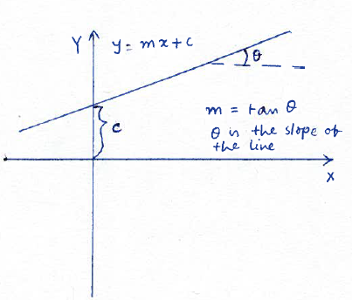

1. We generated two straight lines y1 = m1*x + c1 and y2 = m2 * x + c2. For these straight lines x was a row vector generated as x = -10:10 with default step 1.
2. Subsequently we measured the similarity between y1 and y2 for the following two cases
3. Case 1: m1 = m2 and c1 = c2.
4. Case2: m1 ≠ m2 and c1 ≠ c2.

[Calculate the similarity for these cases again to convince yourself of the validity of the similarity measurement above]