|  |  |  |  |  |
| --- | --- | --- | --- | --- |
| Student Name |  | Student Number | |  |
| Unit Code/s & Name/s | ICTWEB514 Create dynamic web pages  ICTWEB518 Build a document using extensible markup language | | | |
| Cluster Name  *If applicable* | Web Services Cluster | | | |
| Assessment Name | Dynamic Website and XML Portfolio | Assessment Task No. | | 2 of 2 |
| Assessment Due Date | Week 9 | Date submitted | | / / |
| Assessor Name |  | | | |
| **Student Declaration:** I declare that this assessment is my own work. Any ideas and comments made by other people have been acknowledged as references. I understand that if this statement is found to be false, it will be regarded as misconduct and will be subject to disciplinary action as outlined in the TAFE Queensland Student Rules. I understand that by emailing or submitting this assessment electronically, I agree to this Declaration in lieu of a written signature. | | | | |
| Student Signature |  | | Date | / / |

|  |  |
| --- | --- |
| **Instructions to Student** | General Instructions:  You are employed by Uptown IT as a Web Designer/Developer. You have been assigned to a new project and your task is to design a dynamic website that uses XML documents to insert data into a database. The client for this project is *‘High Street Gym’.*  Your teacher/assessor will take on the role of the Project Manager assigned to this project by Uptown IT.  Read the project documentation provided and familiarise yourself with the Project Scenario or Case Study before proceeding with portfolio tasks. Confirm anything you are not sure about the project with your manager (teacher/assessor). It is essential that you have a clear understanding of the scenario and tasks that you need to complete.  This assessment instrument requires the student to complete a project portfolio that is divided into four (4) parts:  PART 1 – Confirm requirements and gather resources for website  Task 1 Conversation Log  Task 2 Confirm dynamic website requirements and legislative requirements  Task 3 Select project software and obtain manager approval to proceed  PART 2 project implementation  Task 1 Dynamic features and database access  Task 2 Plan XML pages  PART 3 Project testing and debugging  PART 4 Web programming research  Materials Required:  Students are required to provide their own storage device. The recommendation for this qualification is an external SSD drive with at least 500 GB capacity, if you need to store a copy of the Virtual Machine (VM). For assessment files only, a 64 GB thumb drive will be sufficient.  Access to PCs and peripherals – these may differ between classrooms  Access to Internet  Access to Connect (LMS)  Access to an XML parser and authoring tool  Access to a text editor  Access to web browsers and devices  Access to Word processing software, such as Microsoft Word  Access to special purpose tools, equipment and materials to complete the assessment portfolio  Online Delivery:  Student to supply their own PC or laptop and peripherals and internet access  Students should have permissions and be able to install software on their computer  Students will require access to Microsoft Office or similar  Students will require access to a web server or the ability to install a local web server on their computer (instructions for this will be provided)  Documentation:  Uptown IT Scenario or Case Study  Client or business requirements  Assessment Criteria:  To achieve a satisfactory result, your assessor will be looking for your ability to demonstrate the following key skills/tasks/knowledge to an acceptable industry standard. Demonstrated ability to:  Obtain and review business requirements in communication with client and stakeholders  Apply legislative and organisational standards  Select and use appropriate languages (client and server-side) and technologies to meet requirements  Produce boilerplate templates as required  Debug and test dynamic website in at least two different browsers and devices  Determine the purpose, and expected functionality of XML documents  Plan and design XML documents and DTDs to meet requirements  Test XML functionality offline and online  Test and confirm XML validity on various browsers and devices  Formally document the dynamic website process  Refer to the marking criteria for specific details:  ICTWEB514_ICTWEB518_AT2_MC_TQM_V1  Details of Location:  TAFE will provide a simulated work environment in the classroom. Research activities may be conducted in the classroom or at home.  If you are unable to attend a scheduled assessment activity, you must notify your teacher before the assessment is due and supply a doctor's certificate and approval from the team manager for an extension.  Time Restrictions:  This assignment is designed to take place over 8 weeks or approximately 32 hours. The student is expected to attend classes as per timetable details and should be able to commit up to 3 hours per week of their own time to study or study-related activities.  Interactions:  Teamwork skills are essential in the IT industry therefore you should work in teams to consult and collaborate on practical activities. However, each student must complete the assessment tasks individually (unless indicated).  Level of Assistance Permitted:  Staff cannot directly show students answers or solutions but support and guide them to complete tasks individually. Teachers and tutors should be available in class, and accessible by email for students working from home.  Reasonable Adjustments:  Reasonable adjustment is available to students for a variety of reasons, including: disability, language, literacy and numeracy (LLN) problems or extenuating circumstances. Talk to your teacher, counsellor, or disability officer if you require extra support or an extension based on the conditions identified.  Number of Attempts:  You will receive up to two (2) attempts at this assessment task. Should your 1st attempt be unsatisfactory (U), your teacher will provide feedback and discuss the relevant sections/questions with you and will arrange a due date for the submission of your 2nd attempt. If your 2nd submission is unsatisfactory (U), or you fail to submit a 2nd attempt, you will receive an overall unsatisfactory result for this assessment task. Only one re-assessment attempt may be granted for each assessment task.  ***For more information, refer to the Student Rules.***  Work, Health and Safety:  The work environment should be assessed for safety prior to class. Special consideration should be taken regarding potential ICT related hazards such as tripping hazards, electromagnetic radiation, ergonomics, and posture. TAFE Queensland health and safety policies and procedures should be followed at all times. |
| **Submission details** (if relevant) | Evidence Required to be Submitted:  Insert your details on the cover page and sign the Student Declaration. Include this template with your submission.  Portfolio items for submission:  All tasks in each of the four parts composing this assessment must be submitted.  Submission via Connect:  Upload a single file into Assessment 2 (AT2) Assignment Folder in Connect.  Multiple files can be compressed into a single file.  Name the file:  **ICTWEB514_ICTWEB518_AT2_Surname_Student Number**  Resubmissions should append an R to the filename:  **ICTWEB514_ICTWEB518_AT2_Surname_Student Number_R**  TAFE Queensland Learning Management System (Connect)  Assessment to be submitted via   * TAFE Queensland Learning Management System (Connect): [*https://connect.tafeqld.edu.au/d2l/login*](https://connect.tafeqld.edu.au/d2l/login) * Username; 9 digit student number * For password resets go to: [*https://passwordreset.tafeqld.edu.au/default.aspx*](https://passwordreset.tafeqld.edu.au/default.aspx) |
| **Instructions to Assessor** | Online Delivery:  Please revise and modify the Instructions to Student section if you are delivering online.  Specifications of Assessment:  To be judged competent in this assessment item the student is required to demonstrate competence in all indicators shown in the marking guide.  Gather evidence to demonstrate consistent performance in conditions that are safe and replicate the workplace. Noise levels, production flow, interruptions and time variances must be typical of those experienced in the web development field of work and include access to:  web development environment  project requirements  Ensure that students read and familiarise themselves with the Project Scenario and the Client provided relevant files and/or resources before attempting the assessment.  Storage Devices:  Students are required to provide their own storage device. The recommendation for this qualification is an external SSD drive with at least 500 GB capacity, if you need to store a copy of the Virtual Machine (VM). For assessment files only, a 64 GB thumb drive will be sufficient.  Assessor to Provide:  Access to PCs and peripherals – these may differ between classrooms  Access to the Internet  Access to Connect (LMS)  Access to an XML parser and authoring tool  Access to a text editor  Access to web browsers and devices  Access to Word processing software, such as Microsoft Word  Access to special-purpose tools, equipment and materials to complete the assessment portfolio  Online Delivery:  Student to supply their own PC or laptop and peripherals and internet access  Students should have permissions and be able to install software on their computer  Students will require access to Microsoft Office or similar  Students will require access to a web server or the ability to install a local web server on their computer (instructions for this will be provided)  Documentation:  Uptown IT Scenario or Case Study  Client or business requirements  Uptown IT Functionality Testing Template  Level of Assistance Permitted:  Teachers and tutors should be available in class, and accessible by email for students working from home. Staff cannot directly show students answers but support and guide them to complete tasks individually. Students with disability will receive reasonable adjustments.  Interactions:  Teamwork skills are essential in the IT industry therefore you should work in teams to consult and collaborate on practical activities. However, each student must complete the assessment tasks individually (unless indicated).  Contingencies:  Reasonable adjustment is available to students for a variety of reasons, including: disability, language, literacy and numeracy (LLN) problems or extenuating circumstances.  Work, Health and Safety:  The work environment should be assessed for safety prior to class. Special consideration should be taken regarding potential ICT related hazards such as tripping hazards, electromagnetic radiation, ergonomics, and posture. TAFE Queensland health and safety policies and procedures should be followed at all times. |
| **Note to Student** | An overview of all Assessment Tasks relevant to this unit is located in the Unit Study Guide. If you have any question or need help regarding this assessment item please contact your teacher/tutor through email or during face-to-face sessions. |

|  |  |
| --- | --- |
| Scenario-01 | Project Scenario |
| You are employed by Uptown IT as a Web Designer/Developer. You have been assigned to a new project and your task is to design a dynamic website solution for the client. The website requires you to create and parse XML documents to transfer data to a database. The client for this project is High Street Gym.  Your teacher will take on the role of Project Manager for the web project. | |

**Project Specification:**

The client, High Street Gym, requires a dynamic website and a database to manage class bookings for a variety of activities offered by the centre. This includes:

* Processing user authentication
* Displaying Gym classes calendar (weekday and times) from database
* Allowing users to book a class with a specific trainer (if more than one are available)
* Displaying a members’ blog with functionality to upload and read messages

The client has specifically requested that at least two (2) XML documents are used to send data to the database. For example, adding a new class/activity or adding a new member.

In terms of programming languages and technologies, the client allows the developer to select the best-suited client and server-side languages and/or platforms for the project.

Current classes/activities include:

* Yoga
* Pilates
* Abs
* HIIT or high-intensity interval training
* Indoor cycling
* Boxing
* Zumba

Other classes will be added if they are requested by gym members and trainers are available.

**Database Requirements:**

The database required for this project includes class bookings only. Financial and administrative records of the gym are not part of this database.

The database needs to store information about:

* Users
* Classes/activities
* Classes calendar/timetable (weekday, time, duration, level and so on)
* Trainers

|  |  |
| --- | --- |
| Note-01 | Note |
| You should create an appropriately formatted report to include all written components including tables, checklists and screenshots for this assessment. This document should be saved in an appropriate format (MS Word or PDF) and named as:   * **AT2_Written_Surname_Student Number** | |

## Part 1 - Confirm requirements and gather resources for the project website

**All tasks in PART 1 must be submitted.**

### Task 1: Conversation Log

1.1 Use the following Conversation Log to keep track of all interactions with your manager and other stakeholders. Oral interactions are essential to this project as you need to maintain continuous contact with your manager, the user groups, and other relevant personnel. Online students may need to communicate via Zoom or similar platform. *There is one oral communication recording (Part 3.6) that needs to be included in your final submission*

|  |  |  |  |
| --- | --- | --- | --- |
| Date | Topic | Discussion | Stakeholder |
|  |  |  |  |
|  |  |  |  |
|  |  |  |  |
|  |  |  |  |

*Add rows as necessary*

### Task 2: Confirm dynamic website requirements and legislative requirements

1.2 Before you proceed with the project, review the scenario presented, complete the table below, and communicate any concerns or issues you may have to your manager. Update the Conversation Log.

|  |  |
| --- | --- |
| Dynamic Website Requirements | Comments |
| Calendar display | How often will it be updated? Does it need more simple ways to add or edit classes? |
| Booking limits | Should there be a limit on the number of classes a member can book per day? |
| Login and Registration | Does the user need to register and log in before they can book a class or use the blog? |
| Admin dashboard | Does the admin require a simple backend to manage classes, blog or users? |
| XML Usage | Besides adding a new class or adding a new member, is there any data needs to be transmitted in XML? |

1.3 Identify and document any legislative and organisational standards that relate to the project. This includes dynamic functionality and XML documents.

* HTML standards
* HTML Living Standards - WHATWG
* CSS standards
* CSS Level 3 – W3C
* Accessibility standards
* Web Content Accessibility Guidelines (WCAG) 2.1 W3C Recommendation, 05 June 2018
* Web Content Accessibility Guidelines (WCAG) 2.2W3C Working Draft, 21 May 2021
* JavaScript standards
* European Association for Standardizing Information and Communication Systems – ECMA-262, 9th edition, June 2018
* XML standards
* Extensible Markup Language (XML) 1.0 (Fifth Edition) W3C Recommendation, 26 November 2008
* XSLT standards
* XSL Transformations (XSLT) Version 3.0 W3C Recommendation, 8 June 2017.
* XML Schema Definition Language (XSD) – W3C
* TLS/SSL certificates

1.4 Confirm legislative and organisational standards with your manager. Update Conversation Log.

### Task 3: Select project software and obtain manager approval to proceed

1.5 Identify and justify the selection of client-side and server-side programming languages, XML (Extensible Markup Language) and CSS platform. Complete the table below providing the full mane and version of each software application.

|  |  |
| --- | --- |
| Software/Technologies | Justification |
| JavaScript | It could allow content, such as booking details and classes schedule to update in real time, and do not have to refresh the page. In this way, it is better for user experience. |
| PHP | It is a popular server-side language that handles dynamic content and interacts well with databased and XML data, making it suitable for backend processing. |
| XML | It is a markup language that provides rules to define any data. Any programming language or software can be implemented for structured data management by using XML. |
| CSS and Bootstrap | CSS styles the appearance of the website and make it more modern, while the Bootstrap framework ensures the site is responsive across devices. It allows for adaptive screen sizes, enabling the display of specific content based on the device. Bootstrap also helps maintain consistency across projects, especially when multiple developer teams are involved, and enables quick prototyping of designs. |
| MySQL | It is great for its compatibility with PHP and could handle relational data more efficient. |

*Add rows as necessary*

1.6 Discuss your software selection with your manager and update Conversation Log. Obtain approval to proceed to implementation.

|  |  |  |
| --- | --- | --- |
| **Project Requirements SIGNOFF**  Signing off on this document signifies that the project requirements have been identified and documented. | | |
| **Project Manager** | **QA Officer** | |
| Signature: | Signature: | |
| Date: | Date: | |
| Project Requirements NOT APPROVED | | |
| Please provide feedback on the changes needed. | | |
| APPROVAL to proceed to next stage: | | Granted  Not Granted |

## Part 2 - Project Implementation

**All tasks in PART 2 must be submitted.**

### Task 1: Dynamic features and database access

2.1 Review the website requirements and identify common page sections and features that could be efficiently implemented using boilerplate templates. Create the template/s.

* **Header**: Contains the gym logo, navigation menu, and user authentication links.
* **Footer**: Contains contact information, social media links, and copyright information.
* **Navigation Menu**: Links to Home, Classes, Blog, and User Dashboard.
* **User Authentication Forms**: Login and registration forms.

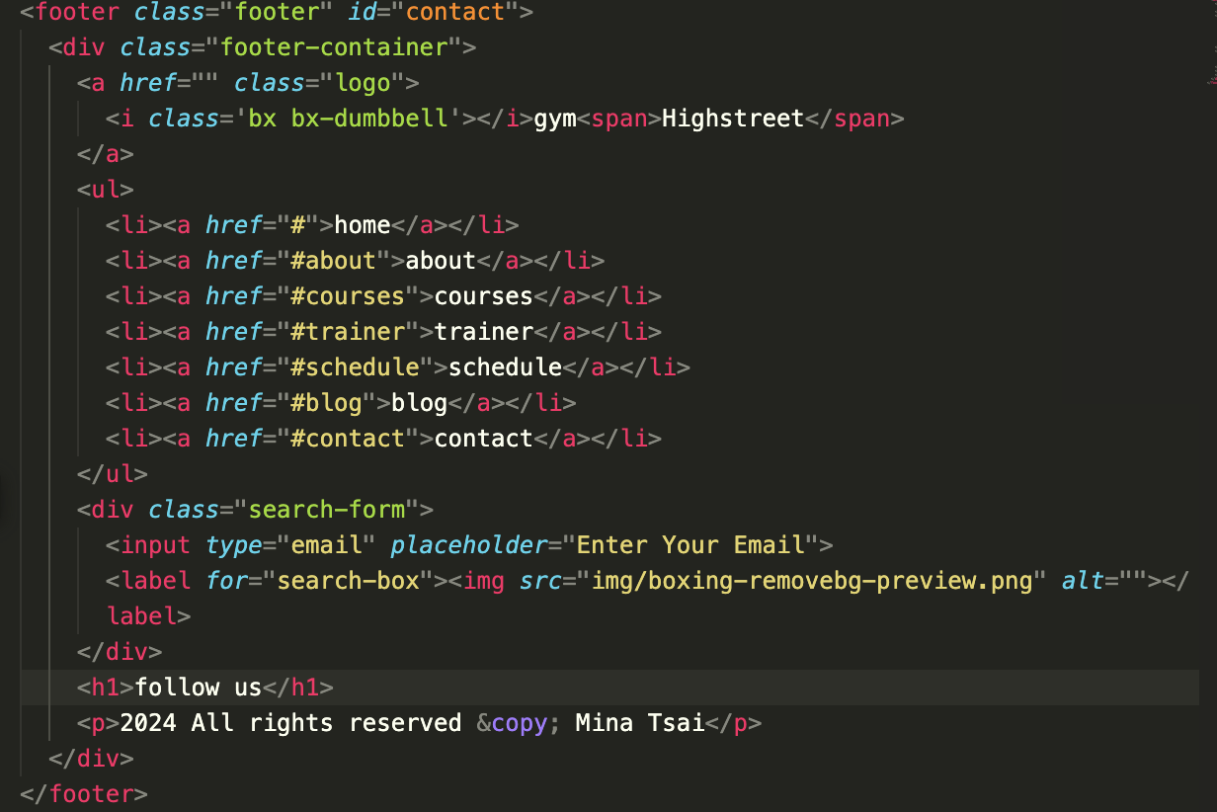

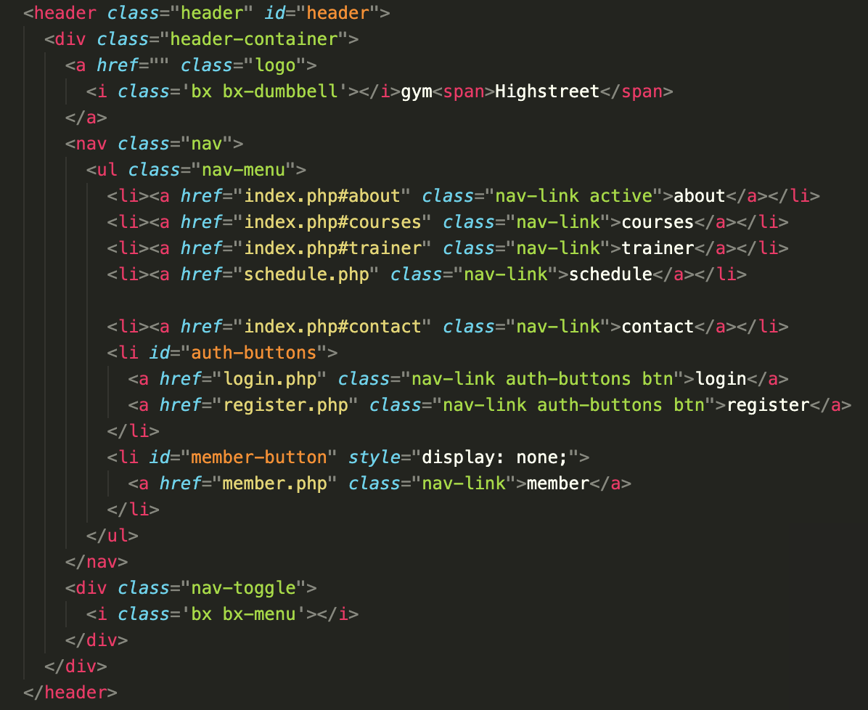

2.2 Create the relational (SQL based) database required to support the class bookings. Refer to the project scenario for details.

* **Users**: user_id (PK), username, password, email
* **Classes**: class_id (PK), class_name, weekday, class_date, time, duration, level, trainer, category
* **Trainers**: trainer_id (PK), trainer_name
* **Bookings**: booking_id (PK), user_id (FK), class_id (FK), booking_date, status, trainer
* **BlogPosts**: post_id (PK), user_id (FK), title, content, post_date
* **members**: id (PK), name, email, phone

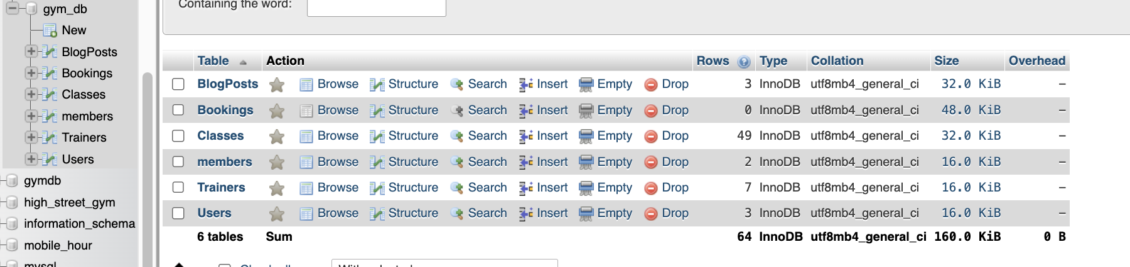

2.3 If appropriate, use the template/s created in Task 1 (2.1) to implement the web pages. The dynamic web features identified in the requirements must be implemented in at least three (3) separate pages. Each page must include client-side and server-side scripting.

The task includes creating pages to:

Process authentication

Display Gym classes calendar/timetable (weekday, time, duration, level and so on) from the database and the facility to book a class and a trainer – if more than one is available

Display a members’ blog with functionality to upload and read messages

In consultation with your project manager, other pages may be included for extra functionality in the website

2.4 Complete the table below to identify which functionality has been implemented and which technology has been used for each function.

|  |  |  |
| --- | --- | --- |
| Page | Functionality | Software/Technology Used |
| Page 1 |  |  |
|  |  |
| *Add rows as necessary* |  |
| Page 2 |  |  |
|  |  |
| *Add rows as necessary* |  |
| Page 3 |  |  |
|  |  |
| *Add rows as necessary* |  |
| Other |  |  |
|  |  |
| *Add rows as necessary* |  |

### Task 2: Implementation plan XML pages

2.5 As per the scenario presented, you need to create at least two (2) XML documents to parse XML data into your database using the server-side language selected in PART 1-Task 3. Review the XML requirements and complete the table below.

|  |  |  |  |
| --- | --- | --- | --- |
| XML Document | Purpose | Expectations | Functionality |
|  |  |  |  |
|  |  |  |  |
|  |  |  |  |
|  |  |  |  |

*Add rows as necessary*

2.6 Outline a plan to create the XML documents, taking into consideration that the XML documents must integrate with and complement the dynamic website features in an iterative process. Identify the design methodology that you are planning to use and indicate at which stage of the methodology you would create and integrate the XML document/s to the webpages. Identify the software that would be used to create the XML pages.

|  |  |  |  |
| --- | --- | --- | --- |
| XML Document 1 | Selected Design Methodology | Stage | Software/Tools |
|  |  |  |  |
|  |  |  |  |
|  |  |  |  |
|  |  |  |  |

*Add rows as necessary*

|  |  |  |  |
| --- | --- | --- | --- |
| XML Document 2 | Selected Design Methodology | Stage | Software/Tools |
|  |  |  |  |
|  |  |  |  |
|  |  |  |  |
|  |  |  |  |

*Add rows as necessary*

2.7 Identify and document the DTD (Document Type Definition) including the XML documents structure, their entities, elements, and attributes. Any media associated features must also be included. You can use graphics to support your written explanation to describe the XML document structures and elements.

2.8 Determine and explain the method you plan to use to embed XML into the HTML pages.

2.9 Discuss with your manager the organisational policies, procedures, and standards applicable to developing the XML documents. Update the Conversation Log.

2.10 Create XML pages as per the plan outlined in 2.6.

## Part 3 - Project testing and debugging

**All tasks in PART 3 must be submitted.**

3.1 Debug the code as necessary and present proof of debugging by providing screenshots of the process. Two instances of debugging are sufficient.

3.2 Validate the HTML and the XML code against current industry standard specifications. Provide screenshots of validation reports.

3.3 Test and evaluate each functionality required and identified in PART 2 is working as expected. This includes programming features and functionality (client and server-side programming). Test website functionality in at least two (2) browsers and two (2) devices. Fix as necessary. Re-test. Provide screenshots as evidence. Use template provided.

3.4 Test XML documents:

a) Test XML document offline. Amend as required. Provide Screenshots.

b) Test XML document online. Amend as required. Provide screenshots.

3.5 Outline what security measures have you implemented on the website for the following three areas:

a) Authentication process

b) Programmatically engineered solutions to avoid cyber-attacks

c) Internet protocols

3.6 Record a simulated meeting with the project manager seeking feedback on the project implementation. For this component you can conduct the meeting with a family member, friend, another student or work colleague. Update website and XML documentation as required. Record the meeting in the Conversation Log.

|  |  |
| --- | --- |
| **Important-01** | Important |
| The above simulated meeting should be recorded and the recording submitted as part of your final assessment. The recording should be approximately 7 - 10 minutes. | |

3.7 Email to manager communicating the project completion.

|  |  |
| --- | --- |
| **Website Implementation SIGNOFF**  Signing off on this document signifies that all required dynamic features and XML documents comply with the Client’s requirements. | |
| **Project Manager** | **QA Officer** |
| Signature: | Signature: |
| Date: | Date: |
| Dynamic Website and XML documents NOT APPROVED | |
| Please provide feedback on the changes needed. | |

3.8 Contingency task. Assume that you have completed the project and have successfully tested it in three (3) popular browsers as requested. However, the client contacts you with a new request to make the website cross-browser compatible with a new not widely used browser. After some testing, you identify that one specific key dynamic feature is not supported by the new browser. How would you proceed with the client at this stage?

## Part 4 - Web programming research

**All answers in PART 4 must be submitted.**

**REFERENCING YOUR WORK**

Part 4 requires you to carry out research and provide answers to a number of questions. Provide the answers in your own words. Plagiarism is a form of academic misconduct and will not be tolerated. Include references for all your sources using a formal referencing style such as APA or Harvard.

4.1 Web programming concepts:

a) Compare multi-factor authentication and certificate-based authentication.

Suggest the most appropriate web security method (multi-factor or certificate-based) for the web project that you have completed in this portfolio. Justify your selection.

b) Research HTTP (Hypertext Transfer Protocol) and identify the current version of the standard specification. Select and explain two (2) new features of the current specification that improve web security.

c) Propose and provide examples of two (2) limiting features of stateless programming that can be overcome using session management.

d) Suggest and outline two (2) strategies that can be used to extend data storage in web applications.

4.2 Web Technologies:

a) Research the progression of HTML specifications from its beginnings in 1993 and theorise what could be the next areas/technologies that will need to be covered by HTML syntax.

b) Identify and describe three (3) differences between CSS grid layout and CSS Flex model. Based on the differences identified, explain which CSS model is better suited for the web project in this portfolio.

4.3 Programming good practice:

a) Good coding techniques include (1) the use of an appropriate naming convention and (2) avoiding deep nesting. For each technique, outline the consequences of not applying the technique to the code.

b) The basic programming control structures are sequence, selection, and iteration. Analyse how iteration works and propose other methods or techniques to achieve iteration or repetition.

c) Select three (3) the areas covered by syntax rules in programming. For each area, explain what is gained by using the specific programming language syntax.

d) In reference to the web project in this portfolio, provide an explanation to justify the use of client and server-side scripting.

e) Propose three (3) techniques that could be used to minimise code errors and the need to debug (fixing code errors). Provide examples to illustrate your answer.

f) Identify and describe two (2) debugging methods that can be used to test server connections.

**End of Assessment**

**DELIVERABLES:**

For this assessment item you should submit the following:

* Report including all tables, checklist, screenshots and answers to knowledge questions.
* All website files including database export
* Any usernames/passwords associated with your website
* Meeting Recording

All of your files should be added to a folder named:

* **ICTWEB514_ICTWEB518_AT2_Surname_Student Number**

Resubmissions should append an R to the filename:

* **ICTWEB514_ICTWEB518_AT2_Surname_Student Number_R**

Once all files have been included into this folder, compress it (e.g. with WinZip) and upload it to the Assignment Folder in Connect for ICTWEB514-ICTWEB518 Assessment 2 (AT2).

**Reference**

<https://aws.amazon.com/what-is/xml/>

<https://developer.mozilla.org/en-US/docs/Web/CSS>

<https://www.cyber.gov.au/resources-business-and-government/maintaining-devices-and-systems/system-hardening-and-administration/web-hardening/implementing-certificates-tls-https-and-opportunistic-tls>