**WelcomePage :-** The project starts with this section and includes login and signup.

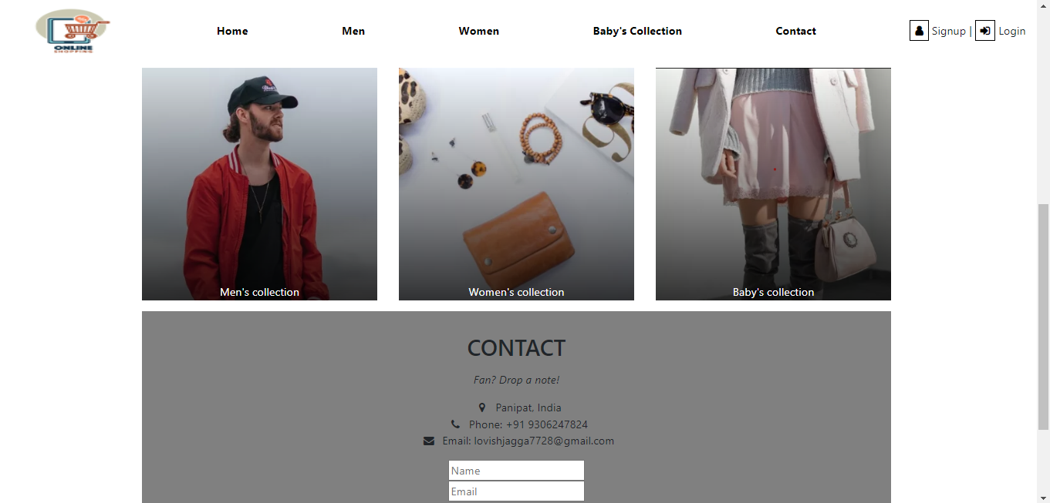

**Men Shopping Page**

**Womens Shop Page :**

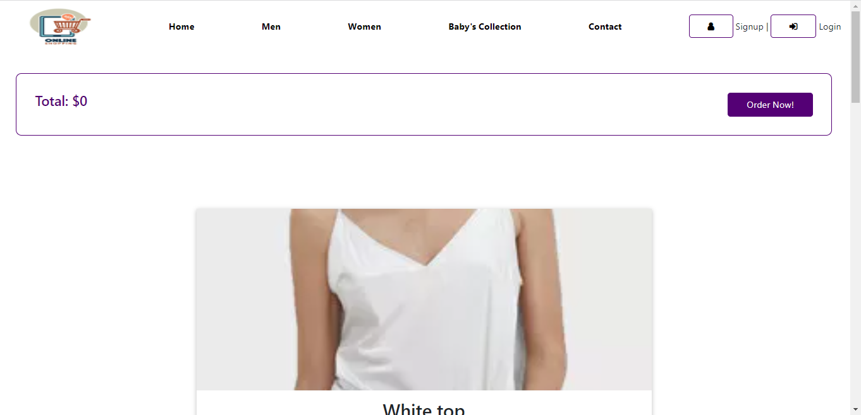

**Baby Shop Page :**

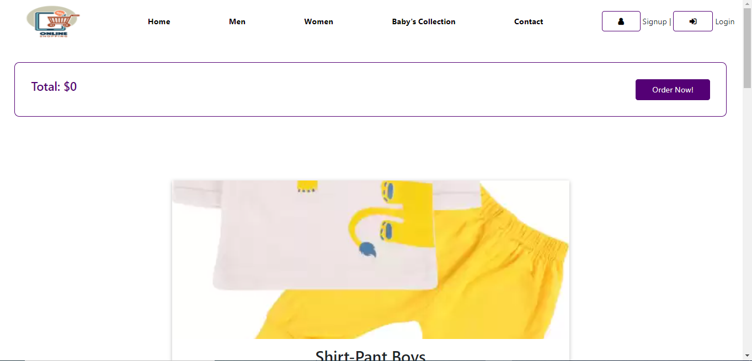

**SignIn Modal :**

**Login Modal :**

