Airbnb Price Prediction Across 10 European Cities
Project report: data cleaning, exploratory analysis, machine-learning modelling and deployment as a web app (PriceScope).

1. Executive summary
- Goal: predict an Airbnb listing's price from its location (city, coordinates, distance to the centre and metro, nearby attractions and restaurants), its characteristics (room type, capacity, bedrooms), host quality, guest reviews and city-level economic indicators.
- Data: 51,707 listings from Amsterdam, Athens, Barcelona, Berlin, Budapest, Lisbon, London, Paris, Rome and Vienna. After cleaning, 51,611 rows with 29 columns remain.
- Best model: a weighted ensemble of CatBoost (42%) + XGBoost (41%) + LightGBM (17%) trained on log price.
- Accuracy on unseen listings: R² = 0.857 on log price, median error 17.1%, and 74.4% of predictions within ±30% of the real price. MAE is €87 on a median price of €261.
- Main price drivers: how central the location is (the proximity, attraction and restaurant indices plus distance to the centre and metro), then city, room type and capacity. Host status and review scores matter much less.
- Deliverable: a Flask web app with a market dashboard, an interactive map explorer (points and heatmaps), a click-on-the-map price predictor with SHAP explanations and comparable listings, a model-performance page, and this report.
Note on the target: price_total comes from the public European Airbnb dataset (Gyódi & Nawaro, 2021), where it is the total price in EUR for a 2-night stay for 2 people. The app therefore also shows an approximate per-night price (total ÷ 2).

2. Dataset
Group | Columns
Target | price_total
Listing | room_type, is_shared_room, is_private_room, max_guests, num_bedrooms
Host and reviews | is_superhost, is_multi_listing, is_business_listing, cleanliness_score, guest_satisfaction_score
Location | latitude, longitude, distance_city_center, distance_metro, attraction_index_norm, restaurant_index_norm, proximity_index
Administrative | city, district, state, country_name
City economics | Crime_Index, Safety_Index, Monthly_Average_Net_salary, Taxi_price_per_Km, Monthly_Basic_Utilities
Time | day_type (weekday / weekend)

3. Data cleaning
The file was already mostly clean (no missing values), but validation still turned up some problems:
Step | Rows removed | Detail
Drop exported index column | 0 | Unnamed: 0 was a pandas index
Missing-value check | 0 | 0 missing cells
Remove exact duplicates | 63 | identical rows
Fix country label | 0 | 4,580 Rome rows were geocoded as Holy See (Vatican City State); relabelled Italy
Room-type flag consistency | 0 | room_type matches is_shared_room / is_private_room
Domain range checks | 0 | scores in range, distances ≥ 0, price > 0
Extreme price outliers | 33 | per-city 3×IQR fence on log price; removes entry errors such as a €43,955 listing

A finding that matters for evaluation: 18,774 listings appear twice, once as a weekday row and once as a weekend row, with almost the same price. A random train/test split would put one copy in training and the other in testing, so the model would be scored partly on listings it had already seen. We give every row a listing_id and split by listing (see section 5).
proximity_index was checked for target leakage. It is a deterministic function of the four location columns (a gradient-boosting model rebuilds it with R² = 0.9994, and adding price on top changes nothing), so it is a valid feature.

4. Exploratory data analysis

4.1 Price distribution
Prices are heavily right-skewed: the median is €261 and the mean is €365. The log of price is close to normal, so all models predict log1p(price).
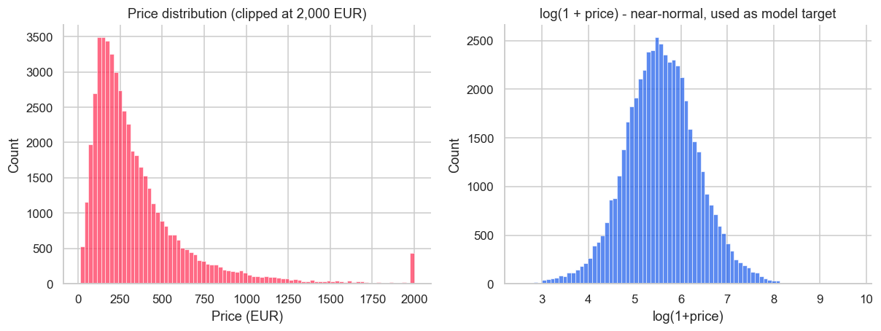

4.2 Cities
Amsterdam (€503) and Paris (€450) are the most expensive markets, about 2.5× Athens (€181) and Rome (€194). London has the most listings (9,989).
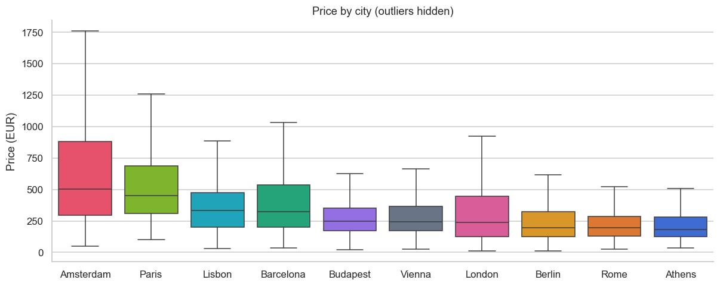

4.3 Room type
An entire home or apartment costs roughly 1.5–2.5× a private room in the same city. Shared rooms are rare (0.7%) and the cheapest.
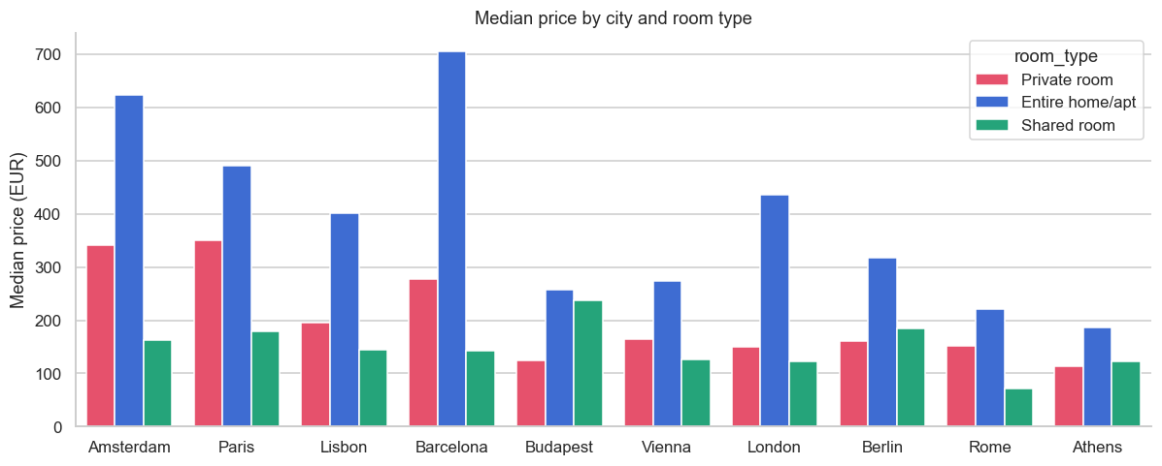

4.4 Weekday vs weekend
Across all cities, weekend stays carry a median premium of +4.6%. The size of the premium varies by city.
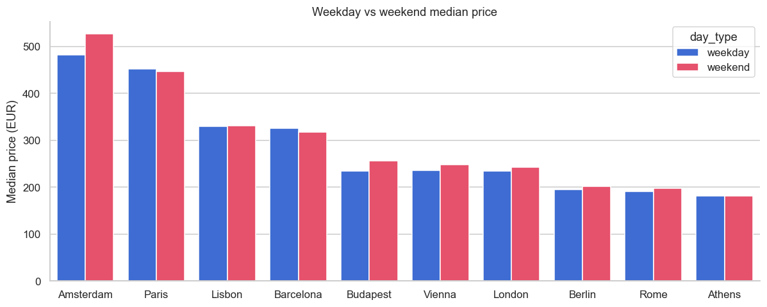

4.5 Location effects
Price falls steadily with distance from the centre and rises with the attraction and restaurant indices. Location is the strongest single signal in the data.
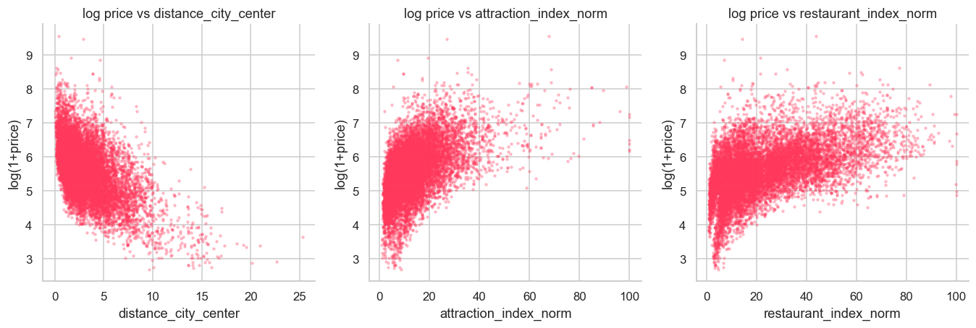

4.6 Capacity
Each extra guest or bedroom raises the price in a near-linear, monotonic way.
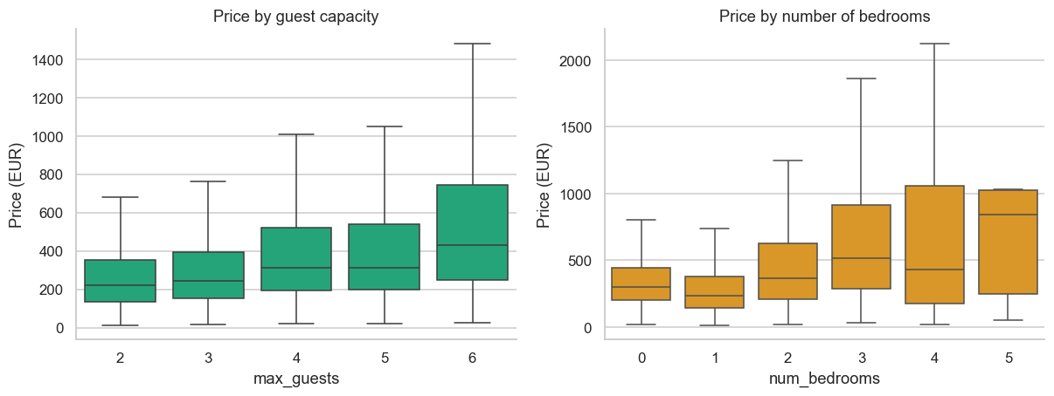

4.7 Correlations
Restaurant and attraction indices are strongly correlated with each other and with proximity_index. The city-level indices (crime, salary, utilities) are constant within a city, so they act as city descriptors.
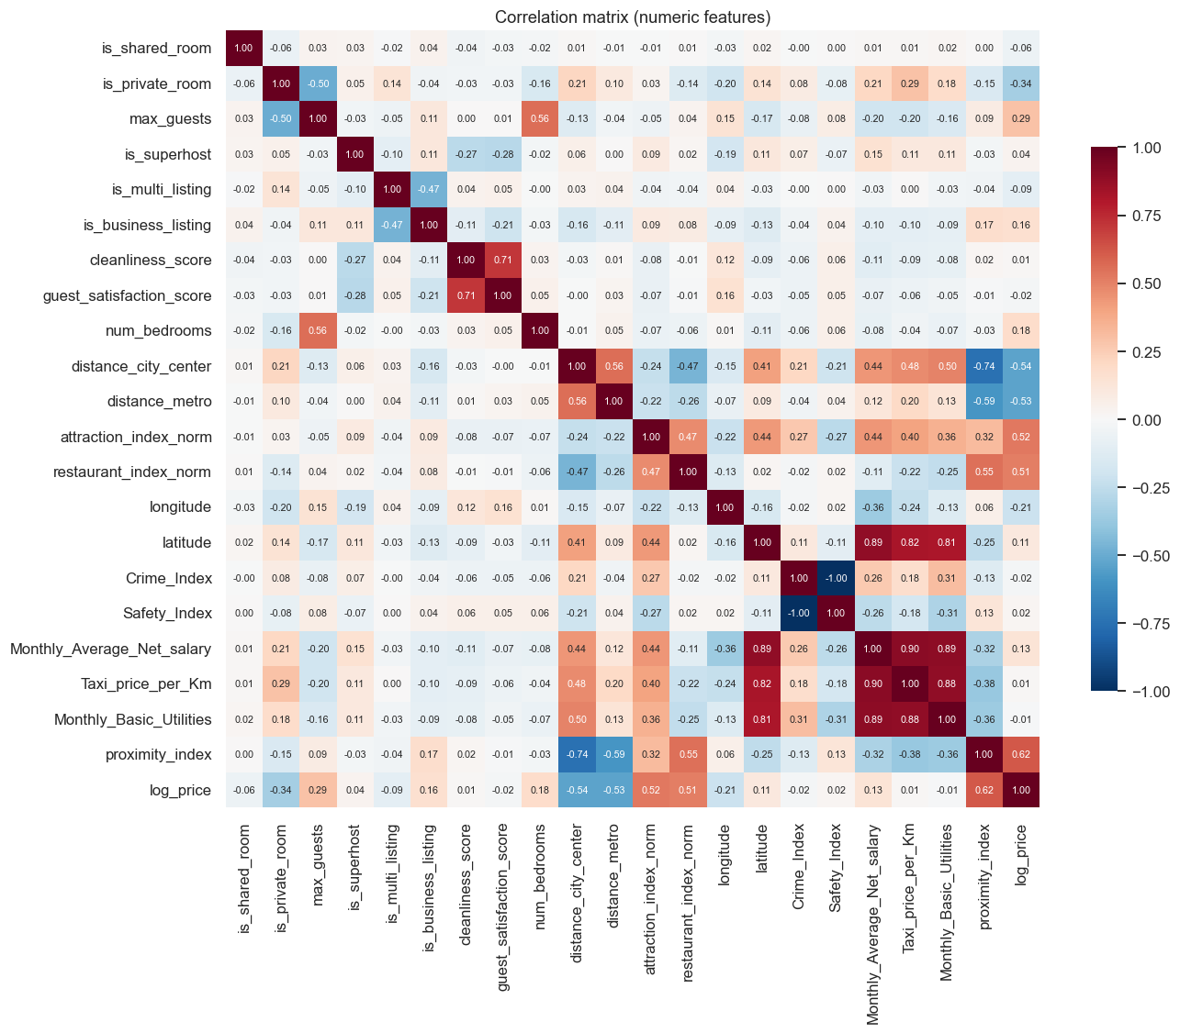

4.8 Host quality
Superhost status and high satisfaction scores have only a small effect on price. Guests seem to pay for location and space rather than for reputation.
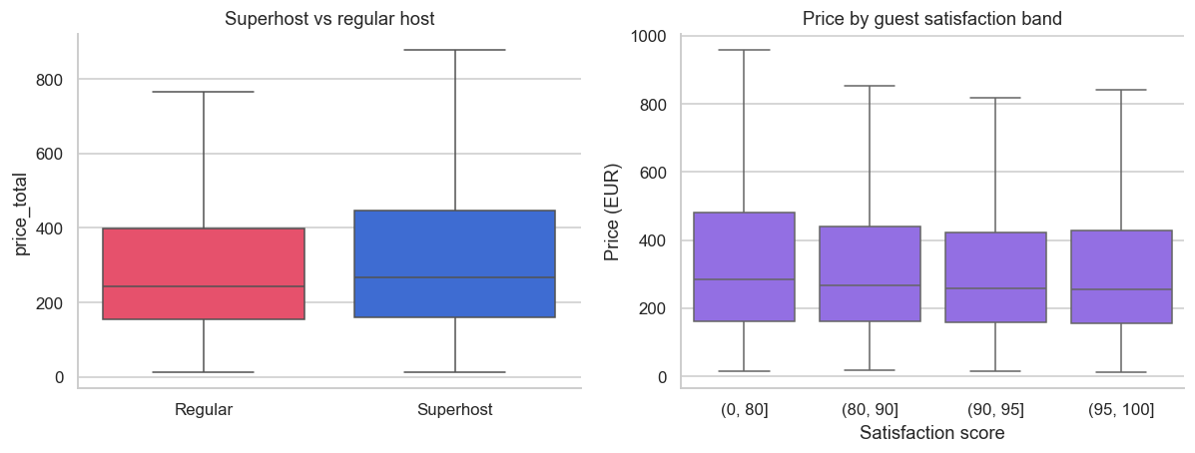

4.9 Affluence
Cities with higher average salaries have higher prices, but tourist demand matters too: Lisbon and Barcelona are priced above what their salary levels alone would suggest.
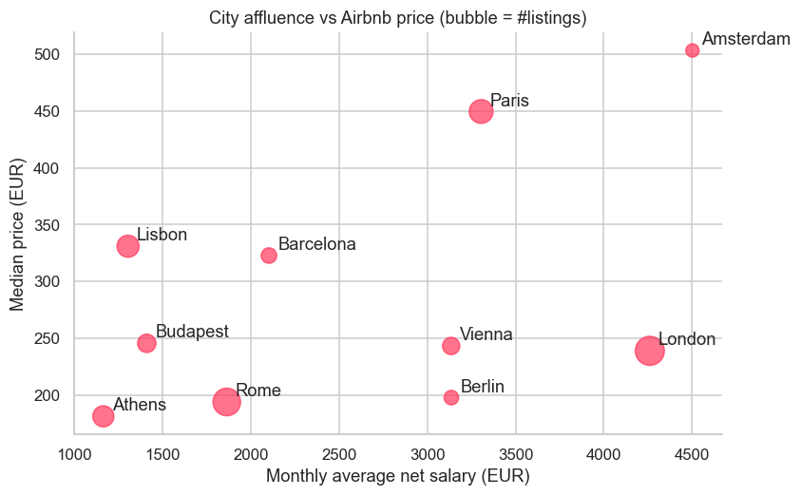

5. Methodology

5.1 Feature engineering (25 features)
In addition to the original listing, location and city features:
Feature | Rationale
is_weekend | binary encoding of day_type
guests_per_bedroom | how crowded the unit is
log_dist_center, log_dist_metro | the price decline with distance is steep near the centre and flattens further out
attr_x_rest | interaction term: a high score requires both attractions and restaurants nearby
quality_score | 0.4 × cleanliness + 0.6 × satisfaction, on a 0–100 scale

district, state and country_name were dropped because each is redundant with city plus the coordinates. is_shared_room and is_private_room were dropped because they duplicate room_type.

5.2 Validation strategy
- Hold-out test set: 20% of listings (10,366 rows), using GroupShuffleSplit by listing_id. No listing appears in both training and test data.
- Early stopping and ensemble weights: set on a further grouped 15% validation fold carved out of the training data. The test set is never used for tuning.
- Production model: refit on 100% of the data with the tuned number of boosting rounds.

5.3 Models
Model | Configuration
City median | baseline
Ridge regression | one-hot encoding, standardised features
Random Forest | 300 trees, max_features=0.5
LightGBM | 63 leaves, learning rate 0.02, row and column subsampling, early stopping
XGBoost | depth 8, learning rate 0.02, hist method, native categorical support
CatBoost | depth 8, learning rate 0.04, native categorical support
Weighted ensemble | non-negative weights minimising validation MSE

6. Results

6.1 Leaderboard (hold-out test set, unseen listings)
Model | R² (log) | R² (€) | MAE € | RMSE € | MAPE | Median APE | ±20% | ±30%
City median (baseline) | 0.157 | 0.040 | 191.4 | 402.2 | 66.7% | 42.2% | 25.3% | 37.3%
Ridge regression | 0.811 | 0.615 | 99.6 | 254.7 | 25.6% | 20.7% | 48.5% | 67.0%
Random Forest | 0.847 | 0.635 | 90.1 | 248.1 | 22.3% | 17.2% | 56.0% | 73.1%
LightGBM | 0.854 | 0.651 | 88.1 | 242.3 | 22.0% | 17.5% | 55.9% | 74.1%
XGBoost | 0.855 | 0.650 | 87.6 | 242.7 | 21.8% | 17.1% | 56.6% | 74.2%
CatBoost | 0.856 | 0.653 | 87.3 | 241.9 | 21.8% | 17.3% | 56.4% | 74.2%
Weighted ensemble | 0.857 | 0.653 | 87.1 | 241.7 | 21.7% | 17.1% | 56.5% | 74.4%

How to read these numbers:
- R² on log price (0.857) is the standard metric for price models. The model explains about 86% of the variation in log price.
- R² in euros (0.65) is lower because a few very expensive listings (€2,000–€9,000) dominate squared error in euro terms. Typical-case accuracy is better described by the median absolute error of 17%.
- Random-split comparison: a naive random row split gives R² = 0.876. That figure is inflated by the duplicated weekday/weekend rows, so we report the stricter 0.857.
- Around 14% of the variation cannot be explained by the available columns. It depends on things the dataset does not contain, such as photos, the interior, the size in m², the view, amenities and dynamic pricing.
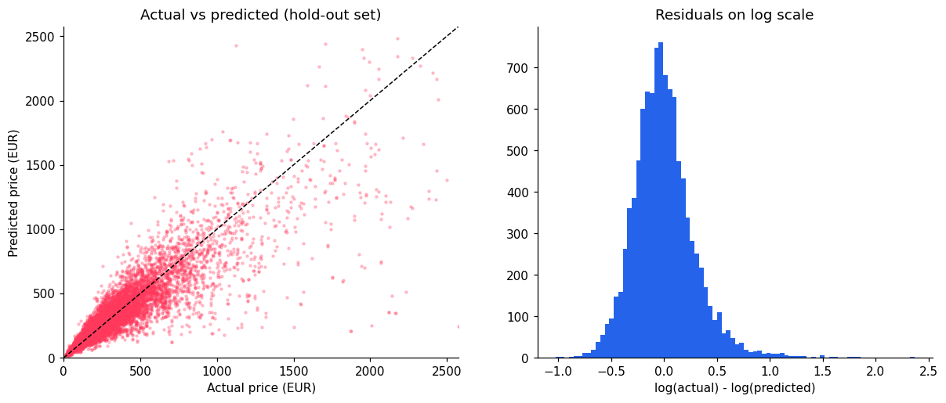

6.2 Accuracy by city
Median absolute error ranges from 14.8% (Lisbon) to 19.3% (Budapest). R² on log price is highest in London (0.884) and Amsterdam (0.864). Paris has the lowest R² (0.721) because prices within Paris vary unusually widely even at similar locations.
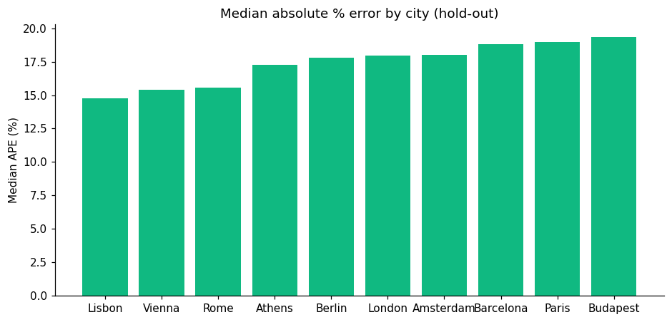

6.3 Explainability
The two most important features are proximity_index (23% of total gain) and attr_x_rest (22%). Next come attraction index, city, room type, distance to metro, longitude, max guests and bedrooms. The SHAP plot shows the direction of each effect: central, well-connected locations, entire homes and more capacity all push the price up.
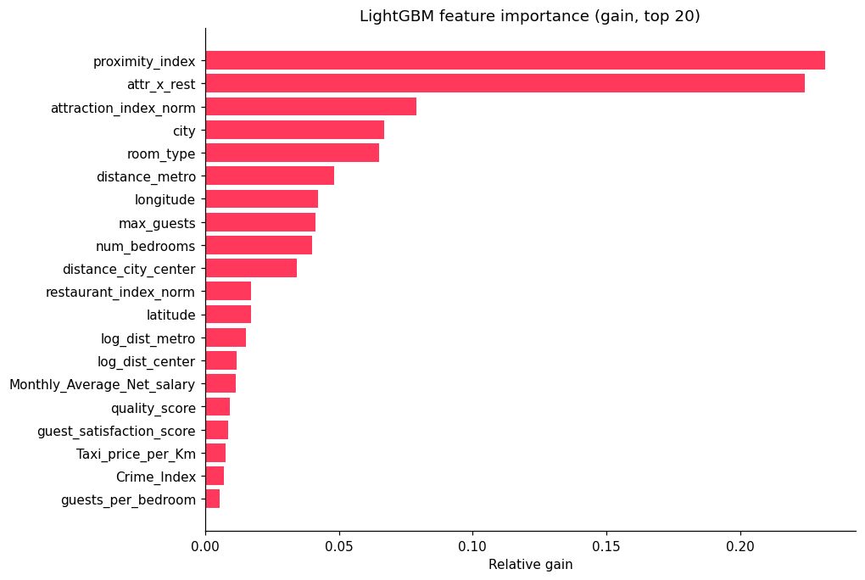
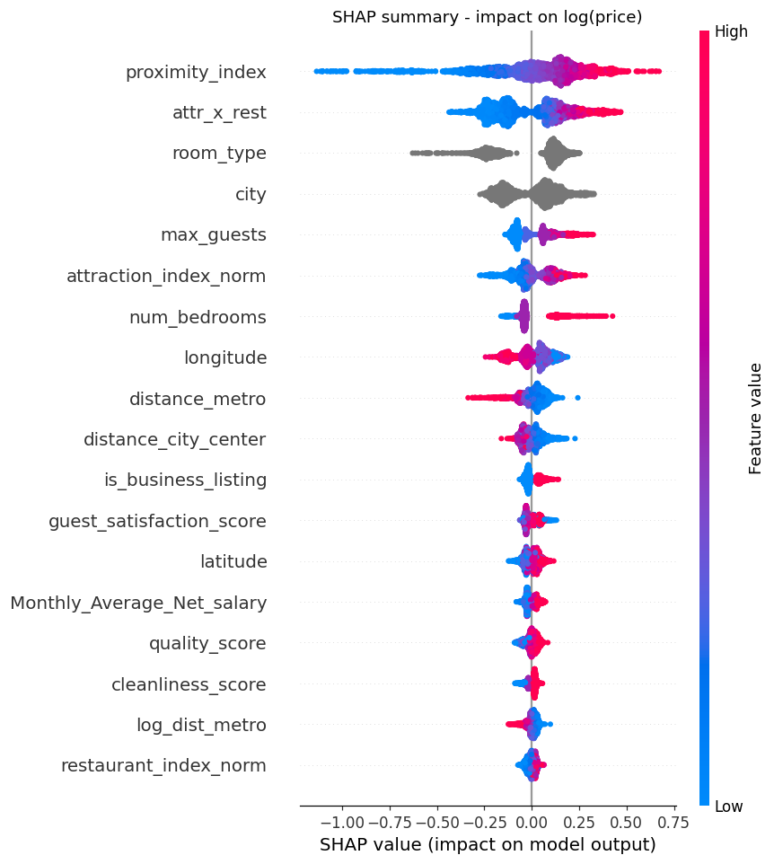

7. The web application (PriceScope)
Page | What it does
Dashboard | KPI cards, a map of Europe with a price bubble per city, charts of price by city, room type, distance to centre and capacity, and a city scorecard
Map Explorer | every listing in a city on an interactive Leaflet map, coloured by price quintile. Switch between point, price-heatmap and density layers; filter by room type, weekday/weekend, maximum price, guests and superhost
Price Predictor | pick a city, click or drag a pin, describe the listing and get an instant estimate. Shows the 2-night price, per-night price, an 80% prediction interval, comparison with the city and neighbourhood medians, a percentile rank, SHAP price drivers, the auto-derived location profile, the individual model predictions and nearby comparable listings shown on the map
Model Performance | leaderboard, feature importance, accuracy per city, actual-vs-predicted and SHAP plots
Project Report | this document, rendered inside the app

How a prediction works: a host knows the address of their listing, not its "attraction index". When a pin is dropped, the app finds the 25 nearest real listings in that city and takes a distance-weighted average of their metro distance, attraction index, restaurant index and proximity index. Distance to the centre is computed exactly, using a city centre that the app estimates from the data. The city-level economic indicators are filled in automatically. Advanced users can override any location value.
Prediction interval: the 10th–90th percentile of the ensemble's residuals on the test set, computed separately for each city.
REST API: POST /api/predict (JSON in, prediction out), GET /api/listings/<city>, GET /api/health.

8. Limitations and next steps
- The coordinates in the source data are rounded to 0.01° (about 1 km), so fine-grained location relies on the distance and index columns.
- There are no listing photos, size, amenities, booking dates or seasonality. Adding them is the most promising way to improve accuracy.
- The data is a snapshot from a single period. Prices should be re-validated before the model is used for live pricing.
- Possible extensions: quantile models trained directly for prediction intervals, hyper-parameter search with Optuna, text features from listing titles, and Docker deployment.

9. How to run
pip install -r requirements-ml.txt
python run_pipeline.py # cleaning -> EDA -> training (about 7 min)
python app.py # open http://127.0.0.1:5000
Live deployment (Vercel): the serverless version installs only Flask, numpy, pandas and markdown. It serves the LightGBM model through a numpy-only export of its trees (models/lgbm_lite.npz), which gives identical predictions to LightGBM (R² 0.854 vs 0.857 for the ensemble) and keeps the bundle well under Vercel's size limit.
Project structure
Cleaned_data.csv raw input
src/config.py paths and constants
src/clean.py step 1: cleaning and validation
src/eda.py step 2: EDA figures and dashboard data
src/features.py feature engineering
src/train.py step 3: training, evaluation, export
src/predictor.py inference service (location features, SHAP)
app.py Flask web app and REST API
templates/, static/ UI (HTML, CSS, JS, figures)
models/ model.joblib, metrics.json, eda.json
reports/ REPORT.md, REPORT.docx, cleaning_log.json

