**CS2106 Operating Systems**

**2017/18 Semester II**

**Term Assignment Answer Book**

|  |  |
| --- | --- |
| STUDENT NUMBER 1: | STUDENT NAME 1: |
| STUDENT NUMBER 2: | STUDENT NAME 2: |
| STUDENT NUMBER 3: | STUDENT NAME 3: |

**Question 1** (15 marks)

My code and explanation for the LINUX scheduler is shown below:

Here is a screenshot showing the output of my LINUX scheduler.

**Question 2** (5 marks)

One advantage of using array of queues:

One disadvantage of using array of queues:

**Question 3** (5 marks)

My pseudocode for “renice” is shown below:

**Question 4.** (20 marks)

My code and explanation for the RMS scheduler is shown below:

(The explanation is shown in the comments)

Here is my screenshot of my RMS scheduler running:

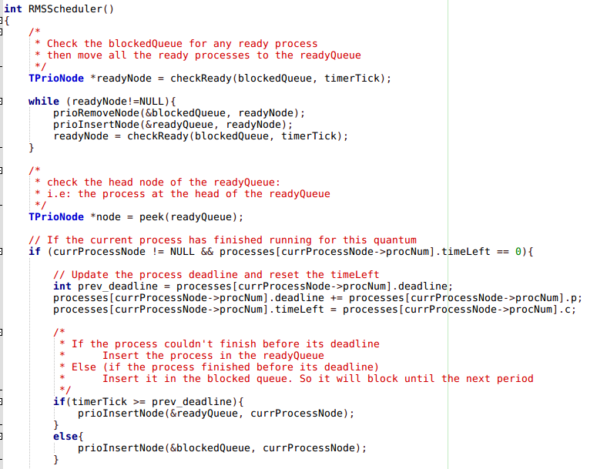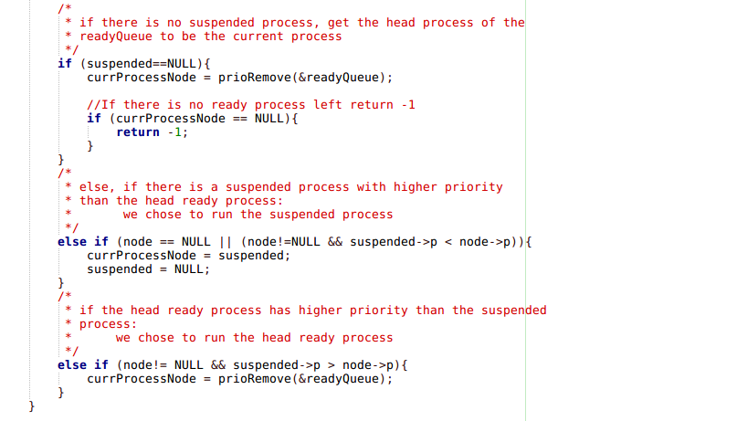

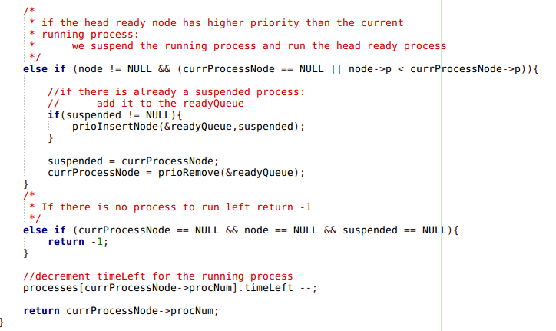

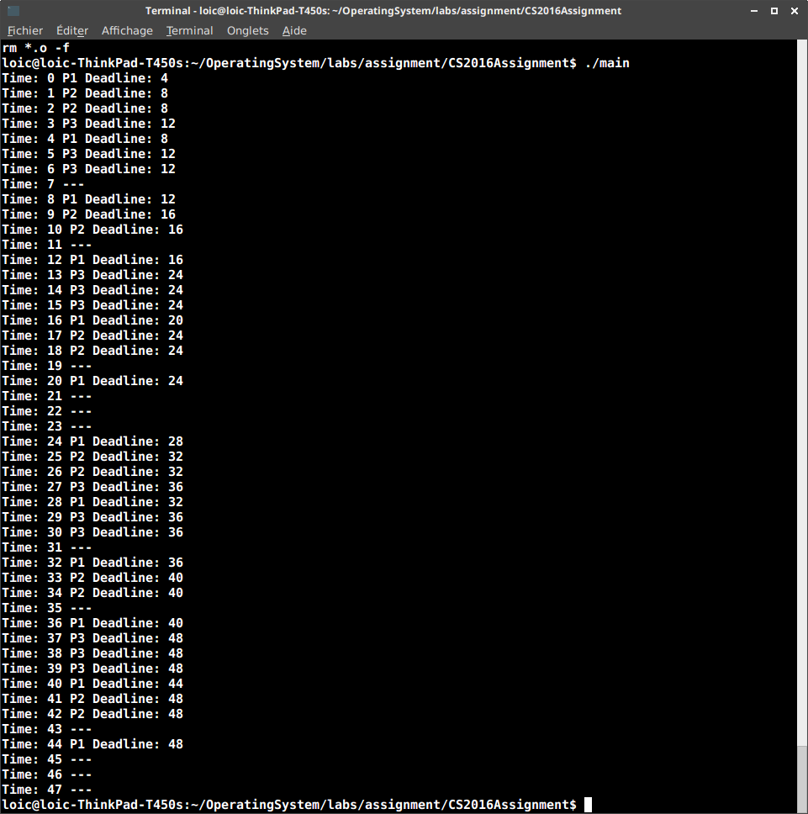

**Question 5.** (5 marks)

CPU Utilization using the formula is:

1/4+2/8+3/12 = ¾ = 0.75

CPU Utilization by counting cycles is:

36 cycles execute a process and 11 cycles does not run anything. So:

36/47 = 0.766

They are roughly the same. This is why:

???

**Question 6.** (10 marks)

My modifications to turn this into an EDF scheduler are:

Sketch modifications and write down pseudocode for how to modify the RMS scheduler you have built into an EDF scheduler. You do not have to build the EDF scheduler, only explain in as much detail as possible how you can convert your RMS scheduler into an EDF scheduler.

**Question 7.** (2 marks)

This is the output of my RMS scheduler with missed deadlines:

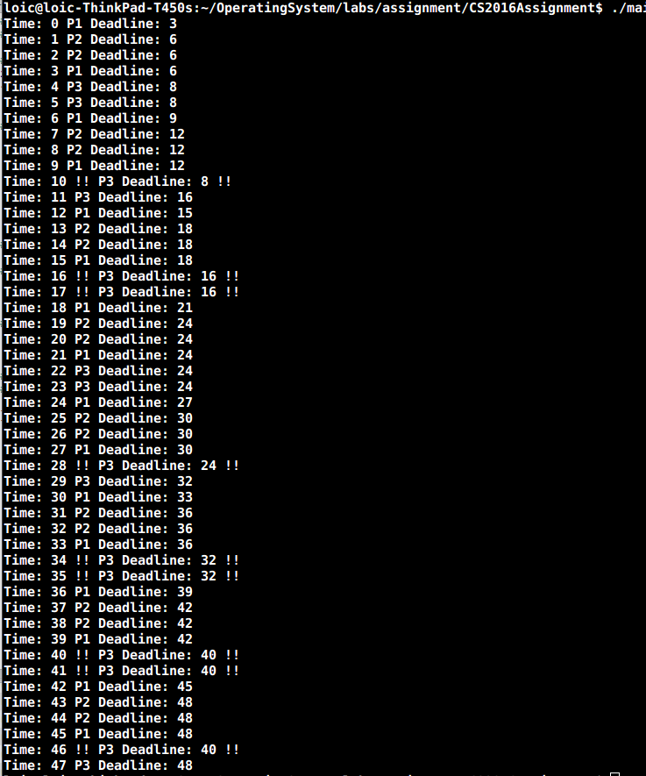

**Question 8.** (8 marks)

CPU utilization (using the utilization formula) is:

1/3 +2/6 +3/8 = 25/24 = ~1.04

Here is my Criticial Instance Analysis (CIA) of the 3 processes:



Based on CPU utilization and CIA we have missed deadlines because:

the final value S3,F is equal to 11 which is larger than P3 = 8 so P3 will miss is deadline.

TOTAL: _________________________ / 70