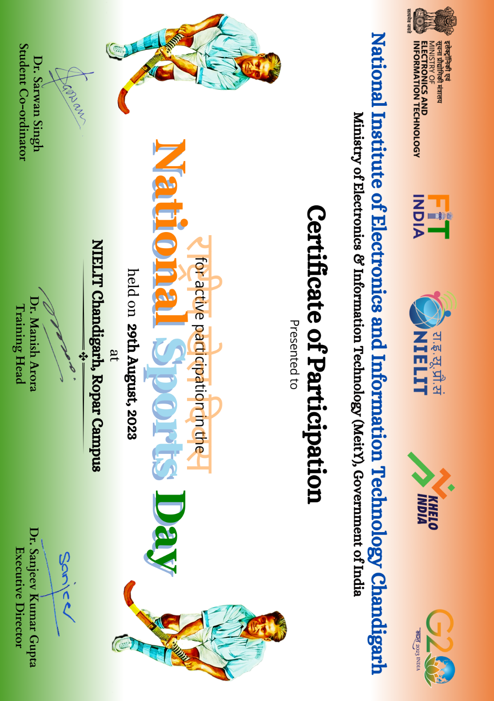
Anita Budhiraja (Lemon Race)

Jasbir Kaur (Lemon Race)

Samroop (Badminton,Lemon Race)

Mithlesh Chaudhary (Badminton)

Ramesh Kumar Besra (Badminton,Tug of War)

Alok Ankit (Carrom,Tug of War)

Naman kumar (Badminton,Tug of War)

Priya Sharma (Badminton,Tug of War)

Vansh paman (Badminton)

Simarjit Singh (Carrom,Badminton)

Kamal jagga (Tug of War)

Karanveer (Carrom,Badminton)

Jashandeep Singh (Badminton)

Vidyaarnav (Tug of War)

Harpreet Singh (Badminton)

Harshdeep Singh (Carrom)

Vikramjeet (Badminton)

Karanjot Vermi (Tug of War)

Aditya (Tug OF WaR)

Manpreet (Tug of War)

Ankur (Badminton)

Mehul (Badminton)

Tanishtha (Lemon Race)

Deepak (Lemon Race)

Aman Choudhary (Carrom)

Gaurav (Lemon Race,Carrom)

Sahibpreet Singh (Tug of War)

Prakash Pratik (Badminton,Tug of War)

Mohd ishaq (Badminton,Tug of War)

Ummar Rabani (Badminton, Carrom,Lemon Race)

Lovnish Verma (Lemon Race)

Alok Raj (Badminton,Tug of War)

Shubham singh (Badminton)

Karandeep Singh (Tug of War)

Hardeep Singh (Tug of War)

Ravinder Singh (Tug of War)

Gurpyar singh (Tug of War)

Avtar Singh (Tug of War)

Gurpreet Singh (Tug of War)

Jagtar Singh (Tug of War)

Harpreet Singh (Tug of War)

Mohammed Adrees (Badminton,Tug of War)

Simran (Carrom)

Jasmeen Sunda (Lemon Race)

Sandeep Kumar (Badminton)

Jaskirat Singh (Badminton)

Seema (Badminton,Carrom)

Digvir Singh (Badminton)

Abhay Singh (Badminton)

Samriddhi (Badminton)

Sunita Chib (Lemon Race)

Vikramjeet Singh (Badminton)

Vighnesh Kumar jha (Tug of War)

Lovnish Verma (Lemon Race)

Rehan (Badminton)

Harkirat Kaur (Carrom)

Gaurav (Badminton)

Hemant Kumar (Badminton)

Shubham singh (Tug of War)

Renu Singla (Lemon Race)

Davinder (Lemon Race)

Jaspreet Singh Saini (Badminton)

Nishit Kashyap (Carrom)

Kirandeep kaur (Lemon Race)

Manmeet (Tug of War)

Chanpreet (Tug of War)

Arvind Rawat (Tug of War)

Baljinder (Tug of War)

Manjinder Singh (Tug of War)

Babita (Tug of War)

Vandana (Tug of War)

Gagan (Tug of War)

Rupinder (Tug of War)

Manpreet (Tug of War)

Kulwinder (Tug of War)

Kiran (Tug of War)

Raman Marya (Lemon Race)

