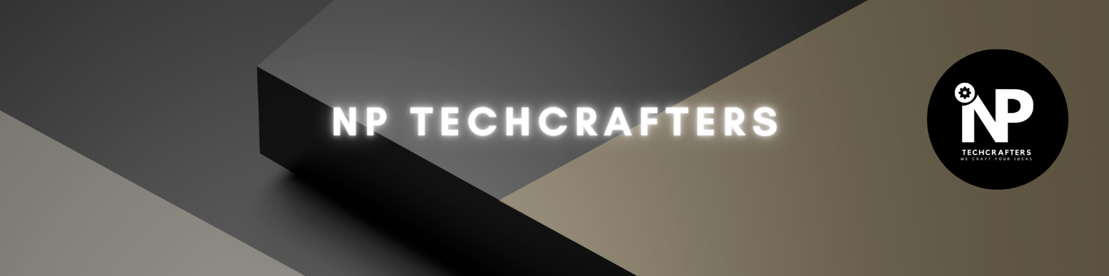

**Offer Letter**

03/07/2024

Dear Chandan Saroj,

Congratulations on securing a virtual internship opportunity at NP TechCrafters, as "AIML" commencing on 01/07/2024. We are excited to welcome you aboard!

At **NP TechCrafters**, we view internships as more than just jobs, they are invaluable educational experiences for students to acquire and refine skills. Throughout this internship, you will engage in hands-on learning, applying theoretical knowledge to real-world scenarios.

Prepare to explore a plethora of opportunities to showcase and enhance your abilities, gaining profound insights into the industry's inner workings.

By accepting this offer, you commit to executing assigned tasks diligently and ensuring excellence in all aspects of your work. We firmly believe that your time with us will be enriching, equipping you with the expertise to excel in your future endeavors. We are thrilled to have you as part of our team, ready to embark on a rewarding journey together.

Warms Regards

**NP TechCrafters**