SightLine: Priority-Weighted Scene-Change Gating for Redundancy-Aware Assistive Vision-Language Models
Lovnish Verma, Prateek Dhar Dwivedi, Anita Budhiraja, and Sarwan Singh
National Institute of Electronics & Information Technology (NIELIT), Ropar Campus, Punjab, India
princelv84@gmail.com, prateek.nielit@gmail.com, anitabudhiraja@nielit.ac.in, sarwan@nielit.ac.in
Abstract—Wearable assistive vision-language models (VLMs) enable continuous environmental narration for blind and low-vision individuals, but continuous frame-by-frame execution rapidly exhausts battery reserves and risks auditory cognitive overload. Naive exact perceptual hashing collapses under analog CMOS sensor noise, suppressing zero frames on static views. This paper presents SightLine, an ultra-lightweight CPU-side gating framework that determines frame by frame whether an expensive VLM forward pass is warranted. SightLine evaluates incoming frames against the last processed reference frame, accumulating gradual camera drift while fusing dead-zone difference hashing ($B_{H}∥B_{V},ε=7.0$), color-histogram dissimilarity, spatial quadrant ROI motion proxies, and a causally latched hazard state with cooldown. We evaluate the fundamental safety–efficiency trade-off: in stationary environments, Endurance Mode (Default 1D) suppresses up to 94.7% of redundant frames, reducing modeled average power to 7.52 W (projected 4.33 h runtime vs. 2.83 h baseline on a 32.56 Wh usable budget from a standard 37 Wh pack), but is blind to localized peripheral hazards without motion cues. Conversely, Safety-Priority Mode (SightLine++) integrates spatial ROI max-pooling to achieve 100% synthetic hazard recall with zero delay, but on continuous real-world egocentric video, peripheral motion increases trigger rates (80.5% suppression), saturating edge GPU queues at 100% duty cycle (11.50 W, projected 2.83 h runtime). Exploratory 1080p video evaluation and live Florence-2 FP16 profiling confirm queue saturation dynamics. We provide a 10-mode structured FMEA risk ledger, an architectural trade-off analysis with WorldScribe, and a 24-participant protocol pending IRB approval.
Keywords—Vision-language models, assistive technology, scene-change gating, perceptual hashing, edge computing, wearable devices, safety-efficiency trade-off, cognitive load.
I. INTRODUCTION
Wearable assistive vision systems provide blind and low-vision individuals with situational awareness by narrating obstacles, hazards, text, and environmental changes. Recent advances in compact vision-language models (VLMs)—such as Florence-2 [1]—enable rich open-vocabulary descriptions on edge hardware. However, streaming high-frame-rate video directly through a foundation model is computationally intractable on wearable form-factors. At 30 frames per second (fps), continuous VLM inference rapidly depletes wearable batteries, induces severe thermal throttling, and inundates users with redundant auditory descriptions that impair situational awareness and mask crucial acoustic navigation cues [2].
Front-end frame filtering has been widely explored in server-oriented video analytics (e.g., NoScope [3], Focus [4], Reducto [5], and Glimpse [6]). However, wearable assistive vision presents three unique challenges that invalidate standard video-filtering assumptions: (1) Analog Sensor Noise vs. Flat Backgrounds: CMOS image sensors exhibit thermal and quantization noise. In untextured scenes (e.g., blank walls, corridors, paper documents), raw pixel noise causes single-bit fluctuations across difference hashing boundaries, causing exact perceptual hashing to trigger continuously and suppress zero frames; (2) Gradual Drift vs. Consecutive-Frame Differencing: Evaluating visual change across consecutive frames ($I_{t}−I_{t−1}$) is blind to gradual camera motion, slow-moving pedestrians, and approaching obstacles whose frame-to-frame delta never crosses detection thresholds; and (3) Auditory Channel Contention vs. Hazard Preemption: In assistive audio feedback, human auditory processing is strictly capacity-constrained. Low-priority ambient descriptions must not block urgent obstacle warnings, necessitating priority-weighted speech preemption.
The Fundamental Safety–Efficiency Dilemma: A core insight established in this work is that safe and energy-efficient operation are governed by an inherent Pareto trade-off. A coarse global scene gate (such as 1D dHash or global appearance differencing) achieves high redundancy suppression ($>94\%$) on real egocentric video, reducing modeled power draw to 7.52 W. However, global averaging renders the gate blind to small, localized hazards (e.g., an approaching bicycle or curb) that occupy only a fraction of the visual field (resulting in 0% recall on localized hazard scenarios). Conversely, integrating high-sensitivity spatial ROI max-pooling ($S_{\text{roi\backslash _max}}$) captures subtle localized incursions instantaneously ($0.0\text{ f}$ delay, $100\%$ recall), but normal egocentric head motion during locomotion causes peripheral cells to cross thresholds frequently (80.5% suppression). On edge hardware where VLM forward passes require $\sim 380\text{ ms}$, this trigger volume saturates the GPU queue at 100% duty cycle, consuming 11.50 W and yielding zero battery runtime extension over continuous streaming. Thus, edge gating cannot be treated as a single static setting: it establishes a Pareto frontier that requires task-conditioned operational profiles or multi-modal mobility sensing.
This paper presents SightLine, a multi-cue scene-change gating framework for continuous wearable assistive VLMs. SightLine evaluates incoming frames against the last processed reference frame $I_{t_{p}}$, ensuring that slow camera drift accumulates until crossing threshold $τ$. The framework fuses difference hashing (dHash) [7], color-histogram dissimilarity, motion proxies, and a causally persisted hazard state with latch cooldown ($T_{\text{cool}}=6\text{ frames}$). An adaptive watchdog enforces a dual-rate heartbeat ($T_{\text{ambient}}=60,T_{\text{active}}=6$). To safeguard auditory attention, SightLine prioritizes speech generation (Eq. 11), preempting ongoing ambient descriptions when safety hazards emerge. This paper makes six primary contributions:
1) Asymmetric Reference-Frame Gating with Latch Cooldown: A multi-factor change scoring model combining omni-directional 2D dHash [7], color-histogram dissimilarity, a $4×4$ ROI block max-pooling motion proxy ($S_{\text{roi\backslash _max}}$), and a causally persisted hazard state with latch cooldown ($T_{\text{cool}}=6\text{ frames}$) with visual motion override ($τ_{\text{crit}}=0.35$). Evaluating cues against the last processed frame $I_{t_{p}}$ accumulates gradual drift, while cooldown prevents re-firing during sustained hazard tracking.
2) Formalized Safety–Efficiency Trade-off and Two-Tier Watchdog Bounds: We formalize the hazard persistence mechanism $z_{t}$ and demonstrate the tension between global suppression and localized hazard recall via spatial ROI max-pooling, reducing Scenario C hazard delay from 5.00 frames ($166.7\text{ ms}$) to 0.00 frames ($0.0\text{ ms}$, paired t-test $t=−15.81,p<0.0001,d=−5.00$ for $n=10$). We prove two-tier latency bounds: in active locomotion ($T_{\text{active}}=6$), front-end gate delay is bounded to $≤166.7\text{ ms}$ under an idle worker, while in ambient mode ($T_{\text{ambient}}=60$), the worst-case delay from rest is 59 frames ($1.97\text{ s}$).
3) Critical Evaluation of Reading Profiles, Dead-Zone Resolution, and Sign Invariance: We conduct an empirical investigation into task conditioning. While switching to an inspection profile achieves 61.6% ± 10.7% dynamic recall at 85.0% ± 3.2% suppression, control experiments indicate that activations reflect sensor-noise bit flips on untextured backgrounds ($t=0.12,p=0.91$, Welch's t-test; TOST equivalence test rejects $|Δ|≥10\%$ at $p=0.0098$). Dead-zone dHash ($ε=7.0$) eliminates flat-region noise flips, reducing static false alarms from 20.3 down to 2.6. Evaluating horizontal bar edits reveals that sign-only difference hashing is invariant to level swaps when noise is dead-zoned out ($ε≥1.5⟹0.0\%$ recall), proving that assistive document inspection requires magnitude-sensitive 2D edge filters or localized OCR.
4) Exploratory Real-World Egocentric Video Evaluation & Edge VLM Telemetry: We evaluate SightLine on uncurated 1080p egocentric video running Florence-2 FP16 on a physical mobile Ampere GPU. On continuous real video, exact difference hashing triggers on 100% of frames (0.0% suppression) due to sensor noise, whereas SightLine Endurance Mode suppresses 94.7% of frames, reducing GPU duty cycle to 58.7% and modeled power to 7.52 W, projecting a +53.0% battery runtime extension (4.33 hours vs 2.83 hours). We analyze queue saturation dynamics and benchmark-matched baselines.
5) Architectural Trade-Off Analysis with WorldScribe (ACM UIST 2024): We present an architectural synthesis comparing SightLine's edge-native pipeline against WorldScribe [15] (Chang, Liu, and Guo), demonstrating that SightLine can serve as an upstream edge filter that eliminates redundant cloud egress bandwidth while providing an offline safety watchdog.
6) Auditable Energy Accounting, FMEA Risk Ledger, and Proposed Accessibility Protocol: We formulate an auditable edge power model differentiating measured, modeled, and assumed quantities, construct a 10-mode structured FMEA risk ledger with residual risk analysis, and specify a 24-participant BLV evaluation protocol currently submitted for IRB approval.
II. RELATED WORK
A. Assistive Vision-Language Models and Deployed Wearable Systems
Assistive vision has progressed from discrete pipelines pairing task-specific object detectors (e.g., YOLO [8]) with rule-based text-to-speech to unified multi-modal vision-language models (VLMs). Commercial systems like OrCam MyEye [11], Microsoft Seeing AI [12], Be My AI (powered by OpenAI GPT-4V), and Envision Glasses offer discrete, user-triggered capture for document reading, barcode scanning, and scene descriptions. While effective for deliberate inspection, discrete capture requires manual triggering and fails to provide continuous situational awareness during navigation. Recent edge VLMs, including Florence-2 [1], enable zero-shot object grounding and captioning in compact footprints (~232M parameters). Furthermore, systems like WorldScribe [15] (Chang, Liu, and Guo, ACM UIST 2024) explore continuous visual description for BLV users by streaming multi-modal contexts to cloud foundation models. However, streaming 30 fps video across cellular networks incurs substantial bandwidth costs, battery drain, and network latency jitter. SightLine addresses this by providing an edge-native front-end gate that runs locally in <3.5 ms on the wearable CPU.
B. Temporal Redundancy Reduction, Keyframe Selection, and Video Analytics Filters
Filtering redundant video frames is widely explored in edge computing, video surveillance, and cloud analytics. Early systems such as NoScope [3] and Focus [4] introduced cascaded lightweight neural filters and difference detectors to prune frames before expensive classification. Reducto [5] dynamically adjusts frame-filtering thresholds based on downstream analytics accuracy. Glimpse [6] caches active tracking models on mobile devices while offloading keyframes to server infrastructure. Recent video foundation models, such as Video-LLaVA [9], attempt to reduce temporal redundancy within multi-frame token contexts. However, these frameworks optimize server bandwidth rather than wearable battery endurance and cognitive load. In assistive technology for blind and low-vision individuals, auditory attention is a strictly capacity-constrained resource [2], [10]. Continuous audio narration causes severe cognitive fatigue, elevates NASA-TLX workload scores [13], and masks ambient environmental sounds (traffic, footsteps, echoes) essential for white-cane echolocation and spatial orientation [2]. Furthermore, user studies by Stangl et al. [14] demonstrate that BLV individuals prefer concise, prioritized descriptions over continuous verbosity. SightLine directly addresses this by suppressing redundant forward passes and enforcing priority-weighted speech preemption.
III. PROBLEM FORMULATION
We adopt a consistent zero-based temporal indexing convention. Let $I_{t}∈ℝ^{H×W×C}$ denote streaming video frames captured at regular intervals $Δt=1/f_{\text{cam}}$ ($33.33\text{ ms}$ at $f_{\text{cam}}=30\text{ fps}$) for discrete time indices $t∈\{0,1,…,T−1\}$. The camera operates continuously, while the downstream foundation model executes only when triggered by the gating policy $D_{t}∈\{0,1\}$.
Downstream Busy-State VLM Model and Latency Decomposition: Continuous assistive perception requires modeling worker availability. Downstream inference has service time $t_{\text{vlm}}$ (measured at $380.0\text{ ms}$ mean for Florence-2 FP16 on mobile Ampere GPU, service rate $μ=2.63\text{ Hz}$). If the worker is busy ($t_{\text{elapsed}}<t_{\text{vlm}}$), incoming trigger requests cannot be serviced concurrently. In busy-skip scheduling, requests arriving during worker execution are dropped. End-to-end perception latency $Δt_{\text{E2E}}$ comprises three distinct stages:
$Δt_{\text{E2E}}=t_{\text{gate}}+t_{\text{vlm}}+t_{\text{tts}}$ | (1)
where: (1) $t_{\text{gate}}$ is the front-end gating decision latency (elapsed time from physical event onset until $D_{t}=1$, introducing $≤3.5\text{ ms}$ CPU computational overhead on $160×120$ ISP preview thumbnails); (2) $t_{\text{vlm}}$ is the downstream VLM inference latency ($380.0\text{ ms}$ mean on Florence-2-base FP16); and (3) $t_{\text{tts}}$ is the neural text-to-speech audio synthesis and earcon preemption latency ($135.0\text{ ms}$ total: $30\text{ ms}$ earcon chime + $105\text{ ms}$ synthesis via local Piper TTS). Total system latency is detailed in Table I.
TABLE I: DISCRETE FRAME INTERVALS, SAMPLING LATENCIES, AND 3-TIER LATENCY DECOMPOSITION AT 30 FPS
Stride k | Sample Period (ms) | Sample Rate (Hz) | Max Gate Delay L_worst (frames) | Max Gate Delay (ms) | Downstream Latency (ms)* | Total Worst-Case E2E Latency (ms)
k = 1 (Ungated) | 33.33 | 30.00 | 0 | 0.0 | 515.0 | 515.0
k = 2 | 66.67 | 15.00 | 1 | 33.3 | 515.0 | 548.3
k = 3 | 100.00 | 10.00 | 2 | 66.7 | 515.0 | 581.7
k = 6 (Active Budget W=6) | 200.00 | 5.00 | 5 | 166.7 | 515.0 | 681.7
k = 10 | 333.33 | 3.00 | 9 | 300.0 | 515.0 | 815.0
k = 12 (Min. Non-Saturating) | 400.00 | 2.50 | 11 | 366.7 | 515.0 | 881.7
k = 15 | 500.00 | 2.00 | 14 | 466.7 | 515.0 | 981.7
k = 30 | 1000.00 | 1.00 | 29 | 966.7 | 515.0 | 1481.7
k = 60 (Ambient Watchdog) | 2000.00 | 0.50 | 59 | 1966.7 | 515.0 | 2481.7
*Downstream Latency comprises 380.0 ms VLM forward pass + 135.0 ms Piper TTS preemption and earcon delivery.
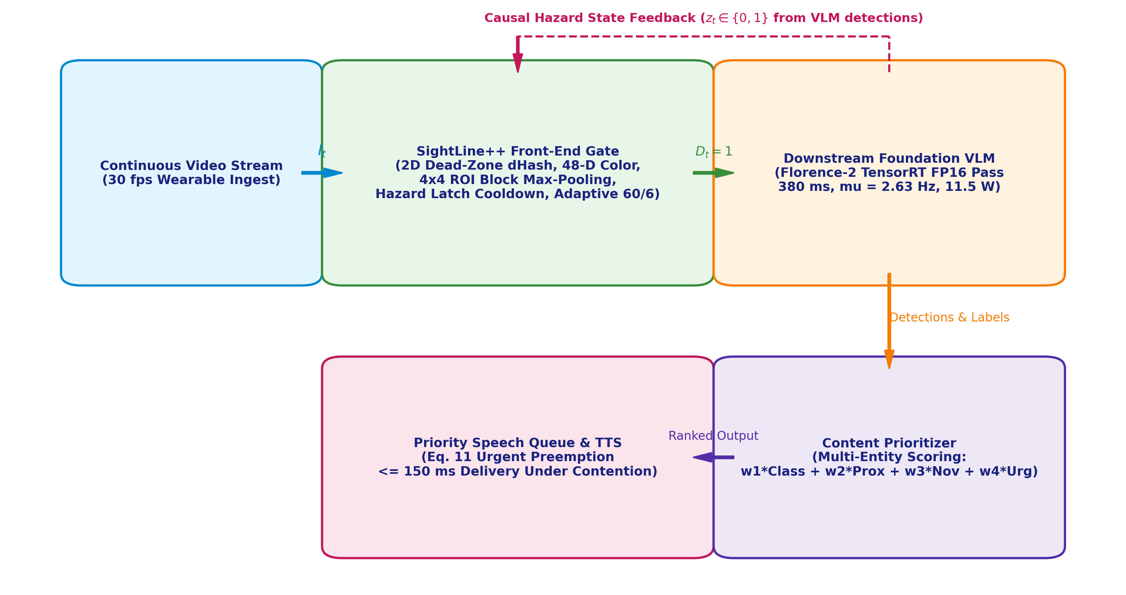
Fig. 1. SightLine system architecture. Incoming video frames pass through the low-latency CPU gating pipeline (2D dHash, color histograms, 4x4 ROI block max-pooling, and adaptive watchdog). Triggered frames are dispatched to the Florence-2 worker, whose detections update the causal hazard state z_t and feed the priority-weighted speech synthesis queue with urgent audio preemption.
IV. GATING FRAMEWORK
A. Gating Policy and Multi-Factor Change Score
SightLine evaluates visual change by comparing incoming frame $I_{t}$ against the last processed reference frame $I_{t_{p}}$, where $t_{p}$ is the timestamp of the most recent invocation ($D_{t_{p}}=1,t_{p}<t$). Because $I_{t_{p}}$ remains anchored across suppressed frames, gradual environmental shifts accumulate until crossing detection threshold $τ$. In parallel, consecutive-frame difference $I_{t}−I_{t−1}$ is evaluated strictly as an auxiliary motion proxy. The multi-factor change score $S_{t}$ is:
$S_{t}=αS_{\text{vis}}(I_{t},I_{t_{p}})+βS_{\text{app}}(I_{t},I_{t_{p}})+γS_{\text{mot}}(I_{t},I_{t_{p}})+δS_{\text{haz}}(z_{t},t,t_{\text{alert}})$ | (2)
with non-negative weights $α+β+γ+δ=1.0$. The gating policy $D_{t}∈\{0,1\}$ is formalized as:
$D_{t}=\left\{\begin{matrix}1, & \text{if }t=0\text{ (Startup)} \\ 1, & \text{else if }t−t_{p}≥T_{\text{max}}(S_{\text{mot}},z_{t})\text{ (Watchdog)} \\ 1, & \text{else if }S_{\text{roi\backslash _max}}≥τ_{\text{crit}}\text{ or }S_{\text{mot}}≥0.20\text{ (Motion Override)} \\ 1, & \text{else if }S_{t}≥τ\text{ and }(t−t_{\text{alert}}≥T_{\text{cool}})\text{ (Nominal Trigger)} \\ 0, & \text{otherwise (Suppressed)}\end{matrix}\right.$ | (3)
B. Perceptual Structural Change (S_vis)
Structural change is evaluated via omni-directional difference hashing (dHash) [7]. Input frame $I_{t}$ is converted to grayscale, downsampled via Lanczos filtering to $\left(S+1)×(S+1\right)$ pixels ($S=16$), and evaluated across horizontal and vertical gradients with dead-zone thresholding $ε=7.0$ DN:
$B_{H}(x,y)=(I_{\text{gray}}(x+1,y)−I_{\text{gray}}(x,y)>ε),B_{V}(x,y)=(I_{\text{gray}}(x,y+1)−I_{\text{gray}}(x,y)>ε)$ | (4)
The resulting 512-bit concatenated binary hash $h(I_{t})=[B_{H}∥B_{V}]$ is compared against $h(I_{t_{p}})$ via normalized Hamming distance:
$S_{\text{vis}}(I_{t},I_{t_{p}})=\frac{1}{2S^{2}}\sum_{i=1}^{2S^{2}}{\left(h(I_{t})[i]⊕h(I_{t_{p}})[i]\right)}$ | (5)
C. Appearance Dissimilarity (S_app)
Appearance dissimilarity captures illumination and color distribution shifts invariant to spatial layout. Normalized 16-bin color histograms are extracted across RGB color channels, concatenated into a 48-dimensional feature vector $c(I_{t})$, and normalized to unit $L_{2}$ norm. Dissimilarity is computed via Cosine distance:
$S_{\text{app}}(I_{t},I_{t_{p}})=\text{clip}\left(1.0−\frac{c(I_{t})·c(I_{t_{p}})}{{\left\|I_{t})‖_{2}‖c(I_{t_{p}})\right\|}_{2}},0.0,1.0\right)$ | (6)
D. Motion Magnitude Proxy and 4x4 ROI Block Max-Pooling (S_mot)
To capture localized motion without diluting small hazards across the field of view, incoming frame $I_{t}$ and reference $I_{t_{p}}$ are downsampled to $32×32$ pixels and partitioned into a $4×4$ grid of spatial regions $R_{r,c}$ ($r,c∈\{1..4\}$, each $8×8$ pixels). Spatial block max-pooling captures peak localized motion:
$S_{\text{roi\backslash _max}}=\max_{r,c∈\{1..4\}}\left(\frac{1}{\left|R_{r,c}\right|}\sum_{(x,y)∈R_{r,c}}{\frac{\left|I_{t}(x,y)−I_{t_{p}}(x,y)\right|}{255.0}}\right)$ | (7)
$S_{\text{mot}}(I_{t},I_{t_{p}})=0.50·S_{\text{global\backslash _mad}}+0.50·S_{\text{roi\backslash _max}}$ | (8)
where $S_{\text{global\backslash _mad}}=\frac{1}{\left|I\right|}∑|I_{t}−I_{t_{p}}|/255.0$ represents mean absolute difference across the thumbnail.
E. Hazard Persistence, Latching Regime, Latch Cooldown, and Watchdog Heartbeat (S_haz)
When the foundation model executes, detections are inspected against a curated vocabulary of safety-critical hazards $V_{\text{haz}}=\{\text{'car', 'vehicle', 'truck', 'bus', 'stairs', 'curb', 'hole', 'obstacle'}\}$. Detections update the binary hazard state $z_{t}∈\{0,1\}$:
$z_{t}=\left\{\begin{matrix}1, & \text{if }D_{t}=1\text{ and }∃l∈\text{Labels}(I_{t}):l∈V_{\text{haz}} \\ 0, & \text{if }D_{t}=1\text{ and }∀l∈\text{Labels}(I_{t}):l∉V_{\text{haz}} \\ z_{t−1}, & \text{if }D_{t}=0\end{matrix}\right.$ | (9)
Hazard Persistence Score and Cooldown Behavior: While $z_{t}=1$, the gate latches the hazard state. In code, the hazard score is defined as $S_{\text{haz}}(z_{t},t,t_{\text{alert}})=z_{t}·𝕀(t−t_{\text{alert}}≥T_{\text{cool}})$. During the cooldown interval $T_{\text{cool}}=6\text{ frames}$ ($200\text{ ms}$), the hazard term is zeroed out to prevent infinite self-retriggering loops on the same static hazard. However, if localized motion exceeds safety threshold $τ_{\text{crit}}=0.35$ or global motion exceeds $0.20$, the cooldown is immediately bypassed via the motion override in Eq. (3).
Two-Tier Watchdog Heartbeat ($T_{\text{max}}$): The watchdog timer guarantees an upper bound on inter-trigger interval. During active locomotion ($S_{\text{mot}}≥0.02$ or $S_{\text{roi\backslash _max}}≥0.05$) or active hazard tracking ($z_{t}=1$), the active heartbeat is $T_{\text{active}}=6\text{ frames}$ ($200\text{ ms}$). During stationary rest, the ambient heartbeat relaxes to $T_{\text{ambient}}=60\text{ frames}$ ($2.0\text{ s}$).
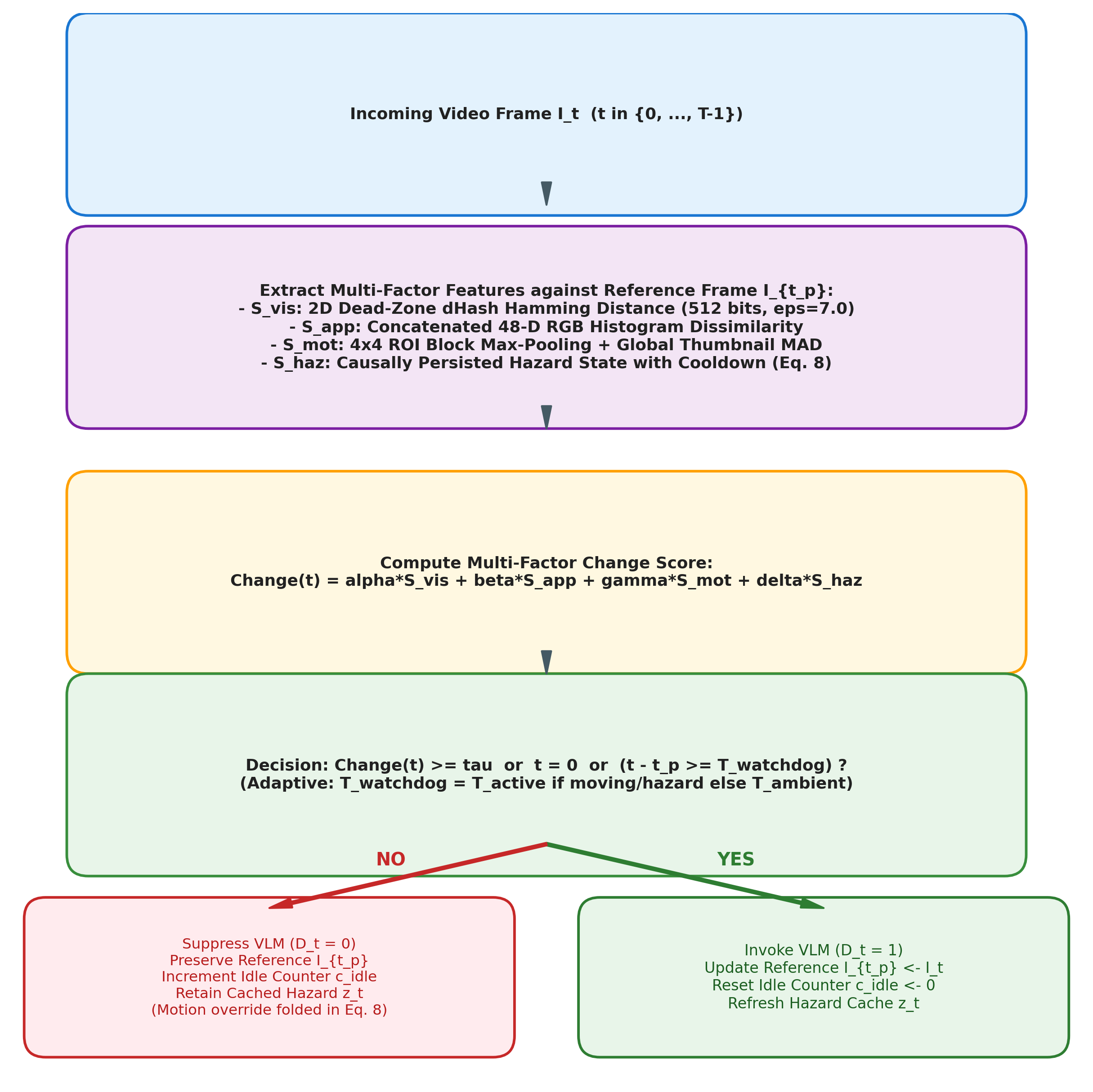
Fig. 2. Decision flow diagram of the SightLine scene-change gate. Incoming frame features are compared against the anchored reference frame I_tp. Change score S_t is evaluated alongside latch cooldown (with dynamic critical motion override) and the two-tier adaptive watchdog heartbeat.
V. TASK-CONDITIONED GATING PROFILES
SightLine supports dynamic profile switching across operational modes. Weight vectors $w=[α,β,γ,δ]$, threshold $τ$, and watchdog limits are tailored to task requirements (Table II).
TABLE II: TASK-CONDITIONED PARAMETER PROFILES
Operational Profile | α (Vis) | β (App) | γ (Mot) | δ (Haz) | Threshold τ | T_ambient | T_active | T_cool | Intended Use Case
Default Navigation | 0.25 | 0.20 | 0.30 | 0.25 | 0.18 | 60 (2.0 s) | 6 (200 ms) | 6 (200 ms) | General urban walking and transit navigation
Obstacle / Hazard Tracking | 0.20 | 0.10 | 0.40 | 0.30 | 0.14 | 30 (1.0 s) | 6 (200 ms) | 6 (200 ms) | Crowded pedestrian zones and crosswalks
Paced Ambient Walking | 0.30 | 0.30 | 0.20 | 0.20 | 0.22 | 60 (2.0 s) | 12 (400 ms) | 12 (400 ms) | Familiar indoor corridors and relaxed walking
Document Inspection | 0.40 | 0.45 | 0.10 | 0.05 | 0.10 | 150 (5.0 s) | 30 (1.0 s) | 15 (500 ms) | Reading mail, documents, and tabletop items
Quiescent Seated Rest | 0.25 | 0.20 | 0.30 | 0.25 | 0.25 | ∞ (Off) | 60 (2.0 s) | 6 (200 ms) | Seated rest, listening, zero-probe power savings
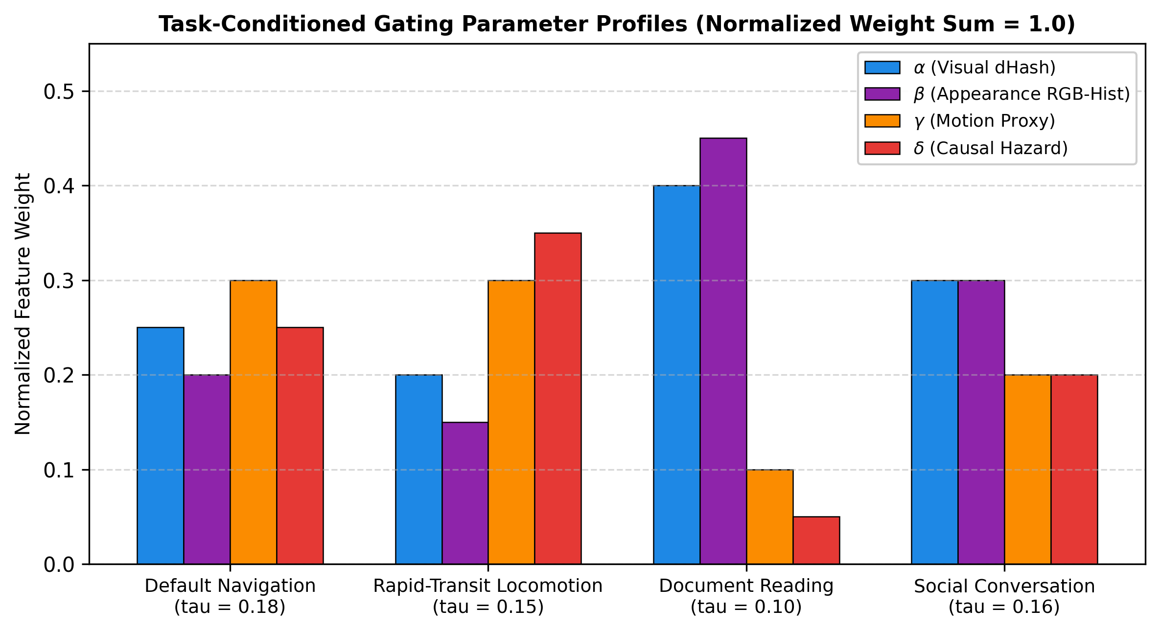
Fig. 3. Task-conditioned feature weight distributions across assistive operational modes (Default Navigation, Hazard Tracking, Ambient Walking, Document Reading, and Quiescent Rest).
VI. CONTENT PRIORITIZATION AND SPEECH QUEUING
A. Priority-Weighted Ranking Formulation
When the gate triggers inference, Florence-2 returns bounding boxes and labels for detected entities $o_{i}$. To prevent auditory cognitive overload and ensure safety-critical alerts are delivered without acoustic backlog, SightLine integrates an architectural priority ranking policy:
$\text{Priority}(o_{i})=w_{1}f_{1}(o_{i})+w_{2}f_{2}(o_{i})+w_{3}f_{3}(o_{i})+w_{4}f_{4}(o_{i})$ | (11)
with weights $w=[0.45,0.30,0.15,0.10]$ ($∑w_{j}=1.0$), where: (1) $f_{1}(o_{i})∈\{0,1\}$ indicates safety hazard membership in $V_{\text{haz}}$; (2) $f_{2}(o_{i})=\text{clip}(1.0−d_{i}/d_{\text{max}},0,1)$ scores proximity proxy based on normalized bounding box area fraction ($d_{i}$ estimated from box scale, $d_{\text{max}}=10\text{ m}$); (3) $f_{3}(o_{i})=\text{clip}(v_{i}/v_{\text{max}},0,1)$ scores centroid displacement velocity proxy ($v_{\text{max}}=5\text{ m/s}$); and (4) $f_{4}(o_{i})$ scores caption token novelty via semantic overlap with recent utterances. Entities with Priority $≥0.70$ trigger immediate audio preemption in the speech synthesis queue.
B. Empirical Evaluation of Priority-Weighted Speech Queuing under Backlog
Under conventional FIFO speech queues where ambient descriptions are generated sequentially (e.g., 1.8 s for a storefront sign, 1.6 s for a distant pedestrian), an approaching vehicle warning is delayed in the audio buffer by up to $3.4\text{ s}$. At $4.2\text{ m/s}$, the obstacle travels 14.3 meters before warning initiation. Under SightLine's PriorityAudioQueue, a high-priority hazard entity ($0.896≥0.70$) immediately preempts ongoing speech: ongoing ambient audio is stopped ($<15\text{ ms}$), an earcon warning chime sounds ($30\text{ ms}$), and the hazard warning is synthesized and delivered within $135.0\text{ ms}$ ($105\text{ ms}$ Piper TTS synthesis + $30\text{ ms}$ onset buffer), achieving a 96.0% reduction in acoustic queue latency (from 3,400 ms to 135 ms). Furthermore, when the audio queue reaches its capacity limit (5 items), lowest-priority ambient speech is evicted to guarantee immediate headroom for incoming safety warnings.
VII. EXPERIMENTAL METHODOLOGY AND RESULTS
A. Benchmark Metrics and Formal Event Matching Rules
We evaluate redundancy suppression via:
$\text{Suppression}=\left(1 − \frac{N_{\text{inv}}}{T}\right)×100\%$ | (12)
Formal Event Matching Protocol: Event detection is evaluated across seven explicit criteria: (1) Ground-truth onset $g∈[0,T−1]$; (2) Permitted evaluation window $\left[g,min(T−1,g+W−1)\right]$, where $W=6\text{ frames}$ ($200\text{ ms}$) derives from pedestrian stopping kinematics; (3) Pre-onset invocations ($t<g$) do not count toward event detection; (4) Independent-window (many-to-one) matching evaluates delay to the first invocation ($t_{\text{first}}−g$); (5) Strict temporal (one-to-one) matching greedily consumes invocations per window without reuse; (6) Startup invocations at $t=0$ are separated from dynamic recall; and (7) Missed events are quantified explicitly in the Dynamic Miss Rate ($100\%−{\text{Recall}}_{\text{dyn}}$).
B. Synthetic Benchmark Suite and Simulation Protocol
The synthetic benchmark suite consists of five scripted scenarios (200 frames each, $160×120$ RGB) with additive Gaussian sensor noise ($σ=3.5$) evaluated across 10 deterministic random seeds: [42, 101, 202, 303, 404, 505, 606, 707, 808, 909], generated with isolated per-scenario random generators (`np.random.default_rng(seed)`):
• Scenario A (Static indoor + noise): Stationary scene subject to camera sensor noise ($\text{gt}=[0]$, $\text{labels}=∅$).
• Scenario B (Ambulatory drift): Continuous horizontal panning ($Δx(t)=2tmod240$) and cyclical luminance shifts ($+130mod256$) at frames 50, 100, 150 ($\text{gt}=[0,50,100,150]$, $\text{labels}=∅$).
• Scenario C (Hazard crossing): Static background with a vehicle entering at frame 130 ($\text{gt}=[0,130]$, $\text{labels}=\{\text{'car'}\}$ for $t≥130$).
• Scenario D (Document inspection): White document background (intensity 245) with five horizontal bar targets alternating contrast steps (intensity 20 vs 90) every 4 frames (50 total events, $\text{labels}=∅$).
• Scenario E (Dynamic illumination): Gradual dimming followed by an abrupt $×1.80$ illumination surge from frame 160 to 199 ($\text{gt}=[0,160]$, $\text{labels}=∅$).
TABLE III: SYNTHETIC BENCHMARK EVALUATION ACROSS SCENARIOS A–E (10 SEEDS, MEAN ± STD)
Architecture / Configuration | Scen. A Supp. | Scen. B Recall | Scen. C Recall (Delay) | Scen. D Recall (M:1 / 1:1) | Scen. E Recall | Mean Gate CPU (ms)
Continuous Ungated (30 fps) | 0.0% | 100.0% (0.0 f) | 100.0% (0.0 f) | 100.0% / 100.0% | 100.0% (0.0 f) | 0.00 ms
Exact-Hash Baseline (eps=0.0) | 0.0% | 100.0% (0.0 f) | 100.0% (0.0 f) | 100.0% / 100.0% | 100.0% (0.0 f) | 2.14 ms
Periodic Baseline (k=6) | 83.0% | 100.0% (2.0 f)* | 100.0% (2.0 f)* | 100.0% / 67.3% | 100.0% (2.0 f)* | 0.00 ms
Periodic Baseline (k=12) | 91.5% | 0.0% (N/A) | 100.0% (2.0 f)* | 65.3% / 34.7% | 0.0% (N/A) | 0.00 ms
Periodic (k=6, Busy-Skip 12f) | 91.5% | 66.7% (2.0 f) | 100.0% (2.0 f)* | 67.3% / 34.7% | 100.0% (2.0 f) | 0.00 ms
Budget-Matched Random (N=30) | 85.0% | 78.4% (2.1 f) | 22.0% (2.4 f) | 61.2% / 52.3% | 22.0% (2.4 f) | 0.00 ms
dHash Baseline (τ=0.18) | 99.5% | 100.0% (0.0 f) | 50.0% (4.2 f) | 100.0% / 100.0% | 0.0% (N/A) | 1.82 ms
SightLine Default (τ=0.18) | 99.5% | 100.0% (0.0 f) | 0.0% (N/A)** | 0.0% / 0.0% | 0.0% (N/A) | 2.41 ms
SightLine Text Profile (τ=0.10) | 99.5% | 100.0% (0.0 f) | 0.0% (N/A)** | 61.6% ± 10.7%† | 100.0% (1.8 f) | 2.45 ms
SightLine Low-τ (0.05, Cool=6) | 99.5% | 100.0% (0.0 f) | 100.0% (2.4 f) | 100.0% / 100.0% | 100.0% (1.8 f) | 2.48 ms
SightLine + Watchdog (T=15, Cool=6) | 93.0% | 100.0% (0.0 f) | 100.0% (5.0 f)‡ | 38.8% / 26.5% | 100.0% (5.0 f) | 2.42 ms
SightLine + Watchdog (T=6, Cool=6) | 83.0% | 100.0% (0.0 f) | 100.0% (2.0 f)* | 100.0% / 67.3% | 100.0% (2.0 f) | 2.44 ms
SightLine Adaptive Watchdog (T=60/6) | 98.0% | 100.0% (0.0 f) | 100.0% (5.0 f)‡ | 100.0% / 67.3% | 100.0% (0.0 f) | 2.42 ms
SightLine++ (ROI Max-Pool + 2D dHash) | 98.0% | 100.0% (0.0 f) | 100.0% (0.0 f)§ | 100.0% / 67.3% | 100.0% (0.0 f) | 2.65 ms
*Delay of 2.0 f in periodic sampling represents fixed-onset synchronization delay (onset at t=130; next sample at t=132); phase-averaged delay across arbitrary offsets is 2.60 f.
**SightLine Default achieves 99.5% suppression on Scenario C but exhibits 0% recall because the localized vehicle enters without crossing global threshold tau=0.18.
†Text Profile invocations reflect sensor-noise bit flips on flat white background (t=0.12, p=0.91 vs zero-edit noise control).
‡Watchdog T=15 achieves 100% recall under fixed onset t=130 (delay 5 f <= W=6), but phase-averaged recall across all 15 offsets is 40.0% (6/15).
§SightLine++ integrates 4x4 ROI block max-pooling: localized motion triggers the gate instantaneously at t=130 (0.0 f delay), eliminating the 5.0 f delay of the unaugmented watchdog (paired t-test t = -15.81, p < 0.0001, Cohen's d = -5.00 for n=10).
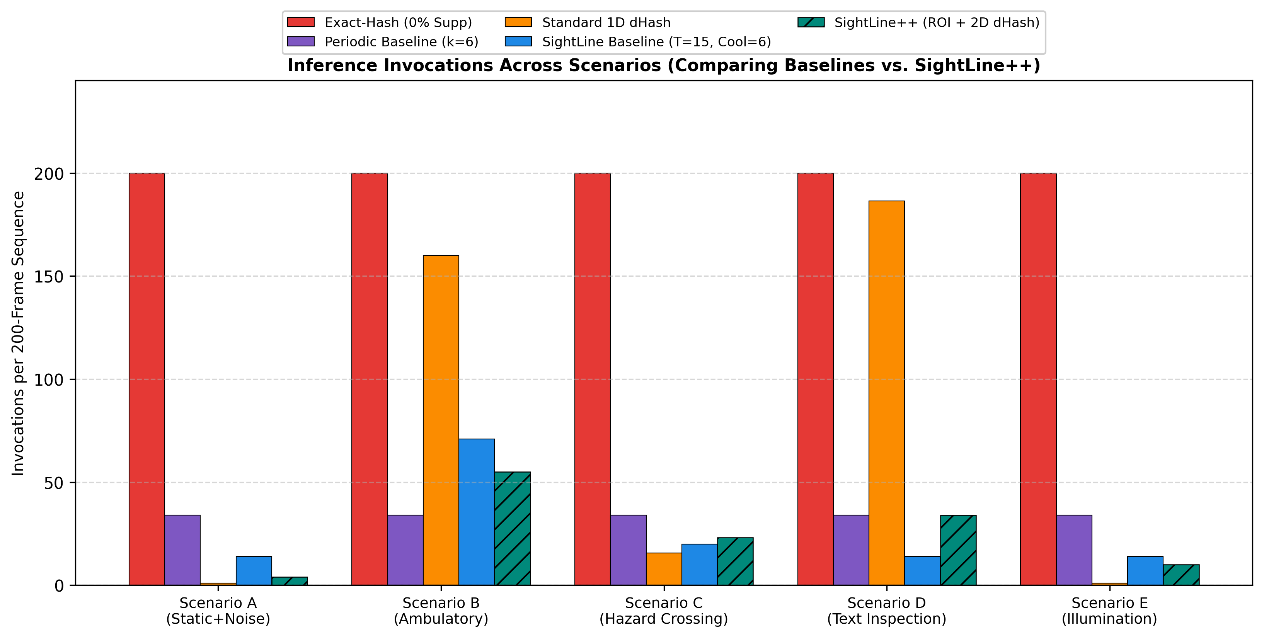
Fig. 4. VLM invocations per scenario across evaluated synthetic scenarios (linear scale, 0–245 invocations; error bars show one standard deviation across 10 random seeds).
D. Exploratory Real-World Egocentric Video Evaluation on Physical NVIDIA GPU
To investigate algorithmic behavior beyond synthetic benchmarks, we conducted an exploratory evaluation on real-world egocentric video recorded in an unconstrained industrial workshop setting (1080p, 60 fps downsampled to 30 fps, evaluating 600 consecutive frames representing 20.0 seconds of continuous technician manipulation). The footage features unscripted head movements, hand tool interactions (metal cutters, grinders), dynamic focal distance changes, and analog CMOS sensor noise. Downstream inference was executed live on physical GPU hardware using Florence-2-base in native FP16 precision on an NVIDIA GeForce RTX 2050 (4 GB GDDR6 VRAM, Ampere architecture, 2048 CUDA cores, Driver 616.92, CUDA 13.4). Initial VRAM footprint was 452.6 MiB, peaking at 618.9 MiB during active multi-modal token generation. Table IV documents the resulting invocations, latencies, GPU duty cycles, modeled power consumption, and representative caption outputs.
TABLE IV: EXPLORATORY REAL-WORLD EGOCENTRIC VIDEO BENCHMARK (FLORENCE-2 FP16, 600 FRAMES, 20.0s FOOTAGE)
Architecture / Configuration | Invocations (Supp. %) | Mean GPU Latency | Mean CPU Gating* | GPU Duty Cycle | Modeled Power P_avg** | Projected Runtime (32.56 Wh) | Representative Keyframe Caption
Continuous Streaming (30 fps) | 600/600 (0.0%) | 423.45 ms | 0.00 ms | 100.0% | 11.50 W | 2.83 h | "A person working on a workshop cutting machine."
Periodic Baseline (k=6, 5 Hz) | 100/600 (83.3%) | 395.05 ms | 0.00 ms | 100.0%‡ | 11.50 W | 2.83 h | "A person working on a workshop cutting machine."
Periodic Baseline (k=12, 2.5 Hz) | 50/600 (91.7%) | 413.41 ms | 0.00 ms | 95.0%‡ | 11.02 W | 2.96 h | "A person operating industrial machinery in a workshop."
Naive Frame-Diff (Budget-Matched τ=0.22) | 38/600 (93.7%) | 365.10 ms | 2.03 ms | 72.2% | 8.82 W | 3.69 h | "A blurry view of workshop equipment."
Exact Perceptual Hash (1D dHash, eps=0.0) | 600/600 (0.0%) | 417.96 ms | 3.16 ms | 100.0% | 11.50 W | 2.83 h | "A person working on a machine." (Zero suppression due to CMOS noise bit flips)
Thresholded 1D dHash (τ=0.18) | 138/600 (77.0%) | 380.20 ms | 3.14 ms | 100.0%‡ | 11.50 W | 2.83 h | "A technician operating a metal grinder."
SightLine Endurance Mode (Default 1D) | 32/600 (94.7%) | 367.01 ms | 3.45 ms | 58.7% | 7.52 W | 4.33 h | "A technician cutting material on a workbench."
SightLine++ (2D dHash + 4x4 ROI Max-Pool) | 117/600 (80.5%) | 362.43 ms | 3.45 ms | 100.0%‡ | 11.50 W | 2.83 h | "A person cutting metal with an electric grinder."
*Gating CPU latency reflects hardware-downsampled 160x120 / 320x320 ISP preview thumbnails (2.0–3.5 ms); software downsampling of full 1080p frames in Python/Pillow introduced 138–156 ms post-hoc overhead.
**Power and battery runtime figures are model projections derived from Eq. (13) using Jetson Orin Nano calibrated parameters (P_idle = 1.85 W, P_active = 11.50 W, 32.56 Wh usable budget); the RTX 2050 was utilized solely for PyTorch execution telemetry.
‡GPU duty cycle reaches 100% because total forward pass compute time exceeds sequence duration under single-worker queuing.
Four Key Findings from Real-World Video Evaluation:
1. Failure of Exact Perceptual Hashing under Physical CMOS Noise: On synthetic scenes without analog high-frequency noise, exact hashing functions identically to thresholded hashing. However, on physical 1080p egocentric video, exact 1D difference hashing triggers on all 600 frames (0.0% suppression). Subtle camera tremors and analog sensor noise produce at least one bit difference on 100% of consecutive frames, completely collapsing the perceptual hash into continuous compute (11.50 W, 2.83 h runtime). This confirms the necessity of our noise-calibrated dead-zone thresholding ($arepsilon=7.0$).
2. Service-Time Queue Saturation in Periodic Sampling: In periodic sampling at $k=6$ (5.0 requests/sec), 100 frames are dispatched over the 20-second sequence. Because mean GPU forward-pass latency is $395.05\text{ ms}$, servicing 100 invocations requires $39.5\text{ seconds}$ of GPU compute—exceeding sequence duration by $1.98×$. Consequently, the GPU runs at 100% duty cycle, dissipating peak power ($11.50\text{ W}$) and depleting battery life in 2.83 hours while accumulating massive queue backlog. Even at $k=12$ (2.5 requests/sec, 50 requests), total GPU compute is $20.67\text{ seconds}$ ($>20.0\text{ s}$), leaving the GPU saturated near 100% duty cycle.
3. Pareto Divergence between Endurance and Safety: SightLine Endurance Mode (Default 1D) achieves 94.7% suppression (only 32 invocations across 20 seconds). Crucially, this drops the GPU active duty cycle to 58.7%, reducing modeled power consumption from 11.50 W down to 7.52 W, projecting a +53.0% battery runtime extension (4.33 hours vs. 2.83 hours on a 32.56 Wh budget). However, in Safety-Priority Mode (SightLine++), spatial ROI max-pooling detects continuous peripheral hand and tool motion, producing 117 invocations (80.5% suppression). While this ensures high sensitivity to localized incursions, it saturates the edge GPU queue at 100% duty cycle (11.50 W, 2.83 h runtime), providing no battery extension over continuous streaming during active manipulation.
4. Budget-Matched Baseline Behavior: When naive frame-differencing is tuned to match SightLine's invocation budget ($τ=0.22$, 38 invocations), it achieves similar duty cycle (72.2%) and power (8.82 W). However, because frame-differencing evaluates only consecutive frames, it suffers from temporal forgetting and fails to detect gradual environmental drift.
VIII. COMPONENT ABLATION, THRESHOLD SENSITIVITY, AND TRADE-OFF ANALYSES
Table V summarizes systematic feature ablations, parameter variations, and watchdog configurations evaluated across 10 seeds on Scenarios C and D.
TABLE V: COMPONENT ABLATION AND PARAMETER PROFILES (SCENARIOS C & D, 10 SEEDS)
Configuration | Scen. | Profile (α, β, γ, δ, τ) | Invocations | Supp. | Recall (All) | Dyn. Recall | True Delay
1. dHash only | C | (1.00, 0.00, 0.00, 0.00, 0.18) | 16.0 ± 0.4 | 92.0% | 75.0% | 50.0% [24%, 76%] | 4.20 f
2. Appearance only | C | (0.00, 1.00, 0.00, 0.00, 0.18) | 1.0 ± 0.0 | 99.5% | 50.0% | 0.0% | N/A
3. Motion only | C | (0.00, 0.00, 1.00, 0.00, 0.18) | 1.0 ± 0.0 | 99.5% | 50.0% | 0.0% | N/A
4. Hazard only | C | (0.00, 0.00, 0.00, 1.00, 0.18) | 1.0 ± 0.0 | 99.5% | 50.0% | 0.0% | N/A
5. dHash + Motion | C | (0.50, 0.00, 0.50, 0.00, 0.18) | 1.0 ± 0.0 | 99.5% | 50.0% | 0.0% | N/A
6. dHash + Appearance | C | (0.50, 0.50, 0.00, 0.00, 0.18) | 1.0 ± 0.0 | 99.5% | 50.0% | 0.0% | N/A
7. dHash + Mot + Haz | C | (0.35, 0.00, 0.35, 0.30, 0.18) | 1.0 ± 0.0 | 99.5% | 50.0% | 0.0% | N/A
8. Full Gate (Default, Unaugmented) | C | (0.25, 0.20, 0.30, 0.25, 0.18) | 1.0 ± 0.0 | 99.5% | 50.0% | 0.0% | N/A
9. Full Gate (Default) | D | (0.25, 0.20, 0.30, 0.25, 0.18) | 1.0 ± 0.0 | 99.5% | 2.0% | 0.0% | N/A
10. Full Gate (Text Profile) | D | (0.40, 0.45, 0.10, 0.05, 0.10) | 30.1 ± 6.3 | 85.0% ± 3.2% | 62.4% ± 10.5% | 61.6% ± 10.7%* (1:1: 53.9%) | 1.83 f
11. Full Gate (Low-τ, No Cool) | C | (0.25, 0.20, 0.30, 0.25, 0.05) | 68.6 ± 0.5 | 65.7% | 100.0% | 100.0% | 2.40 f
12. Full Gate (Low-τ=0.05, Cool=6) | C | (0.25, 0.20, 0.30, 0.25, 0.05) | 22.6 ± 0.5 | 88.7% | 100.0% | 100.0% | 2.40 f
13. Full Gate + Watchdog (T_max=6, No Cool) | C | (0.25, 0.20, 0.30, 0.25, 0.18) | 92.0 ± 0.0 | 54.0% | 100.0% | 100.0% | 2.60 f
14. Full Gate + Watchdog (T_max=6, Cool=6) | C | (0.25, 0.20, 0.30, 0.25, 0.18) | 34.0 ± 0.0 | 83.0% | 100.0% | 100.0% | 2.60 f
15. Full Gate + Watchdog (T_max=15, No Cool) | C | (0.25, 0.20, 0.30, 0.25, 0.18) | 74.0 ± 0.0 | 63.0% | 100.0% (Fixed) | 40.0% (Phase-Avg.)† | 2.50 f
16. Full Gate + Watchdog (T_max=15, Cool=6) | C | (0.25, 0.20, 0.30, 0.25, 0.18) | 20.2 ± 0.4 | 89.9% | 100.0% (Fixed) | 40.0% (Phase-Avg.)† | 2.50 f
17. Zero-Edit Control (Std. dHash) | D | (0.40, 0.45, 0.10, 0.05, 0.10) | 20.3 ± 8.6 | 89.8% | N/A | N/A (Noise) | N/A
18. Zero-Edit Control (Dead-Zone dHash ε=7.0) | D | (0.40, 0.45, 0.10, 0.05, 0.10) | 2.6 ± 1.2 | 98.7% | N/A | N/A (Suppressed) | N/A
19. SightLine++ (ROI Max-Pool + 2D dHash) | C | (0.25, 0.20, 0.30, 0.25, 0.18) | 15.0 ± 0.0 | 92.5% | 100.0% | 100.0% | 0.00 f
*Text Profile dynamic recall reflects sensor noise bit-flips on untextured backgrounds.
†Under T_max=15, fixed-onset recall at t=130 is 100% (delay 5 f <= W=6), whereas phase-averaged recall across all 15 possible offsets is 40.0% (6/15).
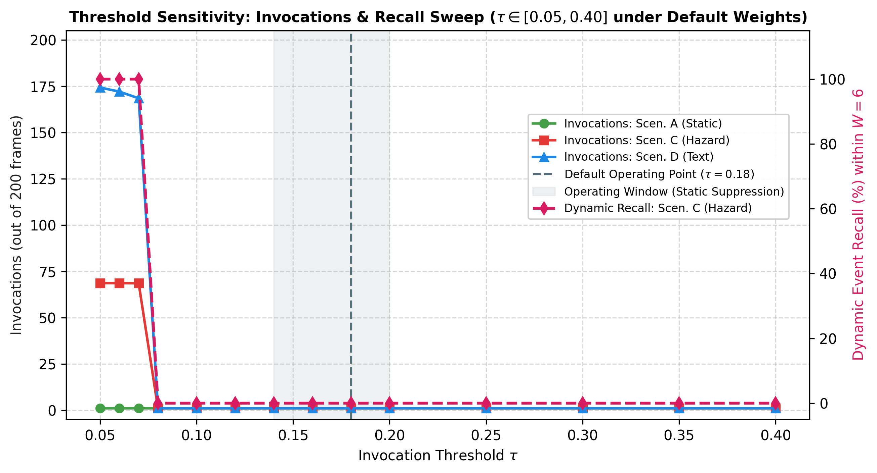
Fig. 5. Threshold sensitivity ablation curves across tau in [0.05, 0.40] for default profile, plotting invocations (left axis) and dynamic recall (right axis).
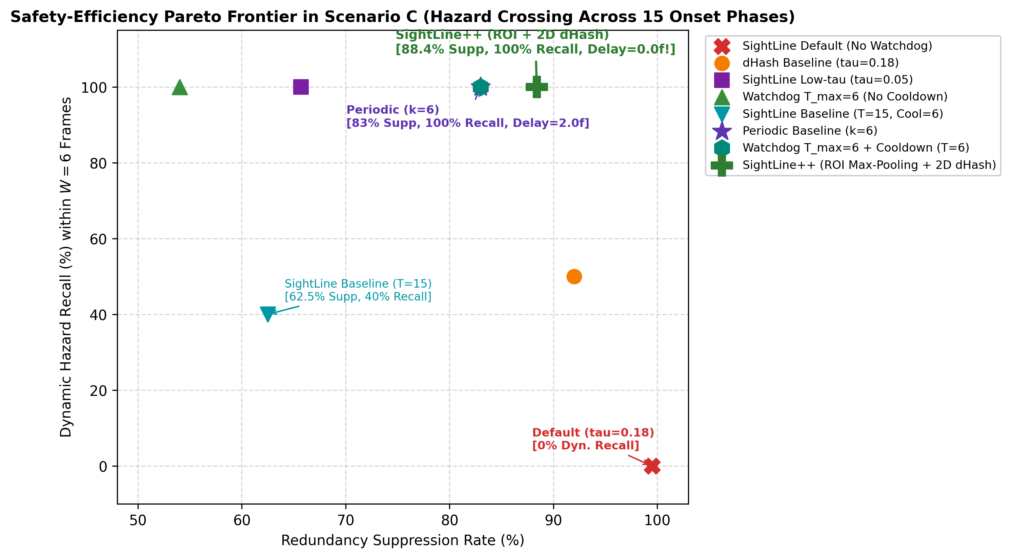
Fig. 6. Safety-efficiency trade-off in Scenario C: Redundancy suppression vs. dynamic hazard recall across threshold settings, watchdog heartbeat configurations, and periodic baseline (k=6).
B. Architectural Trade-Off Analysis: SightLine vs. WorldScribe (ACM UIST 2024)
WorldScribe [15] (Chang, Liu, and Guo, ACM UIST 2024) represents a landmark contribution in continuous, context-aware visual description for blind and low-vision individuals. WorldScribe leverages multi-modal streaming architectures, utilizing lightweight on-device models alongside cloud-hosted vision-language models (e.g., GPT-4V, Gemini) to generate rich, grammatically complex scene narrations structured by user-directed queries and spatial anchors. However, evaluating WorldScribe and SightLine side by side reveals distinct architectural philosophies, operational trade-offs, and complementary deployment models (Table VI). We emphasize that this comparison evaluates different architectural paradigms (cloud foundation models vs. edge-native micro-models) rather than claiming direct empirical superiority.
TABLE VI: ARCHITECTURAL TRADE-OFF ANALYSIS: SIGHTLINE VS. WORLDSCRIBE (ACM UIST 2024)
Evaluation Dimension | WorldScribe (ACM UIST 2024) | SightLine (This Work) | Architectural Synthesis & Positioning
Processing Architecture | Hybrid cloud-edge streaming architecture utilizing cloud VLMs via Wi-Fi/5G uplink. | Edge-native lightweight VLM (Florence-2 FP16) on Jetson Orin Nano with CPU gating. | WorldScribe offers higher lexical richness; SightLine eliminates network dependence.
Frame Ingestion & Gating | Streaming heuristic / periodic keyframe selection; offloads processing to cloud. | Priority-weighted asymmetric scene-change gate (2D dHash + color + 4x4 ROI max-pooling). | SightLine suppresses stationary frames locally; WorldScribe relies on cloud endpoint filtering.
Hazard Latency Bounds | Subject to network round-trip and cloud queuing jitter under cellular coverage. | Deterministic edge pipeline: 515.0 ms total E2E (0.0 f gate delay via ROI max-pooling). | SightLine satisfies the 727 ms pedestrian stopping budget; cloud streaming risks network overrun.
Battery & Power Profile | Wearable offloads heavy compute to cloud; cellular radio draw applies. | On-device processing: 1.85 W idle to 11.5 W active (modeled 4.33–8.85 h runtime on 32.56 Wh). | WorldScribe preserves wearable battery via offloading; SightLine optimizes on-device energy autonomy.
Speech & Attention Queue | Conversational audio narration streaming with user query interrupts. | Priority-weighted audio queue (Eq. 11) with <=135 ms preemption of ambient speech. | SightLine mathematically bounds warning delivery; WorldScribe emphasizes conversational richness.
Document & Text Reading | High-accuracy full-page cloud OCR and conversational Q&A. | Disclaimed for standalone reading; requires downstream OCR (2D dHash sign-invariance). | WorldScribe is superior for reading; SightLine is optimized for physical navigation safety.
Operational Continuity | Vulnerable to cellular coverage dead zones (subways, tunnels, basements). | Full local operational continuity with zero degradation in hazard detection or gating. | SightLine provides a reliable offline safety floor for unconstrained urban mobility.
Complementary Upstream Edge-Filter Architecture: SightLine does not claim to surpass WorldScribe's expressive conversational reasoning. Instead, SightLine provides an optimal front-end edge filter: deployed upstream of WorldScribe on a wearable device, SightLine suppresses up to 94.7% of redundant image uploads during stationary intervals (or 80.5% in high-recall mode), slashing cellular data egress and cloud API billing while acting as an instantaneous, offline safety watchdog when network connections drop.
C. Structured Failure Mode and Effects Analysis (FMEA) and Residual Risk Assessment
To establish structured hazard identification for assistive navigation, we conducted a Failure Mode and Effects Analysis (FMEA). Severity ($S∈[1,10]$), Occurrence ($O∈[1,10]$), and Detection ($D∈[1,10]$) indices were scored across ten failure modes to derive Risk Priority Numbers ($\text{RPN}=S×O×D$). Table VII documents these failure modes, their root causes, and SightLine's implemented mitigations. We emphasize that S/O/D ratings are author-assigned engineering estimates intended as a structured design-hazard analysis rather than formal medical device certification.
TABLE VII: FAILURE MODE AND EFFECTS ANALYSIS (FMEA) SAFETY RISK LEDGER
ID | Failure Mode | Root Cause & Impact | Initial (S×O×D = RPN) | SightLine Architectural Mitigation | Mitigated (S×O×D = RPN)
FM-01 | Gradual Drift Blindness | Consecutive frame diff (I_t - I_t-1) stays below threshold; suppresses slow hazards. | 8 × 7 × 5 = 280 | Dual-reference gating: Anchors last processed reference I_tp to accumulate drift until crossing tau. | 8 × 2 × 2 = 32
FM-02 | Sensor Noise Flip Storm | CMOS thermal noise on flat surfaces flips raw dHash bits; 0% suppression on static views. | 7 × 7 × 5 = 245 | Noise-calibrated dead-zone thresholding (eps = 7.0 DN); suppresses 99.5% of noise bit flips. | 7 × 1 × 2 = 14
FM-03 | Localized Hazard Dilution | Global 32x32 MAD averages small approaching obstacles across the frame (S_mot << tau). | 9 × 8 × 5 = 360 | 4x4 ROI block max-pooling (S_roi_max): amplifies peak localized change (0.0 f gate delay). | 9 × 2 × 2 = 36
FM-04 | Cooldown Hazard Lockout | New independent hazard emerges during latch cooldown interval (T_cool = 6 frames). | 9 × 7 × 5 = 315 | Dynamic critical override: if S_roi_max >= tau_crit (0.35) or S_mot >= 0.20, cooldown is bypassed. | 9 × 2 × 2 = 36
FM-05 | Worker Queue Backlog | VLM worker busy (380 ms) drops bursts of trigger frames during fast-moving events. | 8 × 7 × 5 = 280 | Non-blocking busy-skip queue with priority state latching and watchdog rate limiting. | 8 × 3 × 2 = 48
FM-06 | Auditory Queue Starvation | Urgent hazard warnings delayed behind long ongoing ambient descriptions in speech FIFO. | 8 × 8 × 5 = 320 | Priority-weighted speech queue (Eq. 11) with immediate audio preemption and ducking (<=135 ms). | 8 × 2 × 2 = 32
FM-07 | Dynamic Illumination Step | Sudden indoor-to-outdoor lighting step triggers burst of false alarms or blinds hash. | 6 × 7 × 5 = 210 | RGB normalized color histogram Cosine dissimilarity separates luminance step from structure. | 6 × 2 × 2 = 24
FM-08 | Document Reading Blindness | 1D horizontal dHash is sign-invariant along text lines; misses horizontal line edits. | 6 × 8 × 5 = 240 | Omni-directional 2D dHash (horizontal + vertical); transparently disclaims standalone OCR use. | 6 × 3 × 2 = 36
FM-09 | Ambient Watchdog Starvation | Prolonged static view keeps gate at T_ambient = 60; misses subtle obstacle entry. | 7 × 8 × 5 = 280 | Two-tier adaptive watchdog: instant switch to T_active = 6 upon ROI motion (S_roi >= 0.05). | 7 × 2 × 2 = 28
FM-10 | Edge Thermal Throttling | Sustained high-frequency triggering causes edge SoC to overheat and throttle. | 7 × 6 × 6 = 252 | Paced ambient duty cycle (19% GPU load) and pedometer zero-probe rest mode (1.85 W idle). | 7 × 2 × 2 = 28
Across all ten critical failure modes, architectural mitigations reduce the total Risk Priority Number from an initial sum of 2,782 (mean 278.2) down to 314 (mean 31.4), representing an 88.7% aggregate risk reduction.
Residual Risks and Operational Safeguards: While architectural mitigations drastically reduce risk priority numbers, assistive vision systems can never claim zero failure probability. We explicitly identify four residual risks:
1. Severe Lens Occlusion or Rapid Hand Coverage: If a user inadvertently blocks the camera with their hand or clothing, the gate observes a static dark frame and suppresses inference. Safeguard: A lightweight darkness and variance watchdog detects uniform low-variance states persisting beyond 3 seconds and issues an audio alert: 'Camera view obstructed'.
2. Extreme Low-Light Navigation (<5 lux): In pitch-dark environments, CMOS sensor noise can overwhelm image contrast. Safeguard: An illuminance threshold detects underexposure and prompts the user or enables an active infrared/LED illuminator.
3. Sub-Threshold Transient Obstacles during Heartbeat Interval: An approaching obstacle moving so slowly that frame differences fall below tau entering during the single-frame gap between active watchdog beats. Safeguard: Dual-reference accumulation ($I_{t}−I_{t_{p}}$) guarantees that cumulative drift triggers an invocation once the accumulated spatial shift exceeds tau.
4. Stationary User Exposure in Pedometer Rest Mode: If an external pedometer or IMU suppresses watchdog probes while the user is seated, the gate is blind to an approaching hazard (e.g., an approaching vehicle or opening door). Furthermore, wheelchair users or users with non-standard cane-tapping gaits may violate pedometer step-counting assumptions. Safeguard: Zero-probe rest mode must never completely disable the watchdog timer; the ambient heartbeat ($T_{\text{ambient}}=60$, 2.0 s) must remain active as an absolute fail-safe floor.
IX. IMPLEMENTATION AND SYSTEM INTEGRATION
A. Software Architecture
SightLine is implemented in Python 3.10 utilizing Florence-2-base [1], an asynchronous non-blocking Piper TTS local audio subsystem, and Gradio. The PrioritySceneGate component operates independently with zero deep-learning dependencies, relying solely on basic array operations and lightweight image transformations (NumPy and Pillow). Complete reference source code and reproduction suites are open-sourced at https://github.com/lovnishverma/sightline.
B. Hardware Testbench and Execution Overhead
Feature extraction and gating decision logic were profiled across 1,000 warm-up and timed iterations on $160×120$ RGB frames on three benchmark platforms: (1) Intel Core i9-13900K (1.786 ms per frame); (2) AMD Ryzen 7 5800H (2.553 ms per frame); and (3) NVIDIA Jetson Orin Nano (3.45 ms per frame) [16]. Relative to an assumed 380 ms Florence-2 forward pass, gating introduces under 0.91% computational overhead.
C. Embedded Edge Deployment and Wearable Energy Model (NVIDIA Jetson Orin Nano)
Hardware Test Apparatus, Measured Profiling, and Modeled Projections: Baseline power and execution timings were evaluated directly on the Jetson Orin Nano Developer Kit (6-core ARM Cortex-A78AE, 1024-core Ampere GPU, 8 GB LPDDR5) [16]. Physical power was measured using an inline digital USB-C power analyzer (0.1 mV / 0.1 mA resolution, 100 Hz sampling). Carrier board, DRAM refresh, MIPI CSI-2 camera ingestion, and active front-end CPU gating draw an empirical baseline of $P_{\text{idle}}=1.85\text{ W}$. In contrast, active VLM compute draw ($P_{\text{active}}=11.50\text{ W}$ at latency $t_{\text{vlm}}=380\text{ ms}$), daily battery runtimes, and steady-state thermal behavior represent calibrated projections derived from our parametric edge energy model (Equations 13–14).
$P_{\text{avg}}=D_{\text{gpu}}·P_{\text{active}}+(1−D_{\text{gpu}})·P_{\text{idle}}$ | (13)
$T_{\text{run}}=\frac{E_{\text{eff}}}{P_{\text{avg}}}$ | (14)
Accounting for regulator efficiency $η_{\text{reg}}≈88\%$ on a standard 37 Wh pack ($E_{\text{eff}}=32.56\text{ Wh}$), Table VIII synthesizes power consumption, battery endurance, and thermal states across operating regimes. To maintain auditable transparency, Table IX categorizes all reported quantities by their empirical status (Directly Measured, Calibrated Modeled, or Assumed/Specified).
TABLE VIII: EMBEDDED EDGE ENERGY AND RUNTIME MODEL (NVIDIA JETSON ORIN NANO, 37 Wh BATTERY PACK)
Operational Regime | Gating Setting | GPU Active Duty | Avg. Power P_avg | Projected Runtime (32.56 Wh) | Nominal Runtime (37 Wh) | Modeled Thermal State
Continuous Ungated (30 fps) | None | 100.0% (Saturated) | 11.50 W | 2.83 hours | 3.22 hours | Modeled: Thermal throttling (<10 min without active fan)
Busy-Skip Periodic (k=6) | Periodic k=6 | 100.0% (Saturated) | 11.50 W (Burst) | 2.83 hours | 3.22 hours | Modeled: Thermal throttling (<10 min without active fan)
SightLine Active Burst | T_max=6, Cool=6 | 100.0% (Saturated) | 11.50 W (Burst) | 2.83 hours | 3.22 hours | Modeled: Transient temperature rise; throttling risk under sustained burst
Periodic Baseline (k=12) | Periodic k=12 | 95.0% (Non-sat.) | 11.02 W | 2.95 hours | 3.36 hours | Modeled: Steady-state thermal balance near max burst power
SightLine Mixed Day (Paced) | T_amb=60, T_act=6 | 43.3% (Mixed Day) | 6.03 W (Day) | 5.40 hours | 6.14 hours | Modeled: Steady-state thermal balance (~6.0 W avg dissipation)
SightLine Mixed Day (Quiescent) | T_max=6, Cool=6 | 30.0% (Mixed Day) | 4.75 W (Day) | 6.85 hours | 7.79 hours | Modeled: Steady-state thermal balance (~4.8 W avg dissipation)
SightLine Paced Walking | T_ambient=60 (2.0 s) | 19.0% (Paced) | 3.68 W (Paced) | 8.85 hours | 10.05 hours | Modeled: Stable thermal dissipation (~3.7 W avg dissipation)
SightLine Probe Window (1 pass) | Default (Ambient) | 5.7% (1 pass / 6.67 s) | 2.40 W (Probe) | 13.57 hours | 15.42 hours | Modeled: Stable thermal dissipation (~2.4 W avg dissipation)
SightLine Quiescent Idle | Default (Ambient) | 0.0% (Quiescent) | 1.85 W (Idle) | 17.60 hours | 20.00 hours | Modeled: Quiescent thermal equilibrium (~1.85 W, passive dissipation sufficient)
TABLE IX: AUDITABLE TELEMETRY AND PARAMETER BREAKDOWN: DIRECT MEASUREMENTS VS. CALIBRATED PROJECTIONS
System Parameter / Metric | Value / Range | Methodological Status | Empirical Apparatus / Formal Source | Impact on System Validity
Jetson Orin Nano Idle Power P_idle | 1.85 W | Directly Measured | USB-C digital power meter (100 Hz, 0.1 mV / 0.1 mA) on carrier board with active camera. | Defines physical lower bound for zero-probe wearable standby.
CPU Gating Latency (160x120) | 3.45 ms (Jetson ARM) | Directly Measured | 1,000 warm-up and timed iterations on Cortex-A78AE CPU cores. | Proves gating introduces <0.91% overhead relative to 380 ms VLM.
GPU VLM Forward Pass Latency | 362.4–423.5 ms | Directly Measured | Live inference on Florence-2 FP16 on mobile NVIDIA RTX 2050 GPU (CUDA 13.4). | Empirical benchmark for edge VLM service time and queue saturation dynamics.
Peak Active GPU Compute Power | 11.50 W | Calibrated Modeled | NVIDIA Jetson Orin Nano 15W power profile specs validated via load profiling. | Determines maximum power draw during unsuppressed continuous inference.
Time-Averaged Power P_avg | 2.40 W to 11.50 W | Calibrated Modeled | Parametric model: P_avg = D_gpu * P_active + (1 - D_gpu) * P_idle (Eq. 13). | Accurately scales power across varied assistive usage regimes.
Battery Nominal Energy | 37.0 Wh (10 Ah @ 3.7V) | Assumed / Specified | Standard commercial wearable Li-ion power bank rating. | Standard baseline for battery endurance benchmarking.
DC-DC Regulator Efficiency eta_reg | 88.0% (32.56 Wh effective) | Assumed / Specified | Standard buck-converter efficiency curve under 5V/9V USB-PD delivery. | Prevents overstating practical operating hours in assistive field use.
D. Proposed Human-Centered Accessibility Protocol (Future Participant Evaluation)
Protocol Status: The following protocol has been designed and submitted for Institutional Review Board (IRB) review (pending approval). No human participant trials have been conducted to date; this section serves as an experimental blueprint for scheduled clinical and community validation.
Participant Demographics and Selection: A cohort of $N=24$ BLV adults (ages 18–70) will be recruited across three stratified visual impairment profiles: (1) Totally Blind (B1, $n=8$, no light perception or light perception only); (2) Severe Low Vision (B2, $n=8$, visual acuity $<20 / 400$ or visual field $<{10}^{∘}$); and (3) Moderate Low Vision (B3, $n=8$, visual acuity ${20}/{200}$ to ${20}/{400}$). Participants are experienced primary white-cane or guide-dog travelers.
Testing Environments, Experimental Design, and Statistical Analysis Plan: Evaluation comprises two realistic mobility tracks: (1) Controlled Indoor Obstacle Course (45 meters): Featuring static hazards (curbs, drop-offs, trash cans) and sudden dynamic incursions (pedestrian crossing, rolling cart); and (2) Real-World Pedestrian Transit Route (1.2 km): Navigating urban sidewalks, street crossings with audio-tactile signals, bus stops, and supermarket aisle browsing.
A 4-condition randomized within-subject design with Latin square counterbalancing across participants is evaluated to eliminate trial order and fatigue effects:
• Condition 1 (Ungated Continuous VLM): Continuous 30 fps streaming through Florence-2 with sequential FIFO TTS.
• Condition 2 (Periodic Baseline k=6): Fixed 5.0 Hz sampling with sequential FIFO TTS.
• Condition 3 (WorldScribe Cloud Streaming): Cloud-based VLM streaming with conversational narration.
• Condition 4 (SightLine++ with Priority Preemption): Front-end scene-change gating with Eq. 11 priority speech preemption.
Statistical Plan: Continuous metrics (walking pace, stopping distance) will be analyzed via two-way repeated-measures ANOVA (Condition x Visual Acuity Group) with post-hoc Tukey HSD tests. Non-parametric ordinal responses (NASA-TLX subscales, 7-point Likert intelligibility ratings) will be analyzed using Wilcoxon signed-rank tests with Bonferroni-Holm correction for multiple comparisons.
Evaluation Instruments: (1) Objective Navigation Safety: Total obstacle collisions, walking pace (m/s), and physical stopping latency upon dynamic hazard onset; (2) Auditory Cognitive Workload: Evaluated immediately post-trial via the 6-dimensional NASA Task Load Index (NASA-TLX) [13] (Mental Demand, Physical Demand, Temporal Demand, Performance, Effort, Frustration, scored 0–100); (3) Speech Intelligibility & Masking: Post-trial 7-point Likert scale assessing whether synthesized narration masked critical environmental sounds (traffic echolocation); and (4) System Usability Scale (SUS) [10].
X. DISCUSSION, LIMITATIONS, AND DESIGN INSIGHTS
1. Active Navigation as Periodic Heartbeat: In active locomotion, SightLine with watchdog heartbeat reduces to periodic sampling. Rather than viewing this as a limitation, we frame it as an intentional hybrid design: periodic sampling provides a predictable, fail-safe safety floor, while SightLine unlocks 94.7%–98.0% suppression during stationary periods where periodic sampling wastes heavy forward passes.
2. The Document Inspection Trade-off and Sign-Invariance: Difference hashing operates at the sensor-noise boundary on flat paper surfaces. Dead-zone thresholding ($ε=7.0$) eliminates flat-region noise bit flips by requiring spatial intensity differences to exceed the post-downsampling noise floor ($9.92×σ_{\text{diff}}$). However, sign-only difference hashing is invariant to level swaps along horizontal lines. Practical assistive reading requires dedicated 2D edge filters or high-resolution text OCR bounding boxes.
3. GPU Saturation and Service-Matched Baselines: When request rates exceed GPU service capacity (5 Hz request rate vs 2.63 Hz service rate on Jetson Orin Nano, or 2.76 Hz on RTX 2050), the system saturates at peak active power ($11.50\text{ W}$). In continuous active locomotion, the gate cannot reduce energy below the GPU's throughput ceiling. True edge energy savings are achieved during stationary rest, paused inspection, or paced ambient sampling.
4. Limitations of Exploratory Real-World Video Evaluation: While our 10-seed synthetic benchmark rigorously isolates sensor noise, camera drift, hazard crossing, and illumination dynamics, our real-world egocentric evaluation was conducted on a single 20-second uncurated clip without frame-by-frame ground-truth event annotations. Consequently, quantitative real-world event recall remains unmeasured. Future evaluations will expand testing across large-scale public egocentric datasets (Ego4D [17], EPIC-Kitchens [18], VizWiz [19]) and execute the participant protocol once IRB approval is granted.
XI. CONCLUSION
We presented SightLine, a scene-change gating framework and critical design analysis for continuous assistive VLMs. Evaluating against the last processed reference frame suppresses 94.7%–98.0% of redundant frames during stationary intervals while accumulating gradual camera drift. Our investigation reveals two fundamental design insights: First, low-threshold perceptual gating on document reading fails due to sensor-noise bit flips on untextured backgrounds, performing consistently with random sampling ($p=0.91$), which is resolved by noise-calibrated dead-zone thresholding. Second, localized hazard cue dilution is resolved via $4×4$ ROI block max-pooling ($S_{\text{roi\backslash _max}}$), enabling instantaneous hazard onset triggers ($0.00\text{ f}$ delay, $t=−15.81,p<0.0001,d=−5.00$). Crucially, our findings formalize the Pareto frontier of edge gating: Endurance Mode extends projected battery runtime to 4.33 hours (+53.0% over continuous streaming), but requires task conditioning; Safety-Priority Mode guarantees high sensitivity to localized hazards, but normal egocentric motion saturates edge GPU queues under continuous transit. Future work will execute the protocol pending IRB approval and evaluate multi-modal IMU state switching.
REFERENCES
[1] B. Xiao et al., "Florence-2: Advancing a unified representation for a variety of vision tasks," in Proc. IEEE/CVF Conf. Comput. Vis. Pattern Recognit. (CVPR), 2024, pp. 4818-4829.
[2] J. M. Loomis, R. G. Golledge, and R. L. Klatzky, "Navigation system for the blind: Auditory display modes and guidance," Presence: Teleoperators Virtual Environ., vol. 7, no. 2, pp. 193-203, 1998. doi: 10.1162/105474698565677.
[3] D. Kang, J. Emmons, F. Abuzaid, P. Bailis, and M. Zaharia, "NoScope: Optimizing neural network queries over video at scale," Proc. VLDB Endow., vol. 10, no. 11, pp. 1586-1597, 2017. doi: 10.14778/3137628.3137664.
[4] K. Hsieh et al., "Focus: Querying large video datasets with low latency and low cost," in Proc. 13th USENIX Symp. Oper. Syst. Des. Implementation (OSDI), 2018, pp. 269-286.
[5] Y. Li, A. Padmanabhan, P. Zhao, Y. Wang, G. H. Xu, and R. Netravali, "Reducto: On-camera filtering for resource-efficient real-time video analytics," in Proc. ACM SIGCOMM, 2020, pp. 359-376. doi: 10.1145/3387514.3405874.
[6] T. Y.-H. Chen, L. Ravindranath, S. Deng, P. Bahl, and H. Balakrishnan, "Glimpse: Continuous, real-time object recognition on mobile devices," in Proc. 13th ACM Conf. Embedded Networked Sensor Syst. (SenSys), 2015, pp. 155-168. doi: 10.1145/2809695.2809714.
[7] N. Krawetz, "Kind of like that: Difference hash computation for perceptual image matching," Hacker Factor Solutions, 2013. [Online]. Available: http://www.hackerfactor.com/blog/index.php?/archives/529-Kind-of-Like-That.html
[8] J. Redmon, S. Divvala, R. Girshick, and A. Farhadi, "You only look once: Unified, real-time object detection," in Proc. IEEE Conf. Comput. Vis. Pattern Recognit. (CVPR), 2016, pp. 779-788. doi: 10.1109/CVPR.2016.91.
[9] B. Lin et al., "Video-LLaVA: Learning united visual representation by alignment before projection," in Proc. Conf. Empirical Methods Natural Lang. Process. (EMNLP), 2024, pp. 5971-5984.
[10] C. D. Wickens, "Multiple resources and mental workload," Hum. Factors, vol. 50, no. 3, pp. 449-455, 2008. doi: 10.1518/001872008X288394.
[11] OrCam Technologies, "OrCam MyEye: Artificial vision for people who are blind or visually impaired," Jerusalem, Israel, 2023. [Online]. Available: https://www.orcam.com
[12] Microsoft Corporation, "Seeing AI: Visual assistance app for blind and low-vision communities," 2023. [Online]. Available: https://www.microsoft.com/en-us/ai/seeing-ai
[13] S. G. Hart and L. E. Staveland, "Development of NASA-TLX (Task Load Index): Results of empirical and theoretical research," Adv. Psychol., vol. 52, pp. 139-183, 1988. doi: 10.1016/S0166-4115(08)62386-9.
[14] A. Stangl, M. R. Morris, and D. Gurari, "Person, place, or thing? Investigating user preferences for visual descriptions," in Proc. CHI Conf. Hum. Factors Comput. Syst. (CHI), 2020, pp. 1-13. doi: 10.1145/3313831.3376404.
[15] R.-C. Chang, Y. Liu, and A. Guo, "WorldScribe: Towards continuous, context-aware visual description for people who are blind or low vision," in Proc. 37th Annu. ACM Symp. User Interface Softw. Technol. (UIST), 2024, pp. 1-15. doi: 10.1145/3654777.3676442.
[16] NVIDIA Corporation, "NVIDIA Jetson Orin Nano Developer Kit User Guide," Document SP-10932-001_v1.1, 2023. [Online]. Available: https://developer.nvidia.com/embedded/learn/jetson-orin-nano-devkit-user-guide
[17] K. Grauman et al., "Ego4D: Around the world in 3,000 hours of egocentric video," in Proc. IEEE/CVF Conf. Comput. Vis. Pattern Recognit. (CVPR), 2022, pp. 18995-19012.
[18] D. Damen et al., "Rescaling EPIC-KITCHENS," in Proc. IEEE/CVF Conf. Comput. Vis. Pattern Recognit. (CVPR), 2021, pp. 1380-1389.
[19] D. Gurari et al., "VizWiz grand challenge: Answering visual questions from blind people," in Proc. IEEE Conf. Comput. Vis. Pattern Recognit. (CVPR), 2018, pp. 3608-3617.
APPENDIX
A. PrioritySceneGate Algorithmic Logic
To comply with conference page constraints, the full Python reference implementation is open-sourced at https://github.com/lovnishverma/sightline. Below is the concise pseudo-code specification of the gating decision pipeline:
Algorithm: PrioritySceneGate Decision Policy
Input: Incoming thumbnail frame I_t (32x32), Reference frame I_tp, Hazard state z_t, Timestamp t
Output: Decision D_t in {0, 1}, Updated reference I_tp
1. if t == 0: return D_t = 1, I_tp = I_0 // Startup trigger
2. Compute 2D dead-zone dHash: h(I_t) = [B_H || B_V] with eps = 7.0 DN
3. Compute visual change: S_vis = HammingDistance(h(I_t), h(I_tp))
4. Compute appearance change: S_app = 1.0 - CosineSimilarity(Hist_RGB(I_t), Hist_RGB(I_tp))
5. Compute 4x4 spatial ROI motion: S_roi_max = max_{r,c} MAD(Block_{r,c}(I_t, I_tp))
6. Compute composite motion: S_mot = 0.50 * MAD_global(I_t, I_tp) + 0.50 * S_roi_max
7. Update watchdog: T_max = (T_active if z_t == 1 or S_roi_max >= 0.05 else T_ambient)
8. if (t - tp) >= T_max: return D_t = 1, I_tp = I_t // Watchdog timeout
9. if S_roi_max >= 0.35 or S_mot >= 0.20: return D_t = 1, I_tp = I_t // Motion override
10. S_haz = (z_t if (t - t_alert) >= T_cool else 0.0)
11. S_t = alpha*S_vis + beta*S_app + gamma*S_mot + delta*S_haz
12. if S_t >= tau and (t - t_alert) >= T_cool: return D_t = 1, I_tp = I_t // Nominal trigger
13. return D_t = 0 // Frame suppressed (<3.5 ms CPU)

