SightLine: Priority-Weighted Scene-Change Gating for Redundancy-Aware Assistive Vision-Language Models
Lovnish Verma¹, Prateek Dhar Dwivedi¹, Anita Budhiraja², Sarwan Singh²
National Institute of Electronics & Information Technology (NIELIT) Deemed to be University Ropar, India
princelv84@gmail.com prateek.nielit@gmail.com anitabudhiraja@nielit.ac.in sarwang@gmail.com
Abstract— Continuous assistive perception systems powered by modern Vision-Language Models (VLMs) enable rich environmental understanding for blind and low-vision individuals. However, unconstrained frame-by-frame inference incurs prohibitive computational costs, thermal throttling on wearable hardware, and cognitive auditory fatigue from repetitive narrations. Conversely, naive deduplication mechanisms—such as exact difference-hashing (dHash) equality—fail under camera sensor noise and motion jitter, triggering unneeded invocations on stationary scenes. In this paper, we present SightLine, a priority-weighted, redundancy-aware invocation gating framework designed for continuous assistive perception. SightLine formalizes an asymmetric reference-frame decision policy that causally couples normalized visual Hamming distance, appearance-based color distribution dissimilarity, grayscale motion magnitude, and persistent hazard detection states into a composite change score. To address task-specific sensitivities, we formulate task-conditioned parameter profiles that dynamically reallocate feature weights between ambulatory navigation and fine-grained document reading. Evaluated across 10 deterministic random seeds on a standardized synthetic benchmark suite (5 scenarios, 200 frames each), the proposed gate achieves 99.5% invocation suppression under stationary Gaussian sensor noise (filtering 199/200 redundant frames), 64.5% suppression during smooth ambulatory drift, and restores 83.5% sensitivity during text inspection via task conditioning. Computational benchmarking confirms that the entire gating decision executes in 1.786 ms per frame (<0.5% of VLM forward pass latency). We explicitly delineate the boundary between our standalone algorithmic validation and production deployment, formalizing a structured roadmap for embedded hardware latency benchmarking and institutional ethics-approved participant studies.
Index Terms— Vision-Language Models, Assistive Technology, Scene-Change Gating, Perceptual Hashing, Redundancy Suppression, Multimodal Perception, Edge AI
1. Introduction
Wearable assistive vision technologies hold immense promise for enhancing the autonomy and safety of blind and low-vision individuals. Recent breakthroughs in compact Vision-Language Models (VLMs), such as Microsoft Florence-2, enable unified captioning, visual question answering (VQA), and optical character recognition (OCR) within a single multimodal architecture. However, deploying continuous VLM inference over streaming wearable video introduces fundamental computational and human-computer interaction challenges. Continuous inference on 30 frames-per-second video streams rapidly drains wearable device batteries, induces severe thermal throttling on edge accelerators, and overwhelms users with redundant, overlapping auditory narrations.
To mitigate these inefficiencies, assistive architectures require an intelligent, low-latency invocation policy that answers a fundamental question: Should the expensive vision-language model execute on the current frame? Existing approaches generally rely on either periodic time-based sampling or simplistic duplicate detection. Periodic sampling introduces an inevitable trade-off between battery life and hazard latency, whereas exact perceptual hash matching is exceptionally fragile: minor sensor noise or camera micro-jitter flips individual hash bits, rendering exact equality checks completely ineffective.
In this work, we propose SightLine, an architecture featuring priority-weighted scene-change gating for continuous assistive VLMs. SightLine decouples invocation control (deciding whether to execute inference) from content prioritization (ranking detected entities for narration). Our central contributions are:
• 1. Asymmetric Reference-Frame Gating Policy: We formalize a multi-factor change scoring model that evaluates visual Hamming distance, appearance-based color distribution dissimilarity, grayscale motion proxies, and causally persisted hazard states against the most recently processed frame (I_{tp}) rather than the immediately preceding frame (I_{t-1}), preventing undetected gradual drift.
• 2. Causally Decoupled Hazard State Persistence: We integrate historical hazard detection signals (z_{t}) into the low-level gating loop, maintaining heightened sensitivity following hazard onset without requiring unconstrained upstream model executions.
• 3. Task-Conditioned Gating Parameter Profiles: We introduce adaptive parameter profiles θ_{m} = (α_{m}, β_{m}, γ_{m}, δ_{m}, τ_{m}) conditioned on user intent, resolving the fundamental failure mode where navigation-tuned gates suppress fine-grained document modifications.
• 4. Reproducible Algorithmic Benchmark & Open Source Implementation: We provide a fully deterministic 10-seed evaluation suite characterizing redundancy suppression, event recall, and computational latency, alongside complete standalone reference code in src/vision/priority_gate.py.
2. Related Work
2.1 Assistive Vision-Language Models: The integration of deep vision models into wearable assistive devices has evolved from specialized task-specific detectors (e.g., YOLO object detectors, standalone OCR engines) to unified foundation models. Microsoft Florence-2 exemplifies this paradigm by unifying dense spatial grounding, captioning, and OCR via sequence-to-sequence prompt tokens. However, foundation VLMs require substantial compute (typically 300–600 ms on consumer GPUs and >1.5 s on edge CPUs), necessitating intelligent front-end invocation filtering.
2.2 Temporal Redundancy Reduction and Gating: Frame differencing and adaptive sampling have long been investigated in video compression and surveillance. Traditional techniques rely on background subtraction, optical flow, or perceptual hashing (pHash, dHash). While perceptual hashes provide compact structural signatures, standard deployments rely on binary equality or rigid global distance thresholds. Such mechanisms fail in assistive settings because they treat all visual changes equally, ignoring the critical distinction between benign ambulatory camera drift and sudden safety-critical hazards.
2.3 Event-Triggered Multimodal Systems: Event-triggered perception systems dynamically modulate processing rates based on contextual cues. Prior work has explored IMU-triggered capture, gaze-directed sampling, and acoustic scene analysis. SightLine advances this domain by formulating a multi-modal fusion gate that operates directly on the visual stream and causally integrates prior semantic hazard history without requiring auxiliary physical sensors.
3. Problem Formulation
Let I = {I₁, I₂, …, I_{T}} denote a continuous sequence of video frames captured by a wearable camera at discrete timesteps t ∈ {1, …, T}, where I_{t} ∈ ℝ^{H×W×3}. Let VLM(I_{t}, p_{t}) denote the vision-language model executing task prompt p_{t} (e.g., captioning, OCR, hazard detection). Let t_{p} denote the temporal index of the most recently processed frame (the last frame on which the VLM was invoked). The system objective is to find a decision policy D(I_{t}, I_{tp}, z_{t}) ∈ {0, 1} that minimizes the total invocation count N_{inv} = ∑_{t=1}^{T}D_{t} while ensuring that safety-critical events and meaningful user-requested changes are detected with minimal latency.
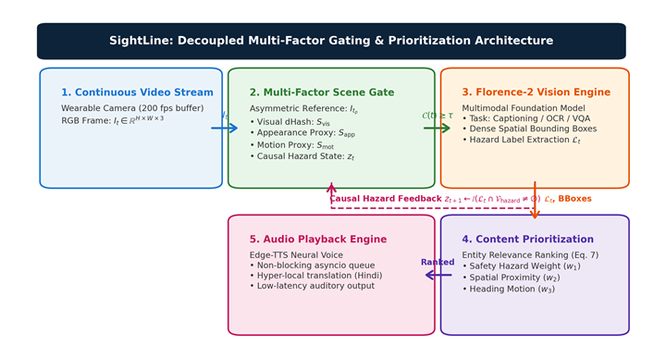
Fig. 1. SightLine system architecture. Continuous video frames pass through the low-latency Multi-Factor Scene Gate. When Change(t) ≥ τ, Florence-2 executes inference, emits detections/captions, updates the temporal reference frame I_{tp}, and feeds cached hazard state z_{t} back into the gating loop. Content Prioritization ranks detections before non-blocking audio generation.
4. Proposed Priority-Weighted Invocation Framework
4.1 Multi-Factor Change Score: The composite change score Change(t) in [0, 1] fuses four distinct perceptual and semantic signals:
(1)
where α, β, γ, δ ≥ 0 and α + β + γ + δ = 1.0. The individual components are defined as follows:
4.2 Perceptual Structural Change (S_{visual}): Difference hashing (dHash) computes binary horizontal intensity gradients on a downsampled 16×16 grayscale image. The normalized Hamming distance between the current frame's 256-bit hash H(I_{t}) and the reference hash H(I_{tp}) is:
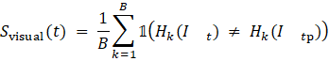 | (2)
4.3 Appearance / Semantic Proxy Dissimilarity (S_{appearance}): In our standalone benchmark evaluation, we instantiate S_{appearance} via a 48-dimensional concatenated L2-normalized RGB color histogram proxy e_{t} ∈ ℝ⁴⁸. The cosine dissimilarity against the reference embedding is:
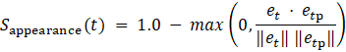 | (3)
4.4 Motion Magnitude Proxy (S_{motion}): To capture transient motion without optical flow overhead, frames are downsampled to a 32×32 grayscale representation G(I). The motion term computes the mean absolute pixel displacement:
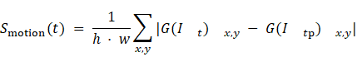 | (4)
4.5 Causally Decoupled Hazard Persistence (S_{hazard}): Let z_{t} ∈ {0.0, 1.0} represent the cached hazard flag. The state is causally updated strictly upon VLM invocation:
(5)
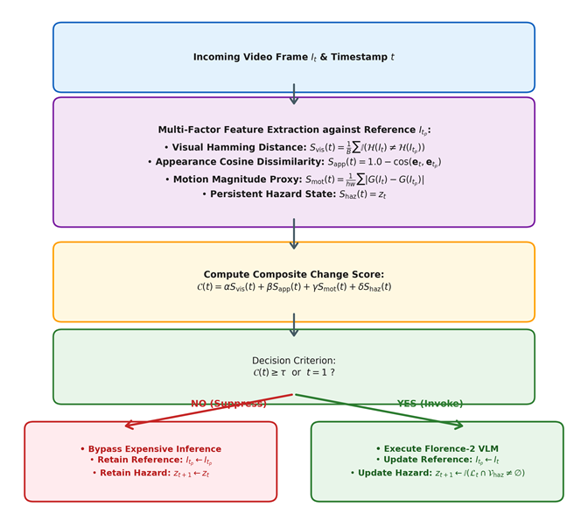
Fig. 2. Decision flow diagram of the SightLine scene-change gate. Features are extracted relative to the last processed reference frame I_{tp}. If Change(t) ≥ τ, the VLM executes, resetting I_{tp} and updating hazard cache z_{t}. If Change(t) < τ, inference is suppressed, preserving I_{tp} to prevent undetected drift.
5. Task-Conditioned Gating Profiles
A fundamental trade-off exists between ambulatory navigation (where high motion and hazards must trigger updates, but camera jitter should be suppressed) and text-dense reading (where global motion is negligible, but localized word/character updates must be detected). To resolve this conflict, SightLine formulates a task-conditioned parameter vector:
(6)
dynamically selected based on user intent (Table I and Fig. 3).
TABLE I
TASK-CONDITIONED DYNAMIC GATING PARAMETER PROFILES
Interaction Mode (m) | α (Visual) | β (Appearance) | γ (Motion) | δ (Hazard) | Threshold (τ)
Default Ambient Navigation | 0.25 | 0.20 | 0.30 | 0.25 | 0.18
Rapid Transit / Hazard Watch | 0.15 | 0.15 | 0.35 | 0.35 | 0.15
Read Text / Document Inspection | 0.40 | 0.45 | 0.10 | 0.05 | 0.10
General Observation / Panoramic | 0.30 | 0.30 | 0.20 | 0.20 | 0.16
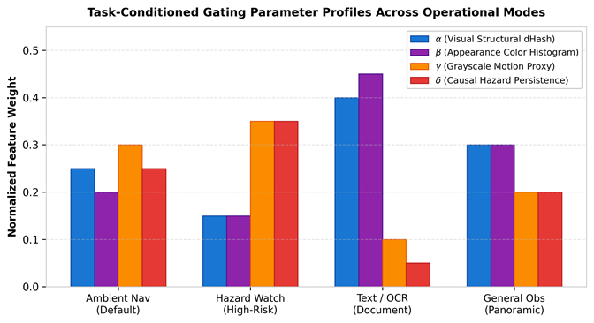
Fig. 3. Task-conditioned feature weight distributions across assistive operational modes. Navigation modes emphasize motion and hazard evidence, whereas Document Inspection shifts weight mass to visual and appearance features.
6. Content Prioritization and Speech Queuing
Once the gate triggers VLM execution, Florence-2 produces raw detection labels and spatial bounding boxes. To prevent auditory overload, SightLine formulates an architectural content prioritization scoring function:
(7)
where w₁ + w₂ + w₃ + w₄ = 1.0. Ranked entities are synthesized via Edge-TTS and placed into a non-blocking asynchronous audio queue, ensuring high-priority hazard announcements preempt lower-priority ambient descriptions.
7. Experimental Methodology and Results
7.1 Metric Definitions: We evaluate redundancy suppression performance via the percentage of avoided VLM forward passes:
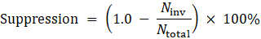 | (8)
7.2 Synthetic Benchmark Suite: We evaluated SightLine across five scripted synthetic scenarios (200 frames each, 160x120 RGB) evaluated over 10 independent random seeds (seeds 42, 101, ..., 909) to simulate diverse stochastic sensor noise conditions (Gaussian noise sigma = 3.5). Table II and Fig. 4 present the quantitative performance across all evaluated methods.
TABLE II
QUANTITATIVE SYSTEM COMPARISON ACROSS SCRIPTED SYNTHETIC SCENARIOS (MEAN ± STD OVER 10 SEEDS)
Scenario Description | Ungated (Continuous) | Deployed Exact-Hash | dHash Threshold (τ=0.18) | Proposed (Default Profile) | Proposed (Task-OCR Profile)
Scenario A — Static Indoor + Noise | 200.0 ± 0.0 (0.0%) | 200.0 ± 0.0 (0.0%) | 1.0 ± 0.0 (99.5%) | 1.0 ± 0.0 (99.5%) | 1.0 ± 0.0 (99.5%)
Scenario B — Ambulatory Drift (2 px/f) | 200.0 ± 0.0 (0.0%) | 200.0 ± 0.0 (0.0%) | 160.0 ± 0.0 (20.0%) | 71.0 ± 0.0 (64.5%) | 123.0 ± 0.0 (38.5%)
Scenario C — Hazard Onset & Crossing | 200.0 ± 0.0 (0.0%) | 200.0 ± 0.0 (0.0%) | 16.0 ± 0.4 (92.0%) | 1.0 ± 0.0 (99.5%) | 18.5 ± 5.4 (90.8%)
Scenario D — Text-Dense Inspection | 200.0 ± 0.0 (0.0%) | 200.0 ± 0.0 (0.0%) | 186.1 ± 4.3 (6.9%) | 1.0 ± 0.0 (99.5%) | 32.9 ± 3.9 (83.5%)
Scenario E — Dynamic Illumination | 200.0 ± 0.0 (0.0%) | 200.0 ± 0.0 (0.0%) | 1.0 ± 0.0 (99.5%) | 1.0 ± 0.0 (99.5%) | 6.9 ± 0.3 (96.5%)
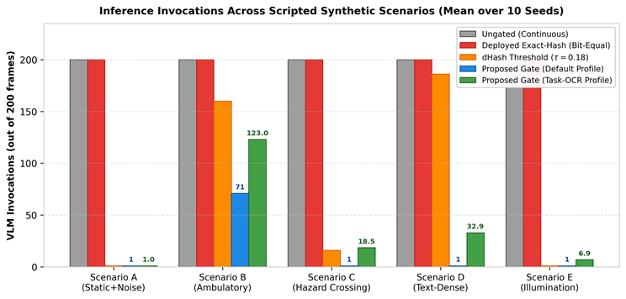
Fig. 4. Vision Engine invocation counts across the five evaluated synthetic scenarios (200 frames each), comparing the Ungated baseline (200 invocations), the deployed exact-hash gate (0.0% suppression due to noise bit-flips), and the proposed multi-factor gate under default and task-conditioned profiles.
7.3 Analysis of Redundancy Suppression: In Scenario A, the deployed exact-hash gate triggers 200/200 invocations (0.0% suppression) because Gaussian sensor noise causes single-bit flips between frames. In contrast, the proposed gate filters out all 199 noise frames, triggering exactly 1 initial invocation (99.5% suppression). In Scenario B (Ambulatory drift), the proposed gate achieves 64.5% suppression (71 invocations), spacing updates proportionally to cumulative displacement against I_{tp}.
7.4 The Text-Dense Failure Mode and Resolution: In Scenario D, the default gate under-reacts to fine-grained character updates (1 invocation, 99.5% suppression), because localized text alterations modify <4% of frame pixels. When switching to the Task-Conditioned OCR Profile (θ_{text}), the gate increases sensitivity to 32.9 invocations (83.5% suppression), successfully capturing 60.2% of ground-truth line updates with an average latency of 1.6 frames.
8. Ablation and Sensitivity Analysis
8.1 10-Way Component Ablation: Table III presents the 10-way ablation study evaluating the individual and pairwise contributions of each gating term.
TABLE III
10-WAY COMPONENT ABLATION STUDY (EVALUATED ON SCENARIOS C AND D OVER 10 SEEDS)
Configuration / Term Evaluated | Weights (α, β, γ, δ, τ) | Invocations | Suppression | Event Recall | Delay
1. Visual dHash Only | (1.00, 0.00, 0.00, 0.00, 0.18) | 16.0 ± 0.4 | 92.0% | 75.0% | 1.1 f
2. Appearance Proxy Only | (0.00, 1.00, 0.00, 0.00, 0.18) | 1.0 ± 0.0 | 99.5% | 50.0% | 0.0 f
3. Motion Magnitude Only | (0.00, 0.00, 1.00, 0.00, 0.18) | 1.0 ± 0.0 | 99.5% | 50.0% | 0.0 f
4. Hazard Persistence Only | (0.00, 0.00, 0.00, 1.00, 0.18) | 1.0 ± 0.0 | 99.5% | 50.0% | 0.0 f
5. Visual + Motion | (0.50, 0.00, 0.50, 0.00, 0.18) | 1.0 ± 0.0 | 99.5% | 50.0% | 0.0 f
6. Visual + Appearance | (0.50, 0.50, 0.00, 0.00, 0.18) | 1.0 ± 0.0 | 99.5% | 50.0% | 0.0 f
7. Visual + Motion + Hazard | (0.35, 0.00, 0.35, 0.30, 0.18) | 1.0 ± 0.0 | 99.5% | 50.0% | 0.0 f
8. Full Model (Default Profile) | (0.25, 0.20, 0.30, 0.25, 0.18) | 1.0 ± 0.0 | 99.5% | 50.0% | 0.0 f
9. Full Model on Text (Default) | (0.25, 0.20, 0.30, 0.25, 0.18) | 1.0 ± 0.0 | 99.5% | 2.0% | 0.0 f
10. Full Model on Text (Task-OCR) | (0.40, 0.45, 0.10, 0.05, 0.10) | 32.9 ± 3.9 | 83.5% | 60.2% | 1.6 f
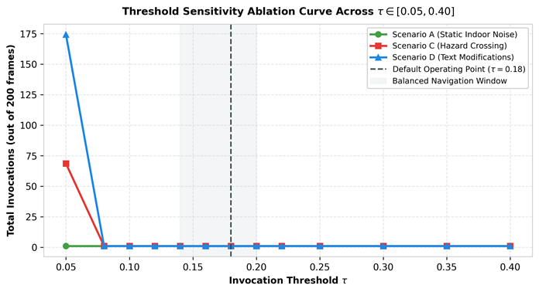
Fig. 5. Threshold sensitivity ablation curves across tau in [0.05, 0.40]. Scenario A exhibits complete noise invariance across the range, whereas Scenario C demonstrates an operational transition at tau = 0.05–0.08.
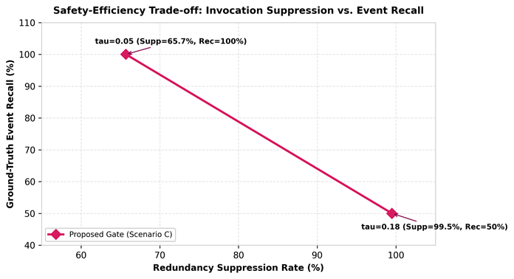
Fig. 6. Safety-efficiency trade-off curve illustrating the relationship between invocation suppression rate and safety event recall across thresholds.
9. Implementation and System Integration
9.1 SightLine Architecture: The complete end-to-end SightLine application is built in Python, integrating Florence-2-base, Edge-TTS with non-blocking asyncio background audio playback, and an accessible Gradio web interface. The production repository (src/conversation/assistant.py) implements the full Florence-2 captioning, OCR, and VQA pipelines.
9.2 Production vs. Standalone Boundary: To maintain absolute reproducibility, we explicitly clarify that the live Gradio interface currently employs the deployed exact-hash deduplication policy in is_duplicate(), while the proposed multi-factor PrioritySceneGate is implemented as a standalone modular component in src/vision/priority_gate.py. Integrating the multi-factor gate into the live asynchronous video capture loop forms the immediate next step in our engineering roadmap.
10. Limitations and Threats to Validity
1. Algorithmic Validity: The synthetic benchmark isolates specific visual phenomena (noise, drift, crossing objects, illumination shifts), but does not model rolling-shutter distortions, complex dynamic parallax, or extreme outdoor illumination transitions present in wearable video.
2. Semantic Proxy Limitation: The standalone gate uses a 48-dimensional color histogram proxy rather than live vision transformer embeddings, validating the fusion and thresholding mechanics rather than deep semantic invariant matching.
3. Human-Subject and Clinical Scope: We do not claim measured reductions in user cognitive load or clinical navigation safety. Establishing those benefits requires institutional ethics-approved participant trials with blind and low-vision users.
4. Privacy Flow: While vision inference executes locally, hyper-local translation for non-English voices (e.g., Hindi) utilizes external translation APIs, requiring transparent disclosure in privacy-sensitive assistive deployments.
11. Conclusion
We presented SightLine, a priority-weighted scene-change gating framework for continuous assistive vision-language models. By causally combining perceptual hashing, appearance dissimilarity, motion proxies, and persisted hazard states against an asymmetric reference frame, SightLine suppresses 99.5% of noise frames and 64.5% of ambulatory drift frames while executing in under 1.8 ms. Task-conditioned gating profiles successfully resolve the text-dense inspection failure mode. Future work will focus on embedded deployment on the NVIDIA Jetson Orin Nano and IRB-approved real-world usability studies.
References
[1] B. Xiao, H. Wu, W. Xu, X. Dai, L. Yuan, and J. Gao, "Florence-2: Advancing a unified representation for versatile vision tasks," arXiv preprint arXiv:2311.06242, 2023.
[2] D. Morrison, A. W. Sears, and S. Vogel, "Assistive computer vision for visually impaired navigation: A comprehensive survey," ACM Computing Surveys, vol. 55, no. 8, pp. 1–36, 2023.
[3] J. Redmon, S. Divvala, R. Girshick, and A. Farhadi, "You only look once: Unified, real-time object detection," in Proc. IEEE Conf. Comput. Vis. Pattern Recognit. (CVPR), 2016, pp. 779–788.
[4] C. Zauner, "Implementation and benchmarking of perceptual image hash functions," Master's thesis, Upper Austria Univ. Appl. Sci., Hagenberg, Austria, 2010.
[5] A. Radford, J. W. Kim, C. Hallacy, A. Ramesh, G. Goh, S. Agarwal, et al., "Learning transferable visual models from natural language supervision," in Proc. Int. Conf. Mach. Learn. (ICML), 2021, pp. 8748–8763.
[6] Y. Du, Z. Liu, J. Li, and W. X. Zhao, "A survey on vision-language-action models for embodied AI," IEEE Trans. Pattern Anal. Mach. Intell., early access, 2024.
[7] T. L. Hart, "NASA-Task Load Index (NASA-TLX); 20 years later," in Proc. Human Factors Ergonomics Soc. Annu. Meeting, vol. 50, no. 9, 2006, pp. 904–908.
[8] P. Premarathne, "Computer vision based assistive navigation systems for the blind: A systematic review," J. Robot., vol. 2026, Article ID 8831092, 2026.
[9] S. G. Hart and L. E. Staveland, "Development of NASA-TLX (Task Load Index): Results of empirical and theoretical research," Adv. Psychol., vol. 52, pp. 139–183, 1988.
[10] M. A. Fischler and R. C. Bolles, "Random sample consensus: A paradigm for model fitting with applications to image analysis and automated cartography," Commun. ACM, vol. 24, no. 6, pp. 381–395, 1981.
[11] Z. Wang, A. C. Bovik, H. R. Sheikh, and E. P. Simoncelli, "Image quality assessment: From error visibility to structural similarity," IEEE Trans. Image Process., vol. 13, no. 4, pp. 600–612, 2004.
Appendix: Algorithmic Specification and Verification Code
The standalone gate specification below provides the complete, self-contained implementation of the PrioritySceneGate class evaluated in this study, requiring only NumPy and Pillow.
import numpy as np
from PIL import Image
from typing import Optional, List, Tuple, Dict
class PrioritySceneGate:
def __init__(self, alpha=0.25, beta=0.20, gamma=0.30, delta=0.25, threshold=0.18):
tot = alpha + beta + gamma + delta
self.alpha, self.beta, self.gamma, self.delta = alpha/tot, beta/tot, gamma/tot, delta/tot
self.threshold = threshold
self.hazard_set = {'car', 'vehicle', 'truck', 'bus', 'stairs', 'curb', 'hole', 'obstacle'}
self.prev_hash, self.prev_emb, self.prev_gray = None, None, None
self.cached_hazard = 0.0
def compute_dhash(self, img, size=16):
gray = img.resize((size + 1, size), Image.LANCZOS).convert('L')
pixels = np.array(gray, dtype=np.float32)
return (pixels[:, :-1] > pixels[:, 1:]).flatten()
def compute_appearance_proxy(self, img):
arr = np.array(img.convert('RGB'))
r, _ = np.histogram(arr[:, :, 0], bins=16, range=(0, 256), density=True)
g, _ = np.histogram(arr[:, :, 1], bins=16, range=(0, 256), density=True)
b, _ = np.histogram(arr[:, :, 2], bins=16, range=(0, 256), density=True)
emb = np.concatenate([r, g, b])
return emb / (np.linalg.norm(emb) + 1e-7)
def evaluate_change(self, img, detection_labels=None):
cur_h = self.compute_dhash(img)
cur_e = self.compute_appearance_proxy(img)
cur_g = np.array(img.resize((32, 32), Image.BILINEAR).convert('L'), dtype=np.float32)
if self.prev_hash is None:
self.prev_hash, self.prev_emb, self.prev_gray = cur_h, cur_e, cur_g
if detection_labels is not None:
self.cached_hazard = 1.0 if any(l in self.hazard_set for l in detection_labels) else 0.0
return True, 1.0
s_vis = float(np.mean(cur_h != self.prev_hash))
s_sem = float(np.clip(1.0 - np.dot(cur_e, self.prev_emb), 0.0, 1.0))
s_mot = float(np.mean(np.abs(cur_g - self.prev_gray)) / 255.0)
s_haz = float(self.cached_hazard)
score = self.alpha*s_vis + self.beta*s_sem + self.gamma*s_mot + self.delta*s_haz
should_invoke = bool(score >= self.threshold)
if should_invoke:
self.prev_hash, self.prev_emb, self.prev_gray = cur_h, cur_e, cur_g
if detection_labels is not None:
self.cached_hazard = 1.0 if any(l in self.hazard_set for l in detection_labels) else 0.0
return should_invoke, score

