Trade Net Trade & Portfolio Management Software:

Software Architecture Description

<<Your Names & NetIDs>>

CSE 4233/6233
Fall 2014

Architectural Documentation (Document Control Information)

Date of issue and status
The document is generated for the final submission of the Architecture Description of the Trade Net Trade & Portfolio Management Software. The report is issued on the 10th December, 2014.

Issuing organization
The document is the final project report for the course Software Architecture and Design (CSE 4233/6233) instructed and supervised by Byron Williams in the department of Computer Science and Engineering of Mississippi State University.

Change history
[Fill in your information]

Summary (System Overview)
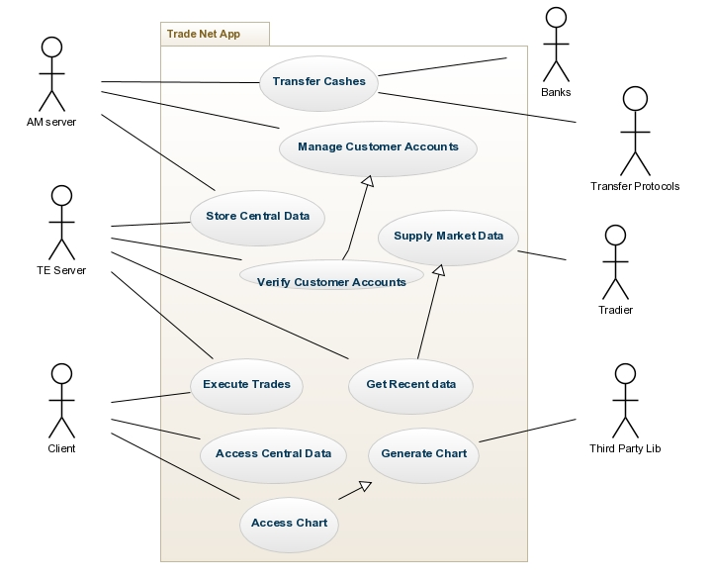
Figure 1: System Level Context Diagram

Context
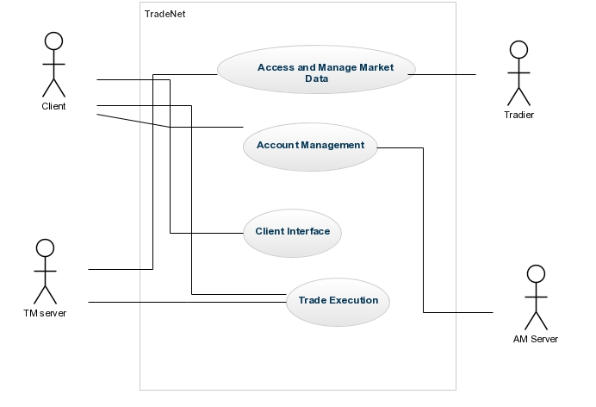
Figure 2: Context Diagram

Glossary
[Fill in your information]

References
[Fill in your information]

Acknowledgements
[Fill in your information]

Identification of Stakeholders and Concerns

Stakeholders

Project Manager
Project Manager cares about Schedule, resources, contingency plans, overall purpose and constraints, interaction with other systems, hardware environment. He will take care of the top level design and work assignment by visualizing the description.

Development Team
They will develop the system using the code resources and infrastructure provided to them for fulfilling the system requirements. As they need to know the requirements of the users and also schedule and budget of the system confined for the development along with their responsibilities, they need to care about architecture description.

Maintainers
Maintainers manage the system by getting information from this description. They will get ideas about any changes or impact on the system for managing them properly. They get information about the dependency across the modules and components.

Designer
Designers are concerned about the architectural structure and design of the whole system. They mostly care about the top level view and conceptual data model from the architecture description.

Customers
Customers will use the system for executing trade, viewing charts, and account management. As they are paying the application for their trade execution, they will care about the overall design of the application and concentrate if it can meet their requirements and interface with other systems properly.

Concerns

(Concern 1) What are the purpose(s) of the Trade Net?
Trade Net provides brokerage services (i.e., the ability to buy and sale shares of a company) to its customers. Trade Net customers pay for executing their trades and also for gathering updated information provided by the application. So the main purpose of the system is to enable proper and correct execution of trade with the supply of latest market data.

(Concern 2) What are the performance issues of the system?
As the trade execution depends on the current market price, the system should provide the requirement properly. The execution should be time and cost efficient as expected by the customers.

(Concern 3) What are the Security issues of the system?
The system maintain cash transfer using wireless protocols and banking interfaces. All kinds of communications and data transfers should be encrypted and secured such that attackers cannot break the system. Moreover, customer account information as managed by AM server should be kept private by maintaining proper access control.

(Concern 4) What are the other quality attributes of the system?
The software should also maintain Flexibility for added features and additional types of client interactions for future addition. Availability is also important for avoiding denial of service attacks from any malicious users.

Architectural views

Logical views
[Overview – Can include an element catalog here, or include it with each view]

Uses View
- Primary Presentation

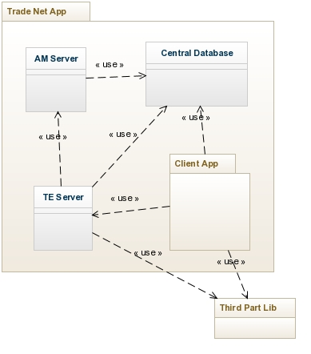
Figure 3: Uses Style (Model View)

[Include (where needed) for each view:
Explanation of style using key
Other information
Related view packets)]
- Element Catalog

Elements | Modules: AM Server, TE Server, Client Application, Central Database
Properties of Elements | - AM and Central database are DB servers  - TE is the server-side trade execution server  - Client Application is the client side application for running trades
Relations | Uses or Depends on:  - TE server uses the information from AM server  - Both AM and TE servers use Central database  - Client Application uses Central database and third party libraries
Properties of Relations | - TE server depends on AM server for customer data verification and authentication  - Both AM and TE servers store data on Central database  - TE server depends on Tradier Network for market data
Interface | - AM Server with service interface (e.g., API, SOAP, REST, SOCKETS etc.)  - web, Mac, PC, iOS, and Android clients interfaces for Client Application
Behavior | - No broad fan out  - No loop  - No long dependency

- Architectural Background
- Rationale:
  - Uses view is used for documenting the uses or depend relationships among the modules. As there is a number of dependencies among the AM, TE and central servers as well as servers with client application, uses view is helpful to document the relationships with clarity.
It clearly describes the relationships among the modules to facilitate the development team, analysts and customers.
- Analysis Results:
  - As TE server depends on AM server for customer authentication, AE server should work correctly for better performance of TE server. If AE server does not maintain data integrity and security it will hamper overall system security and customer privacy.
  - Moreover, the whole system depends on a number of third parties (tradier, Banking, Wireless protocol and so on) for executing all the applications. So the interfaces or APIs for communicating with the third parties should be protected and secured such that no data is leaked to the unauthorized users.
- Assumptions:

Data Model View
- Primary Presentation

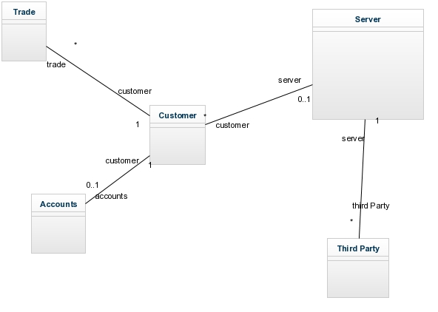
- Element Catalog

Elements | Modules: AM Server, TE Server, Client Application, Central Database
Properties of Elements | - AM and Central database are DB servers  - TE is the server-side trade execution server  - Client Application is the client side application for running trades
Relations | Uses or Depends on:  - TE server uses the information from AM server  - Both AM and TE servers use Central database  - Client Application uses Central database and third party libraries
Properties of Relations | - TE server depends on AM server for customer data verification and authentication  - Both AM and TE servers store data on Central database  - TE server depends on Tradier Network for market data
Interface | - AM Server with service interface (e.g., API, SOAP, REST, SOCKETS etc.)  - web, Mac, PC, iOS, and Android clients interfaces for Client Application
Behavior | - No broad fan out  - No loop  - No long dependency

- Architectural Background
- Rationale:
  - Uses view is used for documenting the uses or depend relationships among the modules. As there is a number of dependencies among the AM, TE and central servers as well as servers with client application, uses view is helpful to document the relationships with clarity.
It clearly describes the relationships among the modules to facilitate the development team, analysts and customers.
- Analysis Results:
  - As TE server depends on AM server for customer authentication, AE server should work correctly for better performance of TE server. If AE server does not maintain data integrity and security it will hamper overall system security and customer privacy.
  - Moreover, the whole system depends on a number of third parties (tradier, Banking, Wireless protocol and so on) for executing all the applications. So the interfaces or APIs for communicating with the third parties should be protected and secured such that no data is leaked to the unauthorized users.
- Assumptions:

Run-time Structure and Dynamic Views
[Overview]

View 1
[Document as described earlier]

View N

Allocation Views

View 1
[Document as described earlier]

View N
[Document as described earlier]

Consistency among Architectural Views (Mapping Between Views)
[Fill in your information]

Architectural Rationale
[Fill in your information – include a mapping of requirements to modules]

