**Insert**

**Select**

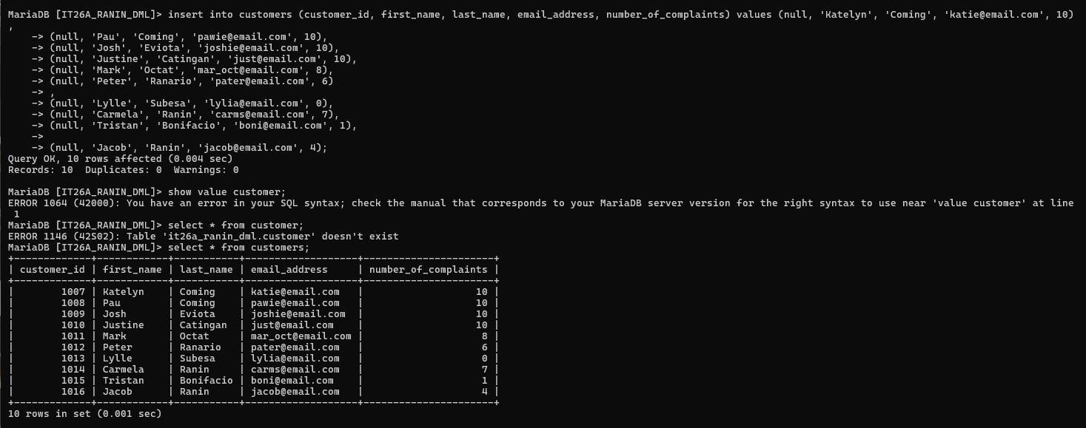

**Update**

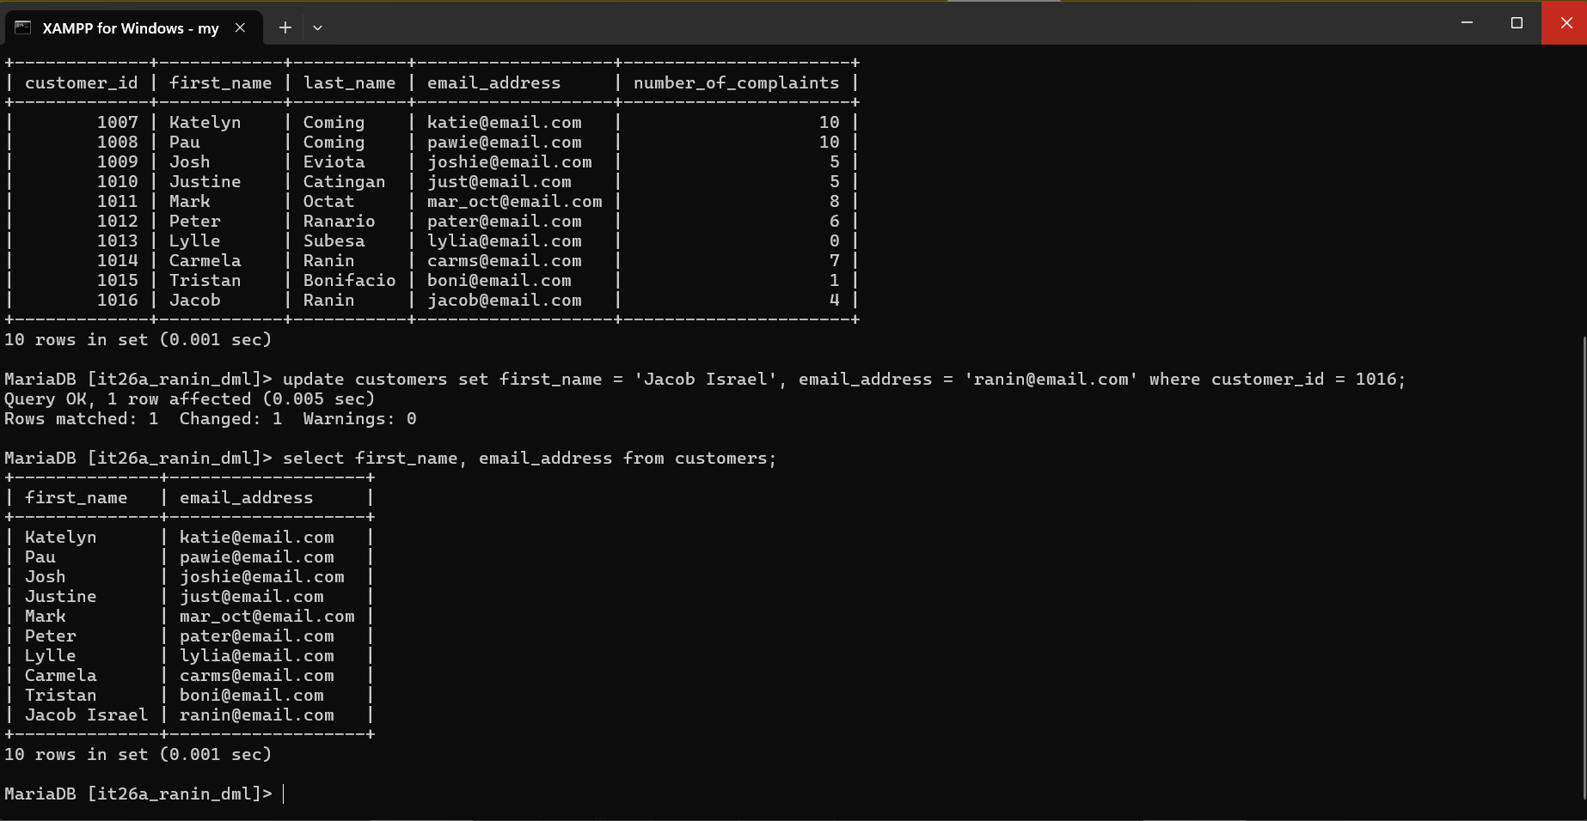

**Delete**

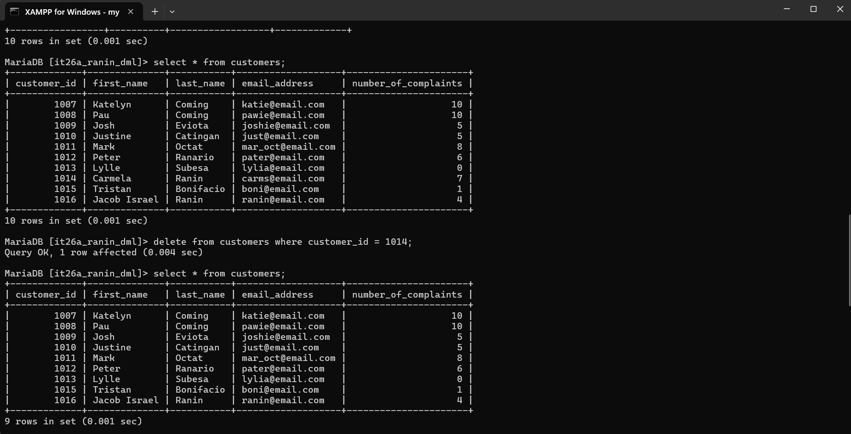

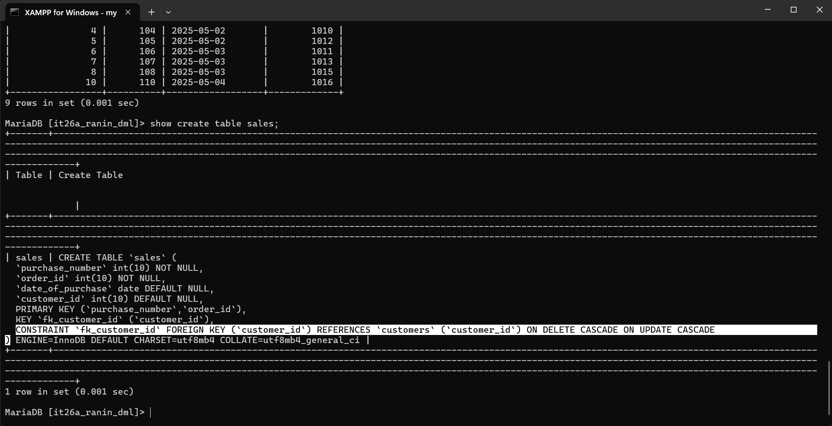**Cascade** behavior (Delete and Update) has been activated.

Behavior of cascading: if you update or delete a row from the parent table, which is the “customers” table, it will also affect the corresponding row on the child table, the “sales” table.

In this picture I’ve provided, I updated a column from the customers table which is the customer_id, a primary key and is also a foreign key to sales table.

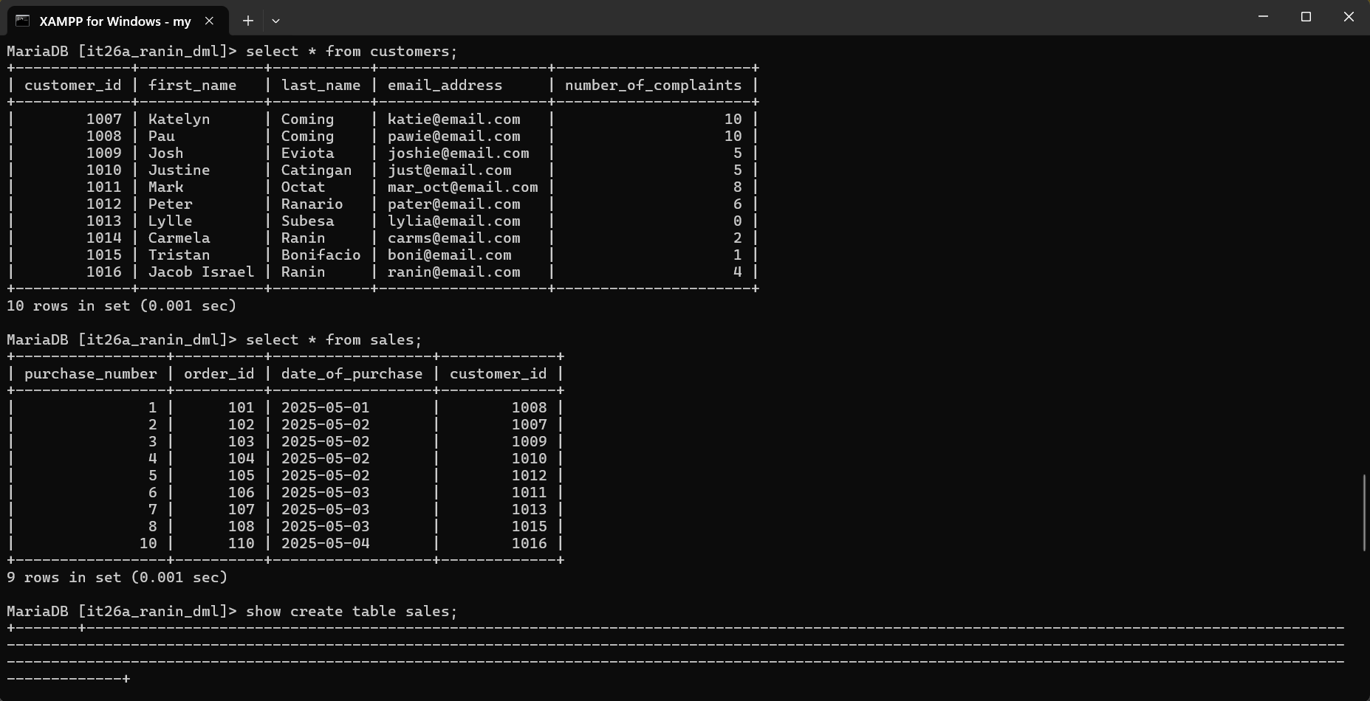Before:

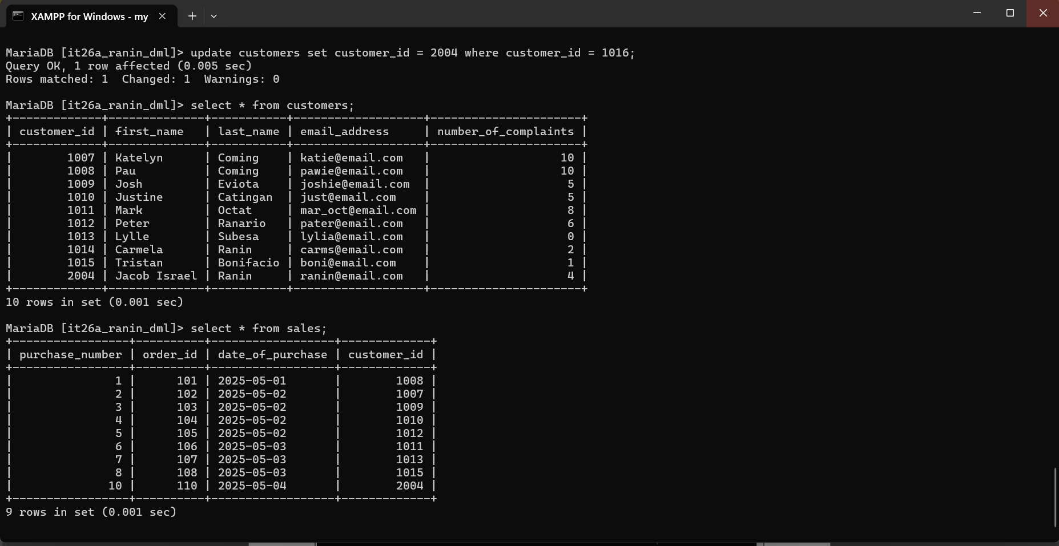After: